Visualizing Texas: odt_document
2019-03-15

Packages
We’ll use ggplot2 for visualization, and some light dplyr for data wrangling.
library(ggplot2) # plotting
library(dplyr) # wrangling

Texas housing data
This data is loaded for you when you install and load the ggplot2 package.
txsamp <- txhousing %>%
filter(city %in% c("Houston", "Fort Worth", "San Antonio", "Dallas", "Austin"))
glimpse(txsamp)
## Observations: 935
## Variables: 9
## $ city <chr> "Austin", "Austin", "Austin", "Austin", "Austin", "Aus…
## $ year <int> 2000, 2000, 2000, 2000, 2000, 2000, 2000, 2000, 2000, …
## $ month <int> 1, 2, 3, 4, 5, 6, 7, 8, 9, 10, 11, 12, 1, 2, 3, 4, 5, …
## $ sales <dbl> 1025, 1277, 1603, 1556, 1980, 1885, 1818, 1880, 1498, …
## $ volume <dbl> 173053635, 226038438, 298557656, 289197960, 393073774,…
## $ median <dbl> 133700, 134000, 136700, 136900, 144700, 148800, 149300…
## $ listings <dbl> 3084, 2989, 3042, 3192, 3617, 3799, 3944, 3948, 4058, …
## $ inventory <dbl> 2.0, 2.0, 2.0, 2.1, 2.3, 2.4, 2.6, 2.6, 2.6, 2.6, 2.7,…
## $ date <dbl> 2000.000, 2000.083, 2000.167, 2000.250, 2000.333, 2000…

Our data is monthly
Here is just a sample of rows from one city to show that we have data for each of the 12 months for each year, except for 2015.
txsamp %>%
filter(city == "Austin") %>%
count(year)
## # A tibble: 16 x 2
## year n
## <int> <int>
## 1 2000 12
## 2 2001 12
## 3 2002 12
## 4 2003 12
## 5 2004 12
## 6 2005 12
## 7 2006 12
## 8 2007 12
## 9 2008 12
## 10 2009 12
## 11 2010 12
## 12 2011 12
## 13 2012 12
## 14 2013 12
## 15 2014 12
## 16 2015 7

Austin is expensive
ggplot(data = txsamp, aes(x = sales, y = median)) +
geom_point(aes(colour = city)) +
scale_colour_viridis_d("City\nCenter", option = params$viridis_palette)
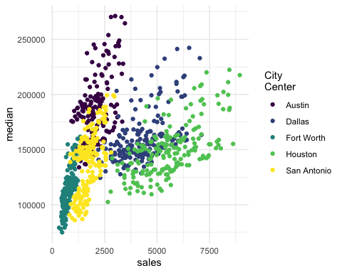

Austin prices on the rise
ggplot(data = filter(txsamp, city == "Austin"), aes(x = sales, y = median)) +
geom_point(aes(colour = year)) +
scale_colour_viridis_c("Austin by year", option = params$viridis_palette, direction = -1)
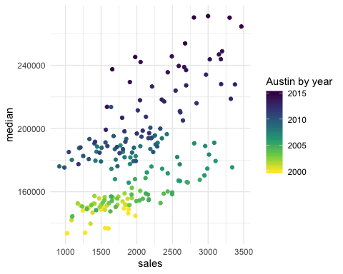

Fort Worth has more affordable housing
library(scales) # to make y-axis in non-scientific notation
ggplot(txsamp, aes(x = median, fill = city)) +
geom_histogram(aes(weight = sales), position = "dodge", binwidth = 15000) +
scale_fill_viridis_d(option = params$viridis_palette)+
scale_y_continuous(labels = comma)
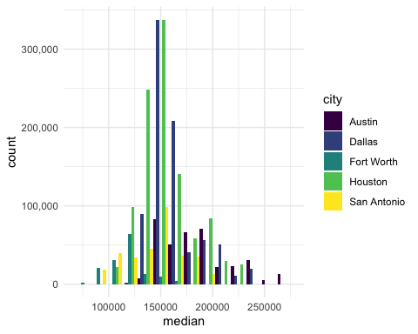

The current pace of sales is fast
“Months inventory”: amount of time it would take to sell all current listings at current pace of sales.
ggplot(data = txsamp, aes(x = year, y = inventory, colour = city)) +
geom_point() +
geom_smooth(se = FALSE) +
scale_colour_viridis_d("City\nCenter", option = params$viridis_palette)
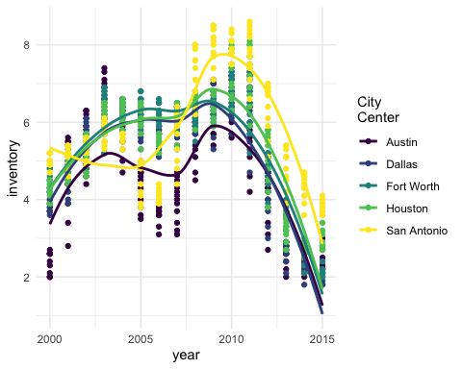

Thanks to…
- Jennifer Thompson: https://github.com/jenniferthompson/ParamRmdExample
- Garrett Grolemund: https://rmarkdown.rstudio.com/lesson-6.html

