Texas Housing Prices: word_document

Alison Hill

The txhousing data is available when you install and load the ggplot2 package.

library(tidyverse)  
txsamp <- txhousing %>%   
 filter(city %in% c("Houston", "Fort Worth", "San Antonio", "Dallas", "Austin"))

# Austin is expensive

ggplot(data = txsamp, aes(x = sales, y = median)) +  
 geom_point(aes(colour = city)) +   
 scale_colour_viridis_d("City\nCenter", option = params$viridis_palette)

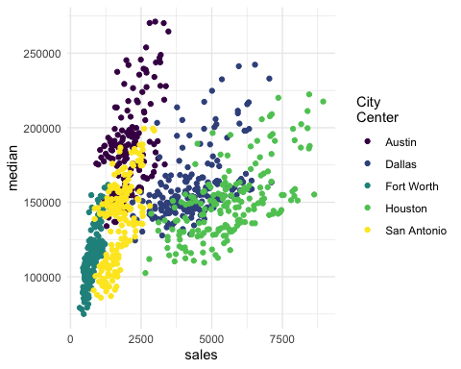

# Austin prices on the rise

ggplot(data = filter(txsamp, city == "Austin"), aes(x = sales, y = median)) +  
 geom_point(aes(colour = year)) +   
 scale_colour_viridis_c("Austin by year", option = params$viridis_palette, direction = -1)

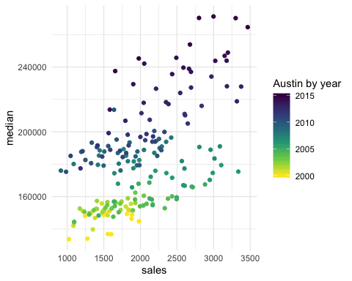

# Fort Worth has more affordable housing

library(scales) # to make y-axis in non-scientific notation  
ggplot(txsamp, aes(x = median, fill = city)) +  
 geom_histogram(aes(weight = sales), position = "dodge", binwidth = 15000) +  
 scale_fill_viridis_d(option = params$viridis_palette)+  
 scale_y_continuous(labels = comma)

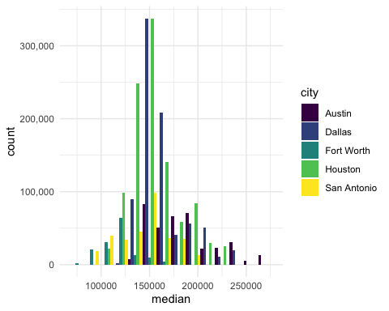

# The current pace of sales is fast

“Months inventory”: amount of time it would take to sell all current listings at current pace of sales.

ggplot(data = txsamp, aes(x = year, y = inventory, colour = city)) +  
 geom_point() +   
 geom_smooth(se = FALSE) +  
 scale_colour_viridis_d("City\nCenter", option = params$viridis_palette)

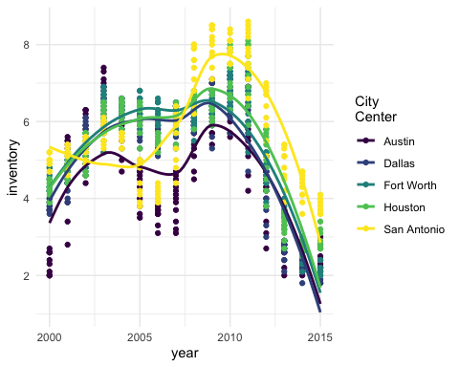

# Thanks to…

* Jennifer Thompson: <https://github.com/jenniferthompson/ParamRmdExample>
* Garrett Grolemund: <https://rmarkdown.rstudio.com/lesson-6.html>