**Application name: Runescape wiki**

**Description: A Web app players of the game Runescape can use to look up any information about the game**

**Task 1: Searching a topic**

Non-technical description:

-Users will be able to search any game topic they may wish to learn about through a search bar and the most relevant page will be opened for their reference.

Technical description:

-A string is entered through the search bar at the top right and will load a page on their topic



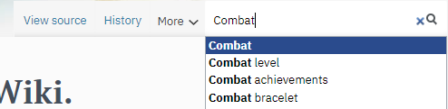

-The database searches the string against entries based on their string title and returns the result that matches the string entered

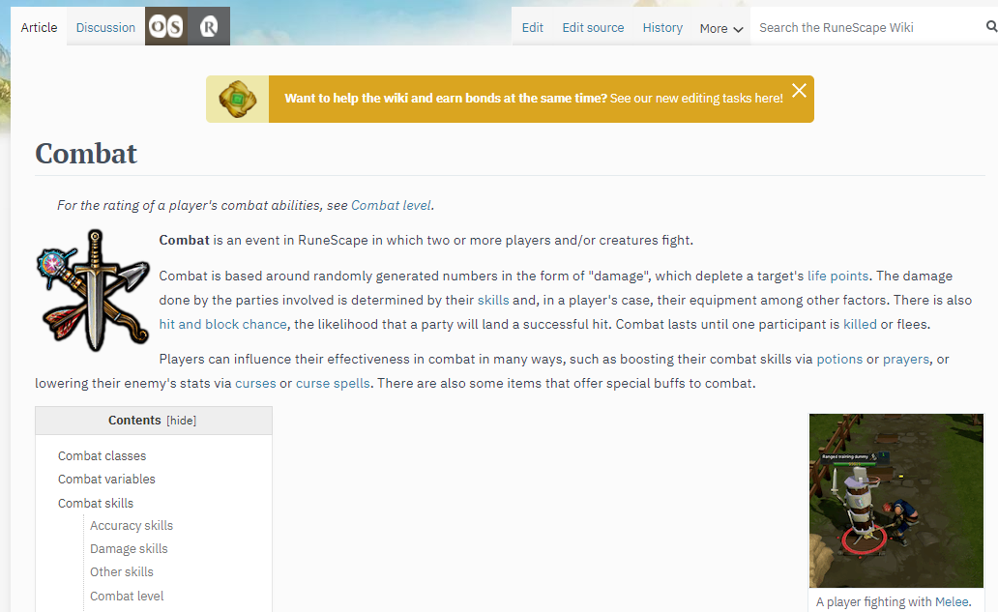

Potential problems:

-A user doesn’t spell their intended topic correctly

-The page doesn’t exist

-Long search time to find what they’re looking for

**Task 2: Creating/editing a topic**

Non-technical description:

-Users or authors of a page can create or edit a topic to be entered into the wiki

Technical description:

-To create a new page, a user will go the sidebar on the main page and choose the create a new page

-There they will enter information into a pre-built template made in order to be able to find the page easily through the search function, and it will also serve to allow any readers to navigate the page if they are used to navigating other wiki pages

-To edit a page, a user will navigate to an already created page and choose the edit button next to the search bar shown in red:

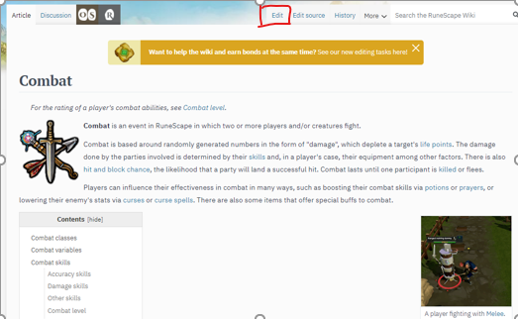

Potential problems:

-Pages unrelated to the game are created

-Multiple pages about the same topic are created

-Malicious users edit page with incorrect information

**Task 3: Using the skill calculators**

Non-technical description:

-This feature calculates how many actions in the game are needed for the player to reach a certain level in a skill that they choose. The user can upload their account information or input the information themselves.

Technical description:

-Here in the green area, The user can input their username and their skill progress will be pulled from the game’s leaderboard on their main website, or players can input the level themselves.

-Name field takes in a string

-level fields take in integers

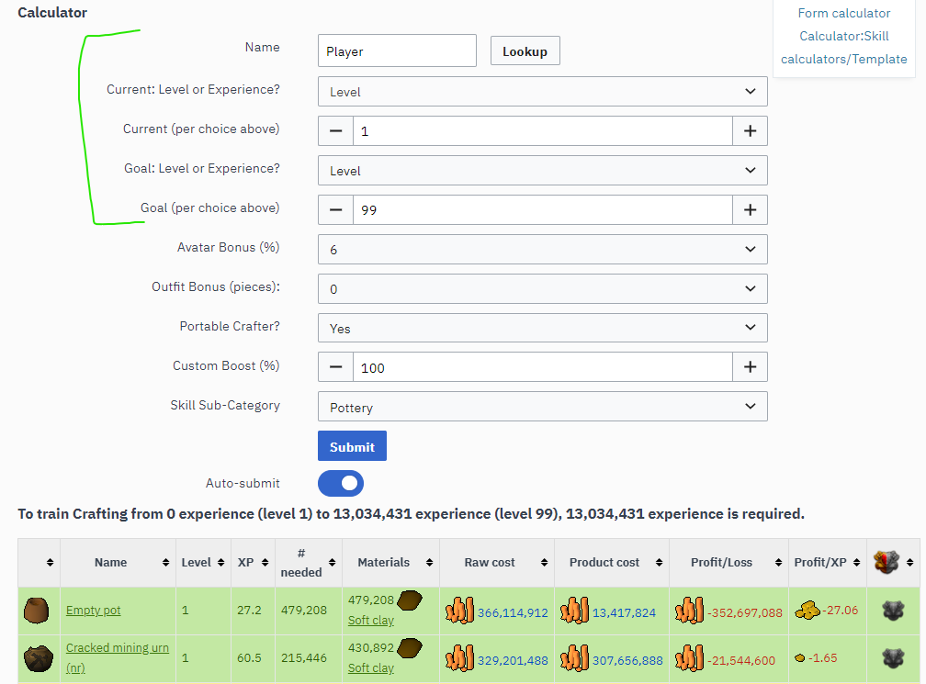

-Any modifiers that would affect the experience amount are entered here in the red area

-these are all drop down menus listing any possible boost implemented in the game

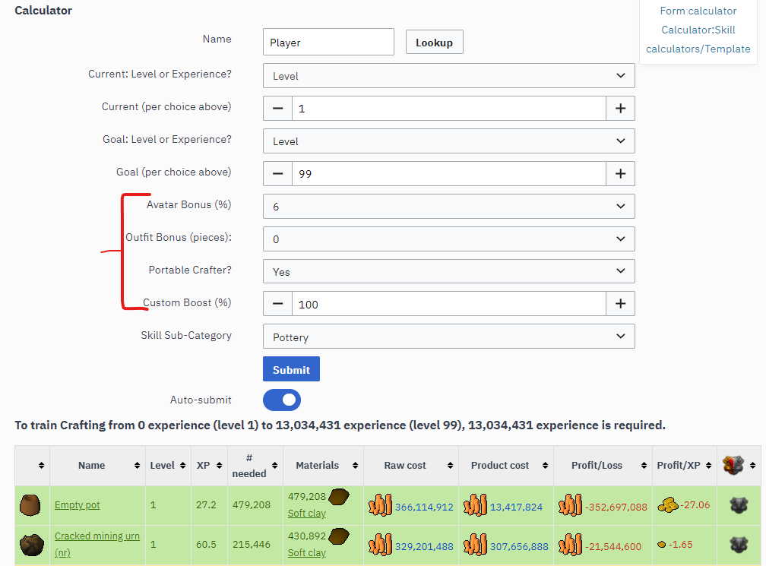

Potential problems:

-Since the same template is used, the wrong skill information could be pulled up

-Skill information could be outdated compared to in-game

-modifiers effect the formula different than how they are applied in game