Users to review
Budget-burn watchlist in OneFlowe Graphical Reports
Feature walkthrough · September 2026
Every branch shares one monthly budget. This feature shows Head Office a short, ranked list of the people whose use of that shared budget looks unusual this month, explains why each of them is on the list, and lets the reviewer open the exact orders behind the figures. It highlights patterns for a person to look at — it does not decide anything, block anything, or prove intent.

Where it lives
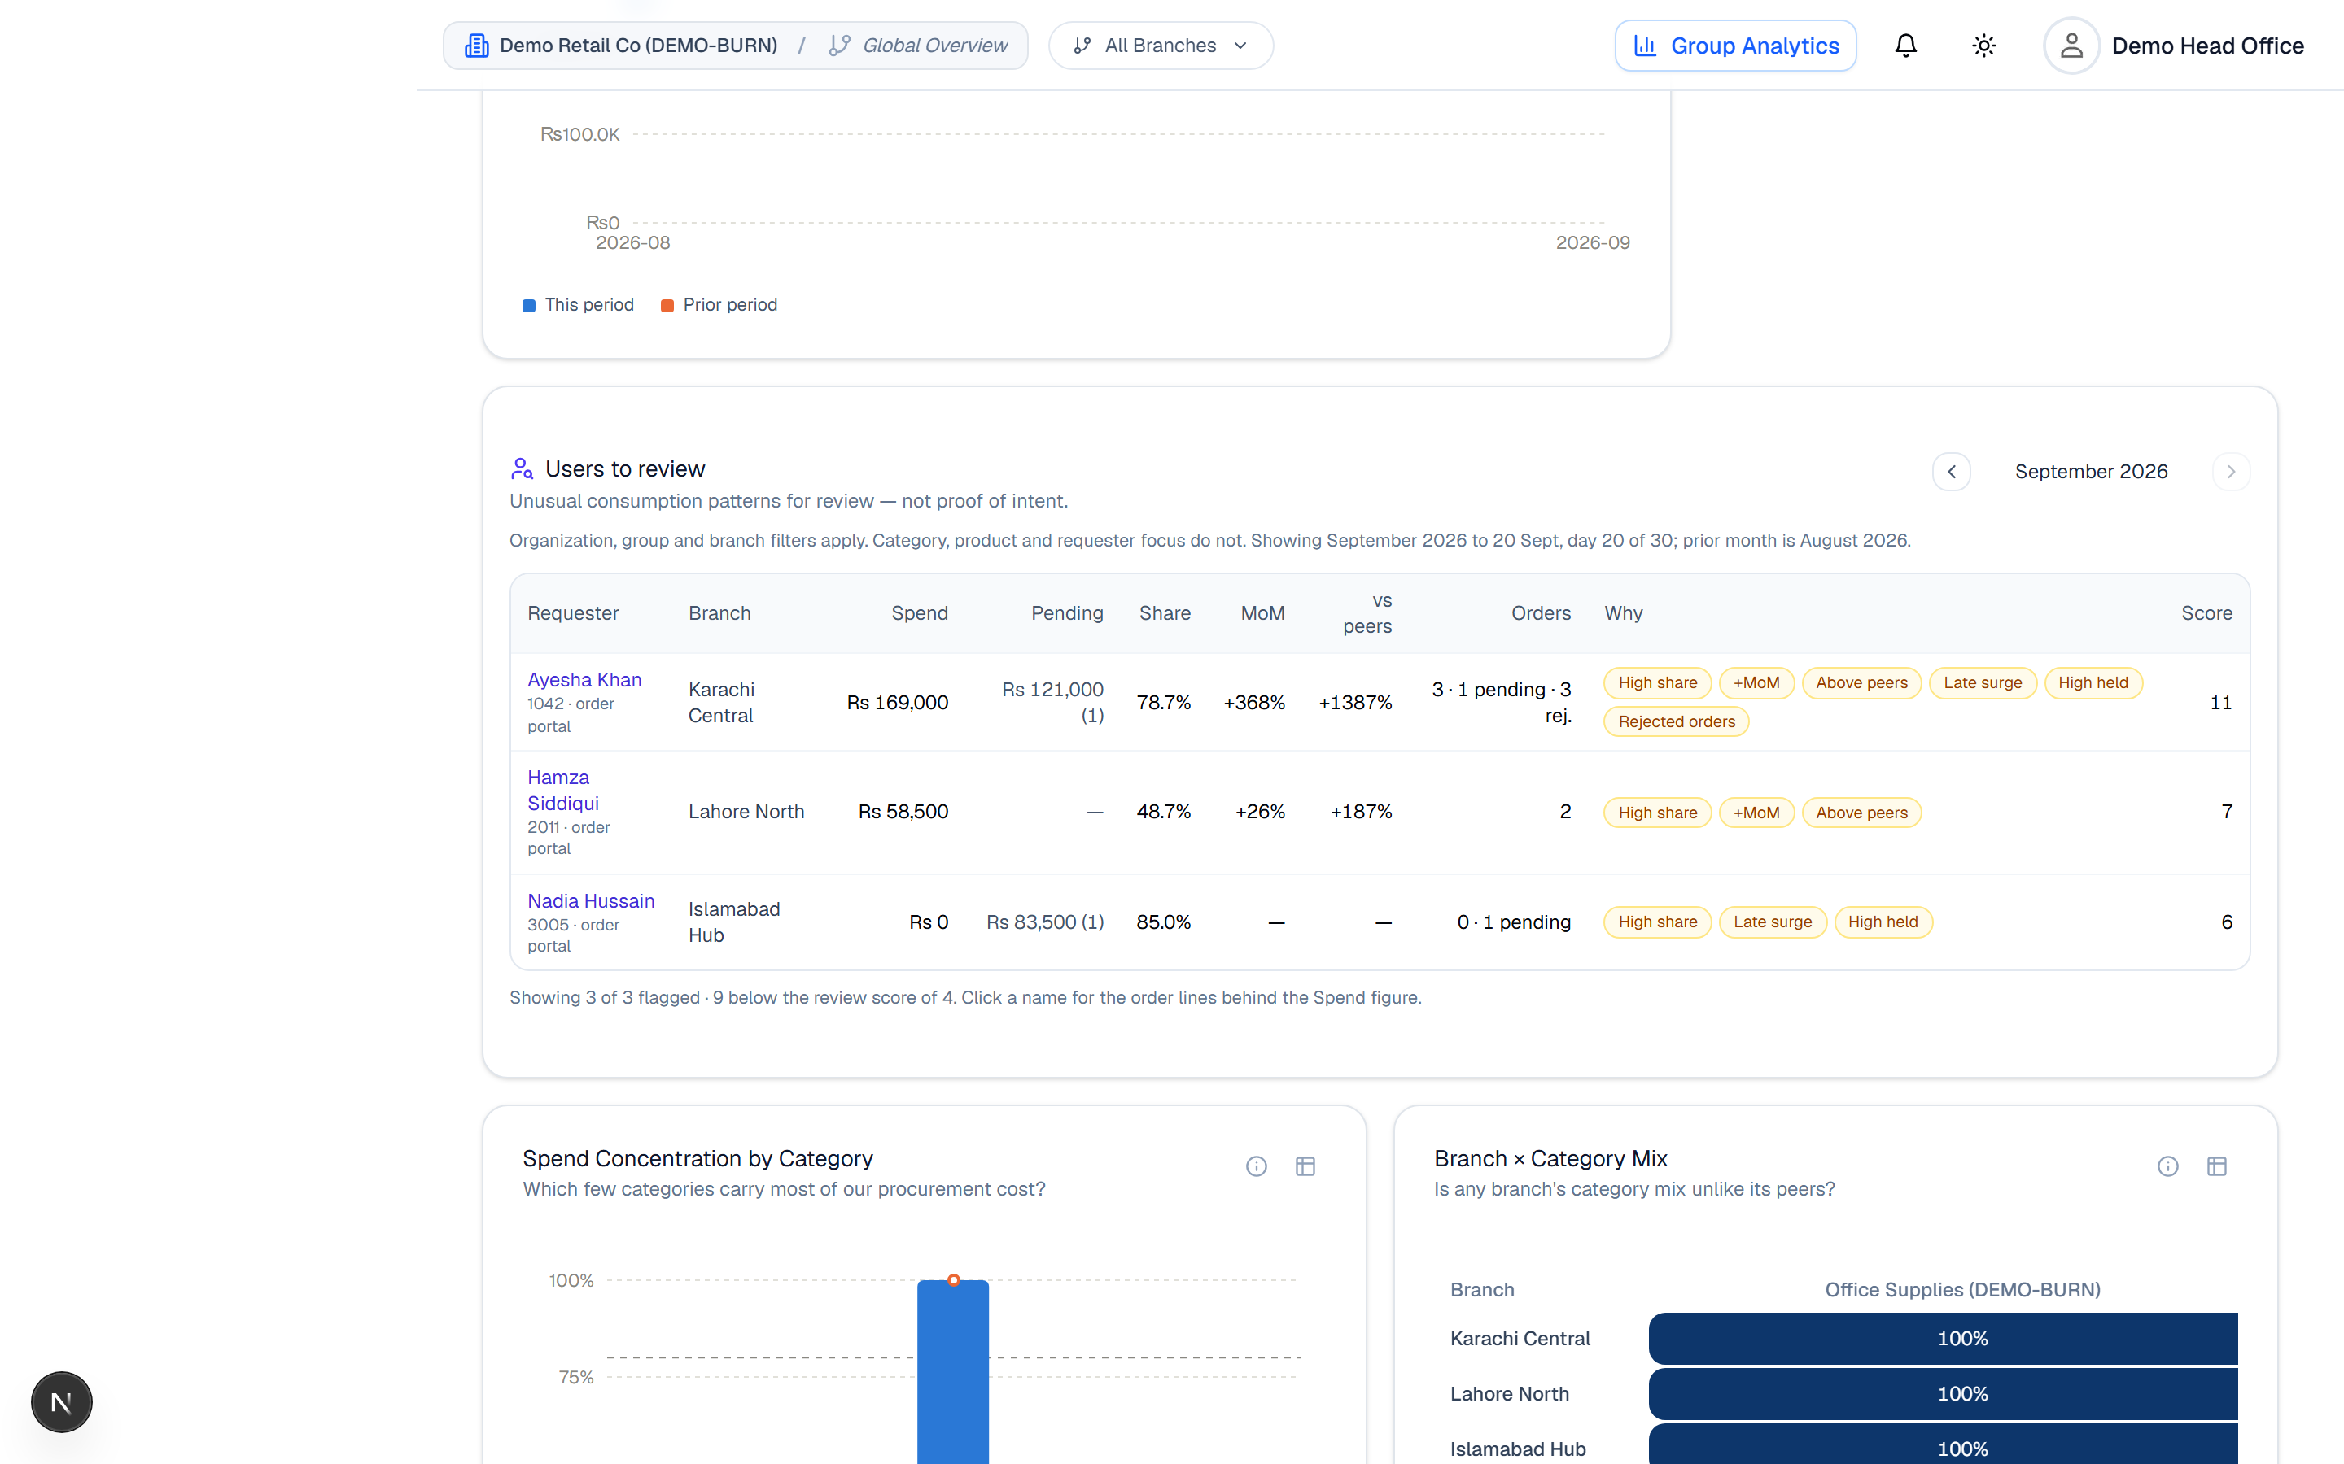
Figure 1. Graphical Reports → Executive Overview. The panel sits below the existing budget and trend charts, beside “Needs attention”. It is available to Head Office and Super Admin accounts, and follows the same organization, group and branch filters as the rest of the page.

The list
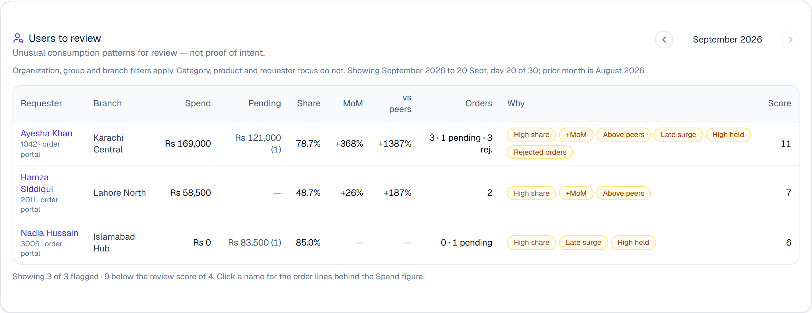
Figure 2. One row per person per branch, ranked by score. Spend is what has been approved or delivered this month; Pending is money locked in orders still awaiting approval, shown separately with the number of orders. Share is the person's part of everything the branch consumed; MoM compares with the same person last month to the same day; vs peers compares with the typical colleague at the same branch. The chips under Why say exactly which patterns were seen, and the score adds them up. A dash means there was nothing fair to compare against.

How someone gets on the list
Each pattern below is a chip. The points are added; a person appears when the total reaches 4. The thresholds are fixed numbers, shown to the reviewer on every chip, so a flag is never just a colour.
Chip | What it means | Points
High share | One person accounts for 40% or more of everything the branch consumed this month (only counted when at least two people at the branch are ordering, and the branch has consumed at least Rs 20,000). ( | 3
+MoM | At least 15% more than the same person consumed in the previous month, measured to the same day of the month. Ignored when last month was below Rs 5,000, so a tiny base that doubled does not flag. | 2
Above peers | At least 50% above the typical (median) colleague at the same branch. Needs at least two other active colleagues to compare against. (comparison b/w branches not users in same branch) | 2
Late surge | Half or more of the month's consumption landed in the last 7 days. Only read once the month is at least 14 days old. | 2
High held | Orders awaiting approval are holding 20% or more of the branch's budget (Rs 25,000 where the branch has no budget set). | 1
Rejected orders | Three or more orders rejected by an approver this month. Cancellations by the person themselves do not count. | 1
A single pattern is never enough on its own: +15% month-over-month, for example, only counts alongside something else. The list also states how many people were reviewed and sat below the line, so it is clear that the list is not everyone.

The orders behind a row
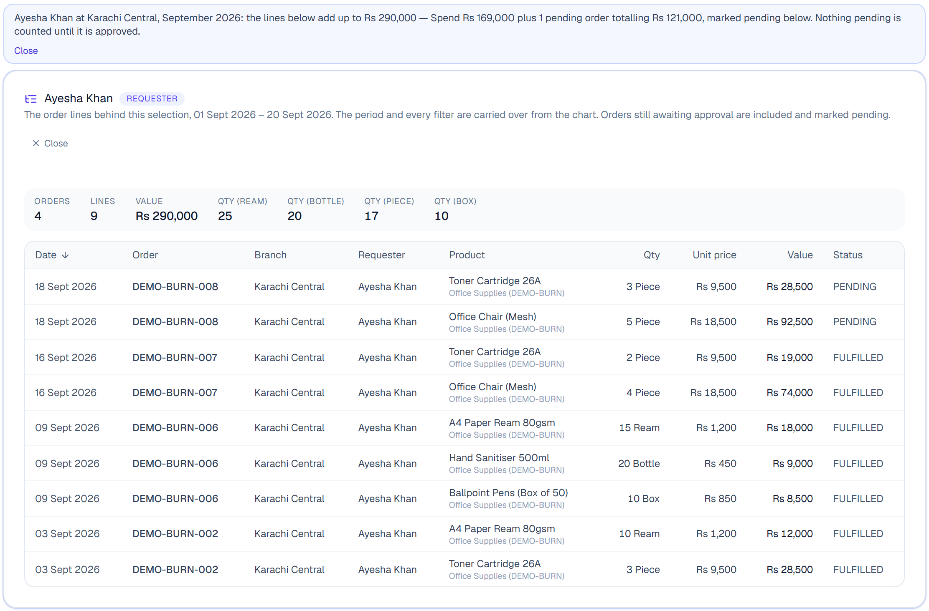
Figure 3. Clicking a name opens the order lines for that person, at that branch, for the month: product, quantity, unit price, value, date and status. The note above states what the lines add up to — Spend plus Pending — and pending lines are marked, because they hold budget but are not yet spent. Nothing pending is counted as spent until it is approved.

Earlier months
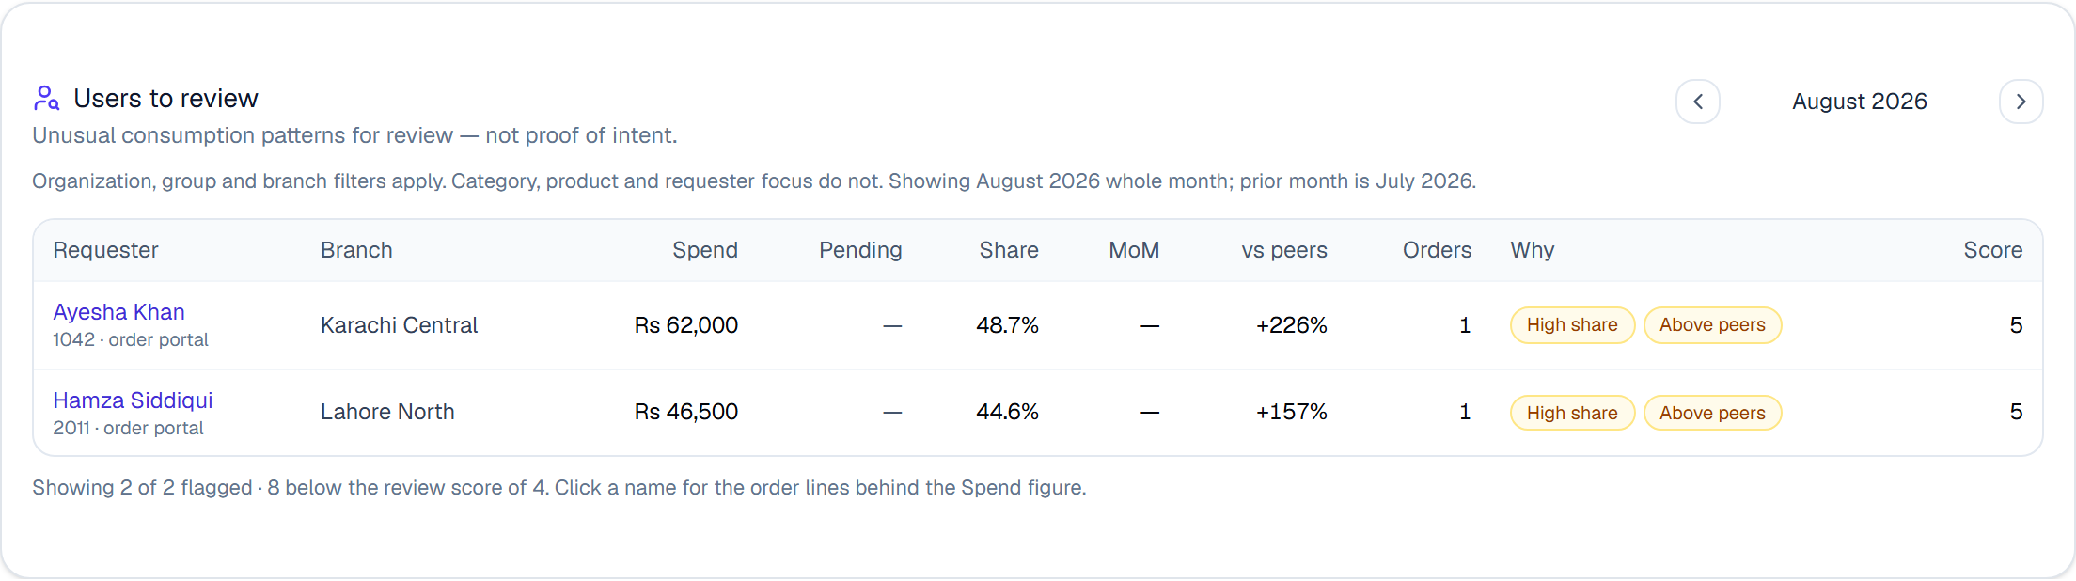
Figure 4. The arrows move month by month, up to two years back. A completed month is compared whole against whole; the current month is compared to date, against the same days of the previous month. Here MoM shows a dash because there was no July activity to compare with — no baseline is shown as no baseline, never as zero.
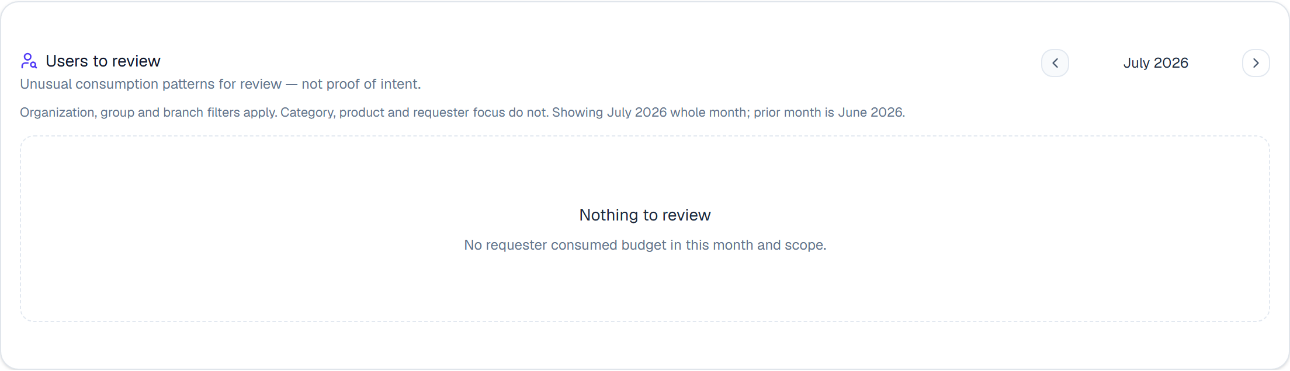
Figure 5. When nobody reaches the review score the panel says so, and says how many people consumed budget without reaching it.

What it deliberately does not do
- It does not block, hold or approve anything. Approval stays with the people who approve today.
- It does not claim intent. The list is a place to start a conversation, and the wording on the panel says so.
- It does not add up quantities across different units — litres and reams are not the same thing — so volume is examined in the order lines, not as a single number.
- Category, product and requester filters do not apply to it; the question is about a branch's whole budget, so only the organization, group and branch filters narrow it.

What can come next
- A Branch Admin view of their own branch, with prices hidden where the organization hides them.
- A branch view: branches where one or two people account for most of the spend, and how many days of budget remain at the current pace.
- Two further patterns: the same product ordered repeatedly, and a new order placed soon after a rejection.
- Only after the list has been used in real reviews: warnings or limits at approval time, with a required reason and an audit trail. That is a product decision, not a technical one.
The screenshots in this document come from a demonstration company with fictitious branches, people and orders, created for this walkthrough.

