OneFlowe — Graphical Reports
Compare Side by Side
User Guide — every filter, every combination, and what each graph represents

Screen: Reports → Graphical Reports → “Compare Side by Side” tab
URL: https://oneflowe.apricart.com/reports/graphical
Audience: Super Admin and Head Office users
Version: September 2026

About the images: The screenshots in this guide are rendered from the live screen’s layout, labels and messages, using illustrative branch, requester and product names. Your own screen will show your organisation’s real data.

Contents
1. What the Compare Side by Side tab is for
2. Anatomy of the screen
3. The shared filter bar (top row)
4. The Unit selector — a deep dive
5. The side-by-side controls (Product, Requesters, Measured by)
6. What is being counted: Amount vs Quantity
7. The seven panels, one by one
8. Filter combinations — what you will see in each case
9. Drill-down: the order lines behind any bar or point
10. Reading the charts: labels, tooltips, legends, formula and table view
11. Worked examples
12. Empty, blocked and error states
13. Limits, rules and frequently asked questions
14. Glossary
15. Appendix A — Coverage of the client requirements

1. What the Compare Side by Side tab is for
Graphical Reports has three levels, shown as tabs at the top right of the page:
Tab | Question it answers | How it works
Executive Overview | What is happening right now? | A fixed set of high-value visuals: budget vs consumed, utilisation ranking, trend, category concentration, price variance, attention list.
Compare Side by Side | Who used this, at which branch, and when? | You fix the subject (all products, one product, or a few) and the screen shows the same measure broken down by product, by requester, by branch, by month, requester-by-month, product-by-month and — for one product — day-by-day; all at once, all under the same filters.
Explore & Compare | One open-ended question of my own | You choose one dimension, one metric and one chart form at a time.

The Compare Side by Side tab exists because the question people usually arrive with is not one question but three: “who consumed this product, at which branch, and when?”. Answering it in the Explore tab would mean building the same comparison three times. Here, every panel is the same comparison with a different breakdown, so the panels can never disagree with each other about what is in scope. Products are both the subject and a breakdown: with several products ticked (or none) the screen also compares the products against each other.
Key guarantees of this screen:
- Same scope everywhere. All panels share the date range, organisation, branch, category, unit, product focus and requester selection. Change any one of them and every panel refreshes together.
- Same measure everywhere. Switching Amount ⇄ Quantity re-asks every question at once.
- Every figure is drillable. Clicking any bar, column or point opens a table of the exact order lines that add up to it, under the same period and filters.
- Nothing is widened by the browser. The server re-derives what you are allowed to see from your own user account. Filters can only narrow the data, never extend it.
Who can open it: only Super Admin and Head Office roles. Any other role sees a “Graphical Reports is not available for your role” message. A Head Office user is fixed to their own organisation; a Super Admin can see all organisations or narrow to one.

2. Anatomy of the screen
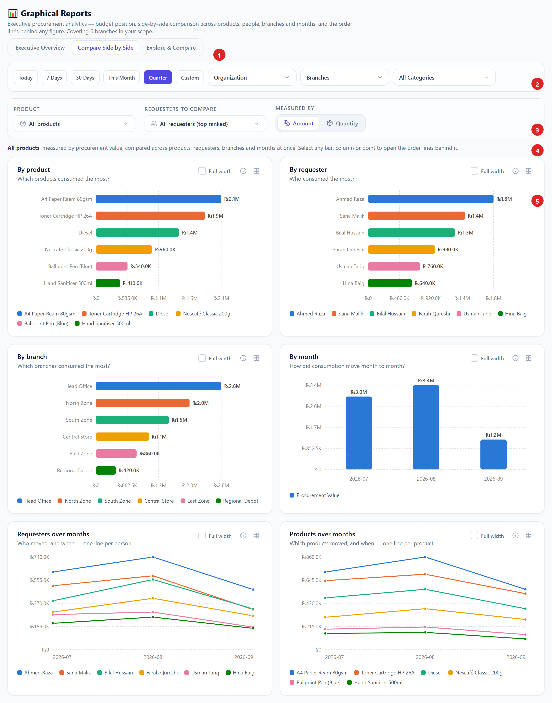
Figure 1 — The Compare Side by Side tab in its default state (all products). Numbered areas are described below.
# | Area | What it does
1 | Level tabs | Switch between Executive Overview, Compare Side by Side and Explore & Compare. Filters in the top row are kept when you switch tabs.
2 | Shared filter bar | Date range, Organisation (Super Admin only), Branches, Categories, Unit (appears only when needed) and Clear. Applies to all three tabs.
3 | Side-by-side controls | Product focus, Requesters to compare, Measured by (Amount / Quantity) and Clear selection. Specific to this tab.
4 | Subject sentence | A plain-language statement of exactly what is being shown, e.g. “A4 Paper Ream 80gsm, measured by procurement value, compared across requesters, branches and months at once.” It also tells you whether the day-by-day panel is available.
5 | Panels | By product, By requester, By branch, By month, Requesters over months, Products over months. When exactly one product is in focus the two product panels give way to Day-by-day consumption (full width) — see Figure 1b.
— | Drill-down (appears on click) | A table of order lines opens below the panels when you click a bar, column or point. See section 9.

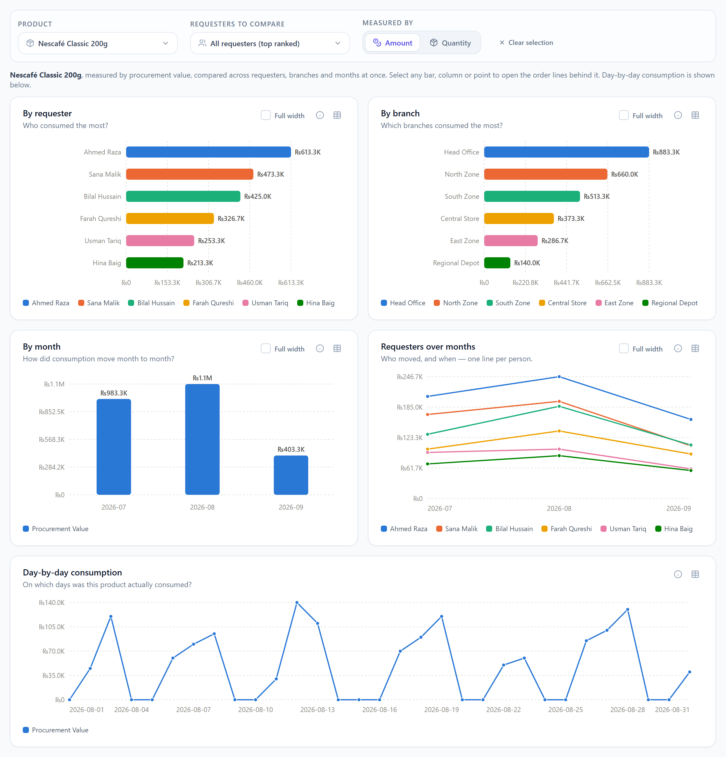
Figure 1b — The same tab with exactly one product in focus: the product panels are replaced by Day-by-day consumption.

3. The shared filter bar (top row)
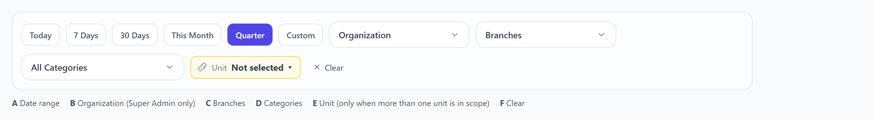
Figure 2 — The shared filter bar. It sits above the tabs’ content and applies to all three levels.
Every control in this row narrows the data on every panel of the Compare Side by Side tab and on the other two tabs as well. Only the filters your role may use are shown.

3.1 Date range (A)
Six quick buttons plus a custom range. The selected range is the period all panels count. The default when you open the page is Quarter.
Button | Period covered | Notes
Today | Today only | Useful with Day-by-day.
7 Days | The last 7 calendar days including today
30 Days | The last 30 calendar days including today
This Month | 1st of the current month to today
Quarter (default) | 1st day of the current calendar quarter to today | Quarters are Jan–Mar, Apr–Jun, Jul–Sep, Oct–Dec.
Custom | Any start and end date you type | Two date boxes appear. Start must be on or before end.

- Prior-period comparison. Every ranked bar carries a “vs prior period” figure in its tooltip. The prior period is the window of exactly the same length immediately before your selected range (e.g. a 1 Jul – 12 Sep range is compared with 19 Apr – 30 Jun). The By month panel does not show a prior figure — see section 7.3.
- Time zone. Orders are placed into days and months using Pakistan time (Asia/Karachi), so a month or day boundary is a local midnight, not a UTC one.
- Remembered. The last date range you used on this page is remembered in your browser and restored next time.

3.2 Organisation (B) — Super Admin only
- Visible only to Super Admin. A Head Office user is already fixed to their own organisation and does not see this control.
- At most one organisation may be selected.
- Selecting or changing the organisation clears the Branches filter, because the branches of one organisation are not valid for another.
- With no organisation selected, a Super Admin sees all organisations combined.

3.3 Branches (C)
- Multi-select. Choose one or more branches; leave empty for all branches in scope.
- Effect on the panels: By requester, By month, Requesters over months and Day-by-day count only orders placed by the chosen branches. By branch shows only the chosen branches.
- Effect on the pickers: the Product list and Requester list only show products and people with activity at the chosen branches.
- On the Executive Overview tab, clicking a branch bar sets this same filter, so it carries over when you switch to Compare Side by Side.

3.4 Categories (D)
- Multi-select of top-level product categories. Leave as “All Categories” for everything.
- A category includes all of its sub-categories: choosing “Stationery” counts products filed under any sub-category of Stationery.
- When a category filter is active, money is counted line-by-line (only the lines belonging to those categories), not by whole order. See section 6.3.
- The Product picker only lists products in the chosen categories.

3.5 Unit (E)
Appears only when more than one unit of measure exists in the current scope. Explained fully in section 4.

3.6 Clear (F)
Shown whenever any of Organisation, Branches, Categories or Unit is set. Resets those four to empty. It does not change the date range, and it does not clear the Product / Requester selection of the side-by-side controls (those have their own “Clear selection” button).

4. The Unit selector — a deep dive
Quantities can only be added up when they are in the same unit of measure. 20 laptops plus 400 litres is not 420 of anything. The Unit selector exists so the screen never prints a meaningless total.
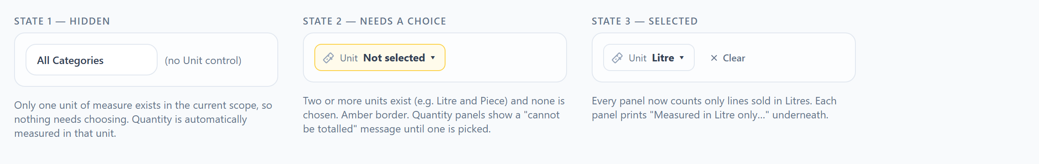
Figure 3 — The three states of the Unit selector.

4.1 When the control appears
- Hidden when only one unit exists among the order lines in your current scope (date range + organisation + branches + categories). Nothing needs choosing; Quantity is automatically measured in that one unit.
- Shown with an amber border and “Not selected” when two or more units exist and none has been chosen. This is a prompt: Quantity cannot be shown until you choose.
- Shown normally with the chosen unit once you pick one. A “Clear” button appears in the filter bar.
The list of units offered is exactly the set of units present on order lines inside your scope for the selected period — for example “Litre, Piece, Ream”. If you widen the date range and a new unit appears, the list grows.

4.2 What happens when you select a unit
Selecting a unit tells every panel to count only order lines sold in that unit. Lines in every other unit are excluded — they are not converted and not added. Each panel then prints a footnote underneath: “Measured in Litre only. Other units in this period are excluded rather than added to it.”
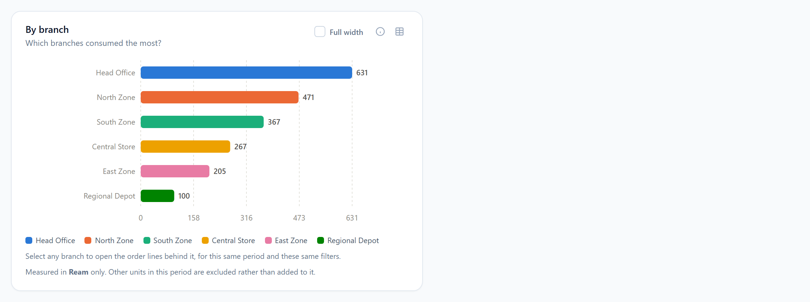
Figure 4 — A panel measured by Quantity with the unit “Ream” selected. Note the footnote.
Measured by | No unit selected, one unit in scope | No unit selected, several units in scope | Unit selected
Quantity | Works. Counts in the only unit present; footnote names it. | Blocked. Every panel shows: “Quantity cannot be totalled across Litre, Piece, Ream. Choose one unit of measure, or narrow the selection to products sharing one.” | Works. Counts only lines in that unit; footnote names it.
Amount, with a product or category in focus | Works. Only that unit’s lines are counted; footnote names it. | Works. Money is addable, so all units are summed together. No footnote. | Only lines in the chosen unit are valued; footnote names it.
Amount, with no product or category in focus | Works. Whole-order totals on the requester/branch/month panels; the two product panels (always line-by-line) count the one unit and show the footnote. | Works. Money is addable, so all units are summed together. | No effect on the requester, branch and month panels — money is counted per whole order, and an order is not in a unit. The two product panels do honour it, because they are always counted line by line.

Important: The last row is the one that surprises people. If you pick a unit while measuring by Amount with “All products” and no category, the requester, branch and month panels do not change — the Unit filter only bites once the figures are counted line by line (Quantity, Amount with a product/category focus, or the two product panels, which are always line-by-line).

4.3 A second way to resolve a unit conflict
Instead of choosing a unit, narrow the Product focus to products that share one unit. If the products you select are all sold per Ream, only one unit is in scope and the block disappears on its own. This is often the more natural route on this tab, because you usually arrive with a product in mind.

4.4 Unit and the drill-down table
The order-line table (section 9) never adds quantities across units either. Its totals strip shows one “Qty (…)” figure per unit found in the rows, e.g. “Qty (Ream) 471” and “Qty (Piece) 12” side by side.

4.5 Unit and the Product picker
The Product list is not narrowed by the chosen unit — listing what exists must not depend on how it is being measured. Each product’s hint line names the unit(s) it is sold in (“per Ream · 128 orders”, or “per Box, Piece · 74 orders”) so you can see which products would share a unit.

5. The side-by-side controls
These three controls are specific to the Compare Side by Side tab. Together with the shared filter bar they define the subject of every panel.

5.1 Product
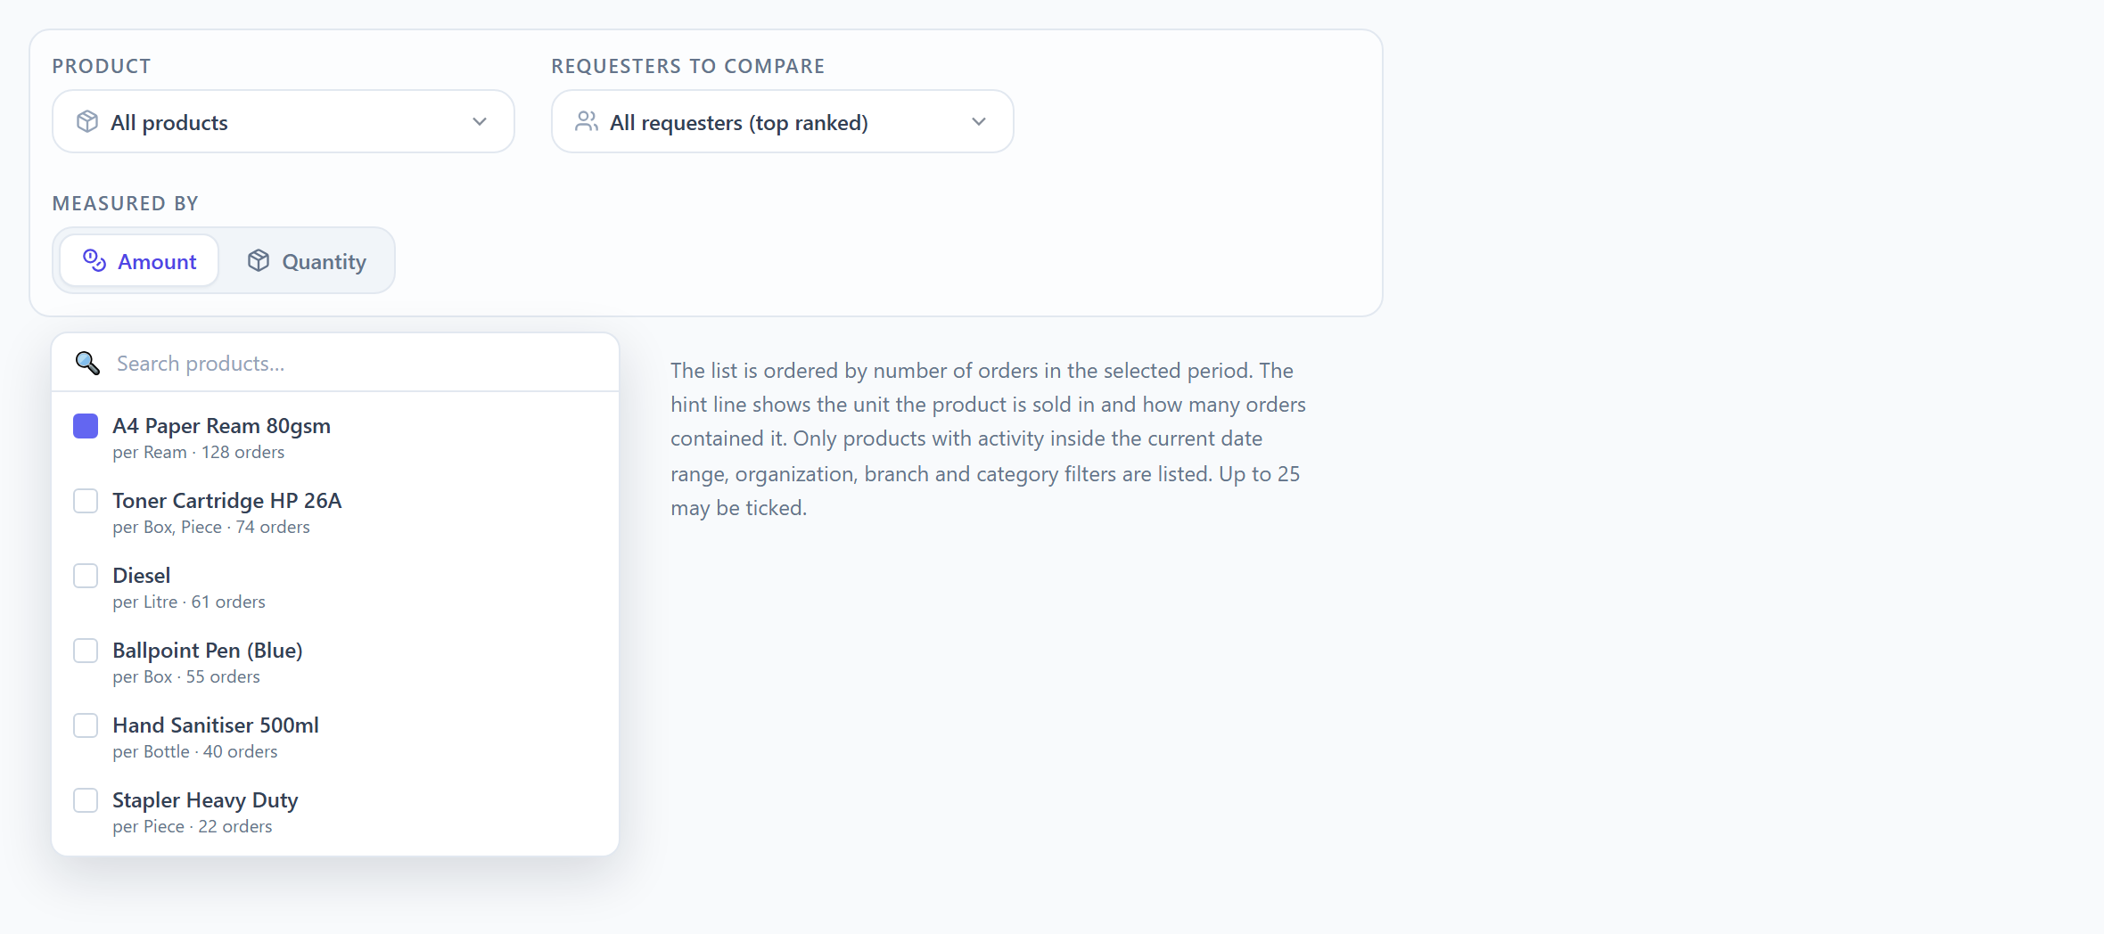
Figure 5 — The Product picker, open. Ticking a product puts it “in focus”.
- What it does. Narrows every panel to the selected product(s). With nothing selected the subject is “All products”.
- What is listed. Only products that have order lines inside the current date range, organisation, branches and categories — and, if requesters are selected, only products those people ordered. Ordered by number of orders, most first. The first 200 are listed; use the search box to find others.
- Hint line. “per <unit> · <n> orders” — the unit(s) the product is sold in, and how many orders in the period contained it. A product sold in more than one unit is listed once, with every unit named: “per Box, Piece · 74 orders”.
- How many. Up to 25 products may be ticked. Past that, the remaining rows are greyed and a notice reads “25 is the most that can be selected at once.”
- Search. Type to filter the list by name. “Clear” inside the popup unticks everything.
- Trigger label. “All products” when empty; the product’s name when one is selected; “3 of 42 products” when several are.
Effect of the number of products in focus:
Products in focus | Panels shown | Subject sentence | How money is counted
None | By product (top 12 products), By requester, By branch, By month, Requesters over months, Products over months (top 6) | “All products … compared across products, requesters, branches and months” | Whole-order totals on the requester/branch/month panels; line-by-line on the two product panels.
Exactly one | By requester, By branch, By month, Requesters over months, plus Day-by-day consumption (full width). The two product panels are hidden — one product against itself is a single bar. | “<Product name> … compared across requesters, branches and months. Day-by-day consumption is shown below.” | Line-by-line: only that product’s own lines are valued.
Two | All six panels; By product and Products over months compare exactly the two ticked products (no Day-by-day) | “<Product A> and <Product B> … compared across products, requesters, branches and months. Choose a single product to see day-by-day consumption.” | Line-by-line: only those products’ lines.
Three or more | All six panels; the product panels compare the ticked products (top 12 bars / top 6 lines if you ticked more) | “3 products … Choose a single product to see day-by-day consumption.” | Line-by-line: only those products’ lines.

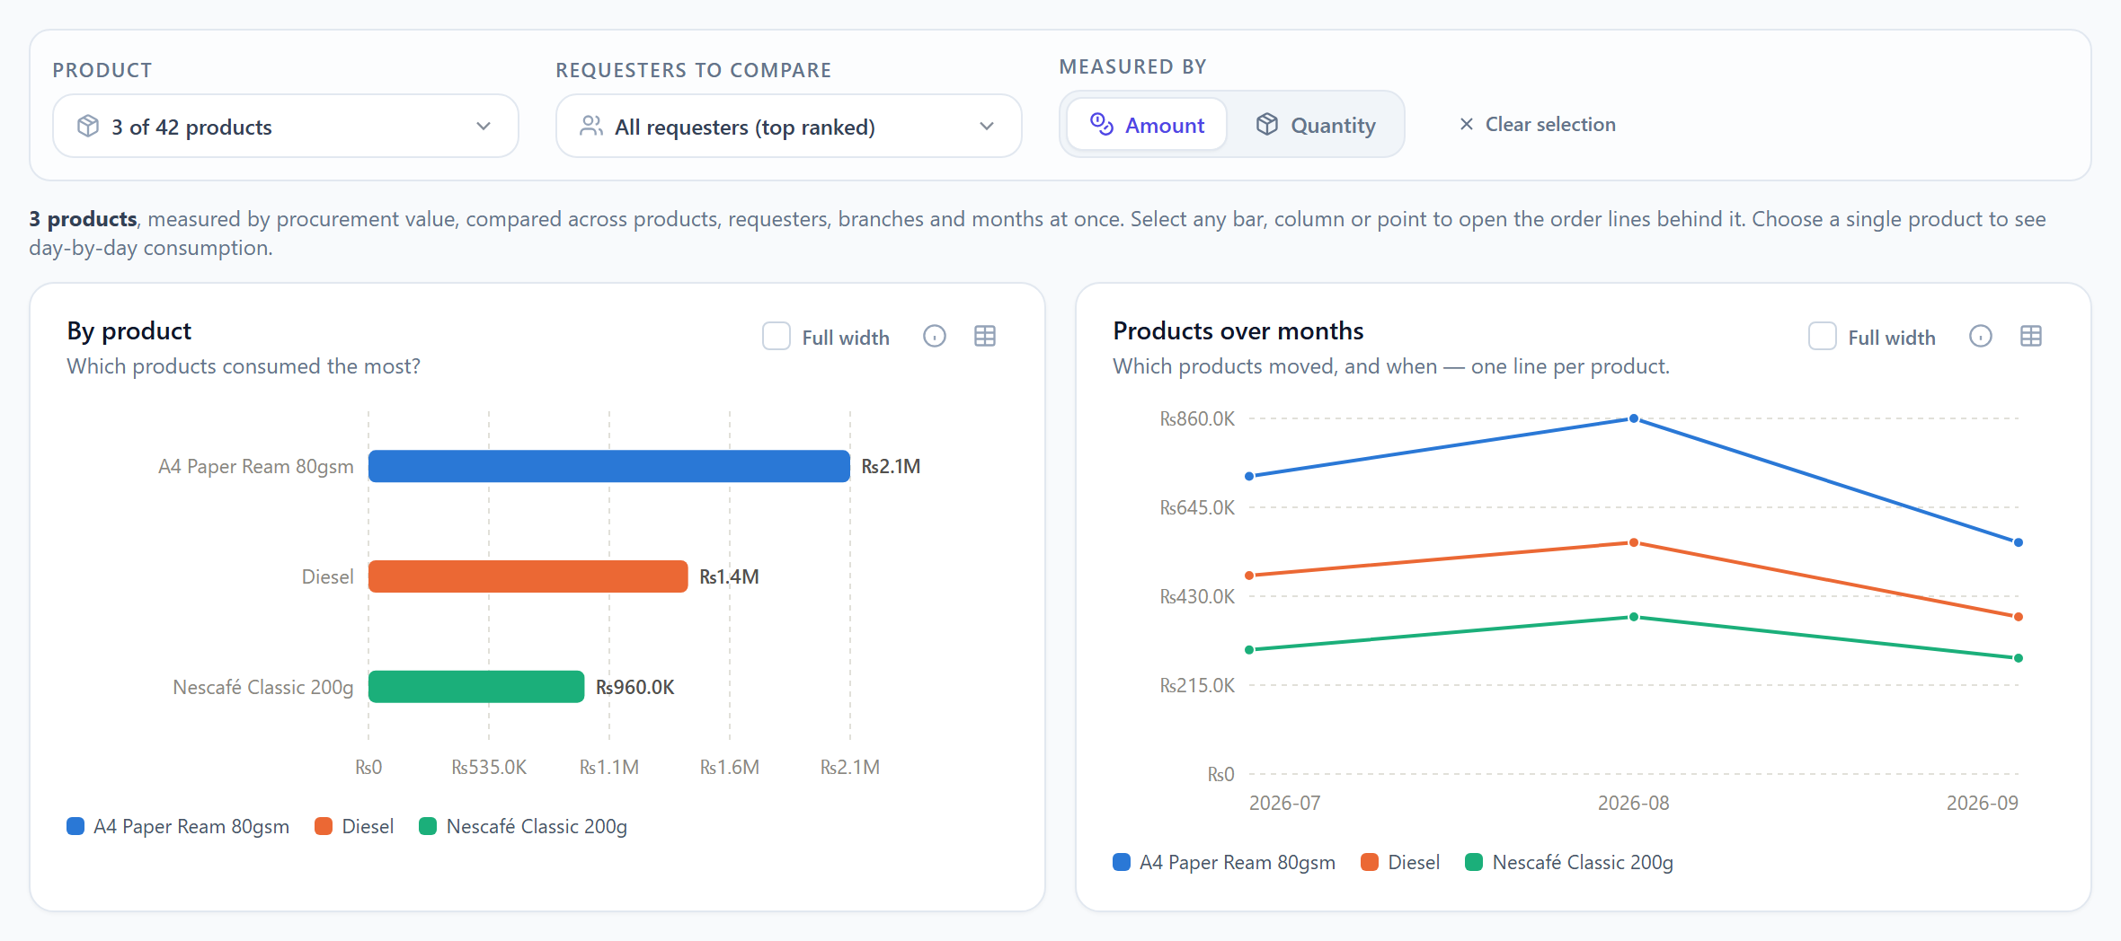
Figure 6 — Three products ticked: By product and Products over months now compare exactly those three (Nescafé Classic against Diesel and A4 paper). Day-by-day is absent, as the subject sentence explains.
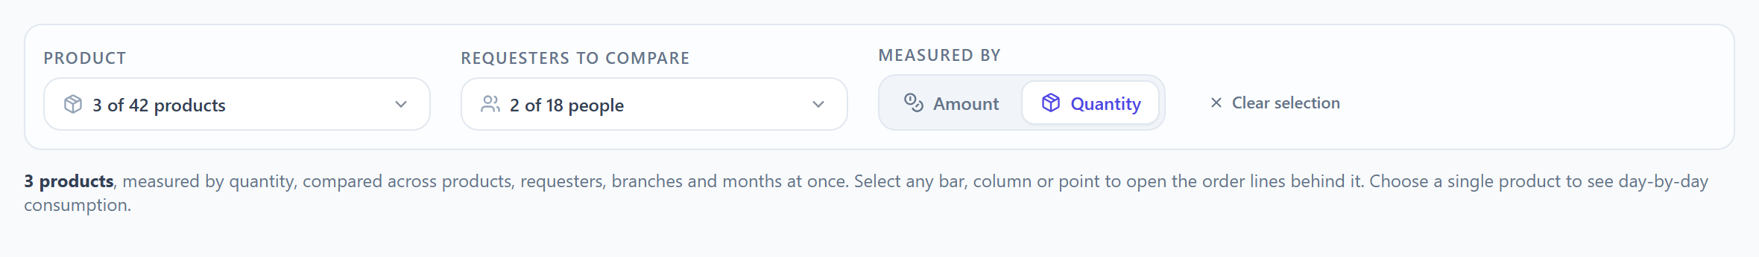
Figure 6b — Three products and two requesters selected, measured by Quantity.

5.2 Requesters to compare
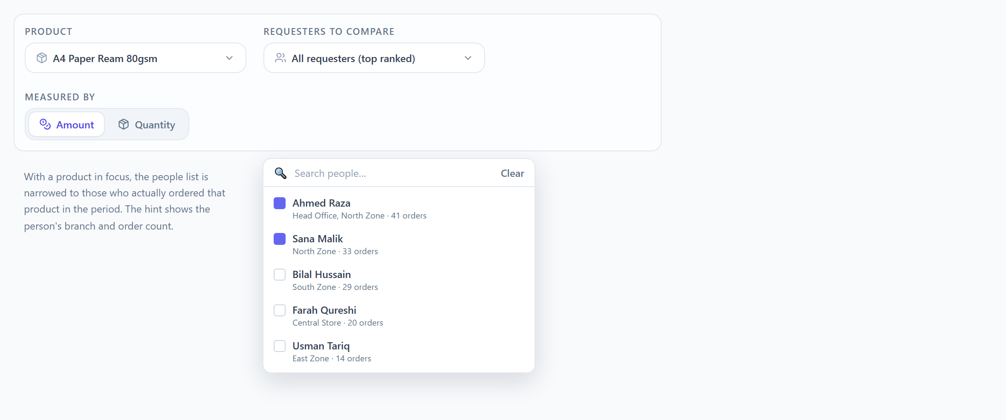
Figure 7 — The Requesters picker, open, with a product already in focus.
- What it does. Chooses which people are compared. A requester is the person who raised the order (the ORDER_PORTAL or Group Order Portal user), not the approver.
- With nothing selected the trigger reads “All requesters (top ranked)”: the By requester panel shows the 12 highest-ranked people and Requesters over months draws the top 6 lines, out of everyone in scope.
- With people selected, the By requester panel ranks only those people, Requesters over months draws one line per selected person (top 6 if you selected more), and — importantly — By branch, By month and Day-by-day are narrowed to orders raised by those people too. The whole screen answers for the same people.
- What is listed. People who raised at least one order (of any status) inside the current filters — and, if products are in focus, who ordered those products. Ordered by order count. Hint line: “<Branch> · <n> orders” — a group requester or someone who has moved branch lists every branch they ordered for, e.g. “Head Office, North Zone · 41 orders”. Each person appears once. Up to 25 may be ticked; first 200 listed; searchable.
- Naming. A person is shown by full name; if that is blank, by employee ID; if that is blank, by email.

5.3 Measured by (Amount / Quantity)
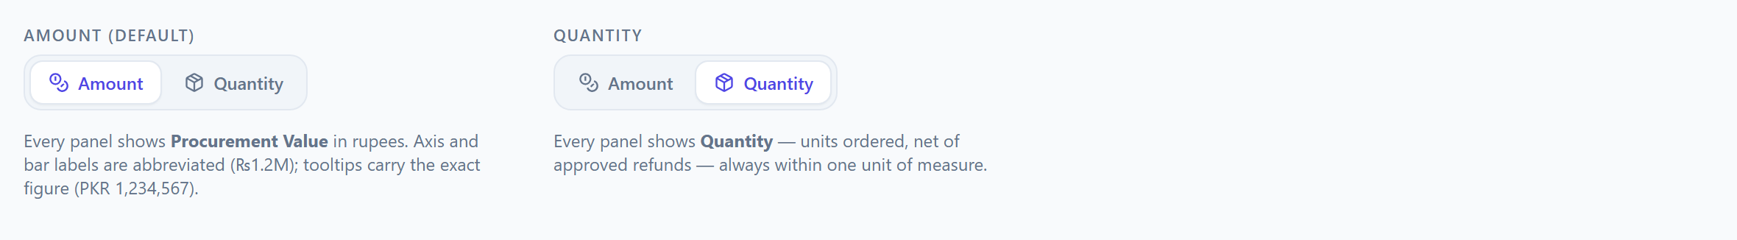
Figure 8 — The Measured by toggle in both positions.
- Amount (default) shows Procurement Value in Pakistani Rupees on every panel.
- Quantity shows the number of units ordered on every panel, within one unit of measure (section 4).
- Switching changes only the measure. The date range, filters, products in focus, requesters selected and any open drill-down table are all kept, so you can flip back and forth to compare money against volume for exactly the same selection.

5.4 Clear selection
Appears once any product or requester is selected. Unticks all products and all requesters and closes any open drill-down table. It does not touch the shared filter bar (date, organisation, branches, categories, unit) and does not reset the measure.

6. What is being counted: Amount vs Quantity

6.1 Which orders count
Only revenue-eligible orders are counted, on every panel and in every measure. An order is revenue-eligible when its status is one of: FULFILLED, APPROVED, PARTIAL, PARTIALLY_FULFILLED.
- PENDING orders are a commitment, not consumption — they are not counted here.
- CANCELLED and REJECTED orders are worth nothing in any figure.
- Approved or completed refunds are deducted: an order’s value is its total minus its refunded amount; a line’s quantity is its quantity minus the refunded quantity. A figure is never allowed to go below zero.

6.2 Amount — Procurement Value
Formula (as shown by the ⓘ button on each panel): SUM(order total − refunded amount) over revenue-eligible orders.
Displayed in rupees. Axis and bar labels are abbreviated — ₨1.8M, ₨640.0K — while tooltips and tables show the exact amount, e.g. PKR 1,840,000.

6.3 Whole-order vs line-by-line counting
With no product and no category in focus, Amount is the whole value of each order, counted once. As soon as a product or category is in focus, Amount switches to line-by-line: only the value of the matching lines is counted. This matters: an order for ₨100,000 that happens to contain ₨4,000 of A4 paper contributes ₨4,000 to “A4 paper by branch”, not ₨100,000. Quantity is always line-by-line.

6.4 Quantity
Formula: SUM(line quantity − refunded quantity) over lines of revenue-eligible orders, within one unit of measure. Displayed as a plain count, abbreviated on axes (1.2K) and exact in tooltips.

6.5 Other figures you will see in tooltips
Figure | Meaning
Share of shown | This bar’s value as a percentage of the bars currently on the chart — not of everything in the period. If 12 requesters are shown out of 40, the shares add up to 100% across those 12.
vs prior period | Percentage change against the same entity in the immediately preceding window of equal length. “no prior period” when there was nothing to compare with; “no change” when the movement is under 0.05%.
Procurement value / Orders (grey lines) | Always shown for context, whichever measure is selected: the rupee value and the number of distinct orders behind the bar.

7. The seven panels, one by one
Every panel has the same header: a title, the question it answers, a “Full width” checkbox, an ⓘ button that reveals the exact formula, and — on the trend panels — a table button. Panels load independently, so if one has nothing to show the others still draw.

7.0 The “Full width” checkbox
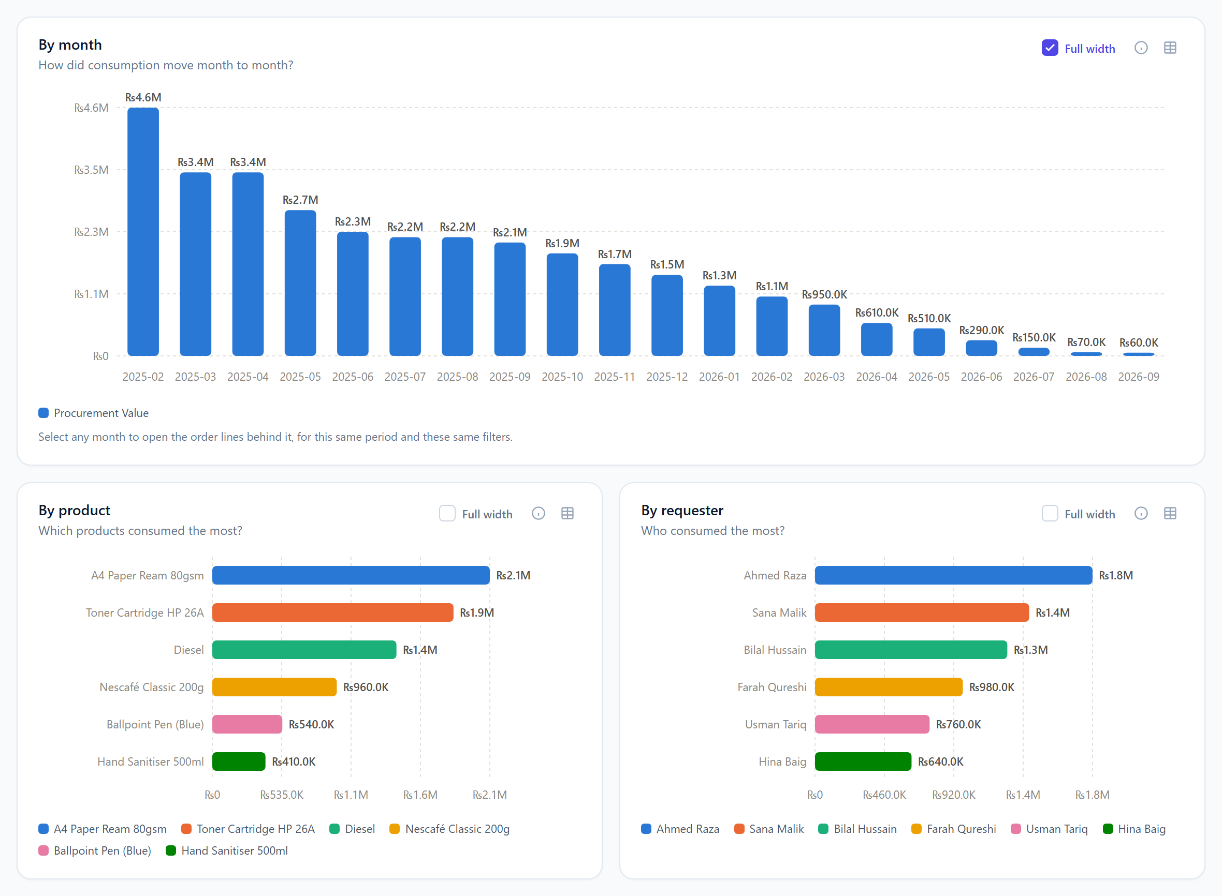
Figure 8b — “Full width” ticked on By month: that panel moves to the top and spans the whole row; the others follow in their usual order.
- What it does. Tick the checkbox in a panel’s header and that panel widens to span the full row — twenty months, or twelve long product names, become legible. Untick to return it to half width.
- Moves to the top. A widened panel moves to the top of the grid so it is the first thing on screen; the other panels follow below in their usual order. Any number of panels can be at full width at once, and widening one never hides another.
- Which panels have it. By product, By requester, By branch, By month, Requesters over months and Products over months. Day-by-day consumption is always full width and has no checkbox.
- Kept while you work. Switching Amount ⇄ Quantity, changing filters or opening a drill-down leaves your full-width choices as they are. They reset when you leave the page.

7.1 By product
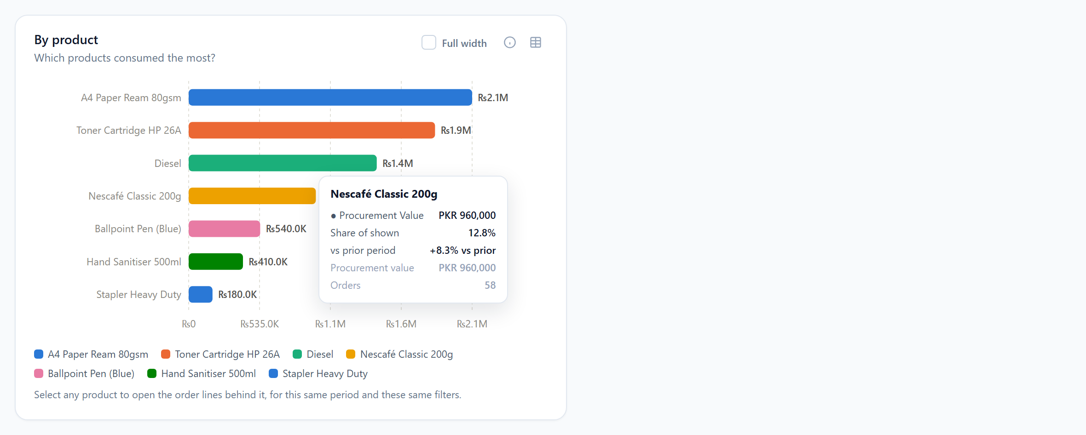
Figure 9a — By product, ranked bars, with the tooltip open on Nescafé Classic.
Aspect | Detail
Question | Which products consumed the most?
When shown | With no product in focus, or with two or more ticked. Hidden when exactly one product is in focus (a single bar would only restate the subject).
Chart | Horizontal ranked bars, largest at the top, one colour per product. The value is printed at the end of every bar.
Each bar | One product: the total Amount or Quantity of its own order lines, under all current filters (branches, categories, selected requesters…). Money is always counted line-by-line here.
How many | Up to 12 products. With no focus: the top 12 by value in scope. With products ticked: exactly those products, ranked (top 12 of them if you ticked more).
Quantity | If the products on the chart use different units, Quantity is blocked until you choose a unit (section 4) or tick only products sharing one — the “per <unit>” hint in the Product picker tells you which.
Tooltip | Product · Procurement Value (or Quantity) · Share of shown · vs prior period · Procurement value · Orders.
Click | Opens the drill-down: every order line of that product in the period, under the same filters.

7.2 By requester
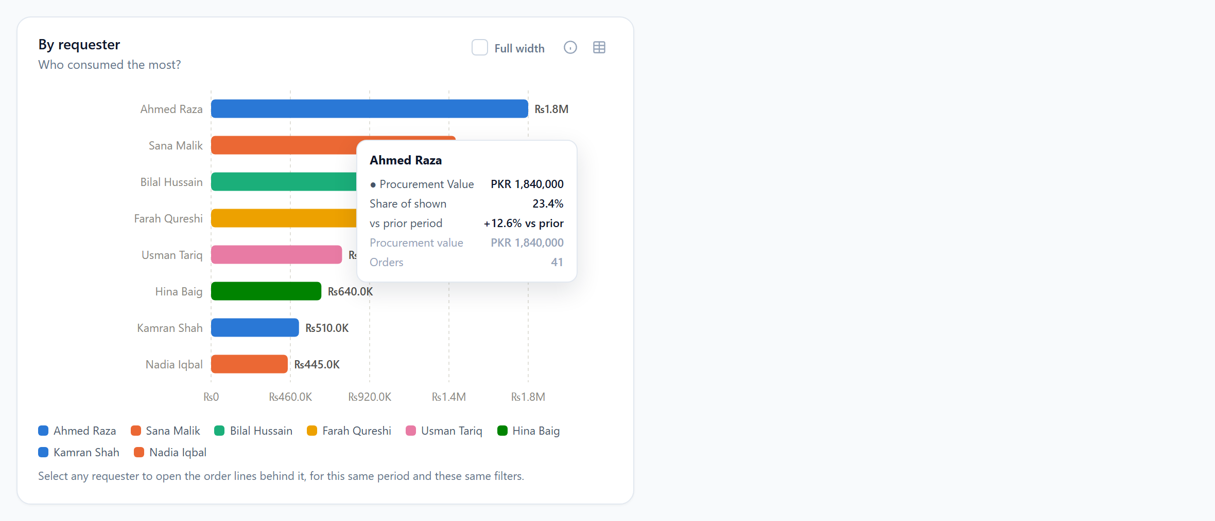
Figure 9b — By requester, ranked bars, with the tooltip open on the top bar.
Aspect | Detail
Question | Who consumed the most?
Chart | Horizontal ranked bars, largest at the top, one colour per person. The value is printed at the end of every bar.
Each bar | One requester: the total Amount or Quantity of the orders they raised, under all current filters.
How many | Up to 12 people. With no requesters selected: the top 12 by value. With requesters selected: those people (the top 12 of them if you selected more), ranked.
Tooltip | Name · Procurement Value (or Quantity) · Share of shown · vs prior period · Procurement value · Orders.
Legend | The first 12 names with their colours (colour is decoration; every bar carries its own label).
Click | Opens the drill-down: every order line raised by that person in the period, under the same filters.

7.3 By branch
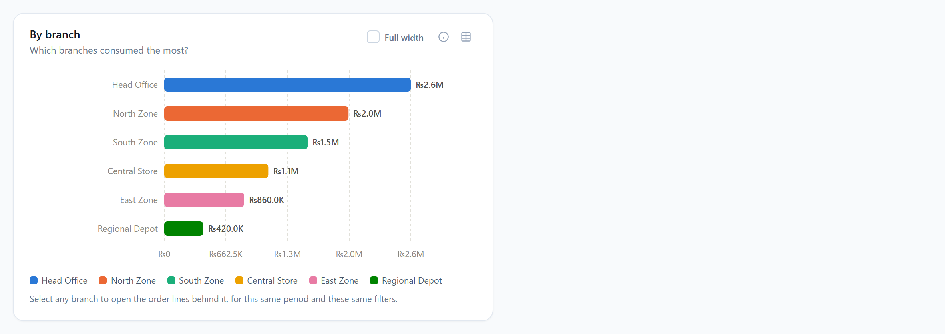
Figure 10 — By branch, ranked bars.
Aspect | Detail
Question | Which branches consumed the most?
Chart | Horizontal ranked bars, largest at the top, one colour per branch.
Each bar | One branch: the total of orders placed at that branch, for the products in focus and the requesters selected.
How many | Up to 12 branches, highest first. If the Branches filter is set, only those branches are eligible.
Tooltip / Legend / Click | As for By requester. Clicking opens that branch’s order lines.
Note | A group order raised for a branch counts for that branch, exactly like an order raised by the branch’s own staff.

7.4 By month
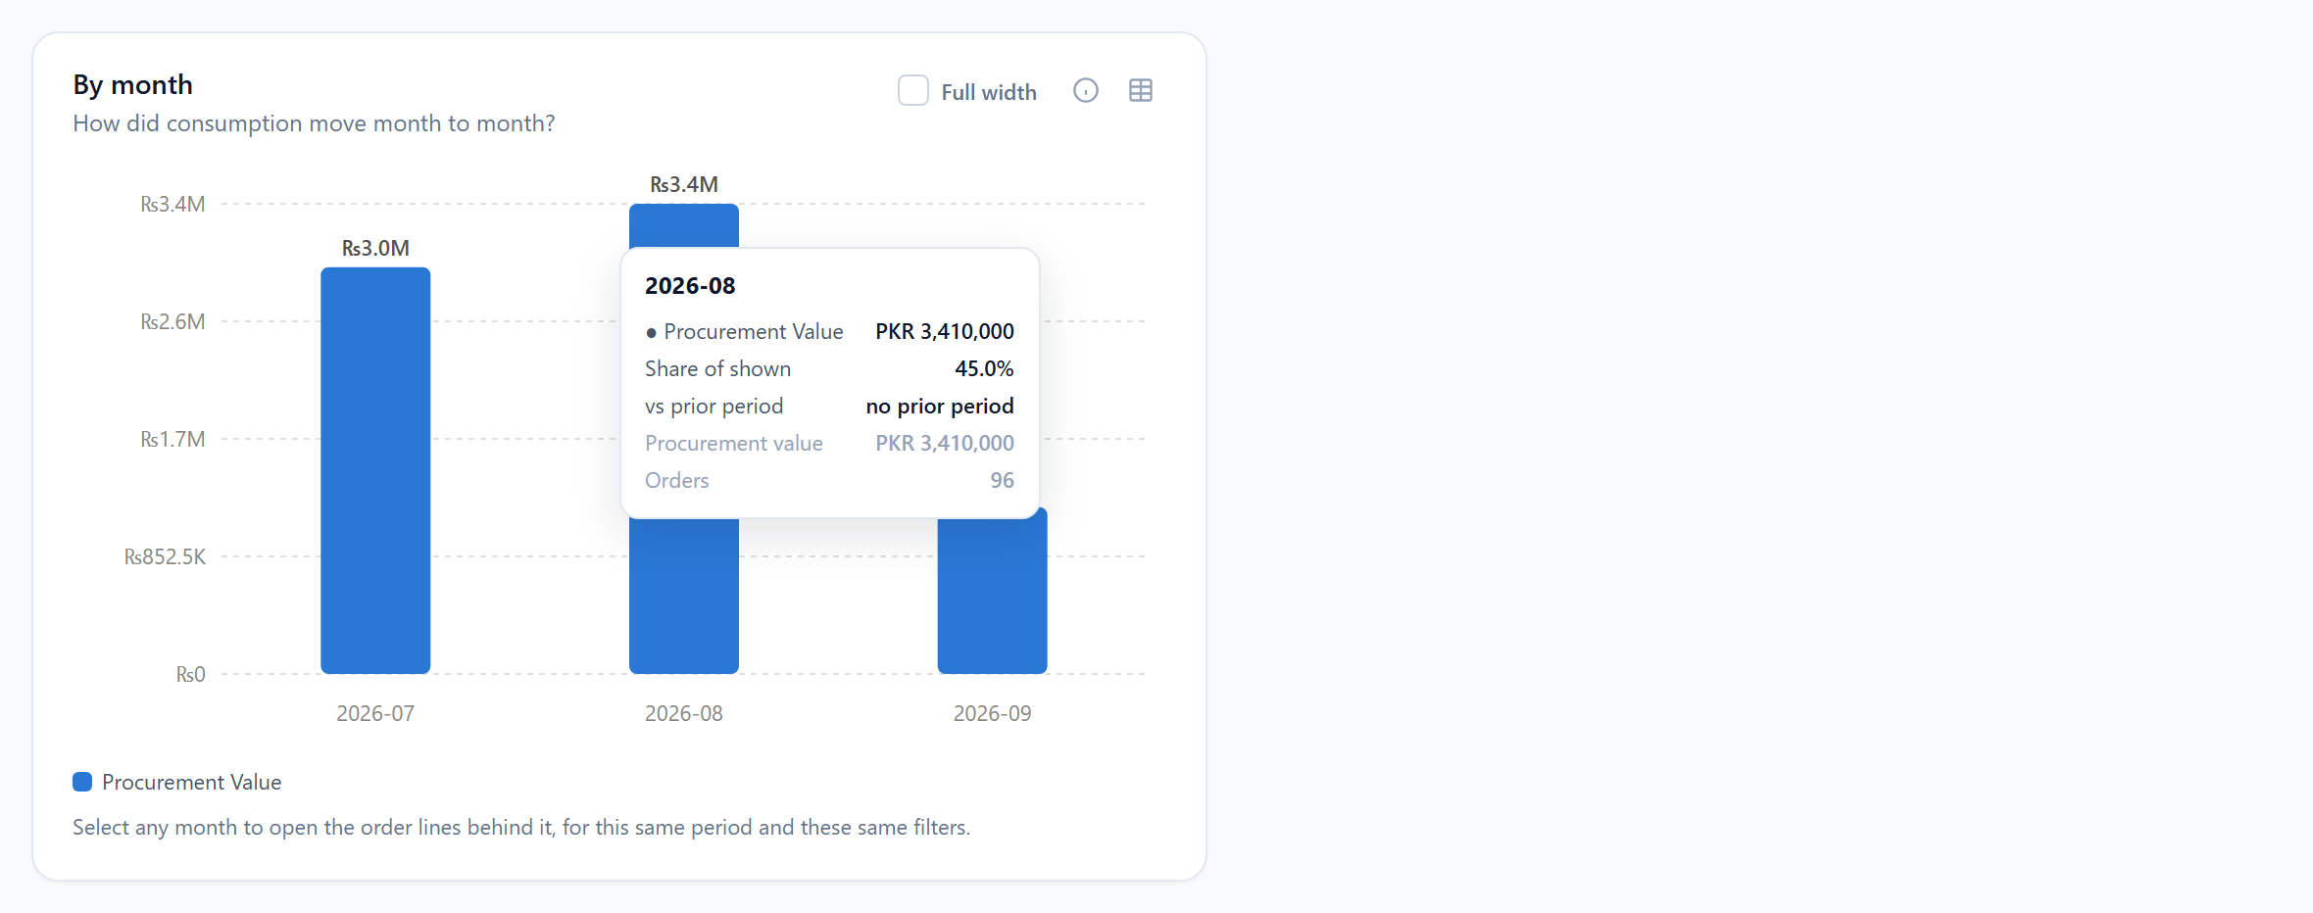
Figure 11 — By month, columns in a single colour, with the tooltip open.
Aspect | Detail
Question | How did consumption move month to month?
Chart | Vertical columns in chronological order, left to right, all in one colour — months are a sequence, so they are deliberately not colour-coded.
Each column | One calendar month (label “YYYY-MM”): the total for that month. The first and last columns may be partial months if your date range starts or ends mid-month.
How many | Every month in the range (up to 120).
Tooltip | Month · value · Share of shown · “no prior period” · Procurement value · Orders. A month never carries a prior-period figure, because the previous month is already the neighbouring column.
Click | Opens the order lines for that month only — clipped to your date range, so clicking September on a range ending 12 September shows 1–12 September.

7.5 Requesters over months
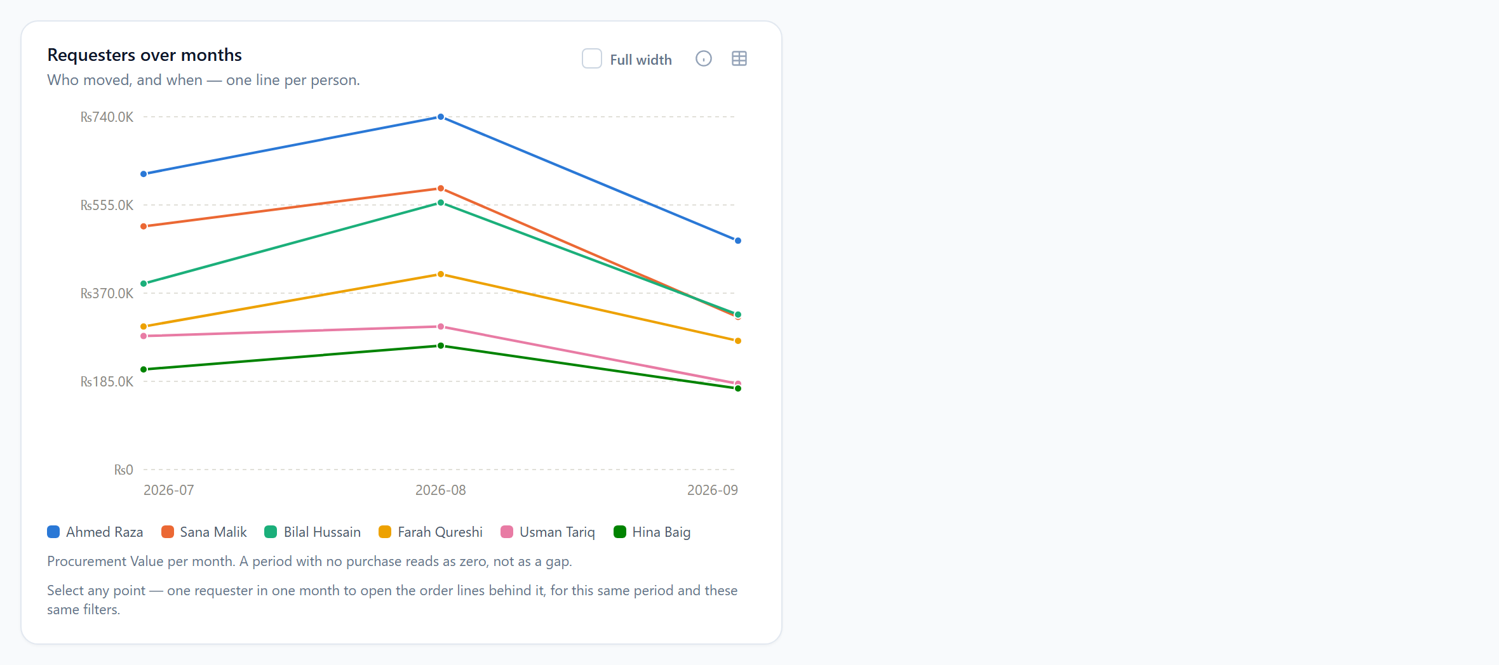
Figure 12 — Requesters over months: one line per person.
Aspect | Detail
Question | Who moved, and when — one line per person.
Chart | A line chart with months across the bottom and one coloured line per requester.
Each line | One person’s monthly total. A month with no purchase is drawn as zero, not as a gap.
How many | Up to 6 lines. With no requesters selected: the 6 highest-ranked people over the whole period. With requesters selected: those people (top 6 of them).
Tooltip | Hover a month to see every line’s value for that month.
Table view | The table button swaps the chart for a grid: one row per person, one column per month. Clicking a name opens that person’s drill-down.
Click | Clicking a point names two things — a person and a month — and the drill-down shows that person’s lines in that month only. The drill-down title reads “<Name> · 2026-08”.

7.6 Products over months
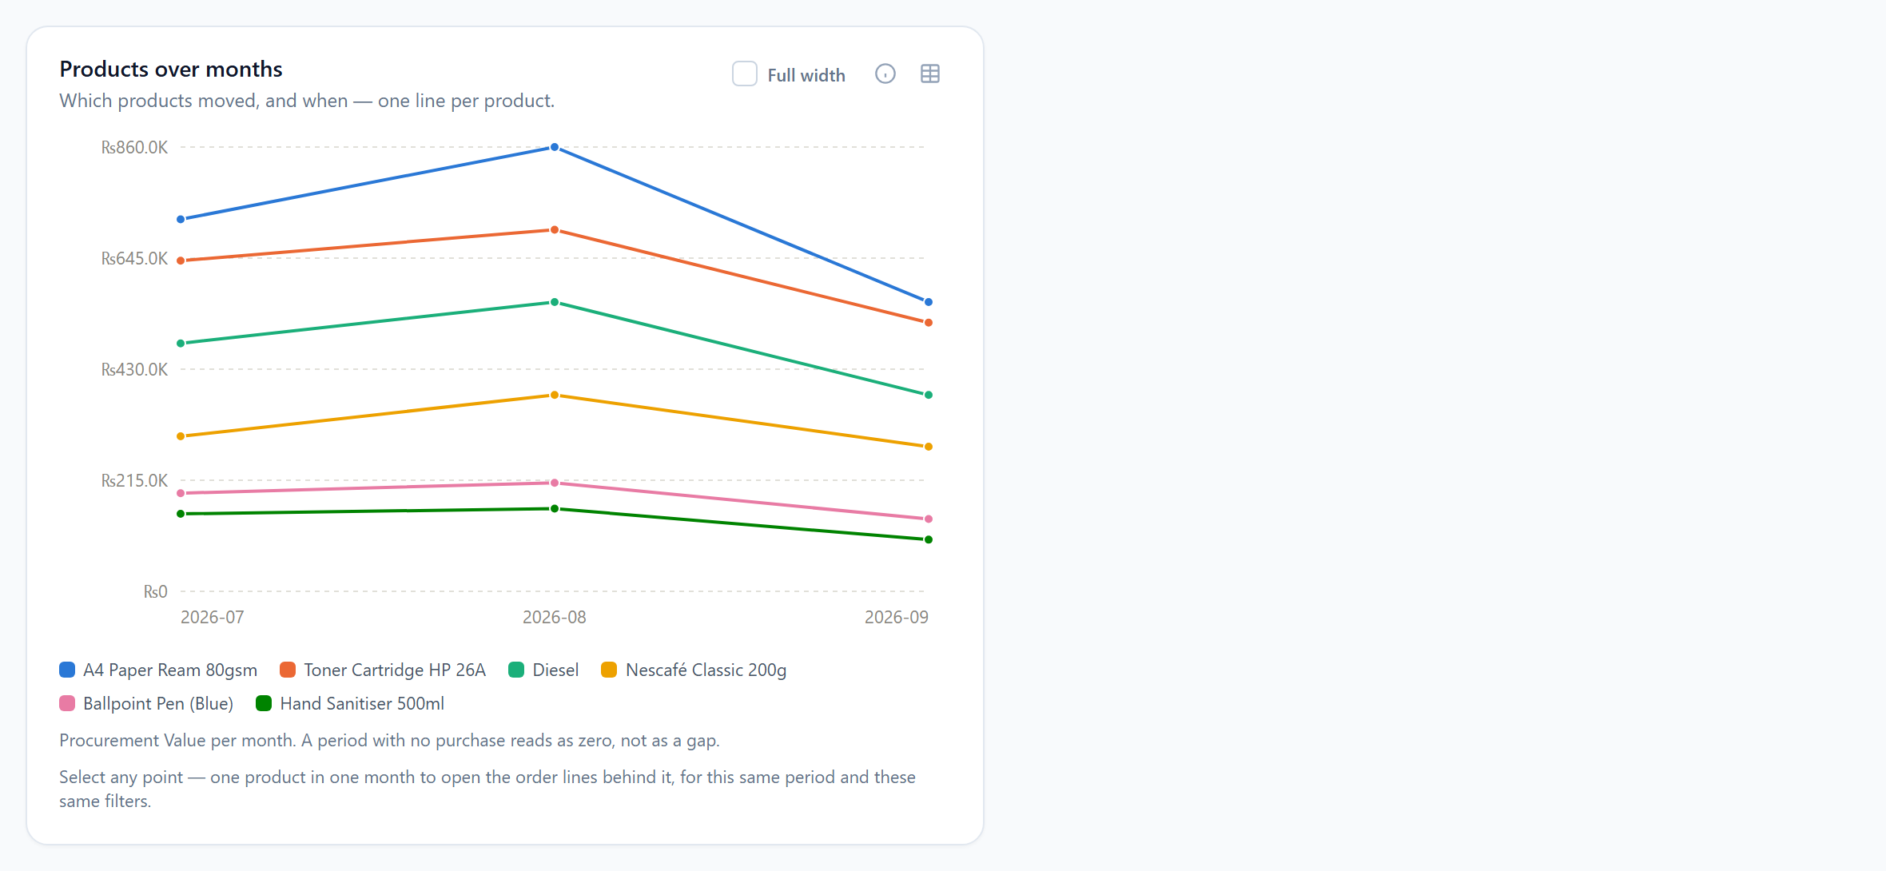
Figure 12b — Products over months: one line per product.
Aspect | Detail
Question | Which products moved, and when — one line per product.
When shown | Same rule as By product: shown with no focus or with two or more products ticked; hidden for a single product (Day-by-day takes its place).
Chart | A line chart with months across the bottom and one coloured line per product. A month with no purchase reads as zero.
How many | Up to 6 lines: the top 6 products in scope, or the ticked products (top 6 of them).
Table view | The table button shows one row per product, one column per month.
Click | A point names a product and a month; the drill-down shows that product’s lines in that month only, titled “<Product> · 2026-08”.

7.7 Day-by-day consumption (single product only)
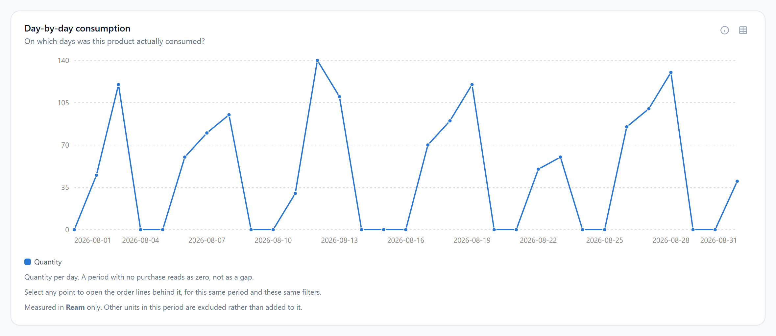
Figure 13 — Day-by-day consumption, shown full width when exactly one product is in focus (here measured by Quantity in Reams).
Aspect | Detail
Question | On which days was this product actually consumed?
When shown | Only when exactly one product is in focus; it takes the place of the two product panels. With none or several products, it is hidden and the subject sentence says “Choose a single product to see day-by-day consumption.”
Chart | A single-colour line, one point per calendar day (label “YYYY-MM-DD”). Days with no purchase read as zero.
How many | Every day in the range, up to 400 days. Choose a shorter range (This Month, 30 Days) for a readable chart.
Table view | One row (the product) with one column per day.
Click | Opens the order lines for that one day.

8. Filter combinations — what you will see in each case
The table below walks through the combinations that matter, from the simplest to the most specific. “Narrowed” means only orders matching the filter are counted.
Selection | By product / Products over months | By requester | By branch | By month | Requesters over months | Day-by-day
Nothing selected (defaults: Quarter, all branches, all products, Amount) | Top 12 products / top 6 lines | Top 12 people by spend, whole-order values | Top 12 branches | Each month of the quarter | Top 6 people | Hidden
One product | Hidden | Top 12 people who ordered it; only that product’s lines are valued | Top 12 branches that bought it | Its monthly total | Top 6 buyers of it | Shown: its daily total
Several products | Exactly those products, ranked / one line each | Combined value of those products’ lines per person | Per branch | Per month | Top 6 | Hidden
Requesters selected (no product) | Products those people ordered, ranked | Only those people, ranked | Only orders raised by those people | Only those people’s orders | One line per selected person (max 6) | Hidden
One product + requesters selected | Hidden | Those people’s consumption of the product | Branches where those people bought it | Those people’s monthly total for it | Their lines for it | Their daily total for it
Branches filter set | Products bought at those branches | People at those branches | Only those branches | Those branches only | People at those branches | As above if one product
Category filter set | Products in that category | Line-by-line values for that category’s products | Same | Same | Same | As above if one product
Organisation set (Super Admin) | Everything fenced to that organisation; branch filter is reset when the organisation changes
Measured by Quantity, one unit in scope | Counts in that unit; footnote names it | Same | Same | Same | Same | Same
Measured by Quantity, several units, no unit chosen | Blocked message on every panel until a unit is chosen or the product focus narrows to one unit
Measured by Amount, unit chosen, no product/category | Only lines in that unit (product panels are always line-by-line) | No effect — whole-order money is not in a unit | No effect | No effect | No effect | —
Measured by Amount, unit chosen, product/category in focus | Only lines in that unit are valued; footnote shown | Same | Same | Same | Same | Same
Short range (Today / 7 Days) | Works; prior period is the equally short window before it |  |  | Only one or two columns | One or two points per line | Most readable here

8.1 How the pickers react to each other
- Selecting products narrows the Requesters list to people who ordered those products.
- Selecting requesters narrows the Product list to products those people ordered.
- Neither picker ever hides something you have already ticked, so a selection can always be changed.
- Both lists honour the shared filter bar (date, organisation, branches, categories) but ignore the Unit.

8.2 Order of operations when you change something
- Change the date range → all five panels and both pickers refresh; any open drill-down refreshes for the new period.
- Change Organisation → Branches filter is cleared; everything refreshes.
- Change Branches / Categories / Unit → everything refreshes; product and requester selections are kept (they may now show nothing if they fall outside the new filters).
- Change Product or Requesters → panels and the other picker refresh; the drill-down (if open) refreshes under the new focus.
- Change Measured by → panels and the drill-down refresh with the new measure; nothing else changes.
- Click Clear selection → products, requesters and drill-down are cleared; filter bar untouched.

9. Drill-down: the order lines behind any bar or point
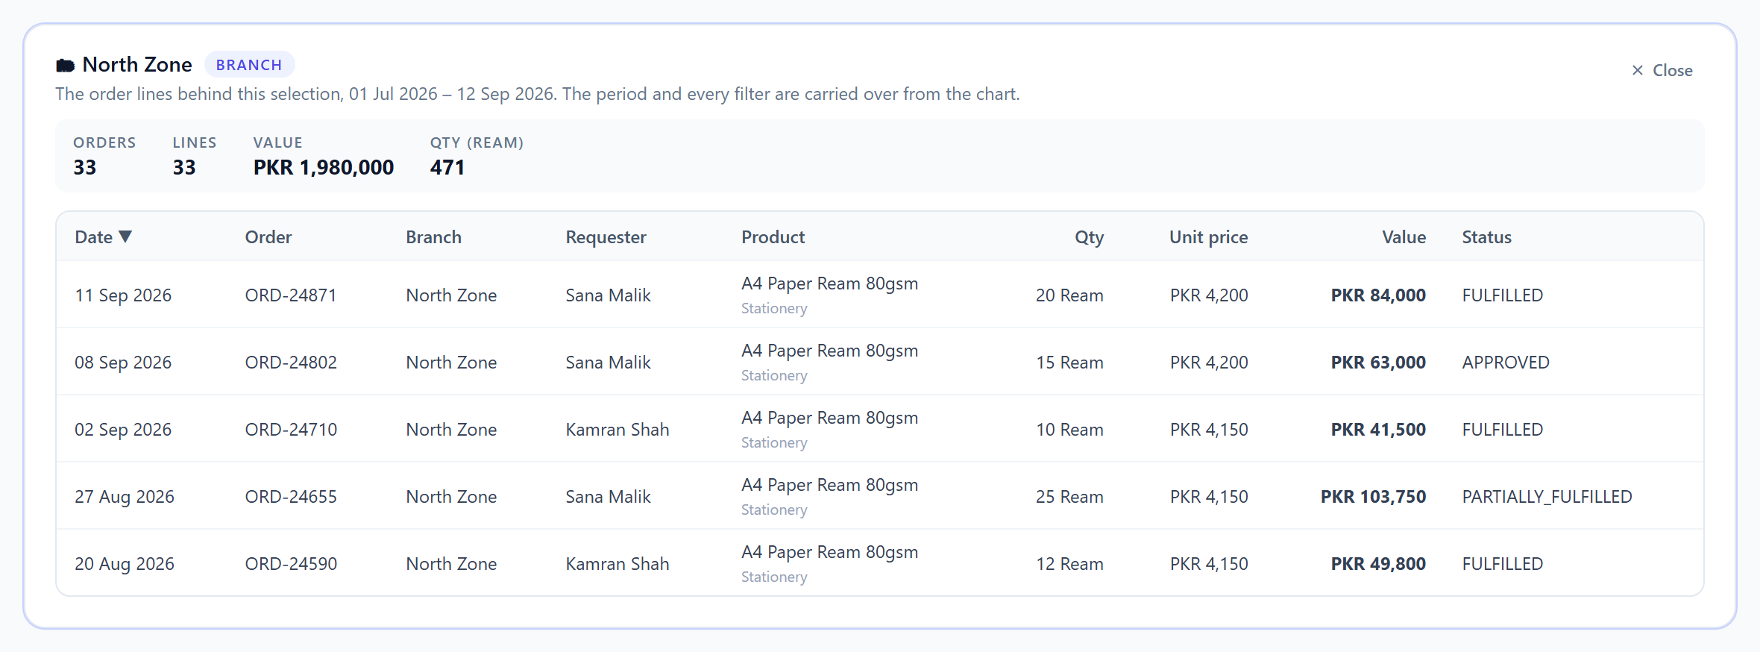
Figure 14 — The drill-down table after clicking the “North Zone” bar with A4 Paper Ream in focus.
A chart answers “how much”; the only honest answer to “why” is the rows themselves. Clicking any bar, column, point or table row opens this panel directly below the charts and the page scrolls to it, so the table is in front of you the moment you click — and again whenever you click a different bar. It lists the individual order lines that add up to the figure you clicked, under exactly the same period and filters.

9.1 Header
- The label of what you clicked (a person, a branch, a month, a day, or “<person> · <month>”) and a badge naming the dimension.
- The exact period covered, e.g. “01 Jul 2026 – 12 Sep 2026”. When you click a month or a day the period is clipped to it.
- A Close button. Selecting another bar replaces the table and scrolls to it again.

9.2 Totals strip
Total | Meaning
Orders | Number of distinct orders behind the selection.
Lines | Number of order lines (an order with three products has three lines).
Value | Sum of the lines’ value in rupees, net of approved refunds. This is the figure to check against the bar you clicked.
Qty (unit) | One figure per unit of measure present, e.g. “Qty (Ream)”. Never added across units.

9.3 Columns
Column | Content | Sortable
Date | The date the order was created, in Pakistan time | Yes (default, newest first)
Order | The order’s transaction ID | No
Branch | The branch the order belongs to | Yes
Requester | The person who raised the order | Yes
Product | Product name, with its category underneath | Yes
Qty | Line quantity with its unit | Yes
Unit price | The price per unit charged on that line | Yes
Value | Qty × unit price, net of refunds | Yes
Status | The order’s status (FULFILLED, APPROVED, PARTIAL, PARTIALLY_FULFILLED) | No

9.4 Sorting and paging
- Click a column heading to sort by it; click again to reverse. Changing the sort returns to the first page.
- 50 lines per page. When there are more, a “Showing 1–50 of N lines” strip with previous/next arrows appears under the table.
- Clicking a different bar starts paging over again from the first page.

9.5 Why the rows match the bar
The drill-down re-applies every filter server-side — date range, organisation, branches, categories, unit, products in focus, requesters selected — and narrows to the clicked entity. On a month or day click it clips the window to that bucket, intersected with your range. This is what guarantees the Value total in the strip equals the bar you came from (when measured by Amount) and the Qty total equals it (when measured by Quantity).

10. Reading the charts: labels, tooltips, legends, formula and table view
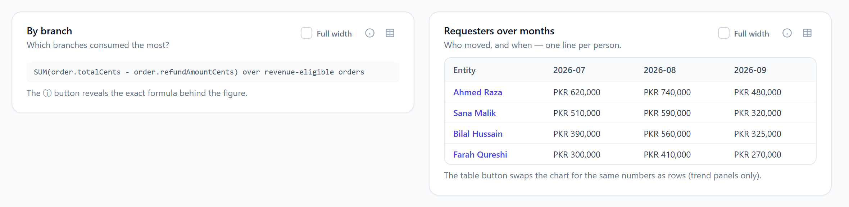
Figure 15 — Left: the ⓘ button reveals the formula. Right: the table button shows a trend panel as rows.
- Direct labels. Every bar and column has its value printed beside it, so colour is never the only way to read a chart.
- Abbreviations. ₨1.8M = 1.8 million rupees; ₨640.0K = 640 thousand; 1.2K = 1,200 units. Hover for the exact figure.
- Colours. Ranked panels use a fixed six-colour palette that repeats after six entities. Time-axis panels (By month, Day-by-day) use one colour on purpose.
- ⓘ Formula. Opens a line showing exactly how the figure is computed, e.g. “SUM(order.totalCents - order.refundAmountCents) over revenue-eligible orders”.
- Full width checkbox. Widens that one panel to the whole row; see section 7.0.
- Table button. Available on Requesters over months, Products over months and Day-by-day. Shows the same numbers as a grid; clicking a row name opens its drill-down. Provided so every chart can be read without colour and by keyboard.
- Footnotes. Each panel prints a one-line reminder that it is clickable, and — when a unit is in effect — the “Measured in <unit> only” note.

11. Worked examples

11.1 “Who is consuming the most A4 paper this quarter, and where?”
- Leave the date range on Quarter. Open Product and tick “A4 Paper Ream 80gsm”.
- By requester now ranks the people who ordered it; By branch ranks the branches; By month shows the quarter’s three months; Requesters over months shows the top 6 people’s monthly lines; Day-by-day appears underneath.
- Switch Measured by to Quantity: since A4 paper is sold only per Ream, the unit resolves automatically and every panel shows reams with a “Measured in Ream only” footnote.
- Click the top requester’s bar to see every A4 order line they raised, with dates, branch, quantity and unit price.

11.2 “Compare Nescafé Classic against the other beverages we buy”
- Leave the date range on Quarter. Open Product and tick “Nescafé Classic 200g”, “Tea Bags 100s” and “Sugar 1kg”.
- By product now shows three bars, one colour each, ranked by value; Products over months draws three lines so you can see which one is rising.
- By requester and By branch show who and where these three beverages are consumed, combined. To see one of them alone, untick the other two — Day-by-day then appears for it.
- Switch to Quantity. If the three are sold in different units (e.g. Piece and Kg), every panel asks you to choose a unit; pick one, or compare only products sold in the same unit.
- Click the Nescafé bar to open every Nescafé order line, with requester, branch, date and unit price.

11.3 “Compare three specific requesters across every product”
- Leave Product empty. Open Requesters to compare and tick the three people.
- By requester shows just those three, ranked. By branch and By month are narrowed to their orders. Requesters over months draws exactly three lines.
- Hover a month on Requesters over months to read all three values for that month; click a point to open one person’s lines for that month.

11.4 “Fuel consumption in litres, by branch, this month”
- Click This Month. Open Product and tick “Diesel”. Set Measured by to Quantity.
- If Diesel is the only product in focus and it is sold per Litre, the unit resolves to Litre automatically. If you had also ticked a product sold per Piece, every panel would show the “cannot be totalled across Litre, Piece” message — either untick it or choose Litre in the Unit selector.
- By branch now ranks branches in litres; Day-by-day shows litres per day for the month.

11.5 “Did a branch buy more, or just pay more?”
- Focus the product and read By branch with Measured by = Amount. Note the branch’s value and its “vs prior period” figure in the tooltip.
- Flip to Quantity. If the amount rose but the quantity did not, the branch paid more per unit. Click its bar and sort the drill-down by Unit price to see the prices actually charged.

12. Empty, blocked and error states
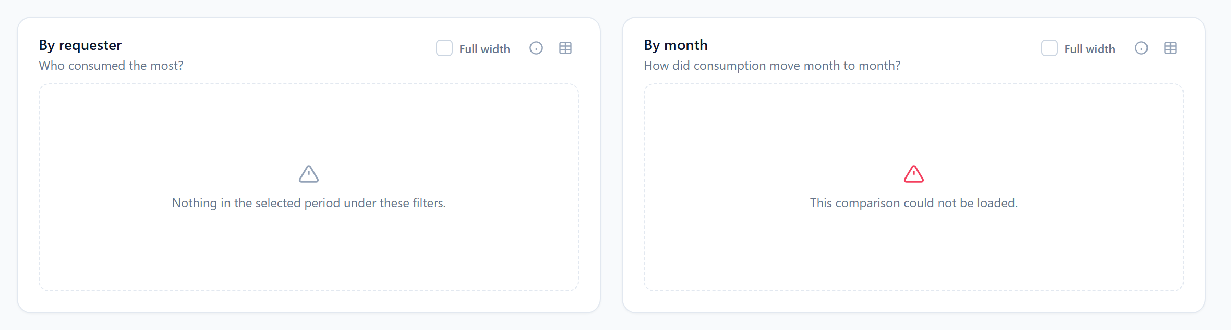
Figure 16 — Left: the empty state. Right: the error state.
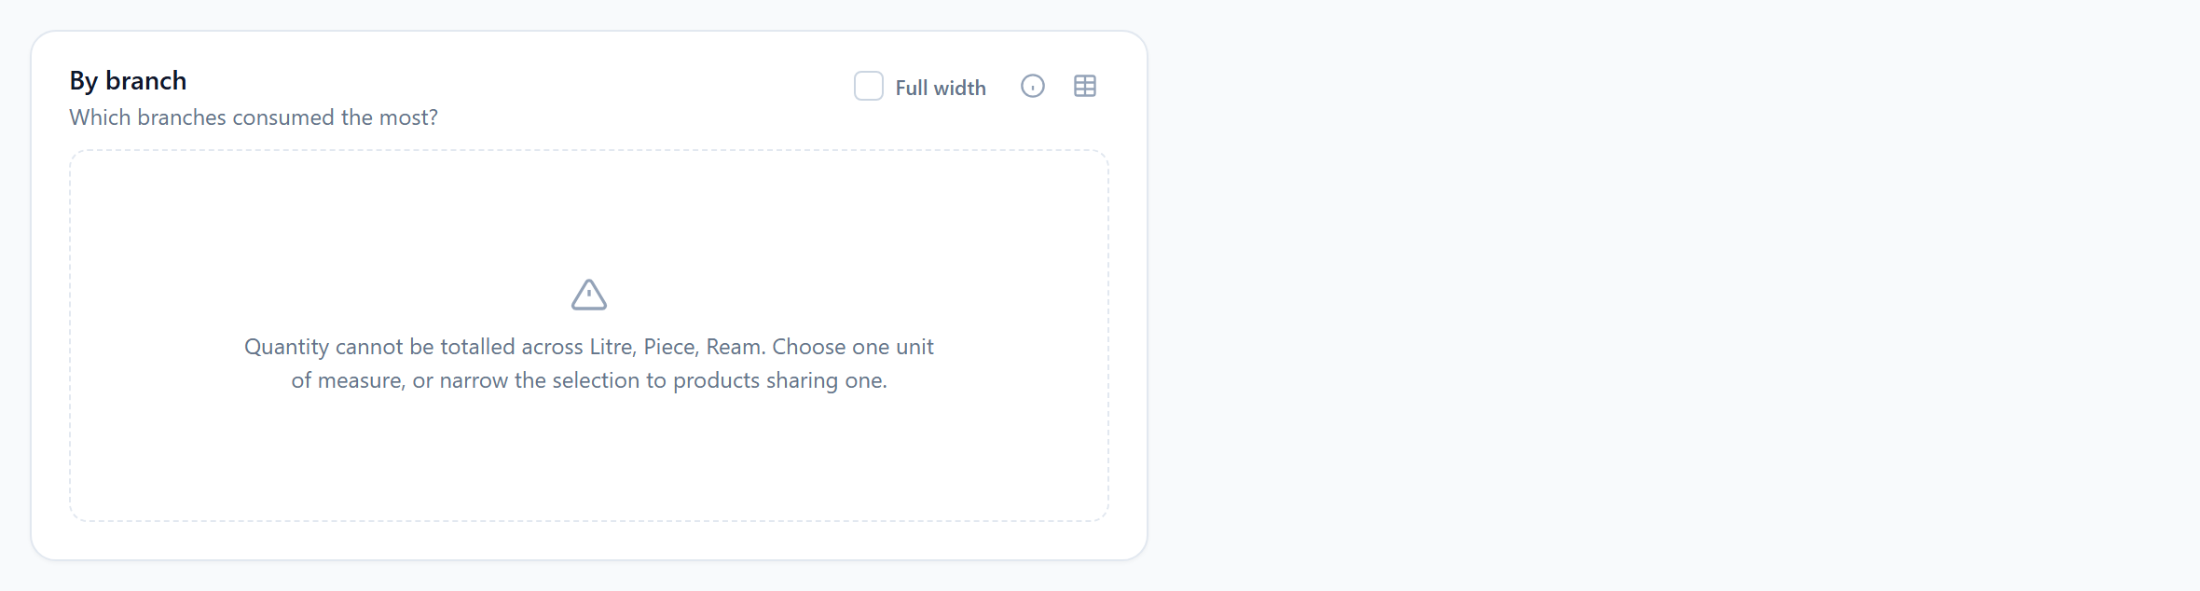
Figure 17 — The blocked state, shown on every panel when Quantity cannot be totalled across units.
Message | When it appears | What to do
Nothing in the selected period under these filters. | The panel’s query ran and found no revenue-eligible orders matching every filter. | Widen the date range, clear a branch/category filter, or check the product/requester selection.
Quantity cannot be totalled across Litre, Piece, Ream. Choose one unit of measure, or narrow the selection to products sharing one. | Measured by = Quantity and more than one unit is in scope with none chosen. | Pick a unit in the filter bar, or focus products that share a unit.
This comparison could not be loaded. | The request failed (e.g. your session expired). | Refresh the page; sign in again if prompted.
The analytics could not be loaded. Your session may have expired, or the selected range returned an error. | Shown above the tabs when the shared overview request fails. | Refresh / sign in again; check the custom date range is valid.
No products with activity in the selected period. / No people with activity in the selected period. | Inside a picker when nothing matches the filters (or the search text). | Widen the filters or clear the search.
No order lines behind this selection, under this period and these filters. | In the drill-down, when the clicked figure has no lines under the current filters. | Usually means a filter changed after the click; select the bar again.
Graphical Reports is not available for your role | The signed-in user is not Super Admin or Head Office. | Ask an administrator; this report is limited to those roles.

13. Limits, rules and frequently asked questions
Limit | Value
Products that can be put in focus at once | 25
Requesters that can be selected at once | 25
Entries listed in a picker | 200 (use search to find others)
Bars on a ranked panel (By product, By requester, By branch) | 12
Lines on Requesters over months / Products over months | 6
Months on By month | 120
Days on Day-by-day | 400
Rows per drill-down page | 50
Roles allowed | Super Admin, Head Office

FAQ
- Why does a person I know ordered something not appear in By requester? Either their orders are outside the filters, their orders are PENDING/CANCELLED/REJECTED (not counted), or they are outside the top 12. Select them explicitly in Requesters to compare and they will be shown.
- Why does By month show “no prior period” in the tooltip? A month’s natural comparison is the neighbouring month, already on the chart, so no separate prior-period figure is computed for months.
- Why do the shares in a tooltip not add up to the whole company? “Share of shown” is share of the bars on the chart (at most 12), not of every entity in the period.
- Why did picking a unit change nothing? You are measuring by Amount with no product or category in focus — whole-order money is not in a unit. See section 4.2.
- Why did By product disappear when I ticked one product? A product compared against itself is a single bar. With one product in focus the screen switches to the day-by-day view of that product; tick a second product and By product returns.
- Do group orders count? Yes. A Group Order Portal submission is recorded as an ordinary order for each branch it covers and is counted for that branch and for the person who raised it.
- Are pending orders counted anywhere here? No. This tab counts consumption (FULFILLED, APPROVED, PARTIAL, PARTIALLY_FULFILLED). Pending commitments appear on the Executive Overview’s budget figures instead.
- Can I see another organisation’s data? Only a Super Admin can, by selecting it in the Organisation filter. A Head Office user is fixed to their own organisation on the server; typing another organisation into the address bar has no effect.
- Is the data live? Yes — every panel queries the database when it loads. Figures include orders up to the moment the page was refreshed.

14. Glossary
Term | Meaning
Requester | The user who raised (created) an order — an Order Portal or Group Order Portal user.
Revenue-eligible order | An order whose status is FULFILLED, APPROVED, PARTIAL or PARTIALLY_FULFILLED. Only these are counted.
Procurement Value | Order total minus approved refunds, in rupees. The “Amount” measure.
Quantity | Units ordered minus refunded units, always within one unit of measure.
Unit (of measure) | How a product is sold — Piece, Ream, Litre, Box, etc. Recorded on each order line.
In focus | The product(s) ticked in the Product picker. Everything on the screen is narrowed to them; with two or more ticked, the product panels compare them against each other.
Scope | The set of branches and organisation(s) you are allowed to see, resolved from your own user account by the server.
Prior period | The window of the same length immediately before the selected date range.
Share of shown | A bar’s percentage of the total of the bars currently drawn.
Drill-down | The table of individual order lines behind a clicked bar, column or point.
Line / order line | One product on one order. An order with three products has three lines.
Line-by-line counting | Valuing only the matching lines of an order (used whenever a product, category or unit is in play) rather than the whole order.

Appendix A — Coverage of the client requirements
How the Compare Side by Side tab meets each stated requirement.

User-wise, item-wise & branch-wise analysis and comparison
Requirement | How the tab meets it
Individual and comparative analysis across items/products, users, branches and months, plus users among themselves, in one screen | Six panels on one screen: By product, By requester, By branch, By month, Requesters over months, Products over months. The Requesters to compare picker sets users against each other; the Product picker sets products against each other.
Compare consumption of a specific product across users, branches and months in one screen | Tick the product: By requester, By branch, By month, Requesters over months and Day-by-day all answer for that product only (sections 5.1, 7).
Example: Nescafé Classic Coffee by individual users and across branches | Sections 11.1 and 11.2 walk through exactly this.
Multiple colours to differentiate users, products, branches | Every entity panel gives each user, product or branch its own colour, with a legend and direct value labels (section 10).
Graphical and tabular views; comparison reachable by clicking fields | Every bar, column, point and table row opens the order-line table (section 9). The trend panels also offer a table toggle, and any panel can be widened to the full row for a closer look (sections 7.0, 10).

Interactive dashboard graphs
Requirement | How the tab meets it
Clicking a bar or data point navigates to the corresponding detailed table | The drill-down opens directly beneath the charts for the clicked entity and the page scrolls to it (section 9).
The detailed table automatically shows the same month/period as the graph | A month or day click clips the table to that bucket; a point on a trend narrows to that entity and that month (sections 7.4–7.6, 9.5).
The drill-down retains the filters and selected criteria from the graph | Date, organisation, branches, categories, unit, products in focus and selected requesters are re-applied server-side (section 9.5).
Graphs offer both Amount and Quantity | The Measured by toggle (section 5.3).
Switching Amount/Quantity keeps filters and comparison criteria | Only the measure changes; everything else, including an open drill-down, is kept (section 5.3).

