DATA FOR DINNER 2026

Food Access:
Global to Alabama
Official-data pull, factual analysis, dataset sufficiency, and modeled county outcome context
SCOPE: Global to United States to project-defined Southeast to Alabama. Feeding America county and state estimates are a separate modeled outcome layer. Food allergies, race and gender demographic analysis, and straight-line distance are outside the active analysis.
Prepared by | Data for Dinner 2026 project team
Frozen pull | Core sources August 22; Feeding America package August 29, 2026
Primary local source | USDA ERS 2025 SNAP-authorized Retailer Access Map
County outcome layer | Feeding America Map the Meal Gap 2026, data year 2024
Project region | AL, AR, FL, GA, KY, LA, MS, NC, SC, TN
Prepared as a factual checkpoint. The report does not assign causes, make causal claims, or combine unlike access measures into one score.

Executive summary
The pull supports the current main question. The primary local dataset is sufficient for Alabama and the ten-state comparison, provided the distance method and measurement boundaries remain explicit. Feeding America now supplies a validated, separate county and state outcome layer for 2024.

Key facts
- Global: FAOSTAT estimates 26.8% of the world population experienced moderate or severe food insecurity in 2023–2025. The U.S. FAOSTAT estimate is 10.7%.
- United States: USDA estimates 13.7% of U.S. households were food insecure in 2024, representing 18.34 million households. Very low food security affected 5.4%, or 7.20 million households.
- Project-defined Southeast: 2022–2024 state household estimates range from 11.8% in North Carolina to 19.4% in Arkansas. Alabama is 12.1% ± 2.23 percentage points and ranks ninth of ten from high to low.
- Alabama: 20.2% of low-income residents, or 656,013 people, are beyond the primary retailer-access threshold.
- Alabama: 151 tracts, or 10.5%, are flagged low-income/low-access. The provisional U.S. share is 7.5%.
- Feeding America outcome context: the modeled Alabama rate is 17.8%, or 919,160 people, and the modeled child rate is 24.4%, or 276,640 children, in 2024.
- Sensitivity: Alabama's low-income burden is 20.2% at the primary threshold, 35.9% at 0.5 mile urban / 10 miles rural, and 19.6% at 1 mile urban / 20 miles rural.

Decisions from this pull
Decision area | Recommendation | Reason
Primary local dataset | Retain USDA 2025 SRAM | Complete for Alabama and the ten project states; supports tract, population, low-income, and subgroup measures.
Global and U.S. context | Retain as separate layers | FAOSTAT population indicators and USDA household estimates answer different questions from retailer proximity.
County outcome context | Retain Map the Meal Gap separately | The validated 2024 county and state modeled estimates fill a descriptive outcome gap without creating a tract outcome or combined score.
More datasets | Add only against a declared gap | Avoid a broad crawl that mixes vintages and measures without an analytical purpose.
Distance method | Road network only | Straight-line distance is excluded because it does not represent road travel and produced implausibly influential outliers for this study.
Allergies | Pause integration; run feasibility crawl | No single official public source links prevalence, tract food insecurity, store inventory, price, and allergens.
COMPARABILITY: Global population indicators, U.S. household food insecurity, Feeding America modeled individual estimates, and tract retailer proximity have different universes, units, and meanings. They are reported side by side, not as one numeric scale.

1. Data selected and captured
All retained sources are official and are either publicly downloadable or supplied through an official request workflow. URLs, file sizes, retrieval timestamps, access notes, and SHA-256 hashes are recorded. Public raw files are reproducibly downloaded; the request-only archive remains local while selected processed tables and metadata are stored with the analysis.
Source ID | Dataset | Geography | Vintage
FAO_FS | FAOSTAT Suite of Food Security Indicators | Global, regional, and national | Current bulk release retrieved 2026-08-22
FAO_COAHD | FAOSTAT Cost and Affordability of a Healthy Diet | Global, regional, and national | July 2026 SOFI release
USDA_SRAM_2025 | 2025 SNAP-authorized Retailer Access Map | 2020 U.S. census tracts | Retailers as of June 2025; released 2026-07-27
USDA_FOOD_SECURITY_CSV | Food Security in the United States data files | United States and states | 2024 annual; 2022-2024 state average
USDA_ERR_358 | Household Food Security in the United States in 2024 (ERR-358) | United States and states | Published 2025; state estimates average 2022-2024
CENSUS_TRACTS_AL_2020 | 2020 Alabama cartographic census tract boundaries, 1:500,000 | Alabama 2020 census tracts | 2020
FEEDING_AMERICA_MMG_2026 | Map the Meal Gap 2026: local food insecurity and food costs in 2024 | U.S. county, congressional district, and state; Alabama county and state extracts retained | 2024 observation year; file updated 2026-07-28; corrected 2023 county estimates included
TEAM_STORY_SANDRA_2026 | WomenInData Data Stats and Summary - Story | Global, U.S., U.S. regions, project-defined Southeast, Alabama counties, and Alabama story regions | Team synthesis received 2026-08-29; underlying sources retain their own vintages

Selection rules
- Use the latest official release available on the pull date; retain observation dates separately from retrieval dates.
- Keep a measure only when its unit, denominator, geography, and join key are clear.
- Use the 1-mile urban / 10-mile rural driving-distance threshold as the primary local measure because it matches the agreed plan and follows the road network.
- Preserve uncertainty for state household estimates and vary only road-network thresholds in sensitivity output.
- Exclude straight-line distance from imported analysis fields, results, workbook tables, and report findings.
- Do not average tract percentages. Aggregate numerators and denominators, then calculate the rate.

Capture package
Artifact | Contents
Source manifest | Official URL, geography, vintage, retrieval time, bytes, SHA-256, local path.
Processed CSVs | Global summary, all state outcomes, all state retailer access, ten-state comparison, Alabama retailer-access tables, and selected Alabama Map the Meal Gap county and state extracts.
Results | QA checks, sensitivity analysis, dataset sufficiency assessment, key findings.
Figures | Six reviewed charts/maps with source notes and consistent styling.
Team files and reproducibility | This report in DOCX/PDF, a filterable workbook with 15 sheets, Sandra Kopecky's prevailing team story workbook, acquisition and analysis scripts, a dependency list, and methods documentation.
TEAM STORY AND CREDIT: Sandra Kopecky created the prevailing team story workbook and contributed data pulls, synthesis, regional framing, Alabama county detail, charts, and narrative development. The submitted workbook is preserved unchanged. This report uses the validated repository tables for exact claims and treats unsourced driver labels as evolving story hypotheses.

2. Global access to food
FAOSTAT provides population-level indicators for food insecurity, undernourishment, and affordability of a healthy diet. Values below are the latest selected period for each series.
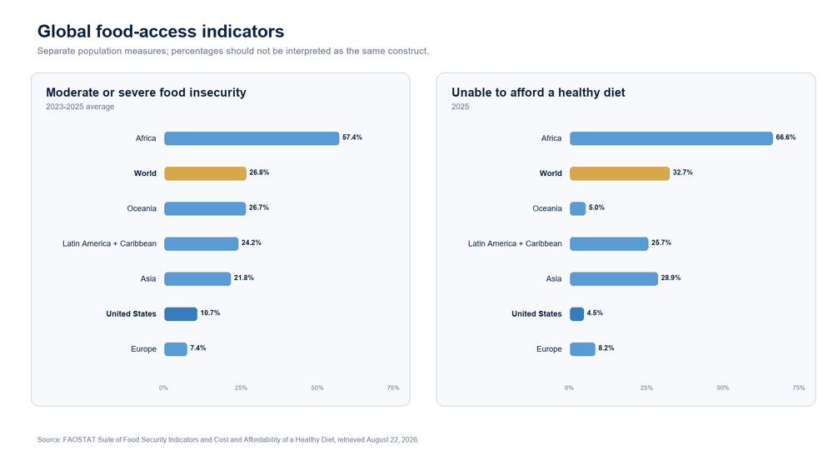
Figure 1. Global food-access indicators from FAOSTAT. Series have different concepts but the same population-percent unit.
Geography | Moderate/severe FI | Severe FI | Undernourished | Unable to afford healthy diet
World | 26.8% | 9.8% | 8.1% | 32.7%
Africa | 57.4% | 21.1% | 20.1% | 66.6%
Asia | 21.8% | 8.6% | 6.5% | 28.9%
Europe | 7.4% | 1.9% | <2.5% | 8.2%
Latin America and the Caribbean | 24.2% | 6.7% | 5.1% | 25.7%
Oceania | 26.7% | 10.3% | 8.2% | 5.0%
United States | 10.7% | 1.1% | <2.5% | 4.5%
Periods: food-insecurity and undernourishment indicators use 2023–2025; healthy-diet unaffordability uses 2025. “<2.5” is preserved as published.

What stands out
- Africa has the highest selected moderate/severe food-insecurity estimate (57.4%), severe estimate (21.1%), undernourishment estimate (20.1%), and healthy-diet unaffordability estimate (66.6%).
- The world estimates are 26.8% moderate/severe food insecurity, 9.8% severe food insecurity, 8.1% undernourishment, and 32.7% unable to afford a healthy diet.
- The United States is below the world estimate on every selected FAOSTAT indicator: 10.7%, 1.1%, less than 2.5%, and 4.5%, respectively.

3. United States access to food
The U.S. section separates household food insecurity from physical proximity to SNAP-authorized retailers.

Household food security, 2024
Status | Share | Households
Food secure | 86.3% | 115.58 million households
Food insecure | 13.7% | 18.34 million households
Very low food security | 5.4% | 7.20 million households

Retailer access, primary threshold
Measure | Count | Share of matching denominator
Population beyond threshold | 62,320,755 | 18.8%
Low-income population beyond threshold | 49,667,746 | 21.2%
Low-income/low-access tracts | 6,301 | 7.5%
Children beyond threshold | N/A | 19.2%
Adults 65+ beyond threshold | N/A | 20.4%
No-vehicle occupied units beyond threshold | N/A | 8.9%
SNAP occupied units beyond threshold | N/A | 11.1%
Primary threshold: more than 1 driving mile in urban tracts or 10 driving miles in rural tracts. The national low-income share is provisional because fourteen New York tracts lack low-income denominators.
BOUNDARY: Household food insecurity is an outcome reported for households. SRAM retailer access is a tract-based proximity measure reported for people or housing units. A household can experience either, both, or neither.

4. Project-defined Southeast
The ten-state comparison uses the same state set throughout: Alabama, Arkansas, Florida, Georgia, Kentucky, Louisiana, Mississippi, North Carolina, South Carolina, and Tennessee.
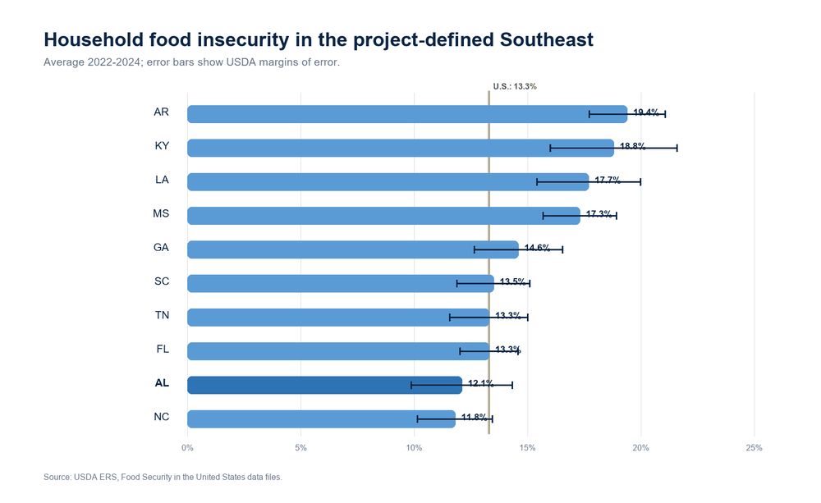
Figure 2. Household food insecurity in the project-defined Southeast, 2022–2024 average.
State | Food insecure | MOE (points) | Very low | Rank high→low
AR | 19.4% | ± 1.67 | 7.6% | 1
KY | 18.8% | ± 2.80 | 9.0% | 2
LA | 17.7% | ± 2.29 | 6.8% | 3
MS | 17.3% | ± 1.62 | 6.9% | 4
GA | 14.6% | ± 1.95 | 5.9% | 5
SC | 13.5% | ± 1.60 | 5.8% | 6
TN | 13.3% | ± 1.72 | 5.8% | 7
FL | 13.3% | ± 1.28 | 4.8% | 7
AL | 12.1% | ± 2.23 | 4.6% | 9
NC | 11.8% | ± 1.66 | 4.4% | 10
Margins of error are material. Small rank differences are descriptive, especially where intervals overlap.

5. Southeast retailer access
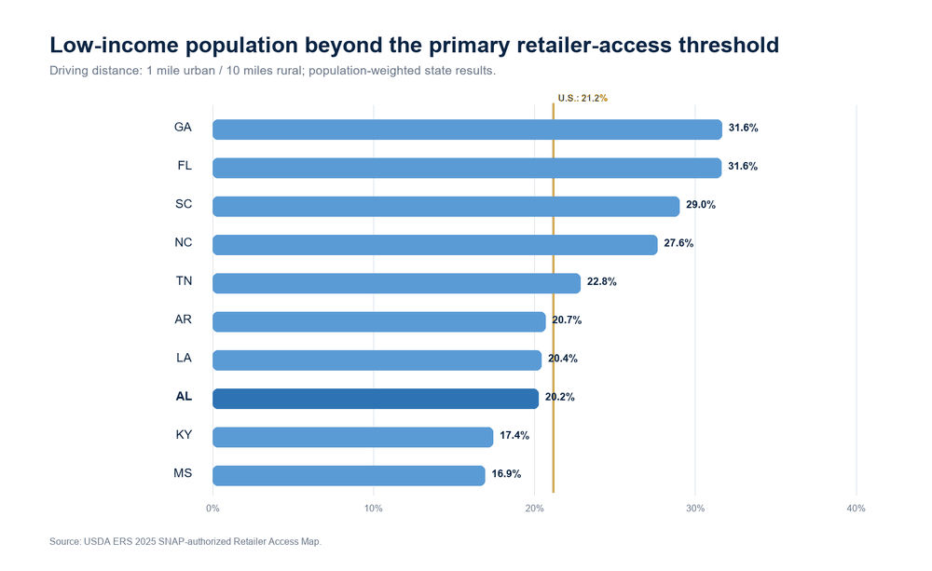
Figure 3. Low-income population beyond the primary retailer-access threshold.
State | Low-income burden | All-population burden | LILA tract share | Rank high→low
GA | 31.6% | 28.2% | 13.6% | 1
FL | 31.6% | 28.1% | 10.1% | 2
SC | 29.0% | 25.6% | 10.8% | 3
NC | 27.6% | 24.9% | 12.0% | 4
TN | 22.8% | 20.3% | 9.8% | 5
AR | 20.7% | 19.0% | 16.8% | 6
LA | 20.4% | 18.6% | 11.8% | 7
AL | 20.2% | 17.8% | 10.5% | 8
KY | 17.4% | 14.9% | 6.8% | 9
MS | 16.9% | 14.8% | 10.4% | 10

What stands out
- Georgia (31.6%) and Florida (31.6%) have the highest low-income retailer-access shares in the ten-state set; Mississippi is lowest at 16.9%.
- Alabama is 20.2%, eighth-highest of ten, and 0.9 percentage points below the provisional U.S. estimate of 21.2%.
- Household food-insecurity ordering and retailer-access ordering differ. Arkansas ranks first on the household outcome and sixth on retailer access; Georgia ranks fifth and first, respectively.

6. Alabama access to food
Alabama has complete primary fields for all 1,436 2020 census tracts and complete joins to the selected Census tract geometry.
Measure | Count | Share
2020 population | 5,024,279 | N/A
Low-income population | 3,243,903 | N/A
Population beyond primary threshold | 895,423 | 17.8%
Low-income population beyond threshold | 656,013 | 20.2%
Low-income/low-access tracts | 151 | 10.5%
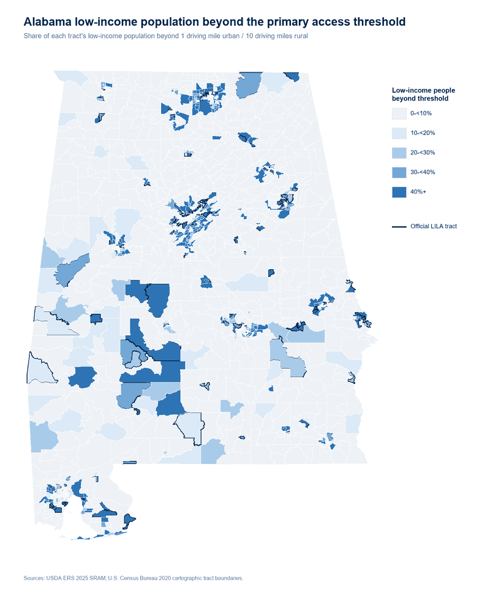
Figure 4. Alabama low-income retailer-access burden by census tract.
Dark shading indicates a larger share of the tract's low-income population beyond the threshold; the map does not show household food-insecurity prevalence.

7. Alabama county and tract detail
Counties below are ordered by the count of affected low-income residents, not by rate. This favors places where the absolute number is largest.
County | Affected low-income residents | Low-income burden | LILA tracts | LILA tract share
Jefferson | 133,014 | 30.8% | 33 | 17.5%
Madison | 106,257 | 35.3% | 8 | 8.4%
Shelby | 68,184 | 36.7% | 1 | 1.8%
Baldwin | 42,834 | 23.9% | 5 | 11.6%
Mobile | 39,741 | 15.8% | 13 | 9.6%
Lee | 37,598 | 32.7% | 10 | 20.8%
Tuscaloosa | 36,811 | 25.1% | 4 | 6.8%
Montgomery | 33,781 | 25.4% | 6 | 8.5%
Morgan | 18,222 | 21.7% | 2 | 6.5%
Calhoun | 14,618 | 21.9% | 10 | 26.3%

Highest affected counts
- Jefferson County: 133,014 affected low-income residents; 30.8% of its low-income population.
- Madison County: 106,257; 35.3%.
- Shelby County: 68,184; 36.7%.
- Baldwin County: 42,834; 23.9%.
- Mobile County: 39,741; 15.8%.
A high count and a high rate answer different questions. The workbook contains all 67 counties and both rankings.

Top LILA tracts by affected low-income count
GEOID | County | Affected low-income | Low-income burden | Poverty rate
01073011110 | Jefferson | 3,388 | 78.6% | 21.6%
01081040602 | Lee | 3,194 | 48.2% | 23.5%
01003011000 | Baldwin | 3,003 | 80.1% | 16.7%
01073012701 | Jefferson | 2,232 | 70.0% | 14.7%
01073012905 | Jefferson | 2,136 | 50.7% | 27.6%
01073011208 | Jefferson | 2,005 | 68.2% | 19.3%
01089010626 | Madison | 1,717 | 65.0% | 12.4%
01003011603 | Baldwin | 1,632 | 69.5% | 3.5%

8. Feeding America modeled outcome context
Map the Meal Gap 2026 adds modeled individual-level food-insecurity and localized food-cost estimates for 2024 at county and state levels. It fills a county outcome gap but does not create a tract outcome and does not replace the USDA household estimate or retailer-access measure.
Alabama measure | 2024 estimate | Unit
Overall food insecurity | 17.8% | 919,160 people
Child food insecurity | 24.4% | 276,640 children
Senior food insecurity | 7.6% | People age 60+
Older-adult food insecurity | 12.4% | People age 50 to 59
Cost per meal | $3.58 | Localized estimate
Annual food budget shortfall | $624,874,000 | State estimate
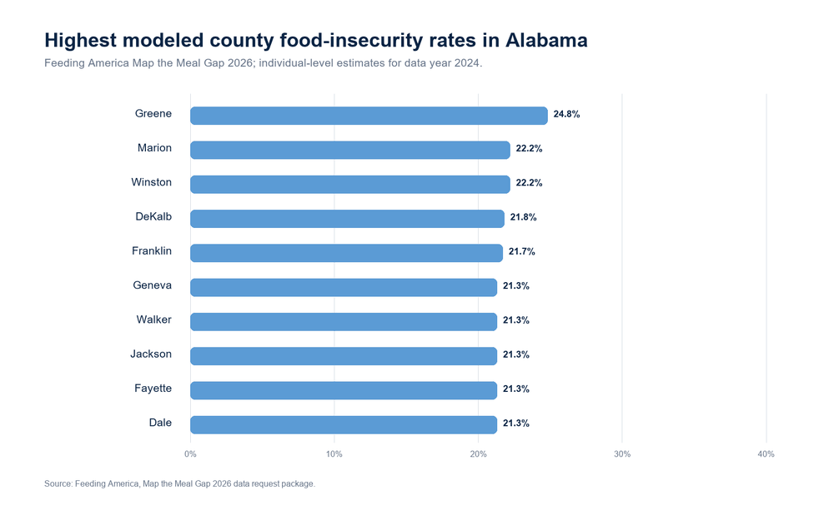
Figure 5. Highest modeled county food-insecurity rates in Alabama, 2024.
County | Overall rate | People | Child rate | Cost per meal
Greene | 24.8% | 1,840 | 39.6% | $4.07
Marion | 22.2% | 6,470 | 28.9% | $3.38
Winston | 22.2% | 5,250 | 29.3% | $3.33
DeKalb | 21.8% | 15,740 | 26.6% | $3.53
Franklin | 21.7% | 6,940 | 26.6% | $3.33
Dale | 21.3% | 10,590 | 32.3% | $3.53
Fayette | 21.3% | 3,420 | 28.7% | $3.38
Geneva | 21.3% | 5,730 | 28.2% | $3.80
Jackson | 21.3% | 11,320 | 27.1% | $3.66
Walker | 21.3% | 13,810 | 27.3% | $3.51
- County overall rates range from 13.1% in Shelby County to 24.8% in Greene County; the county median is 19.0%.
- The highest modeled child rate is 39.6% in Greene County.
- Market-basket values are imputed in 22 counties and should be interpreted cautiously.
- County food-insecure counts sum to 883,710, which is 35,450 below the state estimate. The difference is expected because Feeding America state estimates aggregate congressional-district results.
KEEP SEPARATE: Map the Meal Gap reports modeled individual estimates. USDA reports household survey estimates. SRAM reports tract retailer proximity. The report does not average, join, or combine these values into one score.

9. Subgroup access results
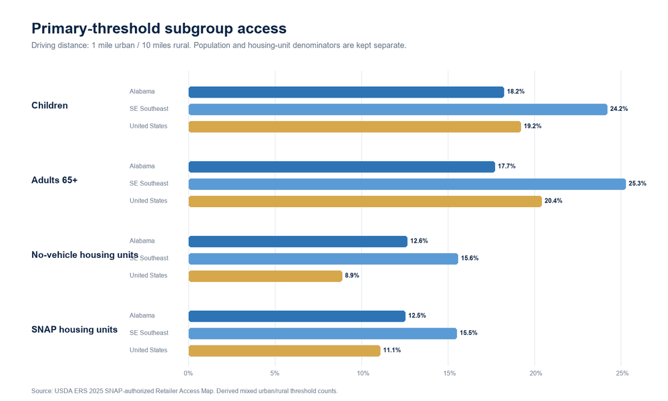
Figure 6. Primary-threshold retailer access by population or housing-unit subgroup.
Group | Alabama | United States | Denominator
All population | 17.8% | 18.8% | People
Low-income population | 20.2% | 21.2% | Low-income people
Children | 18.2% | 19.2% | Children
Adults 65+ | 17.7% | 20.4% | Adults 65+
No-vehicle occupied units | 12.6% | 8.9% | Housing units
SNAP occupied units | 12.5% | 11.1% | Housing units

What stands out
- Alabama is below the provisional U.S. share for all people, low-income people, children, and seniors.
- Alabama is above the U.S. share for no-vehicle occupied units (12.6% versus 8.9%) and SNAP occupied units (12.5% versus 11.1%).
- The no-vehicle and SNAP figures use housing-unit denominators; they should not be numerically pooled with population shares.

10. Sensitivity and sanity checks

Alabama road-network sensitivity
Road-network threshold | All population | Low-income population | LILA tracts
0.5 urban / 10 rural | 34.0% | 35.9% | 22.0%
1 urban / 10 rural | 17.8% | 20.2% | 10.5%
1 urban / 20 rural | 17.1% | 19.6% | 9.7%
- Changing the urban threshold from 1.0 mile to 0.5 mile raises Alabama's low-income burden from 20.2% to 35.9%.
- Changing the rural threshold from 10 to 20 miles lowers the low-income burden only slightly, from 20.2% to 19.6%.
- Straight-line distance is excluded from the study and is not treated as a sensitivity result.
- Recommendation: retain the road-network 1/10 threshold and label it on every table, chart, and spoken finding.

QA result
QA STATUS: 17 PASS • 2 REVIEW • 0 FAIL
Status | Check | Observed | Note
PASS | SRAM normalized row count | 84119 | N/A
PASS | SRAM geography coverage | 51 | N/A
PASS | SRAM duplicate GEOID | 0 | N/A
PASS | GEOID normalization impact | 15636 | General characteristics dropped leading zeros for state FIPS codes below 10; zfill(11) restored matches.
PASS | Latest state food-security rows | 52 | N/A
PASS | DD_SRAM_LAPOP1_10 does not exceed POP2020 | 0 | N/A
PASS | DD_SRAM_LALOWI1_10 does not exceed TractLOWI | 0 | N/A
PASS | la_kids_mixed does not exceed TractKids | 0 | N/A
PASS | la_seniors_mixed does not exceed TractSeniors | 0 | N/A
PASS | la_hunv_mixed does not exceed TractHUNV | 0 | N/A
PASS | la_snap_mixed does not exceed TractSNAP | 0 | N/A
REVIEW | Primary measure completeness | 15 | Fourteen Suffolk County, New York tracts lack low-income denominators; one zero-population Massachusetts tract lacks the LILA flag. Alabama and the project-defined Southeast are complete.
PASS | Alabama geometry join coverage | 1436 | N/A
PASS | Map the Meal Gap Alabama county rows | 67 | N/A
PASS | Map the Meal Gap duplicate county FIPS | 0 | N/A
PASS | Map the Meal Gap Alabama county FIPS format | 1 | N/A
PASS | Map the Meal Gap county rates within 0 to 1 | 1 | N/A
PASS | Map the Meal Gap Alabama state benchmark | 1 | N/A
REVIEW | Map the Meal Gap county to state count reconciliation | 35450 | State estimates aggregate congressional-district estimates, while county estimates use the county model. The source states that their totals need not match.
Two items require review. One covers fourteen Suffolk County, New York tracts without low-income denominators and one zero-population Massachusetts tract without a LILA flag. The other records the expected Map the Meal Gap difference between county sums and the state estimate. Neither is a blocking failure for the reported Alabama results.

11. What is available and whether to change datasets
Source / gap | Grain | Recommendation | Main limitation
FAO_FS | Global/region/country | KEEP - context only | Not comparable to tract retailer access; no U.S. state detail.
FAO_COAHD | Global/region/country | KEEP - context only | National and regional estimates; no U.S. state or tract detail.
USDA_FOOD_SECURITY_CSV | National/state | KEEP - outcome benchmark | State margins of error are material; no official tract outcome.
USDA_SRAM_2025 | 2020 census tract | KEEP - primary local dataset | Measures proximity to SNAP-authorized retailers, not price, quality, inventory, transit, or household food insecurity.
CENSUS_TRACTS_AL_2020 | 2020 census tract | KEEP - mapping support | Geometry only; must join on an 11-digit text GEOID.
USDA_LRAM_2019 | 2010 census tract | OPTIONAL NEXT CRAWL | Different retailer universe and tract base; use as a sensitivity comparison, not a time series.
USDA_FOOD_ENVIRONMENT_ATLAS | County/state | ADD ONLY FOR A DECLARED GAP | Do not add broadly; retain only variables with a specific analytical purpose.
FEEDING_AMERICA_MMG_2026 | County/state | KEEP - separate outcome layer | Modeled estimates, not household survey rates or tract results. State estimates aggregate district results, so county sums differ from the state total.
SUBSTATE_FOOD_INSECURITY_OUTCOME | Tract | GAP - do not infer | Map the Meal Gap fills the county outcome gap but does not provide tract-level food-insecurity estimates.

Recommendation
RETAIN THE CURRENT CORE: USDA SRAM is sufficient for the primary Alabama and Southeast physical-access question. FAOSTAT and USDA household estimates are sufficient as separate factual context and outcome benchmarks.
- Do not replace SRAM with the 2019 Large Retailer Access Map. The retailer universe and tract base differ; use LRAM only as a labeled sensitivity comparison.
- Do not add the full Food Environment Atlas by default. Add a small, predeclared variable set only if the team decides to examine price, assistance, store environment, or another explicit county-level gap.
- Retain Feeding America Map the Meal Gap 2026 as a separate modeled county and state outcome layer. It fills the county gap but does not provide a tract outcome.
- Keep the request-only raw archive outside GitHub because it contains no explicit redistribution license. Publish selected Alabama extracts, hashes, definitions, QA, and citations.
- Preserve the current frozen pull. Refresh only with a new dated snapshot and a change log.

Known blind spots
- SRAM does not measure food price, product quality, nutrition, inventory, store hours, transit, disability access, online purchasing, or household food insecurity.
- The listed retailer universe is SNAP-authorized retailers as of June 2025 and excludes farmers markets and delivery routes.
- Observation periods differ across layers. This is a cross-source snapshot, not a synchronized time series.
- The current data does not quantify food abundance or supply volume. That visual requires an approved measure and source.
- Race and gender demographic analysis is outside the current scope.
- Map the Meal Gap county and state estimates use different geographic models, so their counts should not be forced to reconcile.

12. Recommended next crawl for food allergies
Keep allergies outside the active analysis until feasibility is demonstrated. The public official sources identified here describe different parts of the problem and do not form a direct tract-level access dataset.
Module | Starting source | What it can support | Boundary
Taxonomy | FDA nine major allergens | Milk, egg, fish, crustacean shellfish, tree nuts, peanuts, wheat, soybeans, sesame. | Scope control; not prevalence or availability.
Diagnosed prevalence | CDC/NCHS 2024 NHIS | National adult/child estimates and selected demographic/urbanization comparisons. | Public-use geography does not support a reliable tract-level Alabama join.
Product labels | USDA FoodData Central branded foods | Ingredients, brand owner, category, GTIN/UPC; pilot text classification. | Not store inventory or price; allergen parsing requires validation.
Recall events | openFDA food enforcement | Reason, report date, status, distribution pattern, state when available. | Events are not prevalence or product availability.
Local availability and price | Retailer inventory source | Product × store × date × price, with stable product identifiers. | Not present in the official public sources reviewed; licensing/API gate.

Proceed / pause rule
PROCEED ONLY IF: A product-by-store-by-date source with price, defensible geographic coverage, stable product identifiers, and a validated FDA-allergen mapping is available. Otherwise, keep prevalence, product-label coverage, and recall events as separate descriptive modules or future work.

Recommended crawl sequence
- Lock the FDA nine-major-allergen taxonomy. Keep fruit and chocolate only as separately defined exploratory categories.
- Profile 2024 NHIS prevalence fields, denominators, demographic detail, and public-use geography.
- Pilot FoodData Central ingredient/Contains-text classification on a small sample and manually validate false positives and false negatives.
- Pull openFDA enforcement records for undeclared-allergen events; deduplicate and keep recall geography and dates.
- Search for a retailer inventory-and-price source only after the first four modules are documented; stop if product/store/date joins cannot be proven.

13. Reusable prompt for the allergy crawl
Conduct an official-source-only feasibility crawl for food-allergy access in Alabama and the project-defined Southeast (AL, AR, FL, GA, KY, LA, MS, NC, SC, TN). Keep this separate from the current food-access analysis until joinability is proven. Use the FDA nine major allergens, including milk, egg, fish, crustacean shellfish, tree nuts, peanuts, wheat, soybeans, and sesame, as the primary taxonomy. Treat fruit and chocolate only as explicitly defined exploratory categories. For each candidate dataset, record publisher, exact dataset and table, URL/API endpoint, release and observation dates, population or product universe, geography, unit of analysis, allergen fields, price/inventory fields, identifiers, access/licensing limits, update frequency, missingness, and proposed joins. Prioritize CDC/NCHS 2024 NHIS for diagnosed prevalence, USDA FoodData Central branded foods for a pilot of ingredient/Contains-text classification, and openFDA food-enforcement data for undeclared-allergen recall events. Do not treat recalls as prevalence or FoodData Central as store inventory. Do not make causal or medical claims and do not collect personal health information. Sanity-check denominators, duplicate records, changing labels, geography, dates, and taxonomy. Deliver (1) a source inventory, (2) a field-level data dictionary, (3) small reproducible pilot extracts, (4) QA findings, (5) a joinability matrix, and (6) a proceed/pause recommendation. Proceed to local allergen-safe access only if a product-by-store-by-date source with price and defensible coverage is available; otherwise recommend separate descriptive modules and identify the exact missing data.

Expected output contract
Output | Acceptance check
Source inventory | Every row has an official owner, direct URL/API endpoint, vintage, geography, grain, and access terms.
Field dictionary | Denominators, identifier formats, allergen text fields, and missing-value conventions are explicit.
Pilot extracts | Small, reproducible, dated, hashed, and free of personal health information.
QA report | Duplicates, denominators, taxonomy, date ranges, geography, and label parsing are tested.
Joinability matrix | Every proposed join lists cardinality, expected match rate, temporal alignment, and failure conditions.
Decision | Proceed/pause is tied to product-by-store-by-date inventory and price coverage, not project novelty.

Appendix A. Processing and validation details

Tract key repair
The SRAM general-characteristics CSV stores CensusTract20 without leading zeros when imported as a number. Distance files preserve 11 digits. Normalizing every tract key to text with zfill(11) restored 15,636 joins, including all Alabama and Arkansas tracts. The pipeline then verified 84,119 unique U.S. tracts, 50 states plus the District of Columbia, and zero duplicate GEOIDs.

Aggregation
- Overall burden = sum of people beyond the selected threshold ÷ sum of 2020 population.
- Low-income burden = sum of low-income people beyond the selected threshold ÷ sum of low-income population.
- Subgroup shares use their matching child, senior, no-vehicle housing-unit, or SNAP housing-unit denominator.
- LILA tract share = flagged tracts ÷ all tracts in the geography.

Interpretation limits
- Descriptive comparisons do not establish causes or policy effects.
- State household margins of error should accompany estimates; ranks are descriptive.
- Physical proximity is one dimension of food access and cannot be read as product availability or affordability.
- Map the Meal Gap rates are modeled individual estimates, not observed household survey rates or tract outcomes.
- Map the Meal Gap state and county counts use different geographic models and are not expected to sum to the same value.
- The Feeding America request archive contains no explicit redistribution license, so the raw package remains outside GitHub.
- Straight-line distance is excluded; road-network thresholds must be disclosed.
- The current data does not quantify food abundance or supply volume.
- Race and gender demographic analysis is outside the current scope.
- The national low-income retailer-access estimate is provisional because of fourteen missing New York denominators. Alabama and the project region are unaffected.

Appendix B. Files delivered
Path | Purpose
reports/Data_for_Dinner_Food_Access_Analysis.docx | Editable team report.
reports/Data_for_Dinner_Food_Access_Analysis.pdf | Fixed-layout report.
reports/Data_for_Dinner_Food_Access_Analysis.xlsx | Filterable source, data, sensitivity, QA, and metadata workbook.
data/processed/*.csv | Analysis-ready tables at global, state, county, and tract levels, including selected Alabama Map the Meal Gap extracts.
data/metadata/*.csv | Source manifest and analysis variable dictionary.
results/*.csv / *.json | QA, sensitivity, sufficiency assessment, and key findings.
src/*.py | Reproducible acquisition and analysis.
docs/*.md | Methods, source decisions, limitations, Map the Meal Gap integration, and allergy next-crawl documentation.

Appendix C. Official sources
1. Food and Agriculture Organization of the United Nations. FAOSTAT Suite of Food Security Indicators Global, regional, and national food-security indicators.
2. Food and Agriculture Organization of the United Nations. FAOSTAT Cost and Affordability of a Healthy Diet Healthy-diet affordability indicators through 2025.
3. USDA Economic Research Service. Household Food Security in the United States in 2024 2024 national and 2022–2024 state household estimates.
4. USDA Economic Research Service. Food Security in the U.S.: Key Statistics & Graphics Official national summary and definitions.
5. USDA Economic Research Service. Food Access Research Atlas - Download the Data Official 2025 SRAM download and release information.
6. USDA Economic Research Service. SRAM Reference Guide Variables, thresholds, and retailer universe.
7. USDA Economic Research Service. SRAM Data Sources and Technical Methods STARS, Census, LandScan, ACS, distance, and method details.
8. U.S. Census Bureau. 2020 Alabama Census Tract Boundaries Mapping geometry.
9. Feeding America National Organization. Map the Meal Gap 2026 Report Published July 28, 2026; modeled local food-insecurity and food-cost estimates for 2024.
10. Feeding America National Organization. Map the Meal Gap Methodology Model purpose, inputs, geographic methods, food budget shortfall, and meal-cost methodology.
11. Feeding America National Organization. Map the Meal Gap Data Request Official request workflow for the source package.
12. U.S. Food and Drug Administration. Food Allergies FDA major-allergen taxonomy and labeling context.
13. CDC National Center for Health Statistics. 2024 Adult Food-Allergy Estimates Diagnosed adult prevalence.
14. CDC National Center for Health Statistics. 2024 Child Food-Allergy Estimates Diagnosed child prevalence.
15. USDA Agricultural Research Service. FoodData Central Data Dictionary Branded-food product fields and ingredients.
16. U.S. Food and Drug Administration. openFDA Food Enforcement API Food recall enforcement events.

Appendix D. Final factual checkpoint
Check | Result
Main question answered without allergies | Yes
Global, U.S., Southeast, Alabama facts reported | Yes
Primary measure sufficient for project geography | Yes
Subgroup denominators clear | Yes
Road-network sensitivity disclosed | Yes
Straight-line result excluded | Yes
Source hashes and retrieval dates captured | Yes
Feeding America source gate completed | Yes; separate county and state outcome layer
Blocking QA failures | None
Allergy integration | Paused pending feasibility gate

Appendix E. Project roles
Roles are placed at the end so readers encounter the project question, methods, evidence, and limitations first.
Team member | Primary responsibilities
Sharon Brooks | Team lead and project management, meeting coordination, and review of the repository framework.
Sandra Kopecky | Data and database work, source review, data pulls, and authorship of the prevailing team story workbook, including regional framing and Alabama narrative development.
April Gillespie | Repository management, analysis, technical implementation, documentation updates, and integration of validated team data.
Shared | Review definitions and final numbers, record the presentation, and submit during the weekend ending September 13, 2026.

