Rebuttal Figure 1 shows in detail the region-selection process for Fig. 3H.
Rebuttal Figure 2 shows the region-selection process for Fig. 4E.
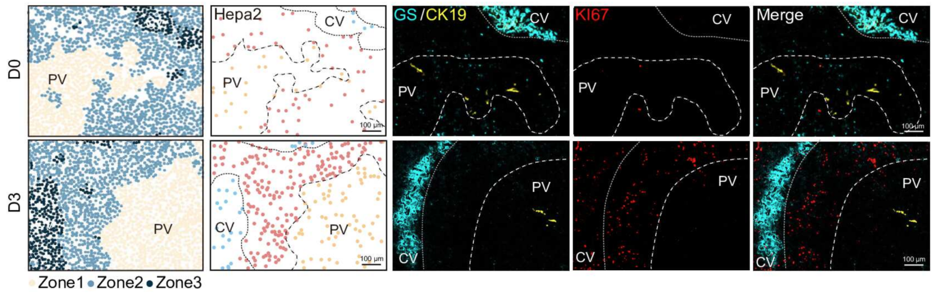
Fig. 3H in the manuscript
Rebuttal Figure1

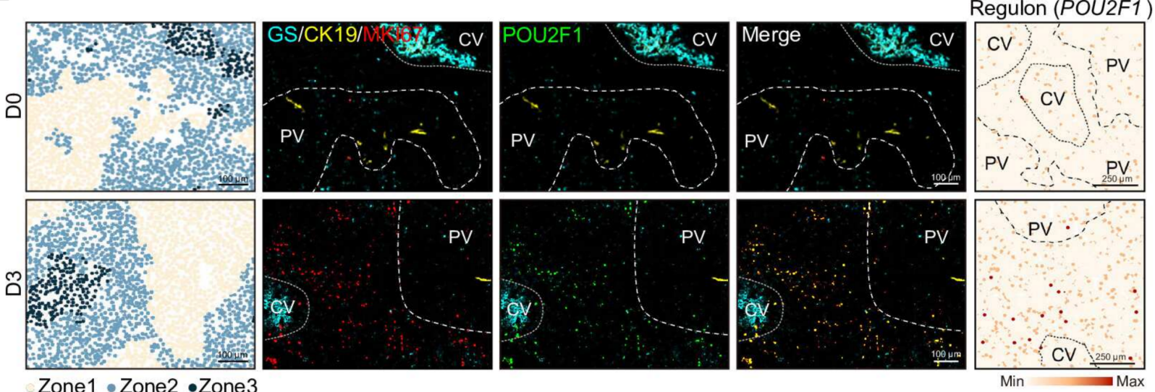
Fig. 4E in the manuscript

Rebuttal Figure2

