April Auger

December 4, 2019

Assignment 8.4 – API Gateway Part V

**REGISTER**

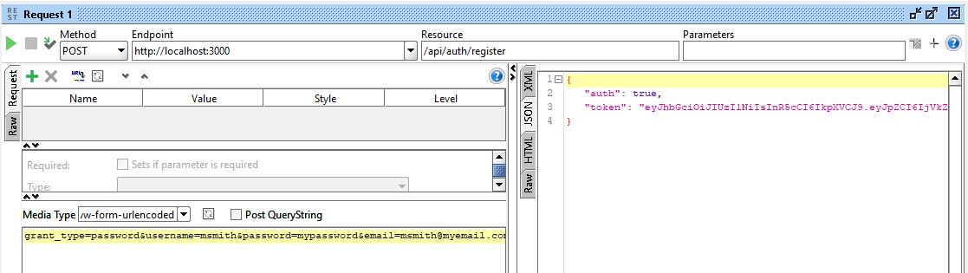

**TOKEN**

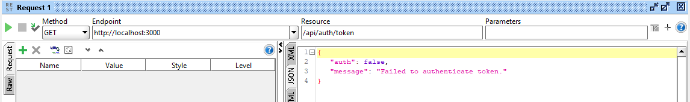

**LOGIN**

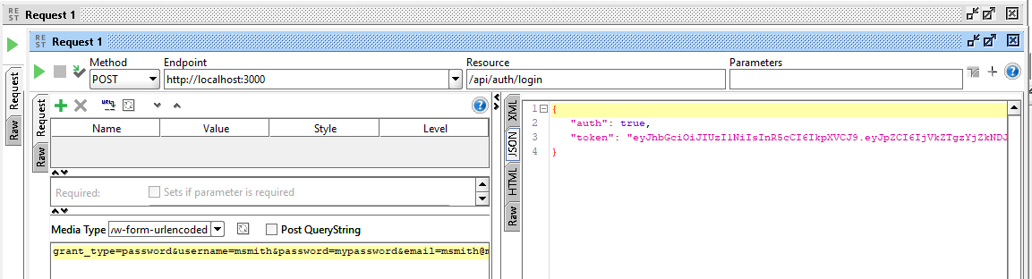

**LOGOUT**

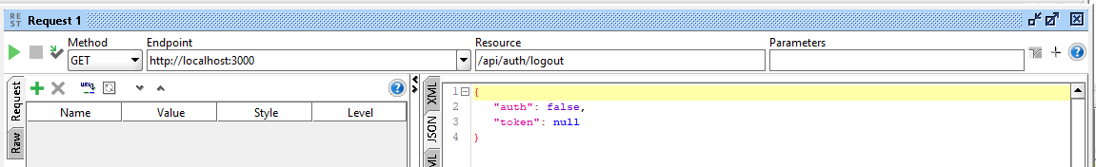

**TERMINAL**

