April Auger

November 7, 2019

Assignment 4.3 – API Gateway Part III

GitHub Repository: https://github.com/sitepioneers/web-420

**SOLUTION WITH DIRECTORIES EXPANDED**

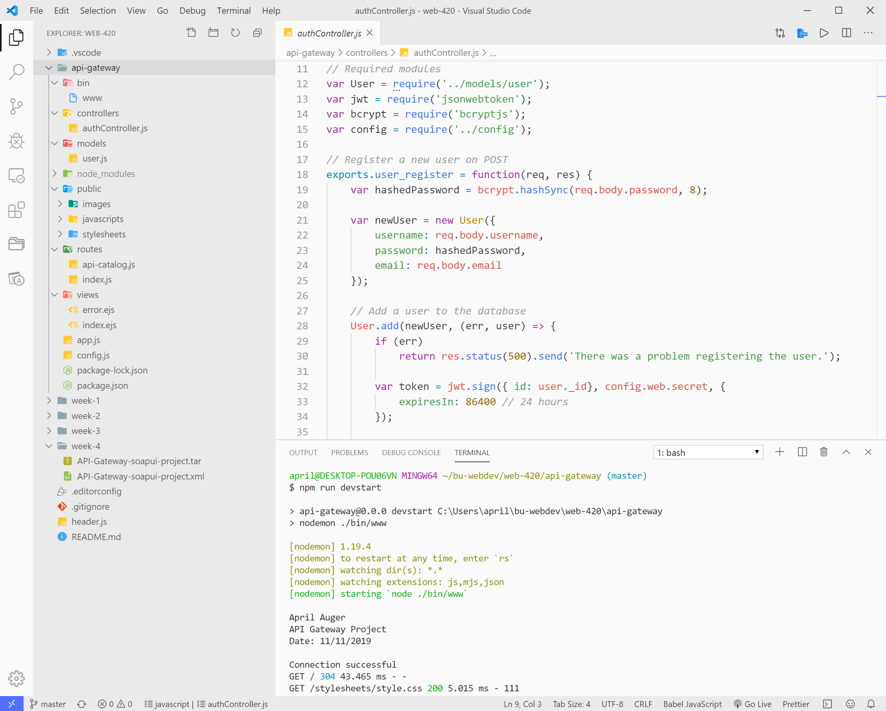

**CLI WINDOW**

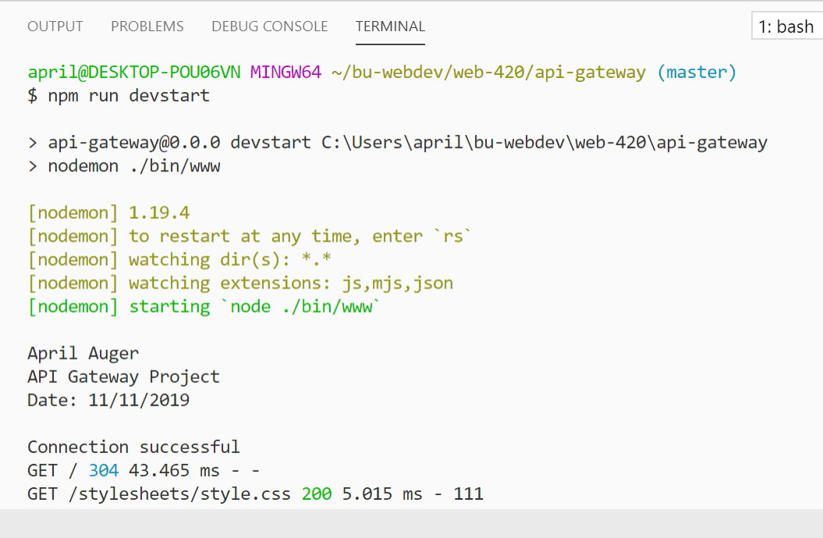

**SOLUTION RUNNING IN WEB BROWSER**

