April Auger

November 10, 2019

Assignment 4.4 – API Gateway Unit Test 01

**RESPONSE**

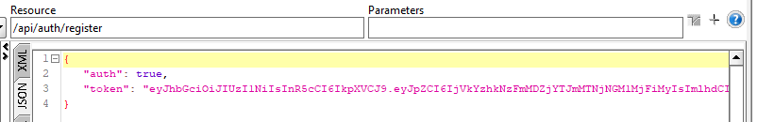

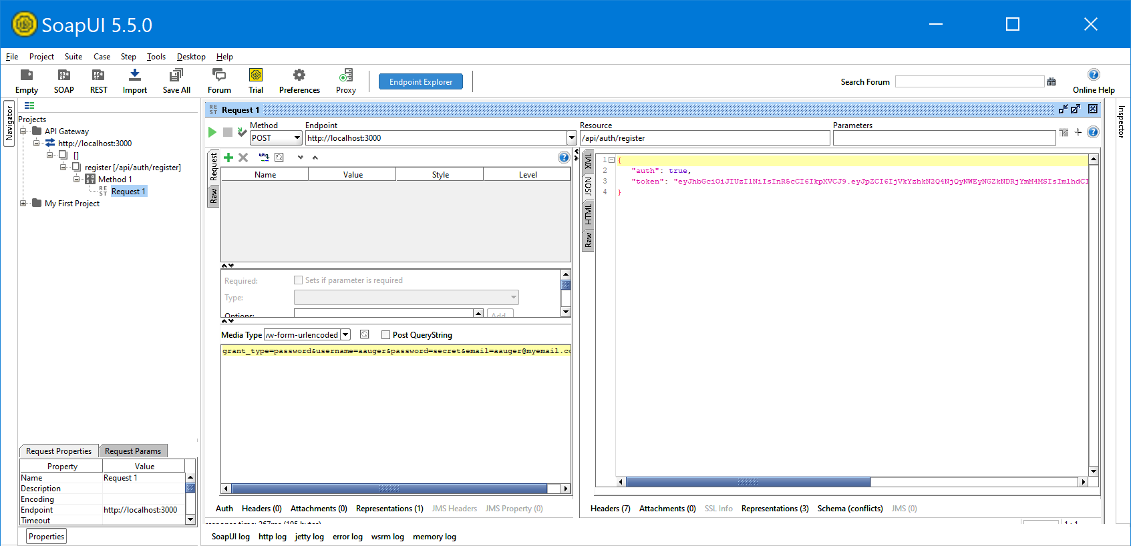

**TERMINAL OUTPUT**

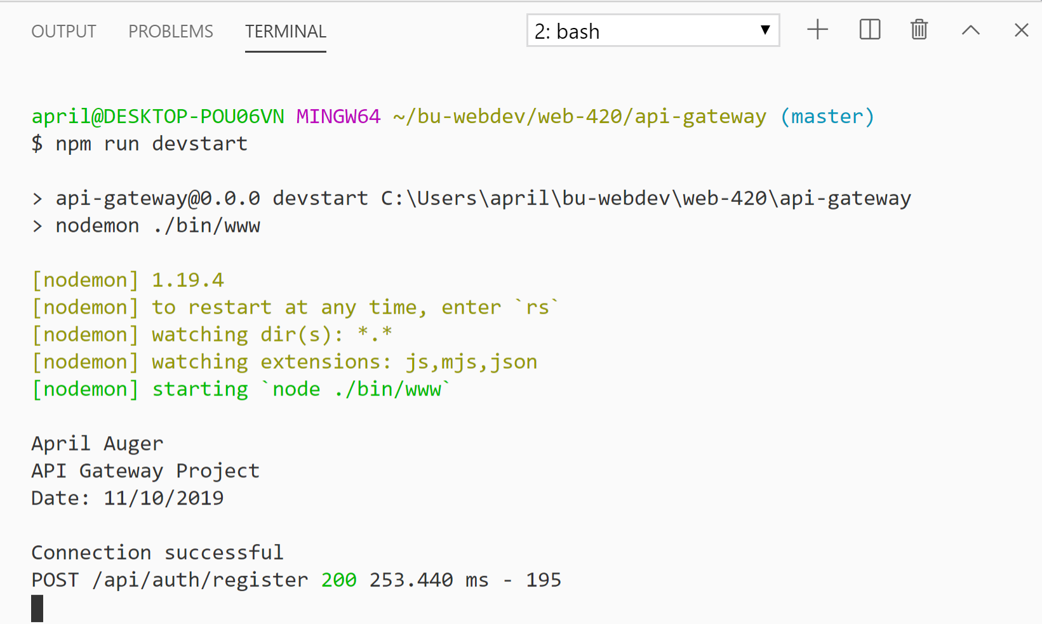

**ENTRY INSERTED INTO MONGODB**

