April Auger

November 16, 2019

Assignment 5.4 – API Gateway Unit Test 02

**CLI**

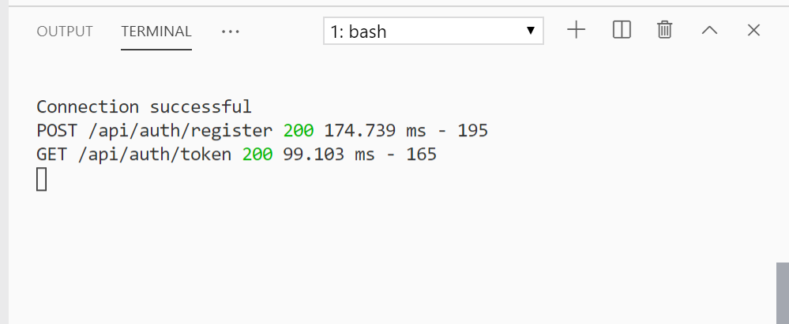

**RESPONSE**

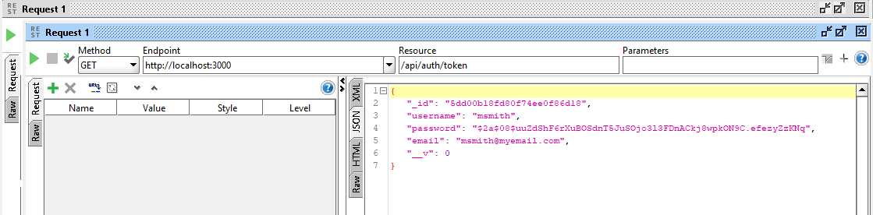

**MONGODB**

