April Auger

November 16, 2019

Exercise 5.2 – Unit Test 01

**HTTPGET REQUEST**

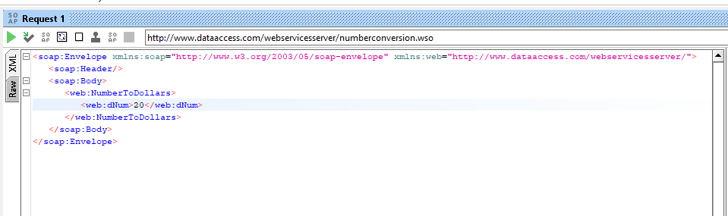

**HTTPGET RESPONSE­­­**

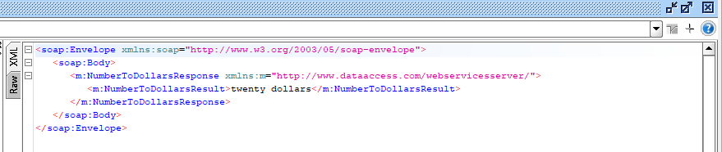

**LEFT PANEL**

