April Auger

November 16, 2019

Exercise 5.3 – Unit Test 02

**REQUEST**



**RESPONSE­­­**

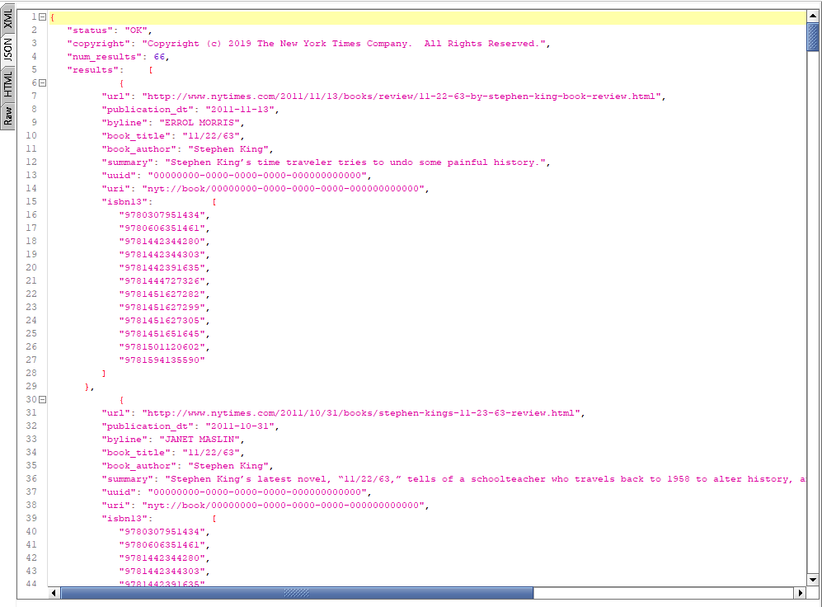

**LEFT PANEL**

