April Boyd

Answers 3.7

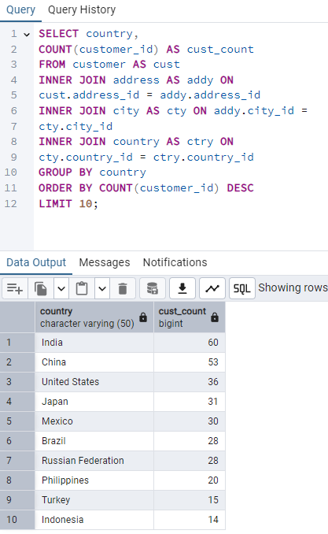

First I took a good look at the question to figure out what scheme I needed which was country and customers. I knew I would need to join those two tables with the inner join function. I set the limit to 10 to only show the top ten results and used DESC to list the country count from highest to lowest.

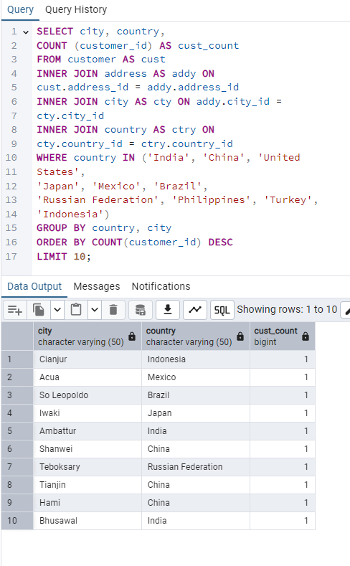

For this query, I needed to add a city column using the SELECT function. The cities should come from the 10 countries, so I added “WHERE country IN” ten listed the top 10 country names. I kept the GROUP BY but added country and city, Desc so it could be from highest to lowest, and limit 10 so it would show me only the top 10.

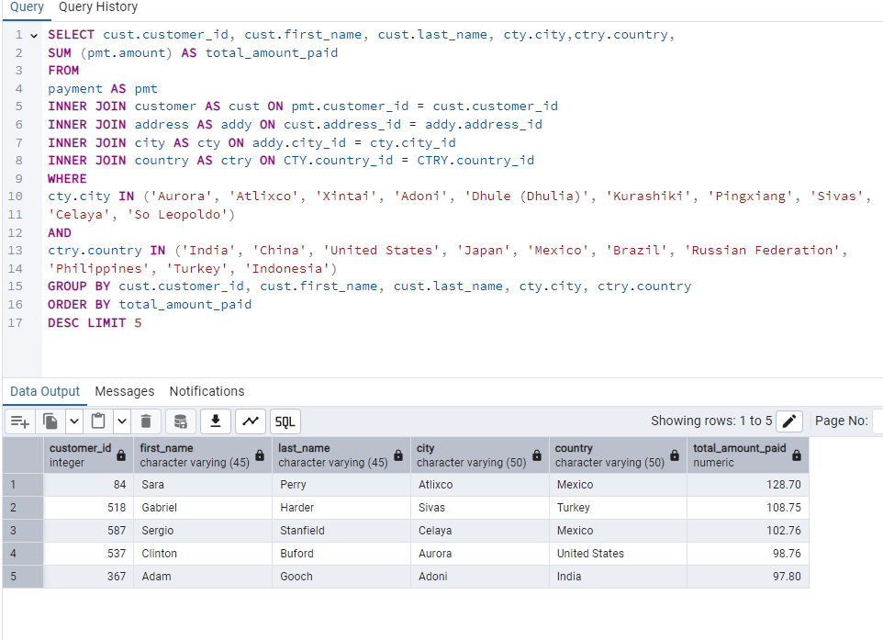

First, I included the columns mentioned in the question. Since it is asking for the amount paid, I know I must get that information from the payment table. Then I used the previous queries or the rest, but I set my limit to 5 instead of 10.