April Boyd

Answers 3.8

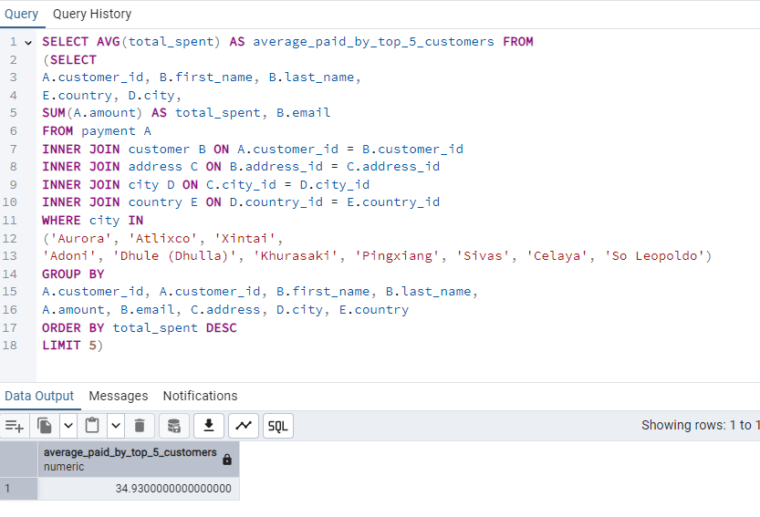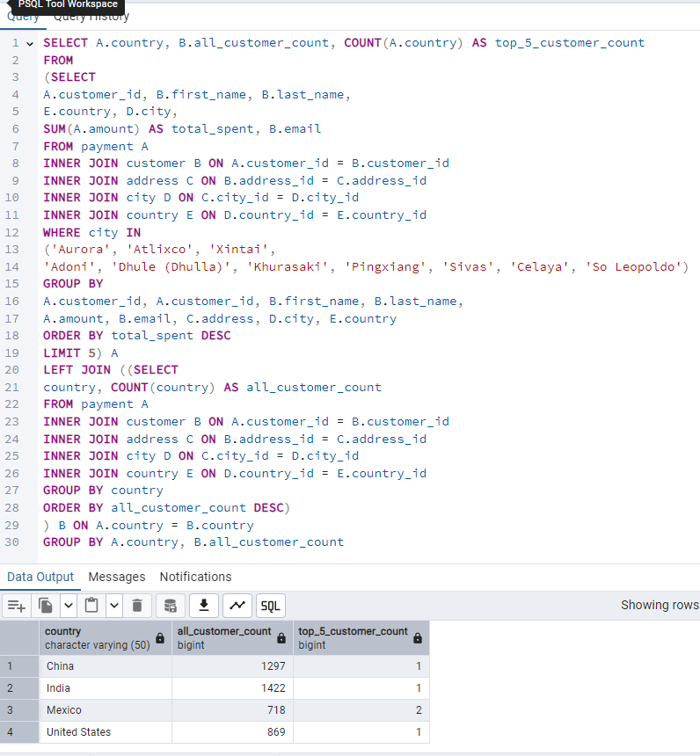

Steps 1 and 2 could technically be done without subqueries, but it would be much more difficult and messy. Without subqueries, we would have to repeat complex logic like identifying the top 5 customers or calculating totals directly within a larger query, which would make the SQL harder to read, maintain, and debug. By using subqueries, we can break the task into smaller, focused parts and treat the result of one query like a temporary table, which keeps things more organized.

Subqueries are especially useful when you need to filter or analyze a specific subset of data before applying further operations. In Step 1, the subquery helped isolate the top 5 customers so we could easily calculate their average spending in the outer query. In Step 2, the subquery made it easy to join the top 5 customers with country-level customer data, allowing us to count how many top customers lived in each country. Subqueries help simplify complex queries and make your logic easier to follow step by step.