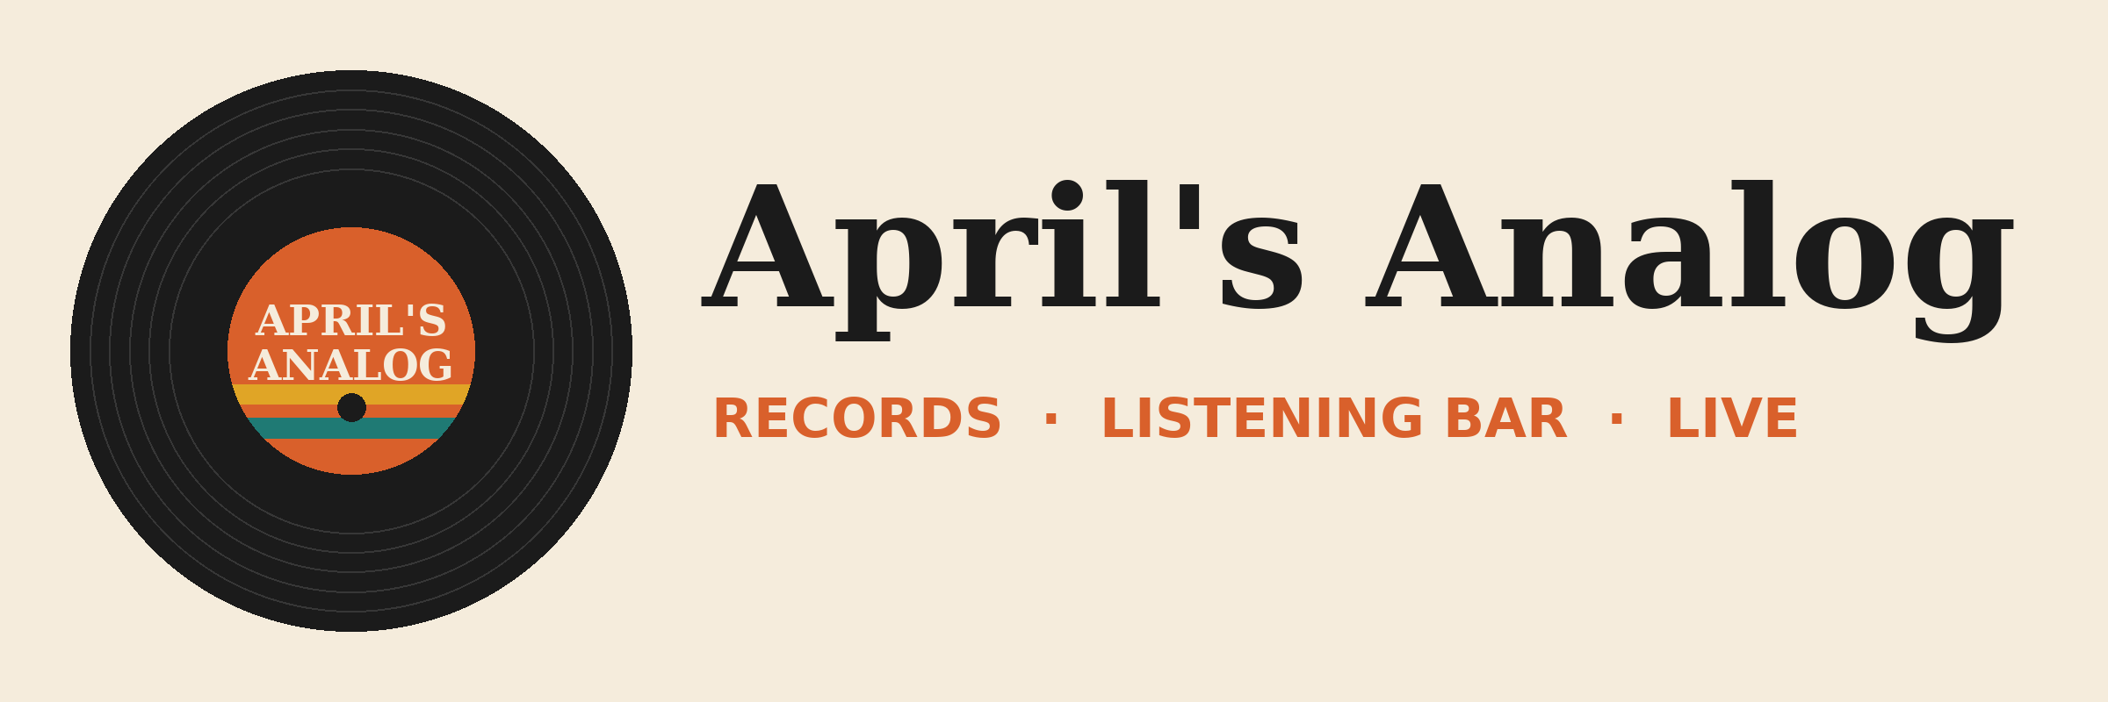

April's Analog brand kit
Everything you need to set up the brand kit that PowerPoint and @brandkit in Excel use in the demos.

Logos
File | Use it for
AprilsAnalog_Logo_Horizontal_Light.png | Light backgrounds, title slides, documents
AprilsAnalog_Logo_Horizontal_Dark.png | Dark backgrounds
AprilsAnalog_Logo_Mark.png | Square spaces: favicon, app icon, social avatar

Colors
Name | Hex | Use
Vinyl Black | #1B1B1B | Text, dark backgrounds
Cream | #F5ECDC | Light backgrounds
Burnt Orange | #D9602B | Primary accent, charts series 1
Deep Orange (text-safe) | #B44A1C | Accent text on cream
Mustard | #E0A526 | Secondary accent, highlights on black
Teal | #1F7A74 | Charts series 2, links

Fonts
- Headings: Georgia (bold)
- Body: Arial

Voice
- Warm, direct, a little music humor
- Contractions always, no em dashes
- Lead with what the reader gets

Setting it up
Create the brand kit wherever your tenant manages brand kits for Copilot in PowerPoint (for example, SharePoint Brand Center), using the logos, colors and fonts above. Name it April's Analog. Check that it shows in PowerPoint's brand kit picker and that @brandkit in Excel applies it. Brand kit locations and menus change often, so confirm the exact steps in your tenant a week before.

