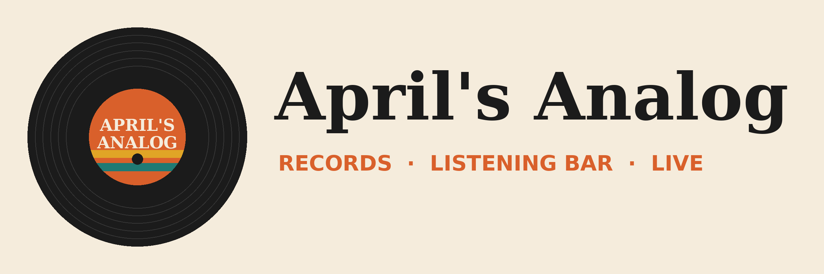

Demo pack setup: I didn't know Copilot could do that
Vibe 2.0 · April's Analog demo world
Every demo runs inside one fictional business, April's Analog, a record shop with a listening bar and a tiny stage getting ready for Analog Fest (October 16-18). Build all of this in the demo tenant at least a week before the session so email, meetings and files are indexed. The demo plan doc has the step-by-step demo scripts. This guide covers what goes where.

What's in this pack
File or folder | Put it here | Demo
02_OneDrive/Inventory.xlsx | OneDrive (root) | No. 10, No. 7
02_OneDrive/Weekend_Sales.xlsx | OneDrive (root) | No. 8
02_OneDrive/Weekend_By_Genre_Chart.xlsx (+ .png) | OneDrive (root). Open it on screen for Vision. | No. 7
02_OneDrive/Skills/analog-event-recap and weekly-sales-review | OneDrive Skills folder, one folder per skill | No. 8
02_OneDrive/MyVoice/ (4 emails) | OneDrive/MyVoice | No. 3
02_OneDrive/sound-like-april.zip | Keep on the desktop to upload | No. 1
02_OneDrive/Needle_Drop_Tech_Rider.docx | Desktop, for the No. 1 bonus | No. 1
03_SharePoint_Analog_Fest/Fest_Plan.docx | SharePoint site 'Analog Fest', Documents library | No. 9, No. 6
03_SharePoint_Analog_Fest/Last_Fest_Recap.pptx | Same library | No. 6, No. 9
03_SharePoint_Analog_Fest/Last_Fest_Notes.docx | Same library | No. 8
04_Outlook/ (emails.json, Seed-Mailbox.ps1, eml/) | Run the script to seed the demo mailbox | No. 6, 4, 3
05_Teams/Fest_Planning_Sync_Meeting_Script.docx | Read aloud in a real Teams meeting | No. 6
06_Confluence_Stage_Ops/ (3 pages) | Confluence space 'Stage Ops' | No. 5
07_Jira_SHOP/SHOP_issues.csv | Import into Jira project SHOP | No. 5
08_Brand_Kit/ | Set up the April's Analog brand kit | No. 9, No. 8
09_Stage_Props/LP_Back_Cover_Needle_Drop_PRINT.pdf | Print it and bring it on stage | No. 7
01_Prompts_Copy_Paste.txt | Keep open on the demo machine | All

One week before

1. Files
- Create a SharePoint team site called Analog Fest and upload the three files from 03_SharePoint_Analog_Fest. Keep the three reviewer comments in Fest_Plan.docx open (don't resolve them).
- Upload Inventory.xlsx, Weekend_Sales.xlsx and Weekend_By_Genre_Chart.xlsx to OneDrive. They're already formatted as Excel tables.
- Create OneDrive/MyVoice and upload the four emails. For the best result, swap in 3-5 emails you actually wrote.
- Copy the two skill folders into your OneDrive Skills folder (check the exact folder PowerPoint reads under Copilot > Settings > Manage skills). Each folder name must match the name in its SKILL.md.

2. Mail
- Sign in as the demo user and run 04_Outlook/Seed-Mailbox.ps1 in PowerShell. It creates the Sound + permits thread, the Crate & Needle thread (ending with the pop-up request), and The Velvet Static emails, dated relative to today.
- If you'd rather not run a script, send the emails in eml/ from a second account, or drag the .eml files into Outlook classic.
- If you also seed the Cowork pack in the same mailbox, seed the Crate & Needle thread only once: .\Seed-Mailbox.ps1 -Sets SoundPermits,VelvetStatic

3. Teams, Confluence, Jira
- Schedule a Teams meeting called Fest planning sync, turn on transcription, and read the script with two colleagues (about 5 minutes).
- Create a Confluence space called Stage Ops and paste the three pages from 06_Confluence_Stage_Ops (the editor accepts pasted markdown).
- Create a Jira project with key SHOP and import SHOP_issues.csv (System > External system import > CSV).
- Connect Jira and Confluence as Copilot connectors, and make sure they've finished their first crawl.

4. Copilot features
- Frontier on for the demo user (Critique, Model Council, skills in Agent Builder)
- Anthropic models enabled in the admin center
- Memory and personalization on
- Copilot Vision allowed; Copilot app installed on your phone
- Pages creation on
- The April's Analog brand kit set up (see Brand_Kit_Guide.docx)
- A Teams team called Analog Staff for the Prompt Gallery, with the three prompts at the bottom of the prompts file saved to it

5. The notebook
Create a Copilot Notebook called Analog Fest and add Fest_Plan.docx, Last_Fest_Recap.pptx, the Sound + permits email thread, and the Fest planning sync meeting.

Night before
- Clear saved memories and custom instructions (Settings > Personalization)
- Add an Inventory.xlsx row for any real LP you'd rather use than the printed cover. The printed cover matches row AA-10042 (Needle Drop, Side B Forever, CNR-042).
- Delete leftover recap decks, Summary sheets and PivotTables from rehearsals
- Record fallback clips for Nos. 9, 8, 6, 2 and 1

Morning of
- Generate the Analog Fest audio overview
- Pre-run the two Researcher tabs (Critique and Model Council) on the subscription-box prompt
- Pre-open Inventory.xlsx, Fest_Plan.docx, PowerPoint on the web, Weekend_Sales.xlsx, the Copilot app, and Outlook on the Crate & Needle pop-up email
- Mirror your phone to the stage screen and test on the venue Wi-Fi
- Browser zoom 150%, notifications off

What's in the data (so you know what Copilot should find)
- Inventory.xlsx: 2,000 records. Row AA-10042 is the Needle Drop green pressing (3 in stock). About two-thirds of stock has been on the shelf over 90 days, so the flag lights up plenty.
- Weekend_Sales.xlsx: Sept 7-20. Jazz is down about 33% week over week, and Blues is down about 15%. Soul spikes on Saturday Sept 19 (a DJ night).
- Fest_Plan.docx: The swap is on Sunday, Needle Drop headlines Saturday, the permit deadline is missing, and the budget table runs long. The three comments ask to fix exactly those.
- Fest planning sync: Decides to move the swap to Saturday, add a bartender, and have Needle Drop headline Sunday.
- Jira SHOP: The high-priority checkout bug blocks weekend pass sales.
- Confluence: The sound check checklist, load-in rules (5 pm, $200 + 20% of the door) and a four-piece stage plot.

