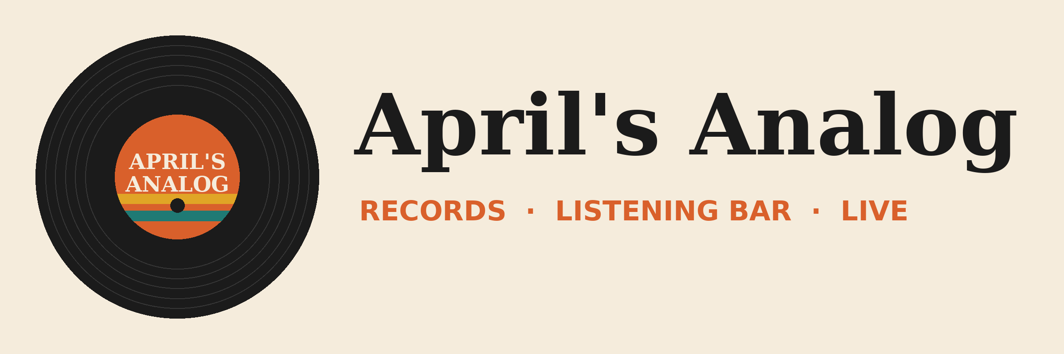

Meeting brief: Crate & Needle Records
Tomorrow, 10:00 am · Rosa Martinez, Label Manager

Where things stand
- Customer since March 2026. Two orders: CNR-0412 (60 units, April) and CNR-0588 (85 units, July). We're their #2 shop in the region.
- Needle Drop's green pressing is nearly sold out (3 left). Tin Can Telephone cassettes are slow (14 on the shelf).
- June shipment arrived a week late. Rosa took 5% off. We passed on the RSD leftovers in August.
- Open request: a pop-up table at Analog Fest on Saturday night, plus a call about fall orders.

Talking points
- Yes to the pop-up. Saturday 6:00-10:30 pm in the listening bar. They sold out their table last year.
- Restock Needle Drop. Ask for 40 more of the green pressing before the fest. Hold off on more cassettes.
- Lock ship dates. Fall orders need a firm ship date after the June delay.

Sources
- Email thread with Rosa Martinez (March to September)
- Teams chat with Marcus Reed
- Vendor_Pipeline.xlsx (Labels and Orders sheets)

