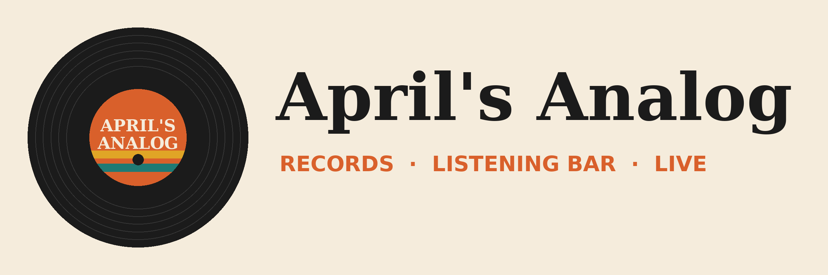

Demo pack setup: Delegating real work to Copilot Cowork
Vibe 2.0 · April's Analog demo world
This pack builds the April's Analog world in your Cowork demo tenant. Build it a week out so mail, chats and files are indexed. The demo plan doc has the demo scripts. This guide covers what goes where.

What's in this pack
File or folder | Put it here | Demo
01_Outlook/ (emails.json, Seed-Mailbox.ps1, eml/) | Run the script to seed the demo mailbox | 1, 2
01_Outlook/Tape_Hiss_Test_Email.txt | Send live from your second mailbox | 4
02_Teams/Teams_Chat_Script_Crate_Needle.docx | Post in a 1:1 chat with a second account | 2
03_OneDrive/Vendor_Pipeline.xlsx | OneDrive (root) | 2, 4, 5
03_OneDrive/Fest_Plan.docx | OneDrive (root) or the Analog Fest site | 6
03_OneDrive/Analog Fest/Meetings/ | Create this folder in OneDrive | 2
04_SharePoint_Lists/Volunteers.csv | New list 'Volunteers' on the Analog Fest site | 3
04_SharePoint_Lists/PopUp_List.csv | New list 'Pop-up list' on the Analog Fest site | 4
05_Fallbacks/FALLBACK_Crate_Needle_Meeting_Brief.docx | Keep on the desktop | 2
05_Fallbacks/vendor-brief/SKILL.md | OneDrive/Documents/Cowork/skills/vendor-brief/ (only as a fallback) | 5
00_Prompts_Copy_Paste.txt | Keep open on the demo machine | All

One week before

1. Mail
- Sign in as the demo user and run 01_Outlook/Seed-Mailbox.ps1. It creates 15 unread emails from this week (the Cowork 101 inbox) and the 6-month Crate & Needle thread, ending with Rosa's pop-up request.
- The unread emails are dated relative to the day you run it. Run it again 1-2 days before the session so they're still 'this week'. To reseed only the inbox: .\Seed-Mailbox.ps1 -Sets FestInbox (delete the old copies first).
- Set your second mailbox's display name to Jonah Pike (Tape Hiss Records) for the Demo 4 trigger email.

2. Teams
Post the six messages from Teams_Chat_Script_Crate_Needle.docx in a 1:1 chat between the demo user (April) and a second account (Marcus).

3. Files and lists
- Upload Vendor_Pipeline.xlsx and Fest_Plan.docx to OneDrive. Create the folder Analog Fest/Meetings.
- On a SharePoint site called Analog Fest, create two lists from CSV (New > List > From CSV): Volunteers from Volunteers.csv and Pop-up list from PopUp_List.csv. When it asks, set CheckedIn to Yes/No.
- Don't upload vendor-brief/SKILL.md unless Demo 5 fails in rehearsal. The point of the demo is Cowork writing it.

4. Cowork
- Cowork enabled for the demo user, with Copilot Credits and a spend policy (check View usage)
- /app live in the tenant (rollout ran September 8-14)
- Miro plugin installed, or monday.com as the backup (only for Demo 6)
- Build the volunteer app once in rehearsal and keep it as the pre-built copy

Night before
- Reseed the unread inbox if the emails are more than 4 days old
- Delete rehearsal drafts, briefs in /Analog Fest/Meetings/, rehearsal automations and the vendor-brief skill
- Record fallback clips for Demos 1, 3 and 4

Morning of
- Mark the 15 fest emails unread again if you rehearsed with them
- Pre-open Cowork, Vendor_Pipeline.xlsx, and the pre-built app
- Draft the Tape Hiss test email in your second mailbox so you only have to press Send

What's in the data (so you know what Cowork should find)
- Unread inbox (15): needs you: the sound quote due Friday, the permit missing its insurance cert, a volunteer who can't make Saturday, Sunday late short 3 people, poster proofs, and a press interview. Quick replies: set time, drum kit, keg drop-off time, swap table size, a customer hold. Noise: 2 newsletters, a payout notice, and an HVAC visit.
- Crate & Needle: Rosa Martinez. Orders CNR-0412 (60 units) and CNR-0588 (85 units). One late shipment (5% off). Pop-up request for Saturday plus a 10am call.
- Vendor_Pipeline.xlsx: 40 labels and 111 orders. Tape Hiss Records last ordered August 20, so Demo 4's rule says yes.
- Volunteers: 40 people across 6 shifts. Sunday late has only 4 (it matches Maya's email). Jess Park is on Saturday early door.
Heads up: the Cowork pack's label is Tape Hiss Records, and the countdown session has a band called Tape Hiss Society. If both packs share a tenant, just say the band is signed to the label.

