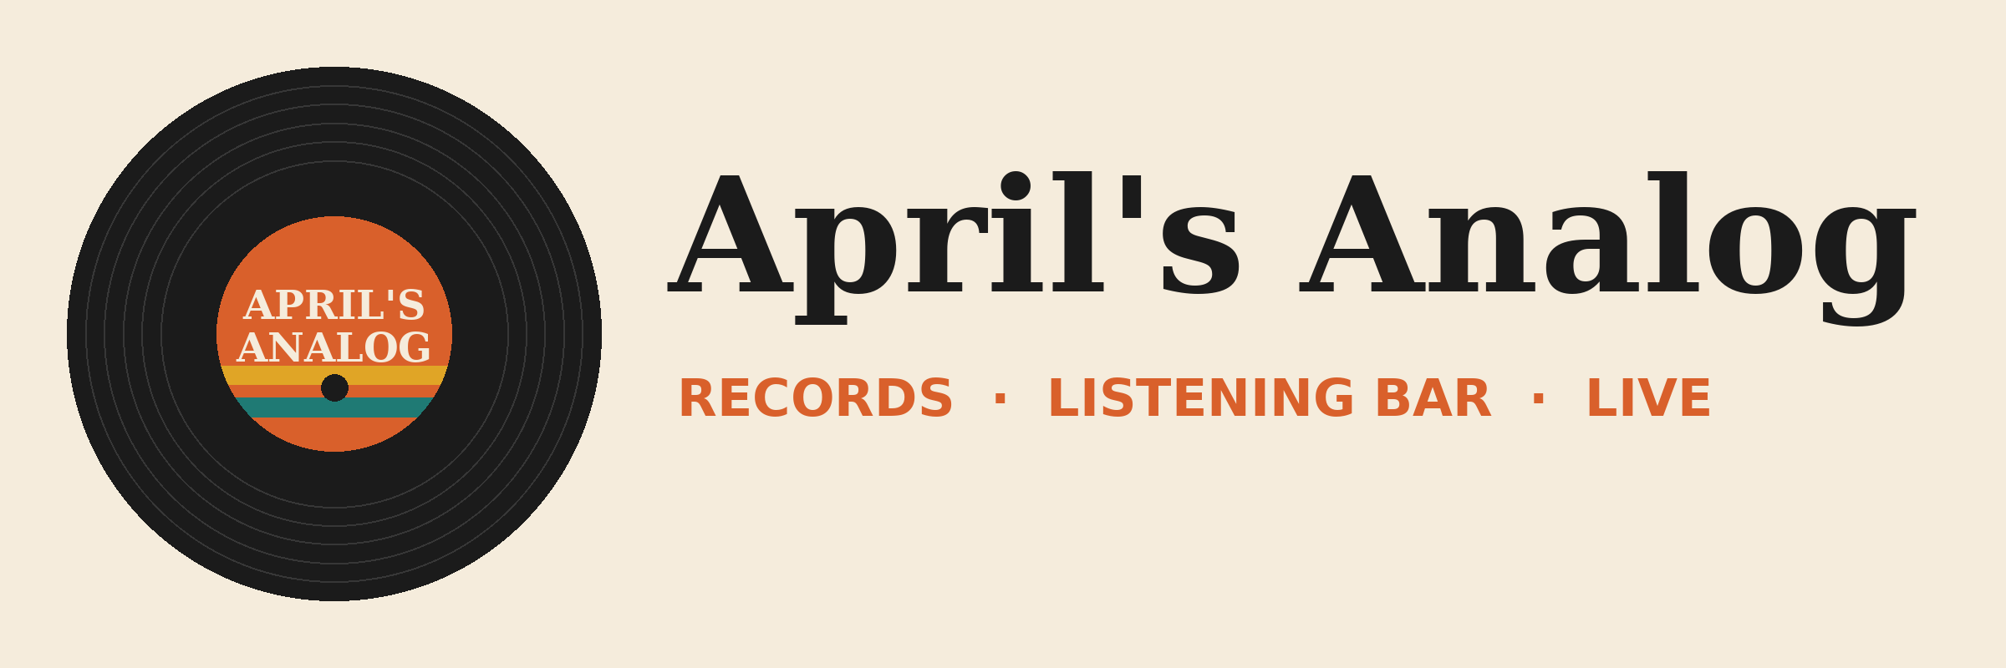

Teams chat script: Crate & Needle
Post these in a 1:1 Teams chat between the demo user (April) and a second account (Marcus, shop manager) a few days before the session.
From | Message
Marcus | Rosa from Crate & Needle called the shop today. She wants a pop-up table at Analog Fest and asked about fall orders.
April | Love that. They sold out their table last year. How are their records moving for us?
Marcus | Needle Drop green pressing is basically gone, 3 left. Tin Can Telephone cassettes are slow though, still 14 on the shelf.
April | OK so push for another Needle Drop restock, skip more cassettes for now.
Marcus | Also they were late on a shipment in June. They gave us 5% off, but we should ask for a firm ship date on fall orders.
April | Good call. I'm meeting Rosa tomorrow at 10. I'll bring it up.

Tip: post from the right accounts so Cowork sees a real conversation. The exact wording matters less than the three facts: green pressing nearly sold out, cassettes slow, and a firm ship date after the June delay.

