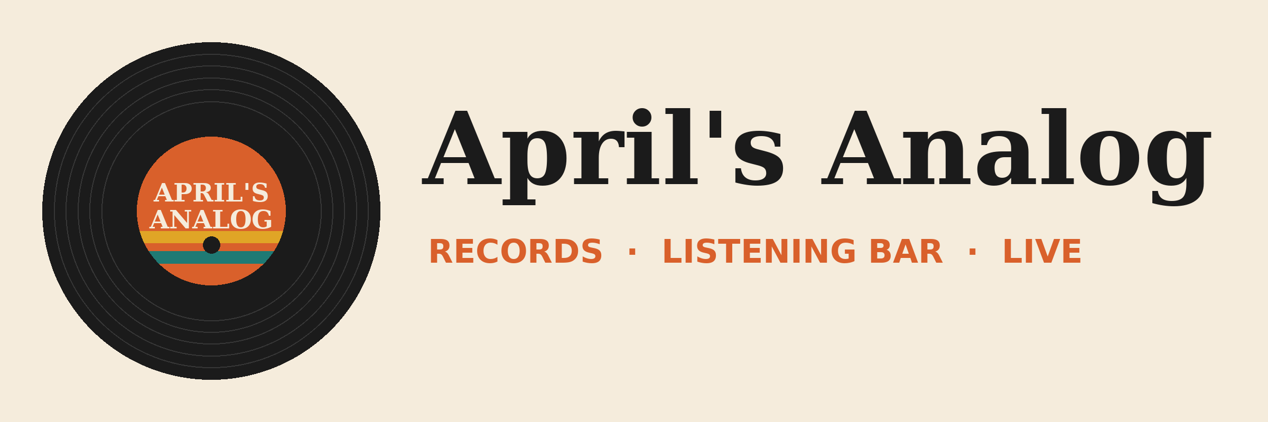

Analog Fest 2026 Plan
Three nights of local bands, label pop-ups, and a record swap. Friday, October 16 to Sunday, October 18.

Goals
- Sell 900 tickets across three nights (last year: 610)
- Hit $24,000 in record sales over the weekend (last year: $15,800)
- Sign up 250 new members for the April's Analog mailing list
- Give 12 local bands a real stage and a real crowd
- Break even on the festival itself. Record sales are the upside.

Lineup
Doors at 6:00 pm Friday and Saturday, 4:30 pm Sunday. 20-minute changeovers between every set. Amplified sound ends at 11:00 pm each night.

Friday, October 16
Time | Act | Notes
6:30-7:10 | The Paper Moons | Opener, 4-piece
7:10-7:30 | Changeover
7:30-8:10 | Static Bloom | Duo, needs 2 DI boxes
8:10-8:30 | Changeover
8:30-9:15 | Tape Hiss Society | 5-piece, tight stage
9:15-9:40 | Changeover | Headliner line check
9:40-10:40 | The Velvet Static | Headliner

Saturday, October 17
Time | Act | Notes
6:30-7:10 | Low Fidelity | Opener
7:10-7:30 | Changeover
7:30-8:10 | Dust Jacket | 4-piece
8:10-8:30 | Changeover
8:30-9:15 | Groove Theory Club | 6-piece with horns
9:15-9:40 | Changeover | Headliner line check
9:40-10:40 | Needle Drop | Headliner

Label pop-up tables run 6:00-10:30 pm on Saturday in the listening bar.

Sunday, October 18
Record swap: 12:00-4:00 pm in the back lot. 20 vendor tables, free entry, $10 per table for vendors.
Time | Act | Notes
5:00-5:40 | Honey Hollow | Acoustic trio
5:40-6:00 | Changeover
6:00-6:40 | B-Side Saints | 4-piece
6:40-7:00 | Changeover
7:00-7:50 | The Liner Notes | 5-piece
7:50-8:10 | Changeover | Headliner line check
8:10-9:10 | Midnight Pressing | Closing set

Permits and vendors
We need a Temporary Amplified Sound Permit and a Temporary Outdoor Event Permit from the city. Sound is Loud & Clear Audio ($1,850 for all three nights). Bar is supplied by Hops & Grooves Brewing.

Budget
Full line-item budget below. Ticket price is $15 per night or $35 for a weekend pass.
Line item | Category | Estimate | Notes
Band pay (12 bands) | Talent | $2,400 | $200 flat per band
Band door share | Talent | $2,700 | 20% of the door
Sound (Loud & Clear Audio) | Production | $1,850 | 3 nights
Drum kit rental | Production | $225 | $75 per night, no house kit
Stage lighting rental | Production | $600 | 2 LED bars + dimmer
Extra power drop | Production | $350 | 2 x 20-amp circuits
Amplified sound permit | Permits | $150 | City
Outdoor event permit | Permits | $200 | City, record swap
Event insurance rider | Permits | $425 | Names city as additional insured
Kegs (Hops & Grooves) | Bar | $1,100 | 4 kegs
Cups, ice, bar supplies | Bar | $300
Bartender (extra shift) | Staffing | $0 | Not budgeted yet
Security (2 per night) | Staffing | $1,200 | Friday and Saturday
Volunteer food + shirts | Staffing | $650 | 40 volunteers
Posters (150) | Marketing | $240 | Pressline Print Shop
Social ads | Marketing | $500 | 2 weeks before
Wristbands + ticketing fees | Operations | $380
Swap tables + tents | Operations | $450 | 20 tables
Portable restroom | Operations | $275 | Back lot, Sunday
Cleanup + trash haul | Operations | $200
Contingency (10%) | Other | $1,420
Total |  | $15,615

Staffing
Role | Friday | Saturday | Sunday
Door + wristbands | 2 staff, 4 volunteers | 2 staff, 4 volunteers | 1 staff, 3 volunteers
Bar | 2 bartenders | 2 bartenders | 1 bartender
Merch + records | Marcus + 2 volunteers | Marcus + 3 volunteers | Marcus + 2 volunteers
Stage manager | Dee Alvarez | Dee Alvarez | Dee Alvarez
Record swap |  |  | Maya + 6 volunteers
Volunteer lead | Maya Chen | Maya Chen | Maya Chen

Key contacts
- Owner: April Dunnam
- Shop manager: Marcus Reed
- Events booker and stage manager: Dee Alvarez
- Volunteer lead: Maya Chen
- Sound: Rick Dawson, Loud & Clear Audio
- City: Dana Whitfield, Special Events Coordinator

