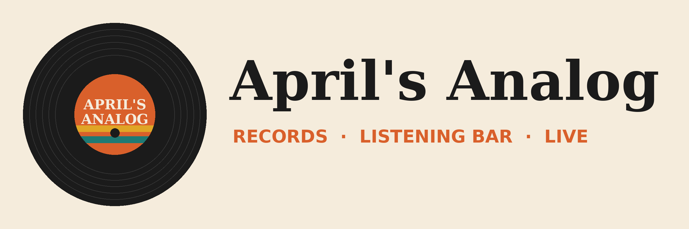

Fest planning sync: meeting script
Read this aloud in a real Teams meeting with transcription on, a week before the session, so Copilot has a transcript to find.
Who: April (owner), Marcus (shop manager), Dee (events booker). Use two colleagues or a second demo account. About 5 minutes. Name the meeting exactly: Fest planning sync.
April: OK, let's make this quick. Three decisions today for Analog Fest: the swap, the bar, and the Sunday headliner.
Marcus: Swap first. Last year Sunday afternoon was dead after two. I want to move the record swap to Saturday, noon to four, before the bands.
Dee: That works for load-in as long as the tables are out of the lot by five. Rick needs the lot clear for the PA truck.
April: Done. Record swap moves to Saturday, noon to four, tables out by five. Marcus, can you update the Fest Plan?
Marcus: Yep.
April: Bar. The line was twenty-five minutes last year.
Marcus: We need a second bartender Friday and Saturday. It's about four hundred dollars for both nights.
April: Let's do it. Add a bartender for Friday and Saturday. Put it in the budget.
Dee: Last one. Needle Drop's manager asked if they could headline Sunday instead of Saturday. Their drummer has a wedding gig Saturday night.
April: Honestly I like that. Sunday needs a draw. So Needle Drop headlines Sunday and Midnight Pressing moves to Saturday headliner?
Dee: Midnight Pressing already said yes to either night. I'll confirm with both.
April: Great. So: swap to Saturday, second bartender Friday and Saturday, Needle Drop headlines Sunday. Dee, you'll confirm with both bands by Friday. Marcus, Fest Plan and budget. I'll handle the permit paperwork, which is due October 2.
Marcus: One more thing. The poster proofs. Can we get them approved this week? Last year they were late.
April: Yes. I'll approve them by Thursday. Thanks, everyone.

Decisions Copilot should pick up
- Move the record swap to Saturday, 12-4 pm, tables out by 5
- Add a second bartender Friday and Saturday (about $400)
- Needle Drop headlines Sunday; Midnight Pressing headlines Saturday
- Owners: Dee confirms bands by Friday; Marcus updates the Fest Plan and budget; April files permits by October 2 and approves posters by Thursday

