LAPORAN PENGERJAAN UJI KOMPETENSI KEJURUAN SMK MAHARDHIKA BATUJAJAR

TAHUN PELAJARAN 2022-2023

KOMPETENSI KEAHLIAN : Rekayasa Perangkat Lunak KELAS : XII RPL 2

NAMA LENGKAP : Aprilia trijaldi

NIS :

PAKET SOAL : 02

JENIS APLIKASI : Web

ALOKASI WAKTU : 24 jam

# PENJADWALAN KEGIATAN

|  |  |  |  |  |  |  |  |  |  |  |  |
| --- | --- | --- | --- | --- | --- | --- | --- | --- | --- | --- | --- |
| **KEGIATAN** | **ALOKASI WAKTU** | | | | | | | | | | **KETERANGAN** |
| **JANUARI** | | | | **FEBRUARI** | | | | **MARET** | |
|
| **Tgl 1-6** | **Tgl 8-13** | **Tgl 15-21** | **Tgl 22-30** | **Tgl 1-6** | **Tgl 8-13** | **Tgl 15-21** | **Tgl 23-29** | **Tgl 1-6** | **Tgl 8-11** |
| Analisa Soal |  |  |  |  |  |  |  |  |  |  |  |
| Persiapan Perangkat Keras |  |  |  |  |  |  |  |  |  |  |  |
| Persiapan Perangkat Lunak |  |  |  |  |  |  |  |  |  |  |  |
| Perancangan Algoritma |  |  |  |  |  |  |  |  |  |  |  |
| Desain Bisnis Data |  |  |  |  |  |  |  |  |  |  |  |
| Implementasi Data Ke Mysql |  |  |  |  |  |  |  |  |  |  |  |
| Desain UI |  |  |  |  |  |  |  |  |  |  |  |
| coding Srtuktur HTML |  |  |  |  |  |  |  |  |  |  |  |
| Coding Style CSS |  |  |  |  |  |  |  |  |  |  |  |
| Coding PHP |  |  |  |  |  |  |  |  |  |  |  |
| Uji Coba Aplikasi |  |  |  |  |  |  |  |  |  |  |  |
| Uji Coba Cetak Struk |  |  |  |  |  |  |  |  |  |  |  |
| UJI Coba Buat Laporan |  |  |  |  |  |  |  |  |  |  |  |
| Upload Ke Hosting |  |  |  |  |  |  |  |  |  |  |  |
| Dokumentasi |  |  |  |  |  |  |  |  |  |  |  |

# PERSIAPAN PERANGKAT KERAS

1. *Monitor*
2. *Keyboard*

# PERSIAPAN PERANGKAT LUNAK

1. *Visual Studio Code*
2. *Xampp*
3. *Chrome*
4. *Astah*
5. *Excel*
6. *Word*
7. *Balsamiq*
8. *Os Windowa 7 ultimate 64-bit*

# PERANCANGAN ALGORITMA APLIKASI

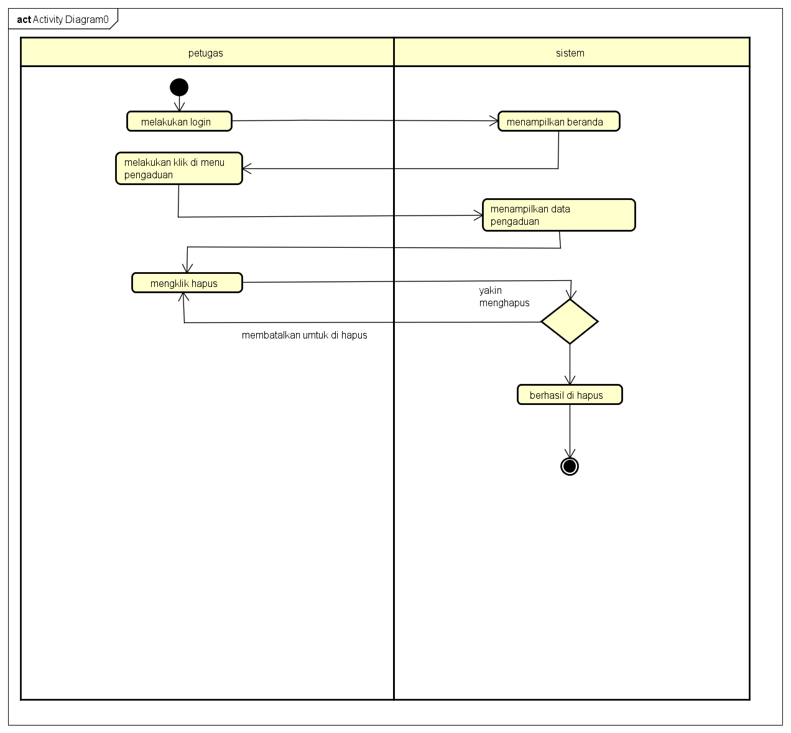

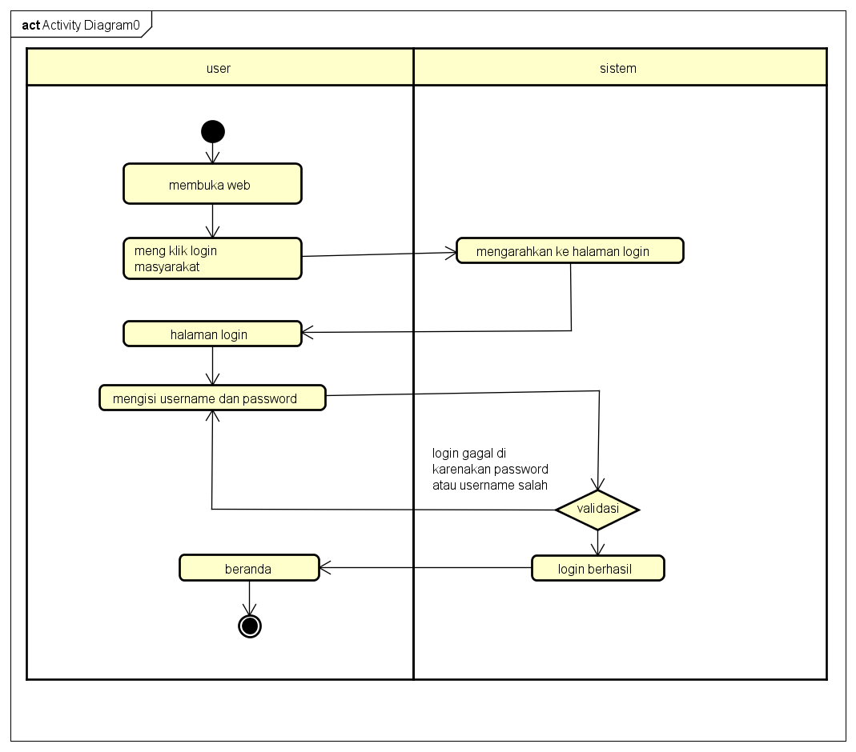

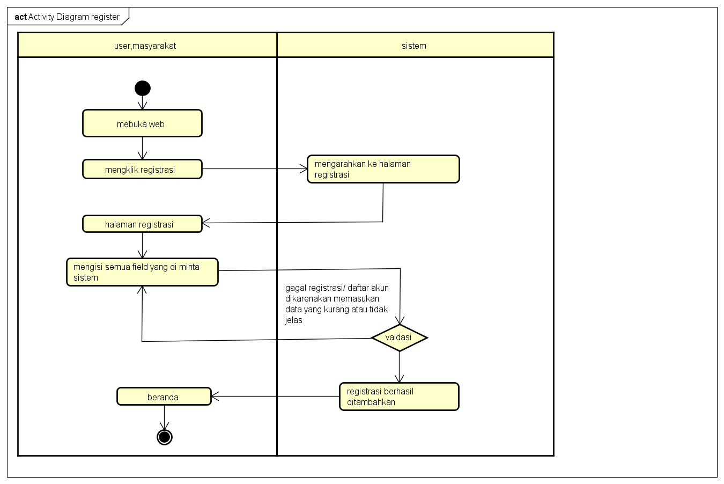

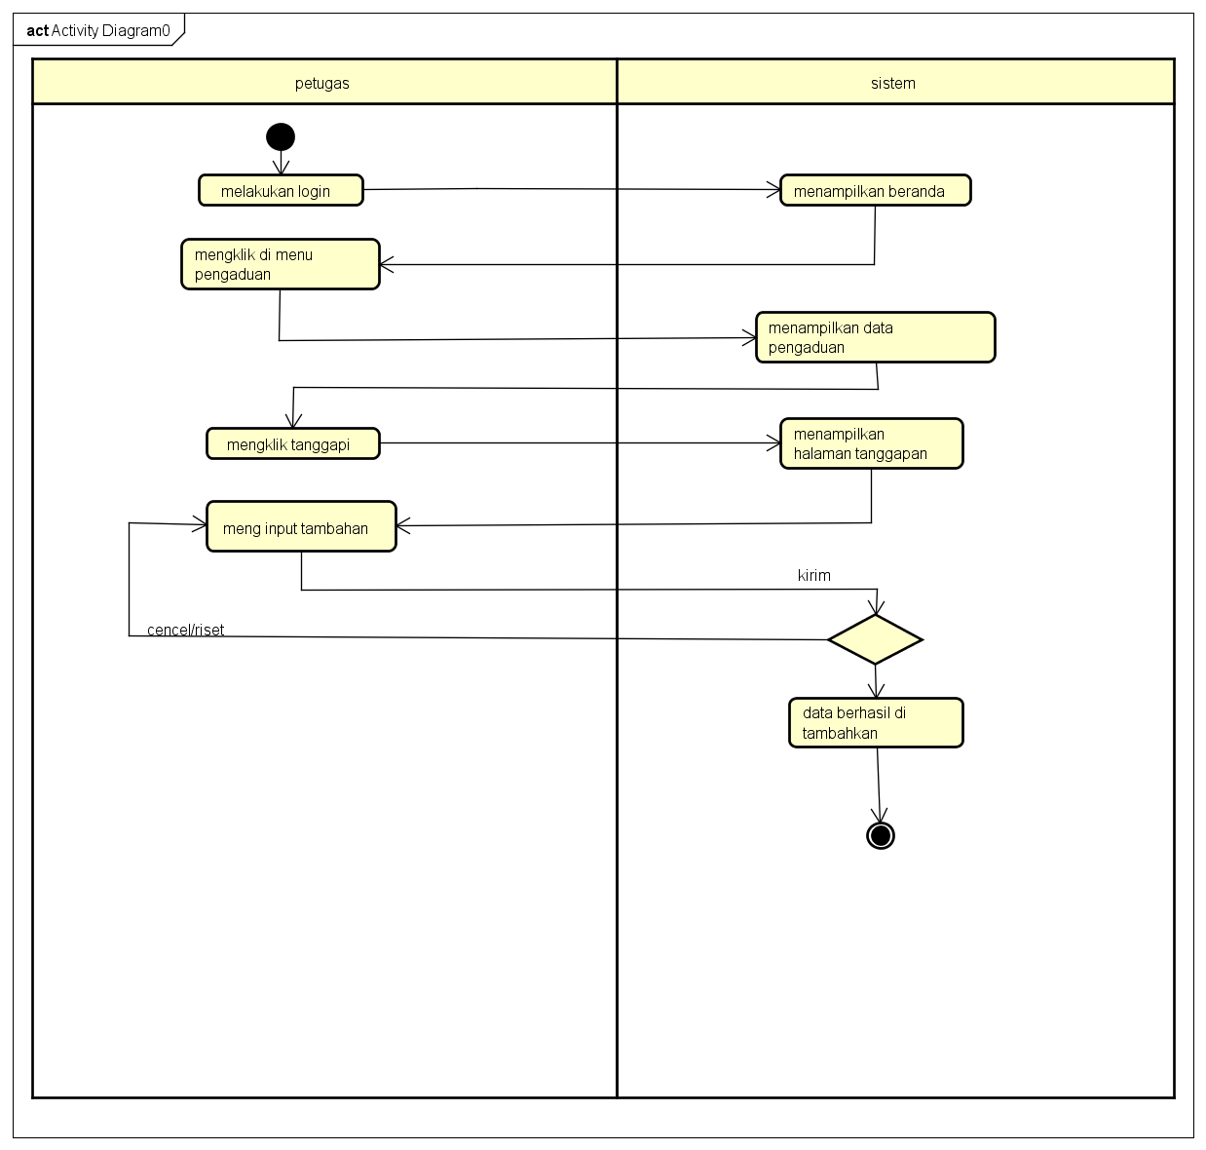

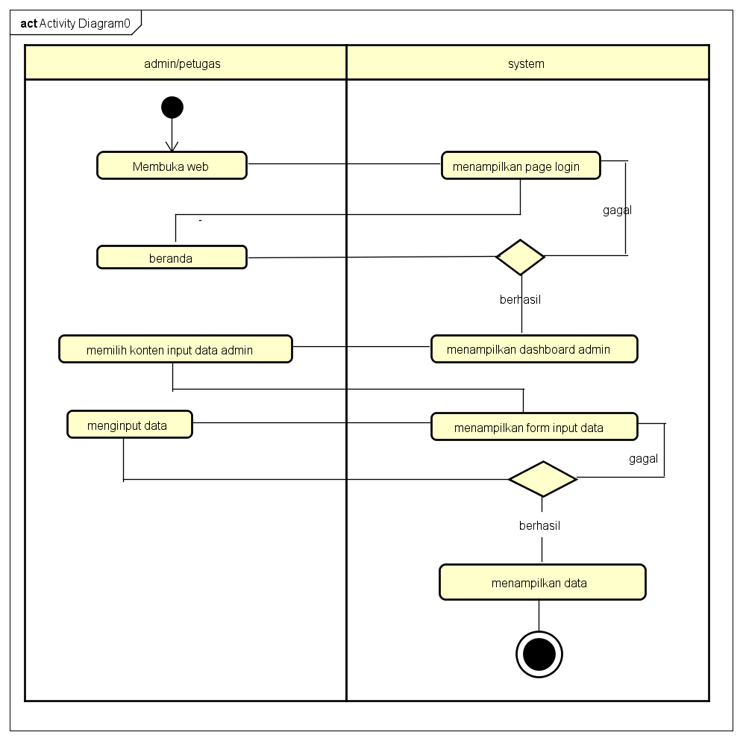

# PERANCANGAN DESAIN BASIS DATA

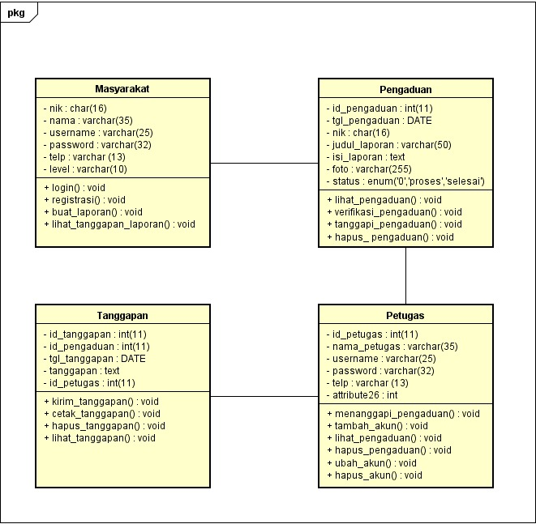

# DUMMY DATA

|  |  |  |  |  |  |
| --- | --- | --- | --- | --- | --- |
| **nIk** | **nama** | **username** | **password** | **telp.** | **level** |
| 123 | Aldi | Aldi | Aldi123(MD5) | 083114912392 | Masyarakat |
|  |  |  |  |  |  |
|  |  |  |  |  |  |
|  |  |  |  |  |  |

|  |  |  |  |  |  |  |
| --- | --- | --- | --- | --- | --- | --- |
| **Id_Pengaduan** | **Tgl_pengaduan** | **nik** | **Judul_laporan** | **Isi_laporan** | **foto** | **status** |
|  | 2023-03-10 | 123 | Bencana Alam | Banjir |  |  |
|  |  |  |  |  |  |  |

|  |  |  |  |  |  |
| --- | --- | --- | --- | --- | --- |
| **Id_petugas** | **nama_petugas** | **username** | **password** | **Telp.** | **level** |
|  | petugas | petugas | Petugas(MD5) | 081345235425 | petugas |
|  | admin | admin | Admin(MD5) | 08523321312 | admin |

|  |  |  |  |  |
| --- | --- | --- | --- | --- |
| **id_tanggapan** | **Id_pengaduan** | **Tgl_tanggapan** | **tanggapan** | **id_petugas** |
|  |  |  |  |  |
|  |  |  |  |  |

# PEMBUATAN BASIS DATA (MySQL Code)

**Tabel Masyarakat**

**

**Tabel Pengaduan**

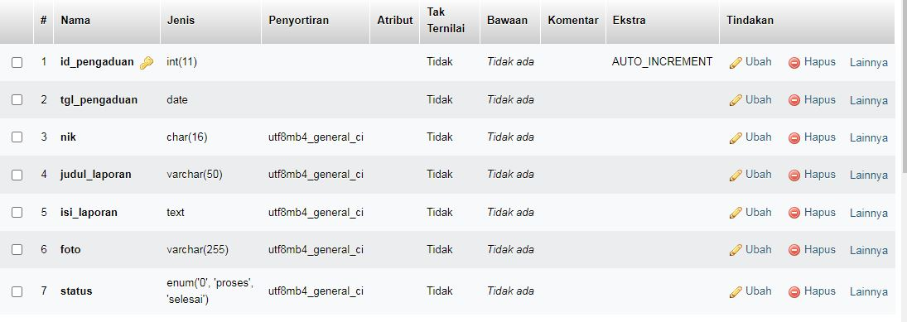

**Tabel Petugas**

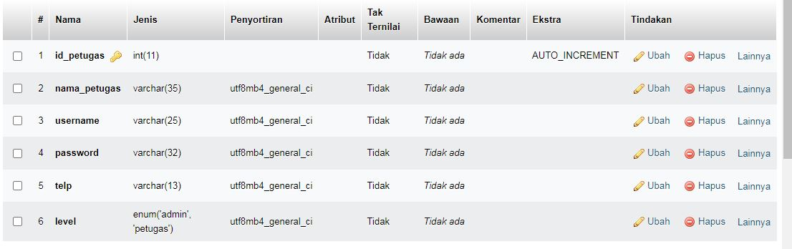

Tabel Tanggapan

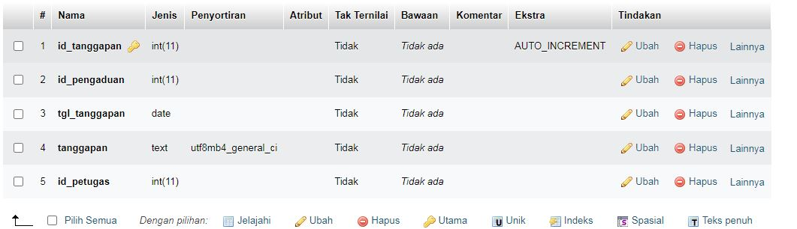

# PERANCANGAN TAMPILAN ANTARMUKA (UI) WEB

* + **Aplikasi pengaduan masyarakat**

1. 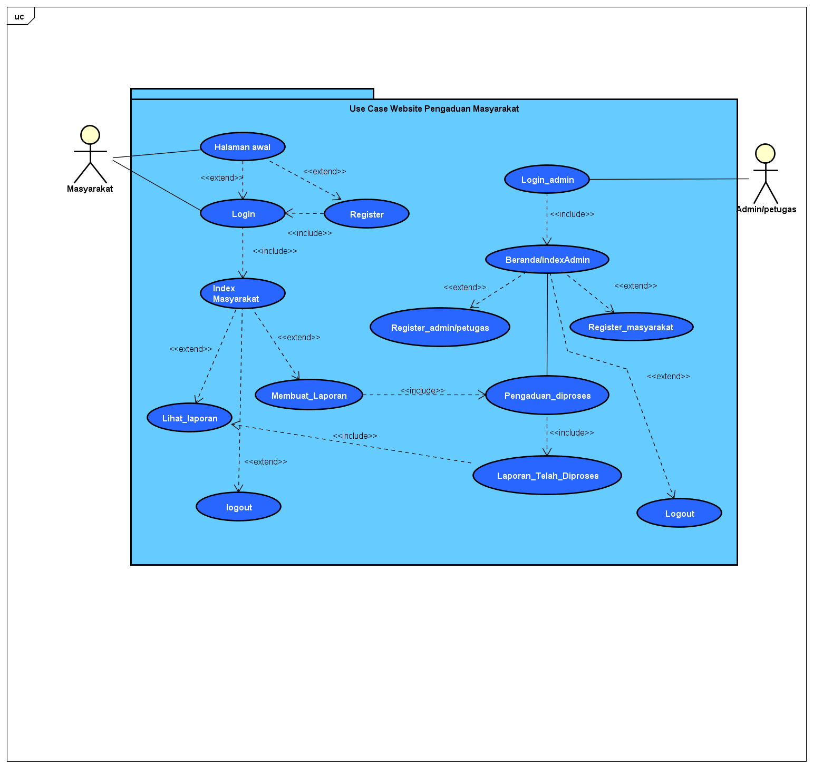
2. Admin dashboard

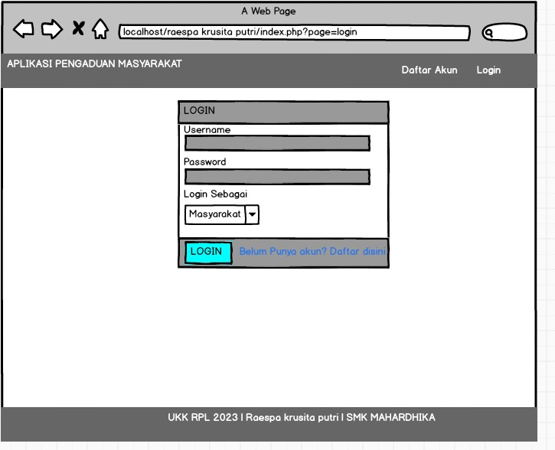

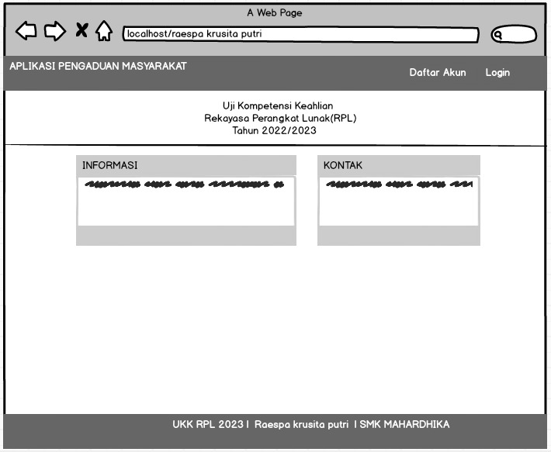

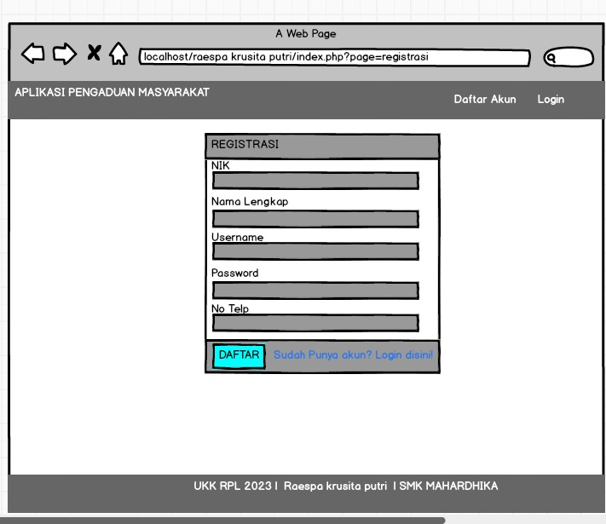

1. Tampilan Petugas

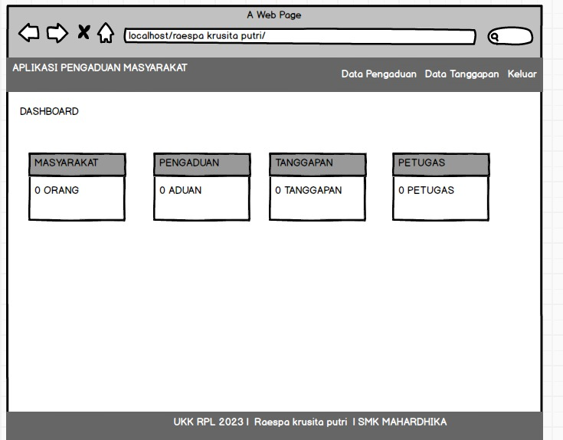

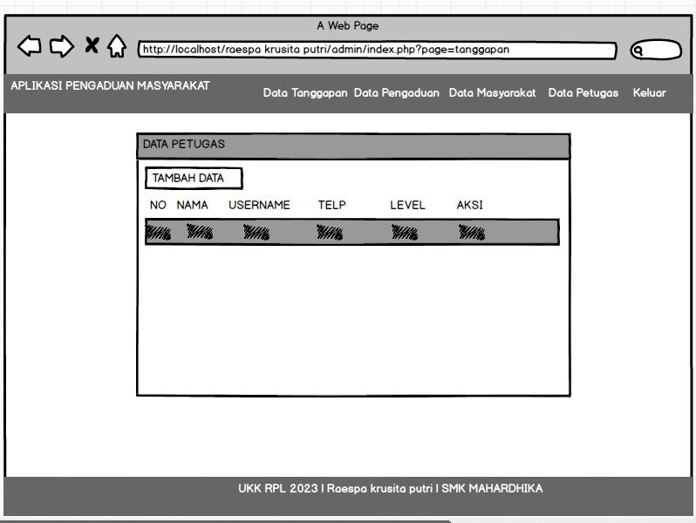

1. Tampilan masyarakat

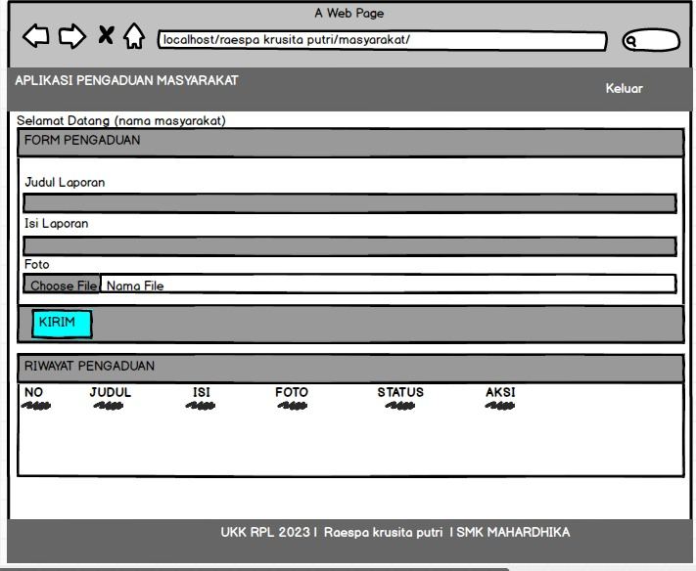

# Aplikasi pengelolaan laundry

1. *Silahkan gambarkan use case diagram aplikasi yang kamu buat*
2. Admin dashboard

Tampilan untuk full manage semua data, buatkan sketsa/mockup-nya

1. Tampilan Kasir

Setiap menu buatkan sketsa/mockup-nya

1. Tampilan owner

Setiap menu buatkan sketsa/mockup-nya

# PEMBUATAN STRUKTUR WEB (HTML)

|  |
| --- |
| <!DOCTYPE html>  <html>  <head>    <meta charset="utf-8">    <meta name="viewport" content="width=device-width, initial-scaled=1">    <title>Aplikasi Pengaduan Masyarakat | Aprilia trijaldi</title>    <link rel="stylesheet" type="text/css" href="assets/css/bootstrap.min.css">  </head>  <body>    <nav class="navbar navbar-expand-lg" style="background-color:#B0E0E6;">    <div class="container">      <a class="navbar-brand" href="index.php">Aplikasi Pengaduan Masyarakat</a>      <button class="navbar-toggler" type="button" data-bs-toggle="collapse" data-bs-target="#navbarNav" aria-controls="navbarNav" aria-expanded="false" aria-label="Toggle navigation">        <span class="navbar-toggler-icon"></span>      </button>      <div class="collapse navbar-collapse justify-content-end" id="navbarNav">        <ul class="navbar-nav">          <li class="nav-item">            <a class="nav-link" href="index.php?page=registrasi">Daftar Akun</a>          </li>          <li class="nav-item">            <a class="nav-link" href="index.php?page=login">Login</a>          </li>        </ul>      </div>    </div>  </nav>  <?php  if (isset($_GET['page'])) {    $page= $_GET['page'];    switch ($page) {      case 'login':        include 'login.php';        break;        case 'registrasi':          include 'registrasi.php';          break;        default:        echo "Halaman tidak tersedia";        break;    }  } else {    include 'home.php';  }   ?>  <footer class="footer py-2 bg-light ">    <div class="container">      <p class="text-center">UKK RPL 2023 | Aprilia trijaldi | SMK MAHARDIKA</p>    </div>  </footer>  <script type="text/javascript" src="assets/js/bootstrap.min.js"></script>  </body>  </html> |

1. PEMBUATAN STYLE WEB (CSS)

File style.css

|  |
| --- |
| * Bootstrap Reboot v5.3.0-alpha1 (https://getbootstrap.com/)   * Copyright 2011-2022 The Bootstrap Authors   * Licensed under MIT (https://github.com/twbs/bootstrap/blob/main/LICENSE)   */  :root,  [data-bs-theme=light] {    --bs-blue: #0d6efd;    --bs-indigo: #6610f2;    --bs-purple: #6f42c1;    --bs-pink: #d63384;    --bs-red: #dc3545;    --bs-orange: #fd7e14;    --bs-yellow: #ffc107;    --bs-green: #198754;    --bs-teal: #20c997;    --bs-cyan: #0dcaf0;    --bs-black: #000;    --bs-white: #fff;    --bs-gray: #6c757d;    --bs-gray-dark: #343a40;    --bs-gray-100: #f8f9fa;    --bs-gray-200: #e9ecef;    --bs-gray-300: #dee2e6;    --bs-gray-400: #ced4da;    --bs-gray-500: #adb5bd;    --bs-gray-600: #6c757d;    --bs-gray-700: #495057;    --bs-gray-800: #343a40;    --bs-gray-900: #212529;    --bs-primary: #0d6efd;    --bs-secondary: #6c757d;    --bs-success: #198754;    --bs-info: #0dcaf0;    --bs-warning: #ffc107;    --bs-danger: #dc3545;    --bs-light: #f8f9fa;    --bs-dark: #212529;    --bs-primary-rgb: 13, 110, 253;    --bs-secondary-rgb: 108, 117, 125;    --bs-success-rgb: 25, 135, 84;    --bs-info-rgb: 13, 202, 240;    --bs-warning-rgb: 255, 193, 7;    --bs-danger-rgb: 220, 53, 69;    --bs-light-rgb: 248, 249, 250;    --bs-dark-rgb: 33, 37, 41;    --bs-primary-text: #0a58ca;    --bs-secondary-text: #6c757d;    --bs-success-text: #146c43;    --bs-info-text: #087990;    --bs-warning-text: #997404;    --bs-danger-text: #b02a37;    --bs-light-text: #6c757d;    --bs-dark-text: #495057;    --bs-primary-bg-subtle: #cfe2ff;    --bs-secondary-bg-subtle: #f8f9fa;    --bs-success-bg-subtle: #d1e7dd;    --bs-info-bg-subtle: #cff4fc;    --bs-warning-bg-subtle: #fff3cd;    --bs-danger-bg-subtle: #f8d7da;    --bs-light-bg-subtle: #fcfcfd;    --bs-dark-bg-subtle: #ced4da;    --bs-primary-border-subtle: #9ec5fe;    --bs-secondary-border-subtle: #e9ecef;    --bs-success-border-subtle: #a3cfbb;    --bs-info-border-subtle: #9eeaf9;    --bs-warning-border-subtle: #ffe69c;    --bs-danger-border-subtle: #f1aeb5;    --bs-light-border-subtle: #e9ecef;    --bs-dark-border-subtle: #adb5bd;    --bs-white-rgb: 255, 255, 255;    --bs-black-rgb: 0, 0, 0;    --bs-body-color-rgb: 33, 37, 41;    --bs-body-bg-rgb: 255, 255, 255;    --bs-font-sans-serif: system-ui, -apple-system, "Segoe UI", Roboto, "Helvetica Neue", "Noto Sans", "Liberation Sans", Arial, sans-serif, "Apple Color Emoji", "Segoe UI Emoji", "Segoe UI Symbol", "Noto Color Emoji";    --bs-font-monospace: SFMono-Regular, Menlo, Monaco, Consolas, "Liberation Mono", "Courier New", monospace;    --bs-gradient: linear-gradient(180deg, rgba(255, 255, 255, 0.15), rgba(255, 255, 255, 0));    --bs-body-font-family: var(--bs-font-sans-serif);    --bs-body-font-size: 1rem;    --bs-body-font-weight: 400;    --bs-body-line-height: 1.5;    --bs-body-color: #212529;    --bs-emphasis-color: #000;    --bs-emphasis-color-rgb: 0, 0, 0;    --bs-secondary-color: rgba(33, 37, 41, 0.75);    --bs-secondary-color-rgb: 33, 37, 41;    --bs-secondary-bg: #e9ecef;    --bs-secondary-bg-rgb: 233, 236, 239;    --bs-tertiary-color: rgba(33, 37, 41, 0.5);    --bs-tertiary-color-rgb: 33, 37, 41;    --bs-tertiary-bg: #f8f9fa;    --bs-tertiary-bg-rgb: 248, 249, 250;    --bs-body-bg: #fff;    --bs-body-bg-rgb: 255, 255, 255;    --bs-link-color: #0d6efd;    --bs-link-color-rgb: 13, 110, 253;    --bs-link-decoration: underline;    --bs-link-hover-color: #0a58ca;    --bs-link-hover-color-rgb: 10, 88, 202;    --bs-code-color: #d63384;    --bs-highlight-bg: #fff3cd;    --bs-border-width: 1px;    --bs-border-style: solid;    --bs-border-color: #dee2e6;    --bs-border-color-translucent: rgba(0, 0, 0, 0.175);    --bs-border-radius: 0.375rem;    --bs-border-radius-sm: 0.25rem;    --bs-border-radius-lg: 0.5rem;    --bs-border-radius-xl: 1rem;    --bs-border-radius-2xl: 2rem;    --bs-border-radius-pill: 50rem;    --bs-box-shadow: 0 0.5rem 1rem rgba(var(--bs-body-color-rgb), 0.15);    --bs-box-shadow-sm: 0 0.125rem 0.25rem rgba(var(--bs-body-color-rgb), 0.075);    --bs-box-shadow-lg: 0 1rem 3rem rgba(var(--bs-body-color-rgb), 0.175);    --bs-box-shadow-inset: inset 0 1px 2px rgba(var(--bs-body-color-rgb), 0.075);    --bs-emphasis-color: #000;    --bs-form-control-bg: var(--bs-body-bg);    --bs-form-control-disabled-bg: var(--bs-secondary-bg);    --bs-highlight-bg: #fff3cd;    --bs-breakpoint-xs: 0;    --bs-breakpoint-sm: 576px;    --bs-breakpoint-md: 768px;    --bs-breakpoint-lg: 992px;    --bs-breakpoint-xl: 1200px;    --bs-breakpoint-xxl: 1400px;  }  [data-bs-theme=dark] {    --bs-body-color: #adb5bd;    --bs-body-color-rgb: 173, 181, 189;    --bs-body-bg: #212529;    --bs-body-bg-rgb: 33, 37, 41;    --bs-emphasis-color: #f8f9fa;    --bs-emphasis-color-rgb: 248, 249, 250;    --bs-secondary-color: rgba(173, 181, 189, 0.75);    --bs-secondary-color-rgb: 173, 181, 189;    --bs-secondary-bg: #343a40;    --bs-secondary-bg-rgb: 52, 58, 64;    --bs-tertiary-color: rgba(173, 181, 189, 0.5);    --bs-tertiary-color-rgb: 173, 181, 189;    --bs-tertiary-bg: #2b3035;    --bs-tertiary-bg-rgb: 43, 48, 53;    --bs-emphasis-color: #fff;    --bs-primary-text: #6ea8fe;    --bs-secondary-text: #dee2e6;    --bs-success-text: #75b798;    --bs-info-text: #6edff6;    --bs-warning-text: #ffda6a;    --bs-danger-text: #ea868f;    --bs-light-text: #f8f9fa;    --bs-dark-text: #dee2e6;    --bs-primary-bg-subtle: #031633;    --bs-secondary-bg-subtle: #212529;    --bs-success-bg-subtle: #051b11;    --bs-info-bg-subtle: #032830;    --bs-warning-bg-subtle: #332701;    --bs-danger-bg-subtle: #2c0b0e;    --bs-light-bg-subtle: #343a40;    --bs-dark-bg-subtle: #1a1d20;    --bs-primary-border-subtle: #084298;    --bs-secondary-border-subtle: #495057;    --bs-success-border-subtle: #0f5132;    --bs-info-border-subtle: #055160;    --bs-warning-border-subtle: #664d03;    --bs-danger-border-subtle: #842029;    --bs-light-border-subtle: #495057;    --bs-dark-border-subtle: #343a40;    --bs-heading-color: #fff;    --bs-link-color: #6ea8fe;    --bs-link-hover-color: #9ec5fe;    --bs-link-color-rgb: 110, 168, 254;    --bs-link-hover-color-rgb: 158, 197, 254;    --bs-code-color: #e685b5;    --bs-border-color: #495057;    --bs-border-color-translucent: rgba(255, 255, 255, 0.15);  }  *,  *::before,  *::after {    box-sizing: border-box;  }  @media (prefers-reduced-motion: no-preference) {    :root {      scroll-behavior: smooth;    }  }  body {    margin: 0;    font-family: var(--bs-body-font-family);    font-size: var(--bs-body-font-size);    font-weight: var(--bs-body-font-weight);    line-height: var(--bs-body-line-height);    color: var(--bs-body-color);    text-align: var(--bs-body-text-align);    background-color: var(--bs-body-bg);    -webkit-text-size-adjust: 100%;    -webkit-tap-highlight-color: rgba(0, 0, 0, 0);  }  hr {    margin: 1rem 0;    color: inherit;    border: 0;    border-top: var(--bs-border-width) solid;    opacity: 0.25;  }  h6, h5, h4, h3, h2, h1 {    margin-top: 0;    margin-bottom: 0.5rem;    font-weight: 500;    line-height: 1.2;    color: var(--bs-heading-color, inherit);  }  h1 {    font-size: calc(1.375rem + 1.5vw);  }  @media (min-width: 1200px) {    h1 {      font-size: 2.5rem;    }  }  h2 {    font-size: calc(1.325rem + 0.9vw);  }  @media (min-width: 1200px) {    h2 {      font-size: 2rem;    }  }  h3 {    font-size: calc(1.3rem + 0.6vw);  }  @media (min-width: 1200px) {    h3 {      font-size: 1.75rem;    }  }  h4 {    font-size: calc(1.275rem + 0.3vw);  }  @media (min-width: 1200px) {    h4 {      font-size: 1.5rem;    }  }  h5 {    font-size: 1.25rem;  }  h6 {    font-size: 1rem;  }  p {    margin-top: 0;    margin-bottom: 1rem;  }  abbr[title] {    -webkit-text-decoration: underline dotted;    text-decoration: underline dotted;    cursor: help;    -webkit-text-decoration-skip-ink: none;    text-decoration-skip-ink: none;  }  address {    margin-bottom: 1rem;    font-style: normal;    line-height: inherit;  }  ol,  ul {    padding-left: 2rem;  }  ol,  ul,  dl {    margin-top: 0;    margin-bottom: 1rem;  }  ol ol,  ul ul,  ol ul,  ul ol {    margin-bottom: 0;  }  dt {    font-weight: 700;  }  dd {    margin-bottom: 0.5rem;    margin-left: 0;  }  blockquote {    margin: 0 0 1rem;  }  b,  strong {    font-weight: bolder;  }  small {    font-size: 0.875em;  }  mark {    padding: 0.1875em;    background-color: var(--bs-highlight-bg);  }  sub,  sup {    position: relative;    font-size: 0.75em;    line-height: 0;    vertical-align: baseline;  }  sub {    bottom: -0.25em;  }  sup {    top: -0.5em;  }  a {    color: rgba(var(--bs-link-color-rgb), var(--bs-link-opacity, 1));    text-decoration: underline;  }  a:hover {    --bs-link-color-rgb: var(--bs-link-hover-color-rgb);  }  a:not([href]):not([class]), a:not([href]):not([class]):hover {    color: inherit;    text-decoration: none;  }  pre,  code,  kbd,  samp {    font-family: var(--bs-font-monospace);    font-size: 1em;  }  pre {    display: block;    margin-top: 0;    margin-bottom: 1rem;    overflow: auto;    font-size: 0.875em;  }  pre code {    font-size: inherit;    color: inherit;    word-break: normal;  }  code {    font-size: 0.875em;    color: var(--bs-code-color);    word-wrap: break-word;  }  a > code {    color: inherit;  }  kbd {    padding: 0.1875rem 0.375rem;    font-size: 0.875em;    color: var(--bs-body-bg);    background-color: var(--bs-body-color);    border-radius: 0.25rem;  }  kbd kbd {    padding: 0;    font-size: 1em;  }  figure {    margin: 0 0 1rem;  }  img,  svg {    vertical-align: middle;  }  table {    caption-side: bottom;    border-collapse: collapse;  }  caption {    padding-top: 0.5rem;    padding-bottom: 0.5rem;    color: var(--bs-secondary-color);    text-align: left;  }  th {    text-align: inherit;    text-align: -webkit-match-parent;  }  thead,  tbody,  tfoot,  tr,  td,  th {    border-color: inherit;    border-style: solid;    border-width: 0;  }  label {    display: inline-block;  }  button {    border-radius: 0;  }  button:focus:not(:focus-visible) {    outline: 0;  }  input,  button,  select,  optgroup,  textarea {    margin: 0;    font-family: inherit;    font-size: inherit;    line-height: inherit;  }  button,  select {    text-transform: none;  }  [role=button] {    cursor: pointer;  }  select {    word-wrap: normal;  }  select:disabled {    opacity: 1;  }  [list]:not([type=date]):not([type=datetime-local]):not([type=month]):not([type=week]):not([type=time])::-webkit-calendar-picker-indicator {    display: none !important;  }  button,  [type=button],  [type=reset],  [type=submit] {    -webkit-appearance: button;  }  button:not(:disabled),  [type=button]:not(:disabled),  [type=reset]:not(:disabled),  [type=submit]:not(:disabled) {    cursor: pointer;  }  ::-moz-focus-inner {    padding: 0;    border-style: none;  }  textarea {    resize: vertical;  }  fieldset {    min-width: 0;    padding: 0;    margin: 0;    border: 0;  }  legend {    float: left;    width: 100%;    padding: 0;    margin-bottom: 0.5rem;    font-size: calc(1.275rem + 0.3vw);    line-height: inherit;  }  @media (min-width: 1200px) {    legend {      font-size: 1.5rem;    }  }  legend + * {    clear: left;  }  ::-webkit-datetime-edit-fields-wrapper,  ::-webkit-datetime-edit-text,  ::-webkit-datetime-edit-minute,  ::-webkit-datetime-edit-hour-field,  ::-webkit-datetime-edit-day-field,  ::-webkit-datetime-edit-month-field,  ::-webkit-datetime-edit-year-field {    padding: 0;  }  ::-webkit-inner-spin-button {    height: auto;  }  [type=search] {    outline-offset: -2px;    -webkit-appearance: textfield;  }  /* rtl:raw:  [type="tel"],  [type="url"],  [type="email"],  [type="number"] {    direction: ltr;  }  */  ::-webkit-search-decoration {    -webkit-appearance: none;  }  ::-webkit-color-swatch-wrapper {    padding: 0;  }  ::-webkit-file-upload-button {    font: inherit;    -webkit-appearance: button;  }  ::file-selector-button {    font: inherit;    -webkit-appearance: button;  }  output {    display: inline-block;  }  iframe {    border: 0;  }  summary {    display: list-item;    cursor: pointer;  }  progress {    vertical-align: baseline;  }  [hidden] {    display: none !important;  }  /*# sourceMappingURL=bootstrap-reboot.css.map */ |

1. PEMBUATAN KODE WEB (PHP/JS) File index.php

|  |
| --- |
| <!DOCTYPE html>  <html>  <head>    <meta charset="utf-8">    <meta name="viewport" content="width=device-width, initial-scaled=1">    <title>Aplikasi Pengaduan Masyarakat | Aprilia trijaldi</title>    <link rel="stylesheet" type="text/css" href="assets/css/bootstrap.min.css">  </head>  <body>    <nav class="navbar navbar-expand-lg" style="background-color:#B0E0E6;">    <div class="container">      <a class="navbar-brand" href="index.php">Aplikasi Pengaduan Masyarakat</a>      <button class="navbar-toggler" type="button" data-bs-toggle="collapse" data-bs-target="#navbarNav" aria-controls="navbarNav" aria-expanded="false" aria-label="Toggle navigation">        <span class="navbar-toggler-icon"></span>      </button>      <div class="collapse navbar-collapse justify-content-end" id="navbarNav">        <ul class="navbar-nav">          <li class="nav-item">            <a class="nav-link" href="index.php?page=registrasi">Daftar Akun</a>          </li>          <li class="nav-item">            <a class="nav-link" href="index.php?page=login">Login</a>          </li>        </ul>      </div>    </div>  </nav>  <?php  if (isset($_GET['page'])) {    $page= $_GET['page'];    switch ($page) {      case 'login':        include 'login.php';        break;        case 'registrasi':          include 'registrasi.php';          break;        default:        echo "Halaman tidak tersedia";        break;    }  } else {    include 'home.php';  }   ?>  <footer class="footer py-2 bg-light ">    <div class="container">      <p class="text-center">UKK RPL 2023 | Aprilia trijaldi | SMK MAHARDIKA</p>    </div>  </footer>  <script type="text/javascript" src="assets/js/bootstrap.min.js"></script>  </body>  </html> |

File koneksi.php

|  |
| --- |
| <?php  $koneksi = mysqli_connect("localhost","root","","aapril");  ?> |

CRUD file

1. UJI COBA
2. 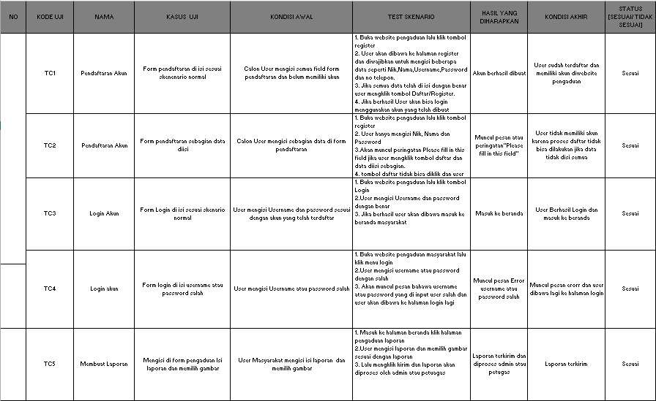
3. REVISI
4. PENENTUAN DOMAIN DAN HOSTING
5. UPLOAD WEB KE HOSTING
6. UPLOAD WEB KE GITHUB
7. PEMBUATAN USER GUIDANCE