**Noisy Elliptical Dots**

**CS457 Shaders: Project Two**

April James : [jamesap@oregonstate.edu](mailto:jamesap@oregonstate.edu)

This project plays around with OpenGL’s built-in noise algorithm. I used this algorithm to vary the noise amplitude and frequency applied to the elliptical pattern, which creates some funky results. I also utilized a Smoothstep function to create a blending feature, as well as a sliding variable to adjust transparency. When transparency is maxed out (alpha=1) I used the discard function to throw away the fragment, which creates a better transparency result. Take a look below!

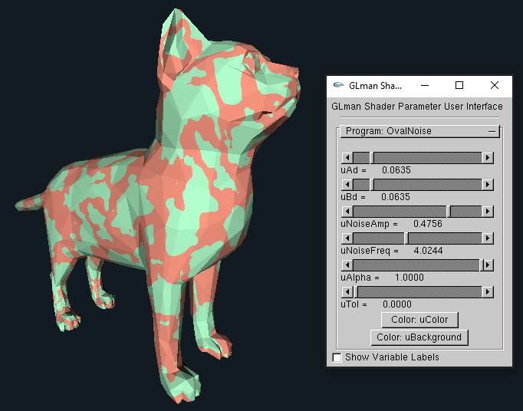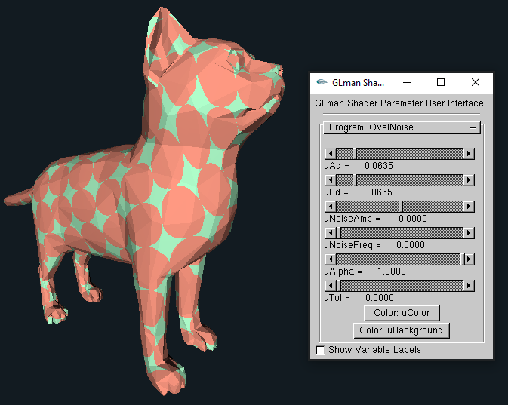Screenshots:

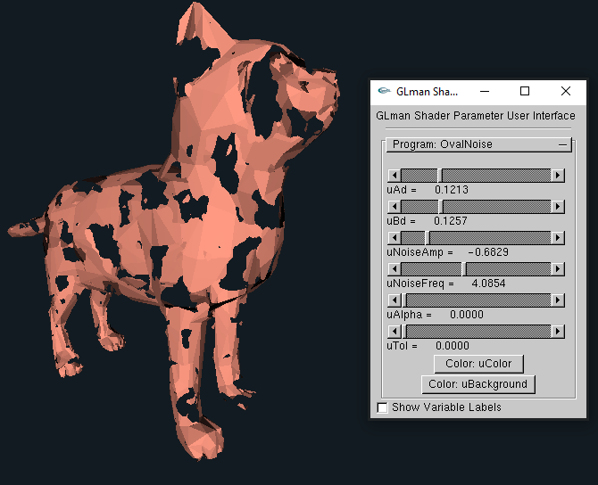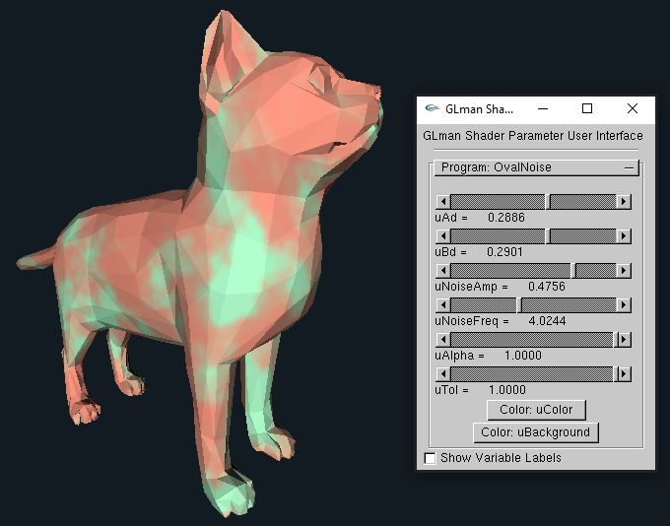

Some noise going on!

No amplitude or frequency applied

Hello, discard()!

Tolerance all the way up

Video link: <https://youtu.be/ckmImTXQL9o>