**Ominous Reflective/Refractive Sheet in Kelley**

**CS457 Shaders: Project Four**

April James : [jamesap@oregonstate.edu](mailto:jamesap@oregonstate.edu)

This project plays around with bump mapping and displacement mapping to create funky textures using the fragment and vertex shaders. The displacement mapping creates physical displacements of the vertices to create waves in the object plane, but the bump mapping creates the illusion of crinkled, random texture by perturbing and adjusting surface normals.

The cooler addition to this project is the ability to have the plane reflect and refract, while adjusting texture and index of refraction. By creating a cube mapping around the plane, we can see how it interacts with the images around it when we adjust the sliding scale between total reflection and total refraction. Some screenshots of the project are included on the next page:

Screenshots:

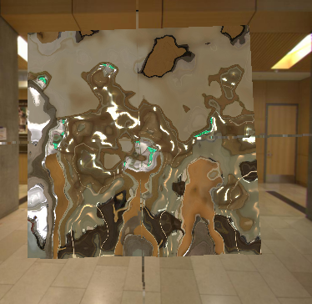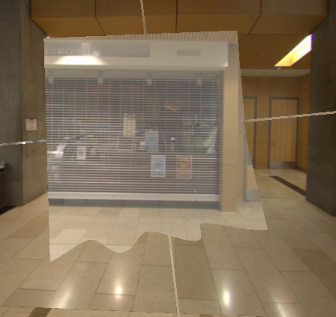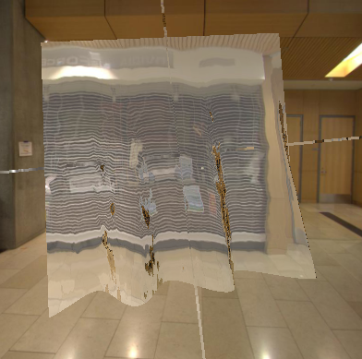

Max refraction, uEta=1.

Max refraction with texture. Can start to see some reflection where the angle of refraction is too high.

Max reflection with some texture thrown in

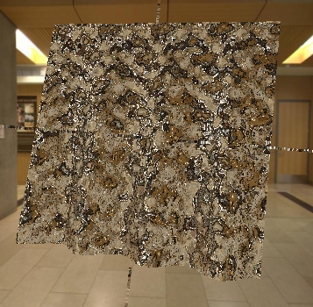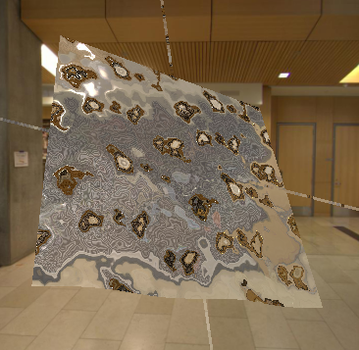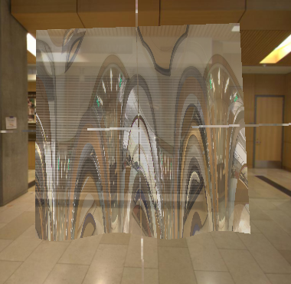

50% reflection, 50% refraction

Max reflection, lots of texture. Chaos mode!

Max refraction, high uEta and texture amplitude. Looks like mold!

Video link: <https://youtu.be/OVp2oDmvyb0>