**Step- and Blended-edged Elliptical Dots**

**CS457 Shaders: Project One**

April James : [jamesap@oregonstate.edu](mailto:jamesap@oregonstate.edu)

This simple first project demonstrates how easily a fragment shader can be used to create repeating patterns. The ellipse pattern was created by using the ellipse equation to create color constraints that keyed off of (s,t) coordinates. The ellipse equation was fed into a smoothstep equation to create the blurred edge effect. Finally, I used the mix function to color the sphere, alternating between background and ellipse color.

Screenshots:

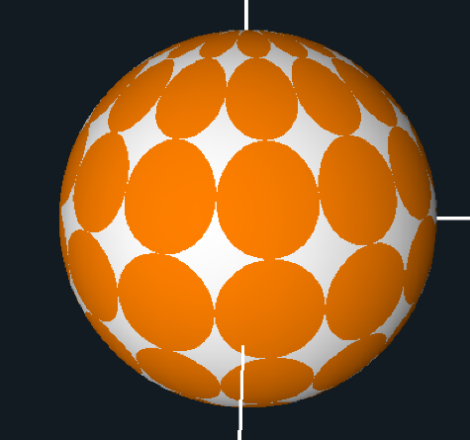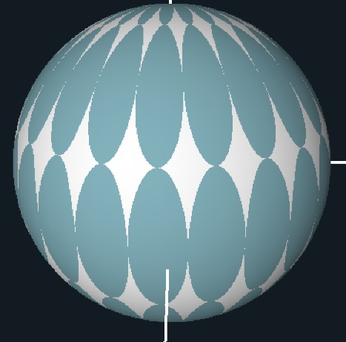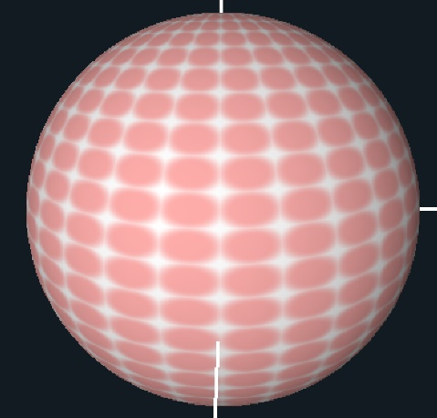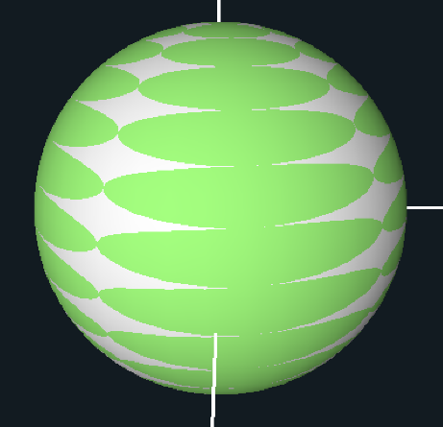

regular old ellipses

small uAd, big uBd

small uAd, small uBd, big uTol!

big uAd, small uBd

Video link: <https://youtu.be/iRCPhgB5wFw>