**Mess Up The Cat!**

**CS457 Shaders: Project Six**

April James : [jamesap@oregonstate.edu](mailto:jamesap@oregonstate.edu)

Have you wondered about how the fall of the planet may come to fruition? Does your cat stare at you from odd corners of your home, seeming to plot the demise of humankind? Fortunately, this project allows us humble students, equipped with shaders, to mess up as many (virtual) cats as possible to prevent them from rising up. My attack of choice is the rainbow cat spiral peeler, where I turn my unsuspecting cat into a colorful shredded ribbon using a variation of Connett’s Circle2 algorithm. Bonus: with the change of a slider, the cat turns into hectic Christmas lights.

All of the work is done in the fragment shader; the vertex shader simply performs modelviewprojection transformation and passes s&t coordinates along. The algorithm used is a distorted variation of the Circle-squared algorithm by J. E. Connett, borrowed from Professor Bailey’s code in *Graphics Shaders: Theory and Practice*.

It normally works by using the equation for a circle (x2 + y2) for each (s,t) increment, and colors that point uColor (or discards the fragment) if the result is a multiple of modulus uMod. The higher the modulus, the more uColor (or blank space) is shown. Otherwise, it colors the fragment by passing the result of the location modulus’s remainder into a rainbow function that outputs a vec3 color. In my case, I modified the circle equation by raising x and y to powers other than 2, which distorted the circles and created cooler patterns. Depending on your values, the pattern may look like stripes or little circles.

Some screenshots of my project are included in the next page.

Screenshots (includes detailed views):

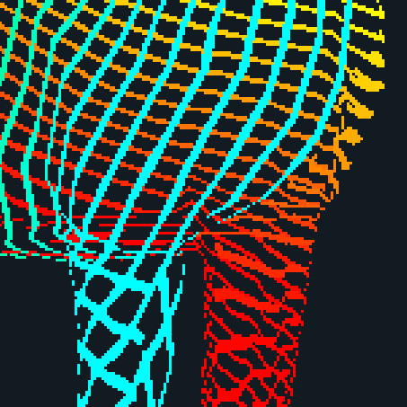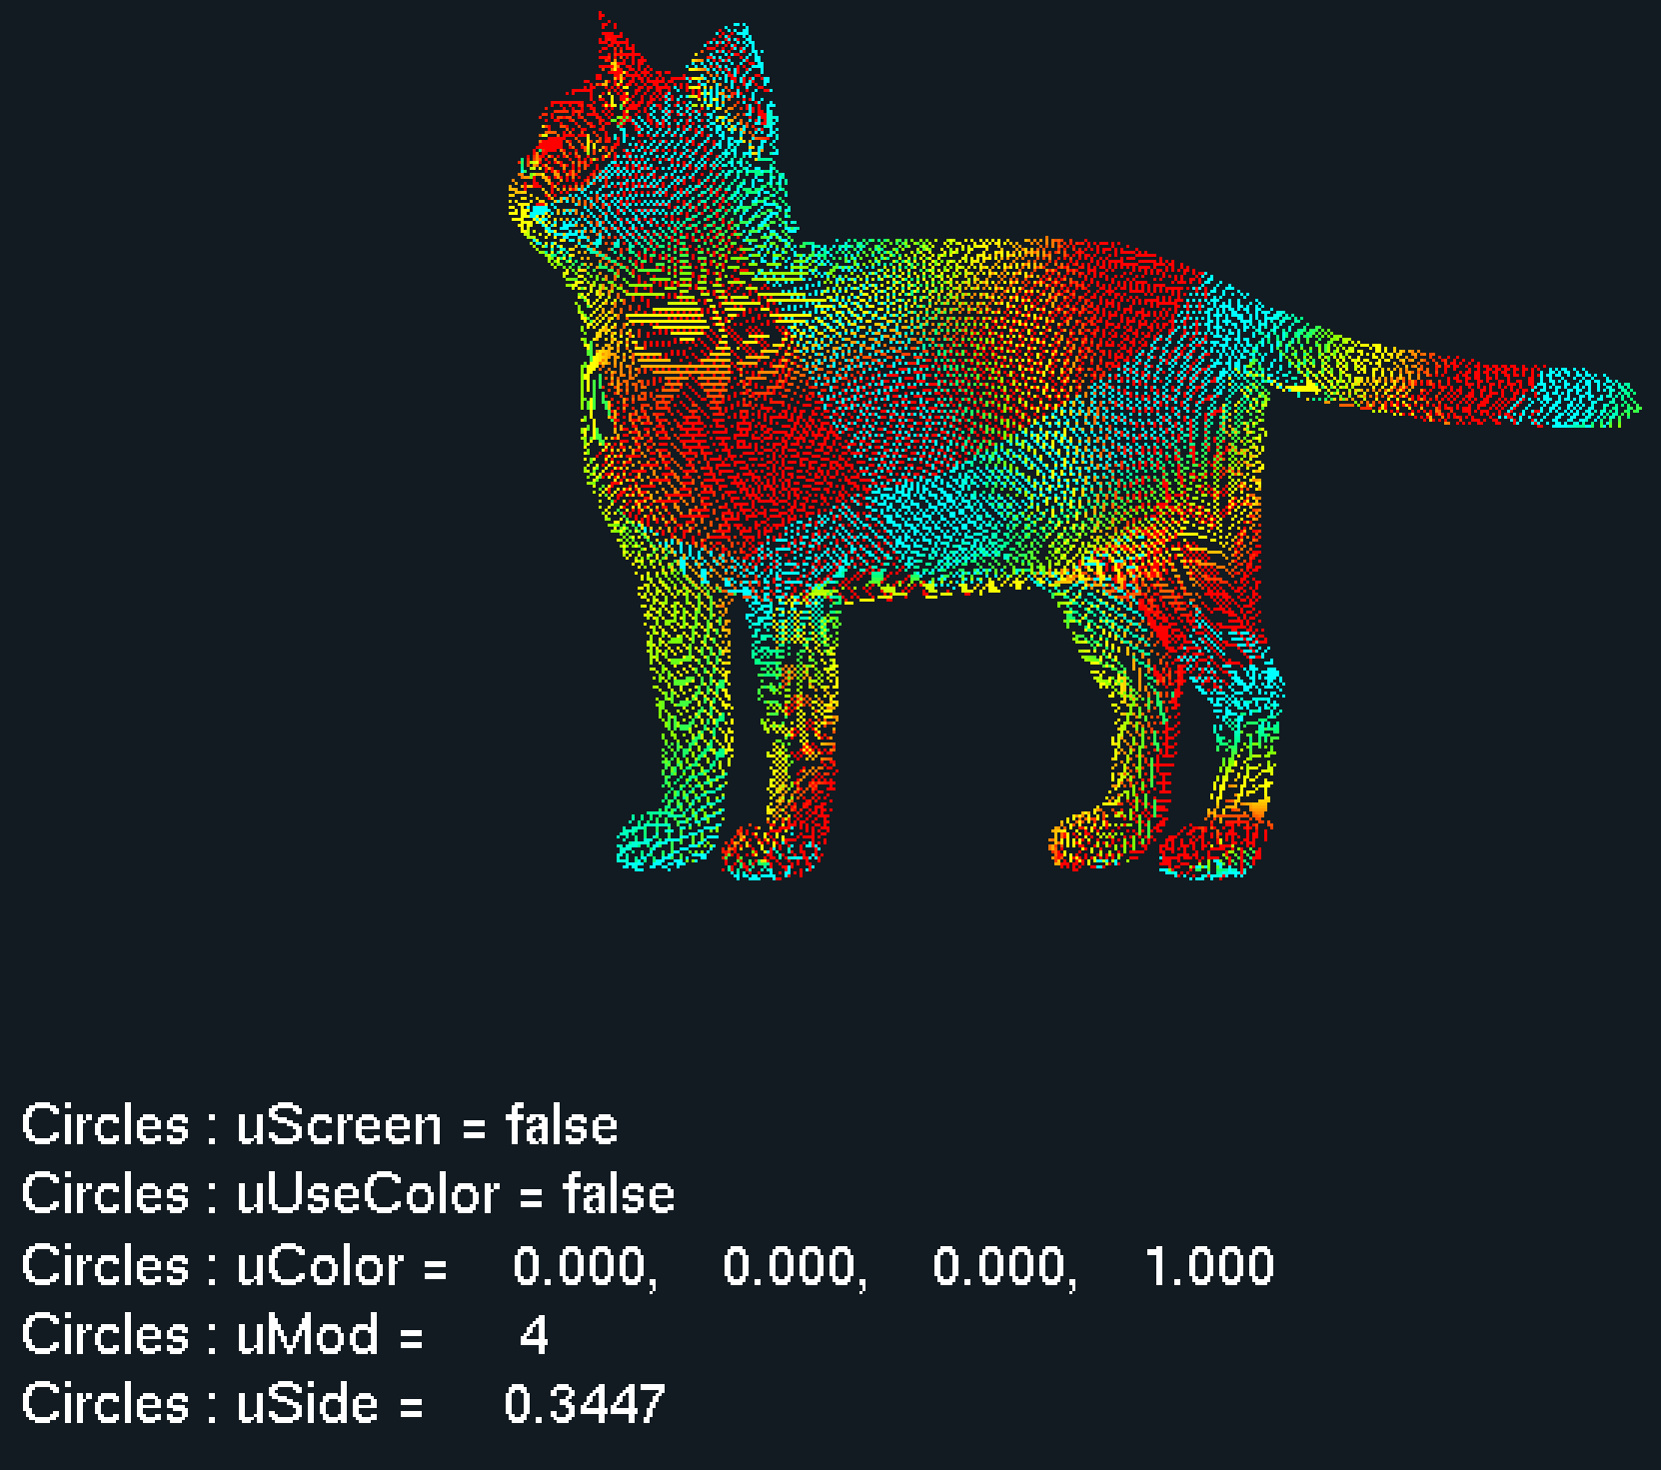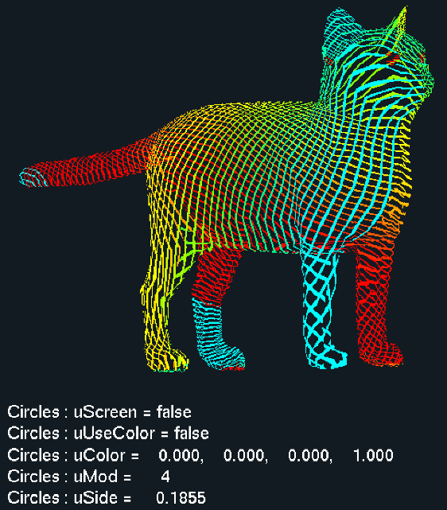

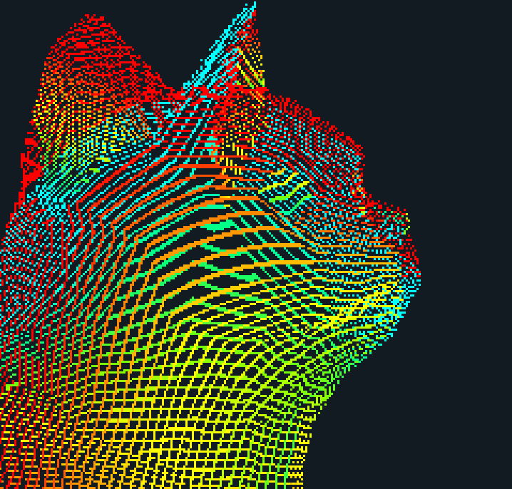

Rainbow cat spiral peel! (keying off object s&t)

Patchwork cat (keying off object s&t)

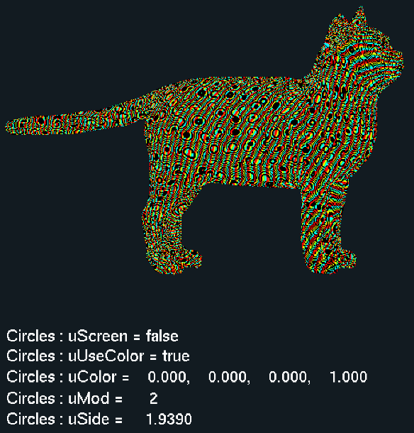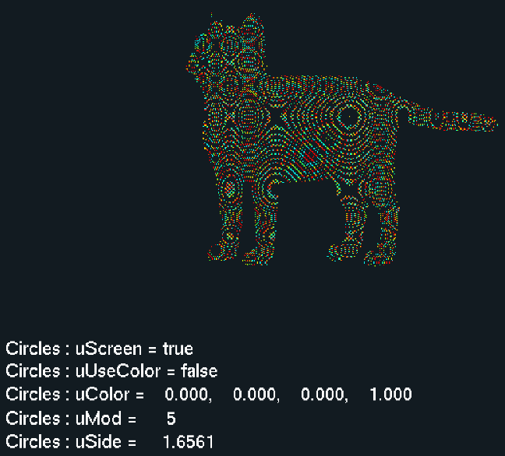

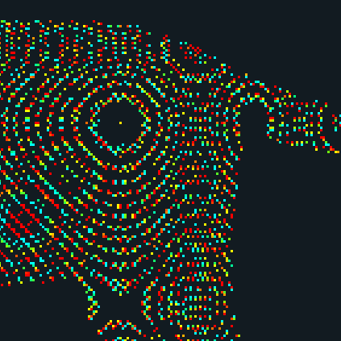

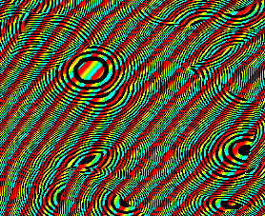

Some nice Connett circles (keying off screen)

Stripes and spots (keying off object s&t)

Video link: <https://youtu.be/3WGr1lmdFgU>