**Crystalized Sugar in the Geometry Shader**

**CS457 Shaders: Project Seven**

April James : [jamesap@oregonstate.edu](mailto:jamesap@oregonstate.edu)

Do you find yourself staring at a computer screen so long that what you’re looking at starts to shift shape? Does it feel like each of your vertices are being passed into a geometry shader, manipulated, and passed out in chunks? If you agree, you may be the cat that has just been quantized in my project. Congratulations!

In this project, the “lego” appearance is created by quantizing the position of all the vertices, making the cat appear blocky and low-res. First, the triangles passed in had to be subdivided into multiple little triangles, in order to increase the amount of vertices available to be quantized (this makes for a nice, clean cube effect). Then, the triangle is split into triangle strips (the geometry shader output), and each strip is quantized into cubes based on the s,t locations. The program either quantizes in the model coordinates, which makes the surface of the cat look like it’s covered in cubes; or the quantizing happens in eye coordinates, which causes the pattern to be suspended in space, and can be seen as the cat passes through it.

Some screenshots of my project are included in the next page.

Screenshots:

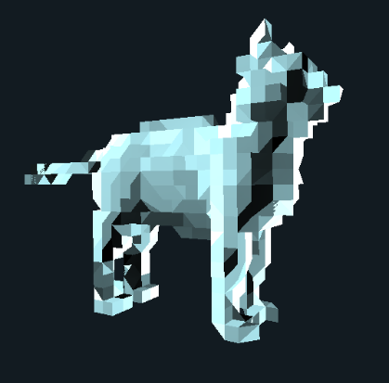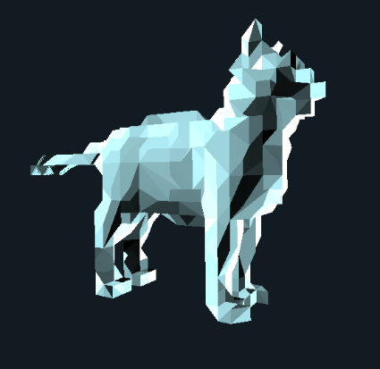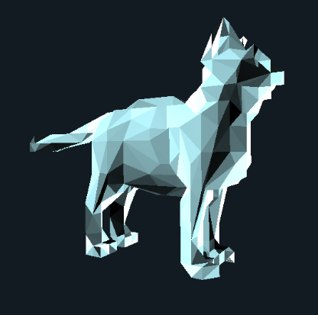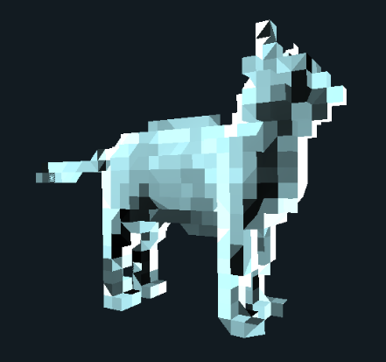

uQuantize=5, uLevel=0 uLevel=1 uLevel=2 uLevel=3

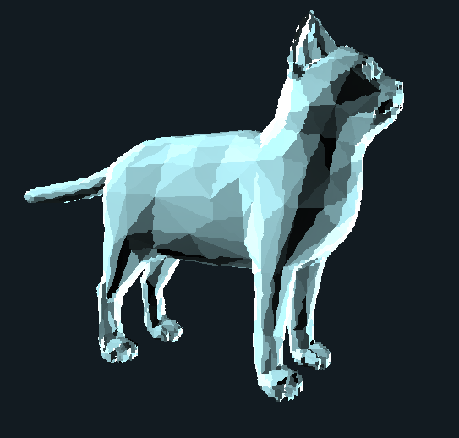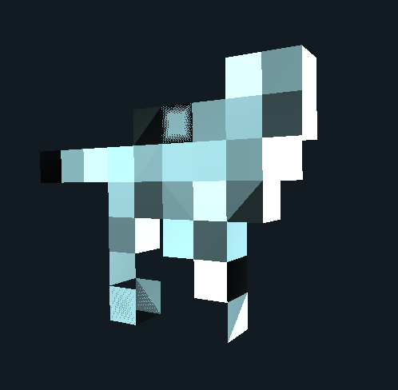

uLevel=3, uQuantize=30

uLevel=3, uQuantize=2

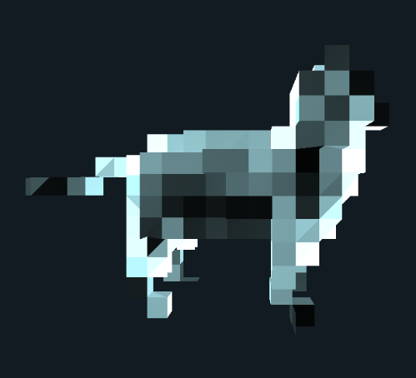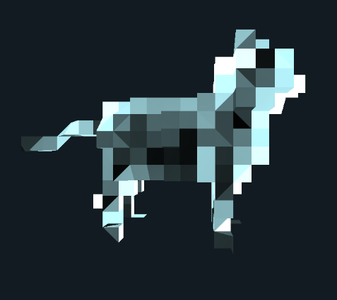

Quantized in Eye Coordinates

Quantized in Eye Coordinates, shifted a tiny bit in the x axis (pattern changes on the cat)

Video link: <https://youtu.be/vXP12v1699Q>