WEB APPLICATION AND TECHNOLOGIES
Laboratories Documentation

Dugan, April Lyssa P.
BSIT-3A

This is a documentation on how I upload manually my laboratory activities to GitHub. I opened my GitHub through its website. Since, I already have an account, there I checked the recent activity I already sent.
On how I upload my other laboratory activities, here’s a step-by-step explanation. First, I open my command prompt. I navigate my project folder using this command,
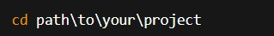
Then I initialize the git, I start a local repository in the current folder using command,
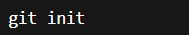

next step is to add all files to staging, I use this command,
git add .
and then I connect my local folder to GitHub repository using this command to link my repo
URL,
git remote add origin https://github.com/aprillyssaparedes01/Laboratories.git

After several commands I typed on command prompt, my local project and GitHub repo finally sync.
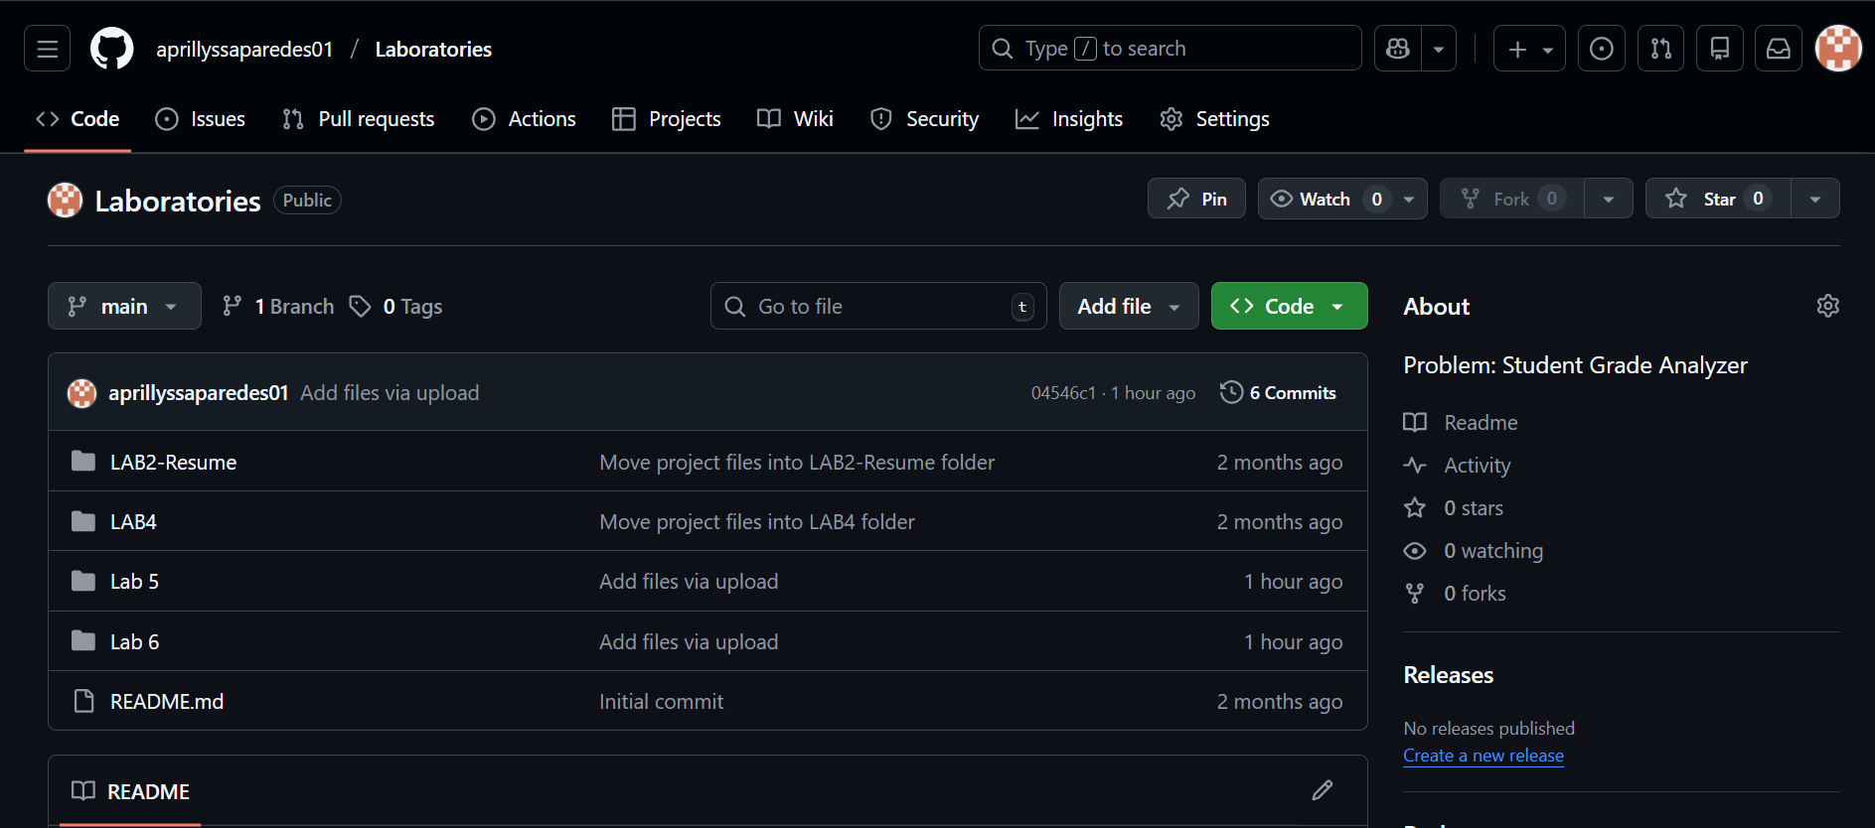

Here’s the commands I use,

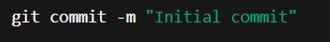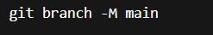

git remote add origin https://github.com/aprillyssaparedes01/Laboratories.git 