Variance and standard deviation are both measures of spread in a dataset, showing the variability of data points. Variance quantifies the average squared deviation of each data point from the mean, showing how spread out the values are, but it is expressed in the squared units of the data, which can make interpretation less straightforward.

The formula is:  
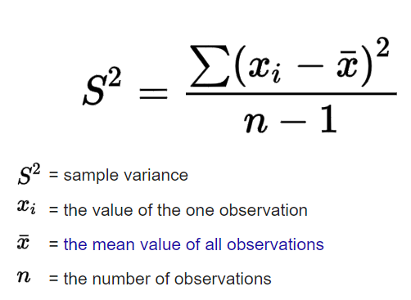

Standard deviation, on the other hand, is the square root of the variance, bringing it back to the original units of the data, making it more intuitive to understand as it represents the typical distance of data points from the mean. While variance is useful for certain statistical calculations and theoretical understanding, standard deviation is often preferred in practical applications because it is directly comparable to the data values themselves.

The formula is:  
