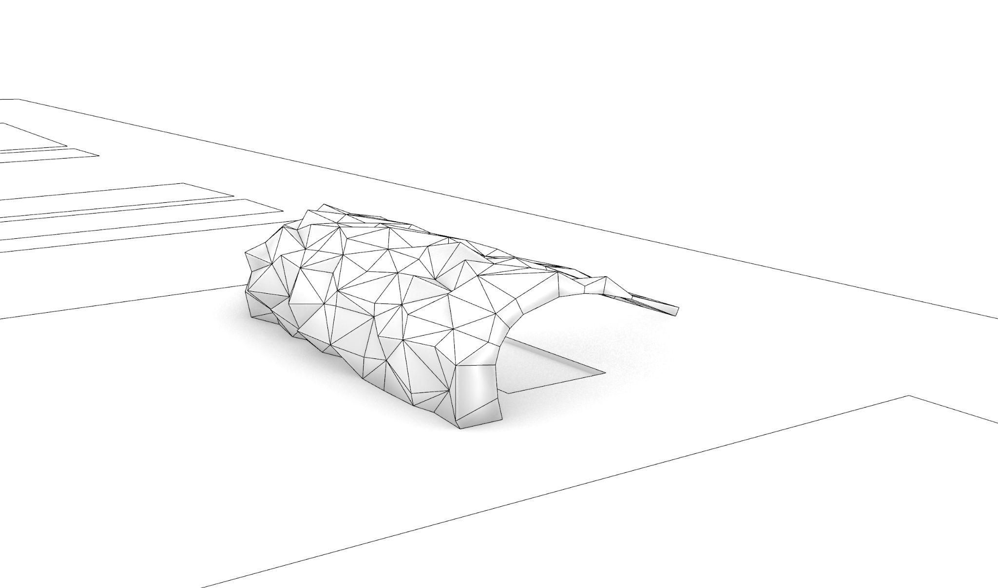
對談中的圖片如上圖
前情提要:
PETER需要一張帶有陰影的線稿圖，因為他需要在上面進行手繪。由於手繪紙很貴，我先印在普通紙上
You: Hi Peter. I want to borrow a minute of your time for your feedback on the render. This is the shadow you wanted, and this is the bird's-eye perspective. What do you think about it?
Peter: I think it's fine. The primary characteristic for my needs is that there's a sufficient variety of triangles—they're not all the same kind of triangle. One wants a little bit of variety, but in a way, because they're still generated by the regular system (the distortions of the regular system), one wants it to have some feeling of reading the rotational shape, which I think it does.
You: So, is the angle right, or do you want to tweak it a bit?
Peter: No, I think this is ideal for my needs.
You: Okay.
Peter: Yeah. And if we can make it bigger... obviously, I mean, you know, I only really need it from there to there. So I would extend the scale to a bigger size.
You: Yeah, okay.
Peter: But I think this is good. I think this gives me quite a range of triangles, because there won't necessarily be a color assigned to a particular triangle. I'll probably run it as three colors. Yeah, three usually gives you enough maneuverability. You don't want to have six colors, otherwise, it gets confusing. I might have to go to a fourth color, but I'll see what I can do with three.
You: But I think it's better to have some space like this greenery space besides it, so I won't...
Peter: Still, to set it off, I think actually in the final analysis, I'd make it just a bit more cropped. Yeah, I'd make it probably cropped from here to there, you know? Otherwise, it's a little bit tiny. There's a lot of "nothing much happening," though I know one wants to show the structure of the area. So I would say crop down to there. Maybe just get this corner in. Maybe we can pull that. Is that a site boundary line?
You: Yes, this is another greenery space. So that means this is like a plaza in the middle, yeah? And a pedestrian path beside the sea.
Peter: The only question is that it calls attention to this area here. Yeah, because in a way, it'll be blocked, right? Nothing much happens here. I wonder if we run another path behind it. Shall I... can I sketch on here?
You: Yes, I printed it on regular paper, so it's okay.
Peter: Okay. So let's do another path that comes maybe quite close to it, so people can come up to it and look at it, you know? And then if we have this... I mean, that will run into the main materiality. The path here will have its own materiality right here. And then I think what we might do is to connect here. We come with our own path—it's our own path system. We come there at each end, so it links into another path. Maybe we have a bit of planting here so they can feel this path in the plants too.
You: Yeah, you can do it.
Peter: Never do this... maybe actually correcting myself as I go along. So we come up here and come down there. Maybe actually the hard surface goes right up to the back of the building, because this is going to be hard. So it's like a little walkway where you can actually look at the panels close up.
You: Yeah. So it will not be like a straight line. It's like a different shape beside the panel.
Peter:We're going to do that where the color is... just to make sure. So we come out with a path here, round to the end of it. We make that a hard surface—a path surface. So it's framed by a path at the back and framed by a path in the front.
You: Oh, great.
Peter: And then we put vegetation coming in.
You: Yeah. Should I draw these pedestrian lines for you and...?
Peter: Yeah, yeah. Okay.
You: Yeah, no problem. Thank you, thank you.

