**Report**

**On**

**32 BIT PIPELINED RISC PROCESSOR**

**Apoorv Dethe**

**JUNE ‘20**

In this project, 16 bit pipelined RISC processor is designed in verilog language and is simulated in ModelSim.

The instruction set of RISC processor consist of following 3 types of instruction format

1. R Type format.
2. I type format.
3. J type format.

The R type instruction format is followed by all arithmetic instructions whose operands are in registers. I type format is followed by lw, sw, adi etc. J type format is followed by j, jal type instructions.

In this project the following things are assumed:

Instruction length is 16 bit.

Registers are of 8 bit length.

There are 8 registers.

Opcode is of 4 bits.

First of all single cycle data path is designed and the block diagram of single cycle datapath is shown below. This datapath does not include hardware for jump instruction

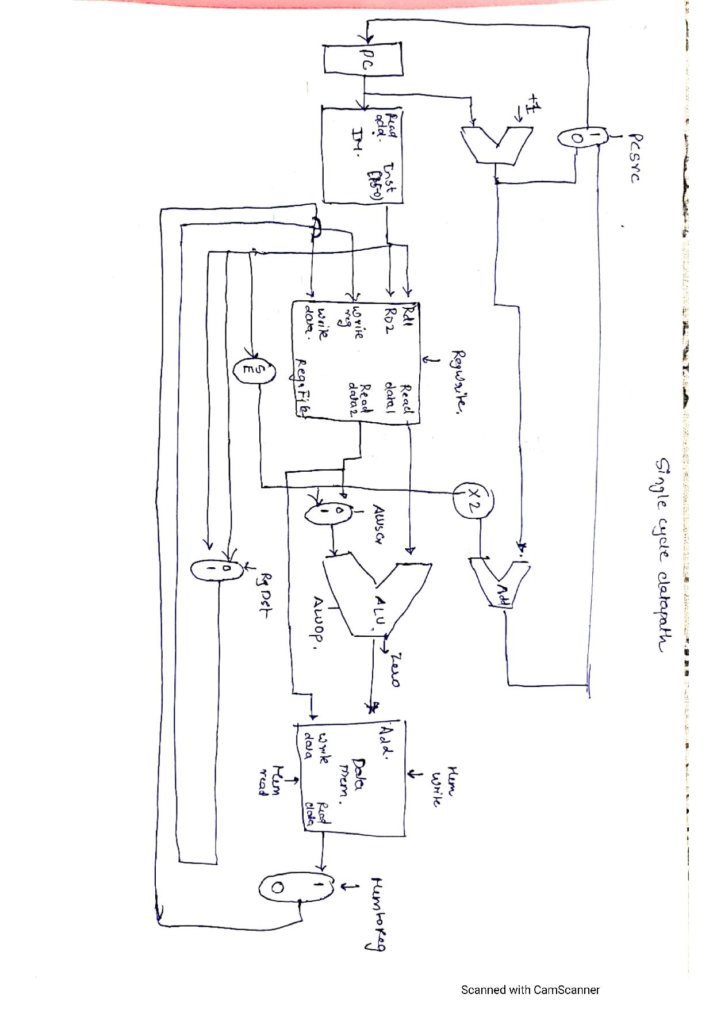

Single cycle datapath

.

Now to make it 5 staged PIPELINED architecture we add 4 registers.

These are :

1. Instruction fetch - decode
2. Decode - execution
3. Execution - memory
4. Memory - write back

The new block diagram is as shown below:

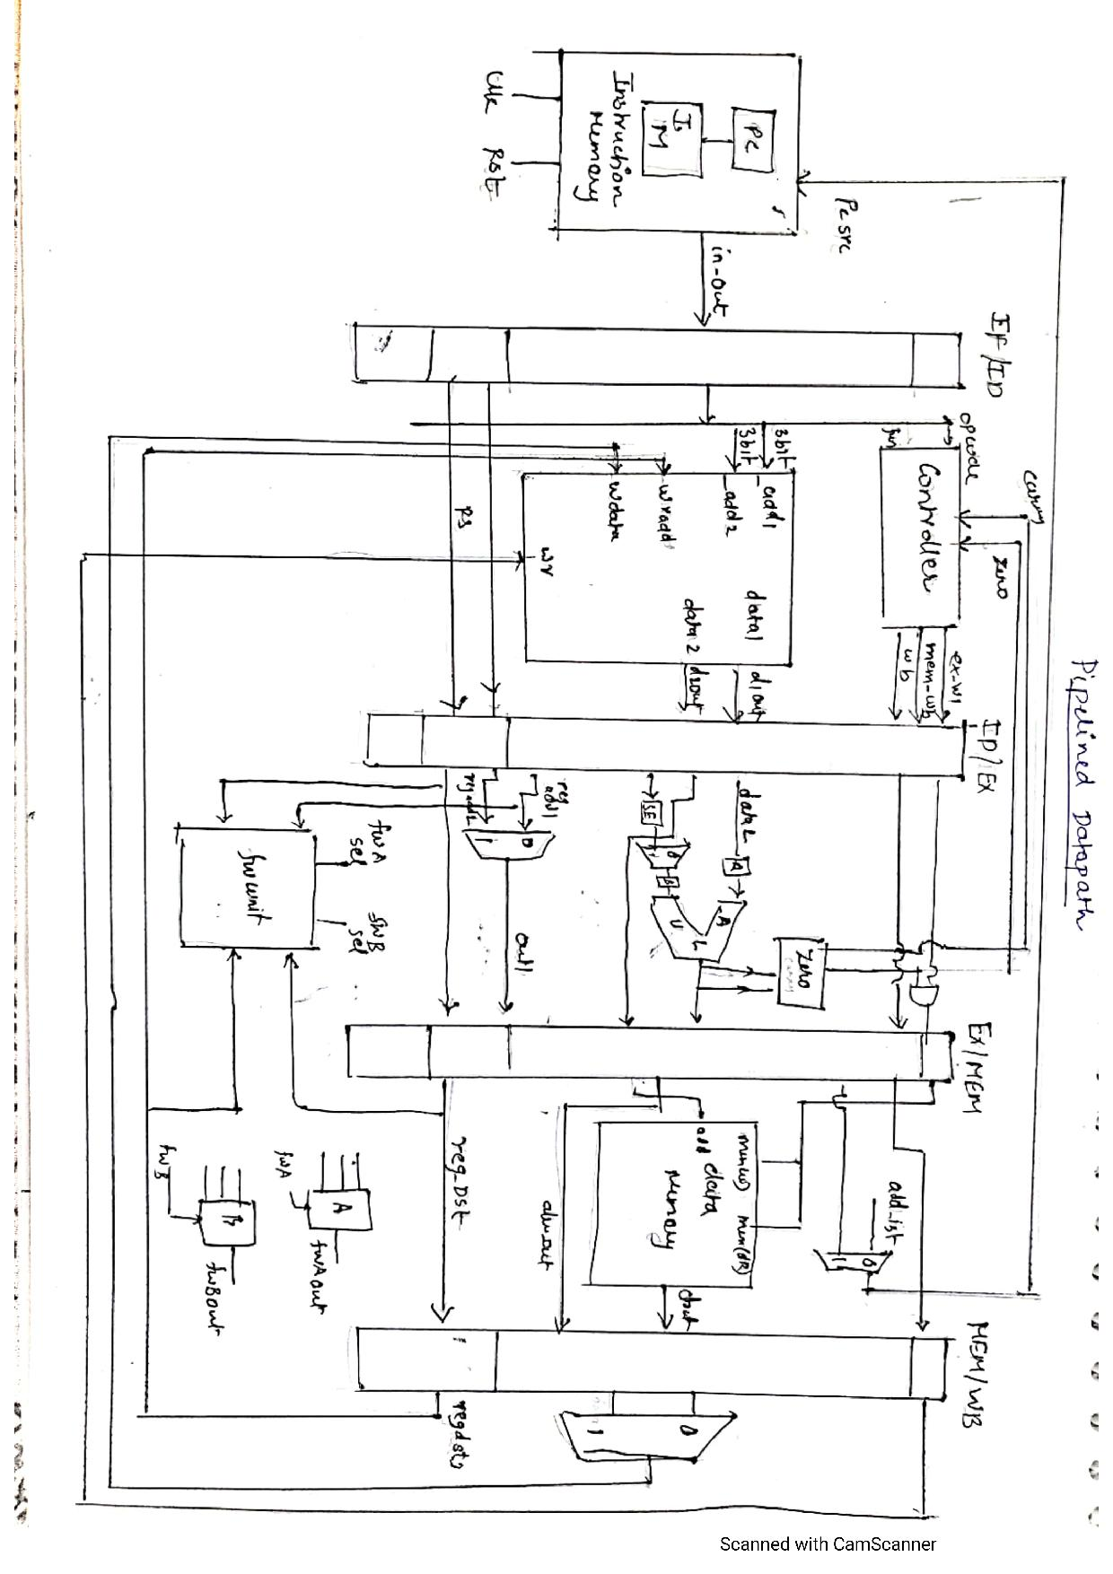

Everything works fine but when there are two instructions back to back and in 1st instruction data is written into register and in second instruction data is used then there creates a problem. This is call data hazard and this hazard can be can be mitigated by data forwarding unit.

In this forwarding unit data is directly fed into ALU input when its calculated.

In this project , arithmetic, logical, branch, load and store instructions are implemented.

The simulations of instructions is shown below:

**For arithmetic/logical instructions:**

The content of register file is

R0 = 6

R1 = 5

R2 = 3

R3 = 6

R4 = 2

R5 = FF

R6 = FF

R7 = PC

We will execute following instructions:

ADD R2,R0,R1; /////////R2=11;

SUB R3,R3,R0;/////////R3=0;

ADZ R4,R4,R1;///////////R4=7;

From the simulations we also get R4 =7;

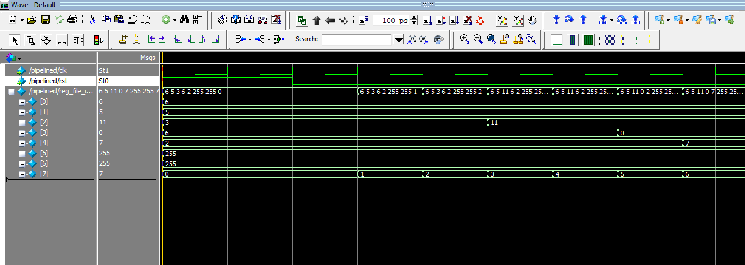

Arithmetic

**For lw :**

We will execute the following instruction

lw R3,R2,4; ////which means address = ( content(R2) +4)

R3 = mem(address)

We can calculate address = 7

So data at mem(7) should be stored at R3

**0021 which is stored in mem[7] is loaded into R3**

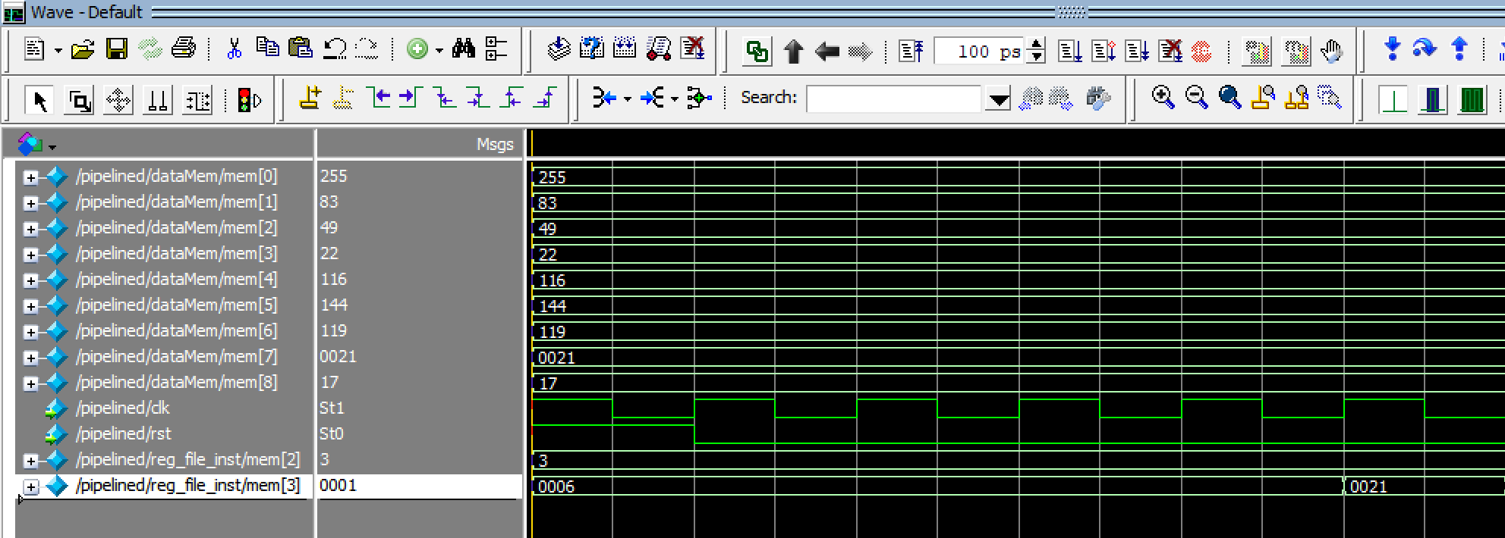

LW

**For sw :**

We will execute the following instruction to store word from register to memory

sw R3,R2,3; /////it means the data of register R3 will be stored at (content(R2)+3)

Content of R3 will be stored at mem(6) which is aso confirmed from simulations

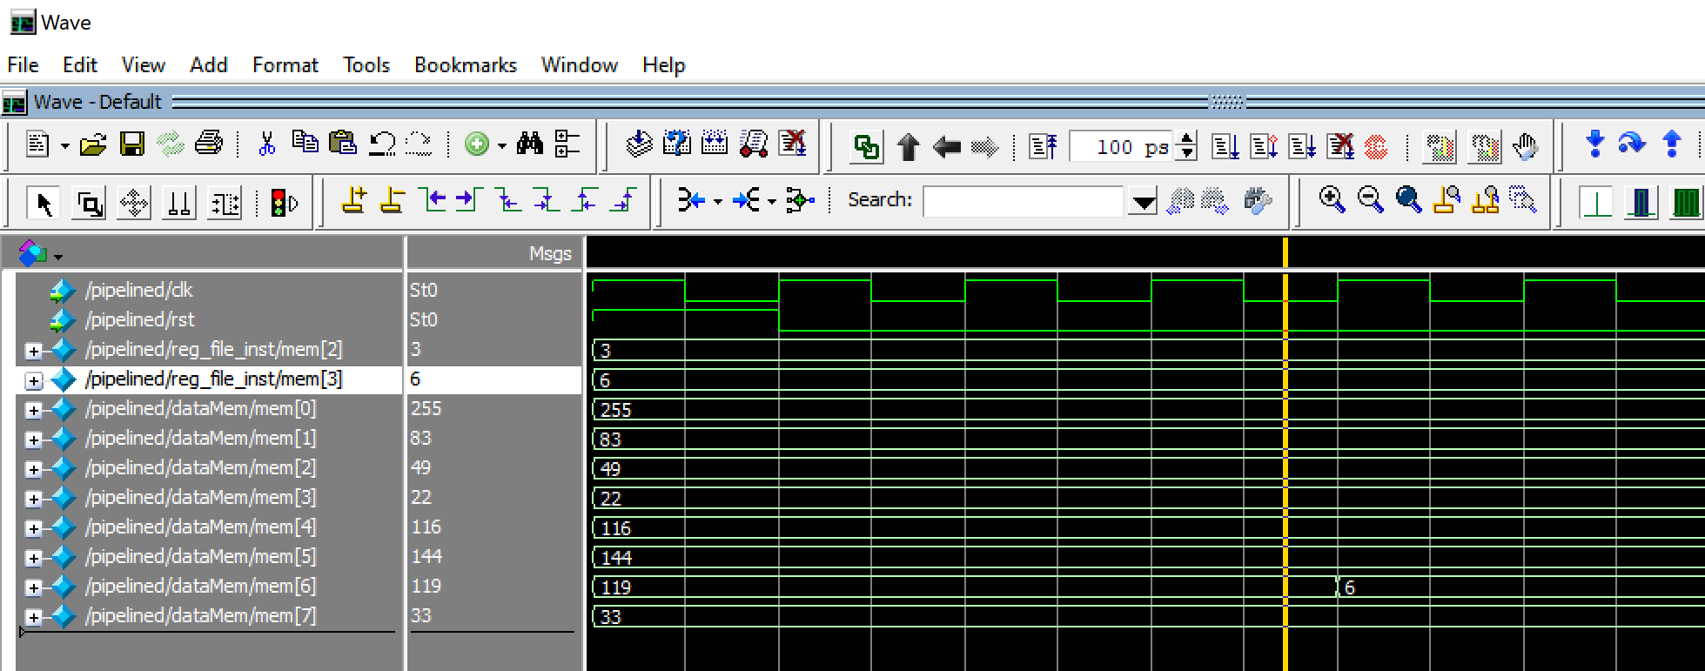

SW

**For branch instruction:**

We will consider the following instruction set;

The content of register file is

R0 = 6

R1 = 5

R2 = 3

R3 = 6

R4 = 2

R5 = FF

R6 = FF

R7 = PC

ADD R3,R0,R1

BEQ R2,R1,1; //////If contents of R2 and R1 are equal then branch

ADD R3,R2,R0;

ADD R3,R1,R0;

ADD R3,R2,R0;

ADD R3,R3,R1; ////Branch here

ADD R1,R0,R1;

After this instruction the content of R3 = 13;

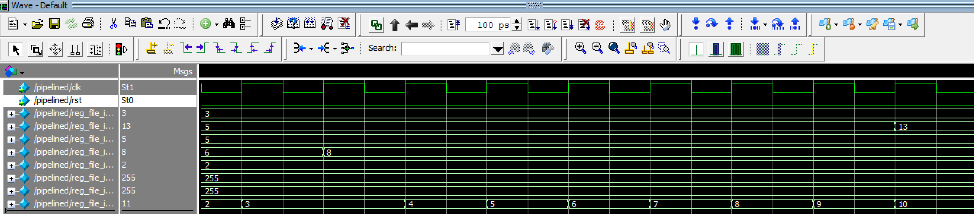

BEQ