E-KART

Ayush Singhal (181500181)

Aditya Pratap Singh (181500045)

Yashvardhan (181500833)

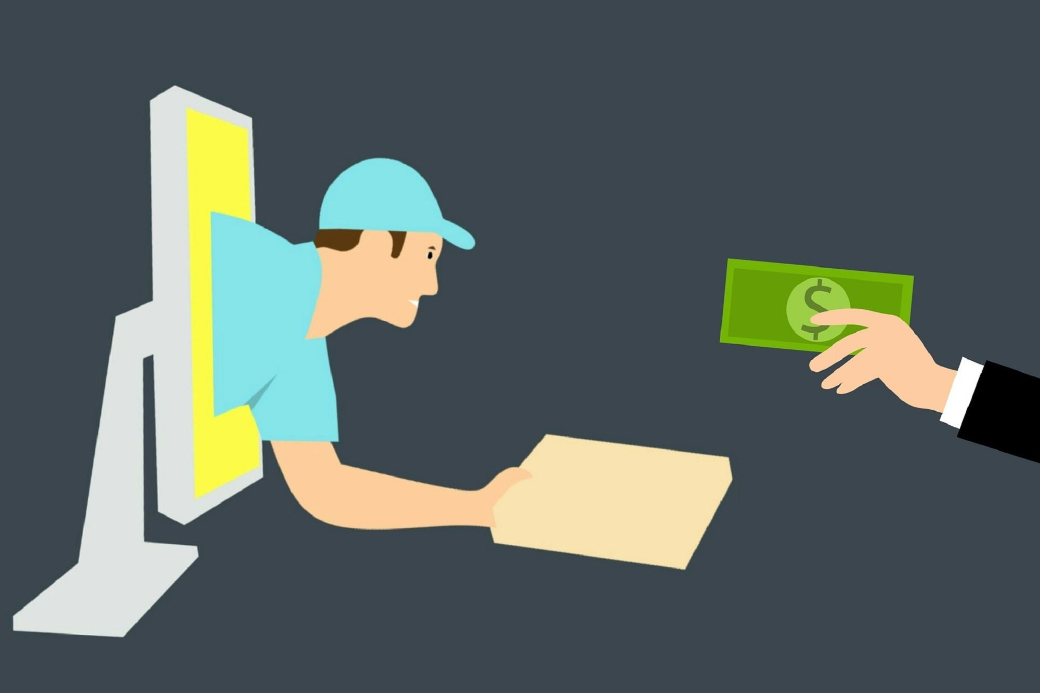

“An E-commerce website”

Problem Statement

As we all know the last year for all of us was a rollercoaster and that resulted in shutting down of many offline stores and small businesses due to lack of sales, but the online shopping market has flown up rapidly in these times as you can get pretty much everything delivered to your doorstep. But what about the local vendors of the city you live in, they don’t have resources to sell on big platform like amazon or the problem of waiting for days for your items to arrive and the absurd delivery charges on those items. And that’s where we focused.

Reason for selecting the topic

The reason for selecting this topic was to firstly to provide support to the local vendors and small businesses in this tough times and other was to save the consumer from the wait of getting the item or can’t getting it in the case of emergency due to delivery delays but now they can easily search for that item in their local city instead of asking shop-to-shop.

Objective of the project

Through E-mart we will target the small vendors or small home businesses to expand there selling area by allowing them to get orders from whole city and save you from paying extra and the wait for an item that you can get from a few blocks away from your home but if the item you desire isn’t available in your city we will then search for the city closest to your location to get your wish fulfilled.

Contribution of the project

Our project will highly benefit the local shops in the city by expanding there field of customers and the consumers by getting there desired item to them quickly with no extra “Prime” cost ; )

Feasibility study

Talking about the feasibility of this project, in the current scenario, there are not many websites out there who cover local shops at a great scale they are just limited to a single city we will destroy that barrier and cover small cities with large over the course of time.

Other supporting reason is the amount of people shopping online in current time.

The graph below shows the increase in online sales from 2017-2020, as it is shown clearly the boom came in 2020 due to pandemic.

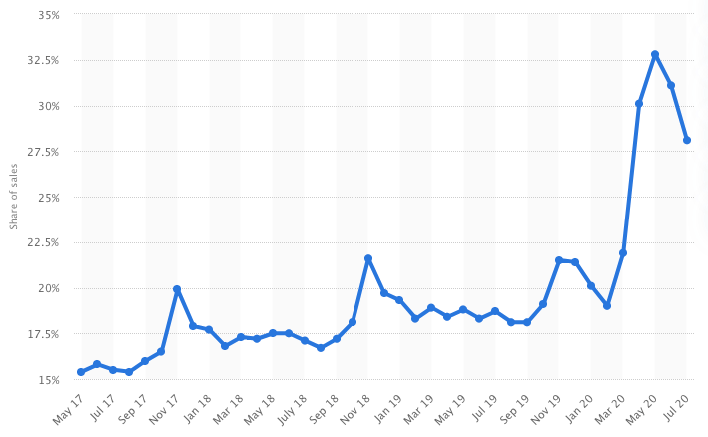

Methodology

In this project, we will use Front End Technologies like HTML, CSS, JavaScript (using React.js) to design our website. We will keep our website design responsive so that it will work smoothly on all gadgets. We will also use some creative softwares like Adobe Photoshop and Adobe Illustrator to design the logo and make images of items to be displayed clear.

For Back End technologies like Express.js and Node.js for communication with database and server and MongoDB for storing the data into the database will be used.

So, in summary we will use Full Stack for the development of our project.

**Scope for Extension into a Major Project**

**Our project has a great scope for extension into a major project. After pandemic, mostly people prefer online shopping, so we will add an option where Customer can shop and add items in the cart and will notify them about after how much time they will pick up their goods from the shop and will also be creating an mobile application for ease of customers as today’s world is all about smartphones and applications.**

Future Scope

For the future, we intend to cover more shops and stores from different cities and will also be adding global brands so that our website will fulfil demands of all types of customers who will be visiting our site. Also, we will update our website according to future needs.

Hardware and Software to be used

**HARDWARE:**

1. Laptop or PC with the following configuration (minimum, for decent execution):
   * **Processor**: Intel Core i3 6th Generation
   * **Ram**: 4GB
   * **OS**: Microsoft Windows 7 or above

**SOFTWARE:**

1. **GitHub**: For hosting the website (At the initial stage) and to store the website design and related stuff.
2. **Front End Technologies**:
   1. HTML5
   2. CSS 3
   3. JavaScript using React.js
3. **Back End Technologies**:
   1. MongoDB – document database
   2. Express.js – server-side web framework
   3. Node.js – premier JavaScript web server

Testing Technologies to be used

**HARDWARE:**

1. Desktop
2. Laptop
3. Tablet
4. Cellphone

**SOFTWARE:**

1. Browsers (for compatibility check):
   1. Google Chrome
   2. Mozilla Firefox
   3. Microsoft Internet Explorer
   4. Microsoft Edge
   5. Apple Safari
2. Search Engines

References / Bibliography

1. Google
2. Wikipedia
3. Tutorial sites
4. Bing images