BBDITM INTERNAL HACKATHON — SIH 2026
Babu Banarasi Das Institute of Technology & Management
PHASE 3 SUBMISSION TEMPLATE
Prototype / MVP Demonstration
Maximum Marks: 30 | Evaluation Date: 22 Sep 2026

TEAM DETAILS
Team ID: BBDITM_2026_039
Team Name: ThreatHunt
Team Leader, Members: Aditya Khare (TL), Apoorv Singh, Devansh Mishra, Anuj Yadav, Anshu Verma, Adrika Singh
Panel (A-204 / B-604 / C-614): B-604
Submission Date: 22/09/2026

INSTRUCTIONS
Fill in every section below directly in this document. Keep responses specific and evidence-based — judges score each criterion independently. Export as PDF and submit as TeamID_Phase3.pdf. Bring this document open (or printed) to your panel table on the evaluation date.

1. Core Functionality (10 marks)
What judges assess: Your primary use case, start to finish. Provide a live demo AND a backup recorded video link in case of connectivity issues. This carries the most weight — prioritize a working core flow over extra features.
Demo Video Link (backup): https://drive.google.com/file/d/1eEnQWIb8vIvptLTN4lWwZO5wO7NoGPK8/view?usp=sharing
Your Response:`
An analyst uploads a suspicious .eml file, which is parsed for metadata, headers, and body content. The data routes through a multi-layered analysis pipeline combining header forensics for domain spoofing, an ML model for phishing probability, and threat intelligence for IP reputation and domain age. These signals feed a custom engine that calculates a 0-100 risk score, classifies the threat (e.g., Phishing, BEC), and triggers automated alerts for critical risks. The final report is saved to an SQLite database, dynamically populating a live frontend dashboard with threat metrics and downloadable forensic reports.

2. UI/UX (5 marks)
What judges assess: Attach screenshots showing the user journey, with a line on the design decisions made for usability — not just "it looks nice."
[ Paste UI screenshots here ]
Your Response:
The dashboard utilizes progressive disclosure to guide users from high-level metrics down to granular forensics, paired with a standardized severity color system within a high-contrast dark theme to minimize cognitive load and accelerate threat triage during incident response
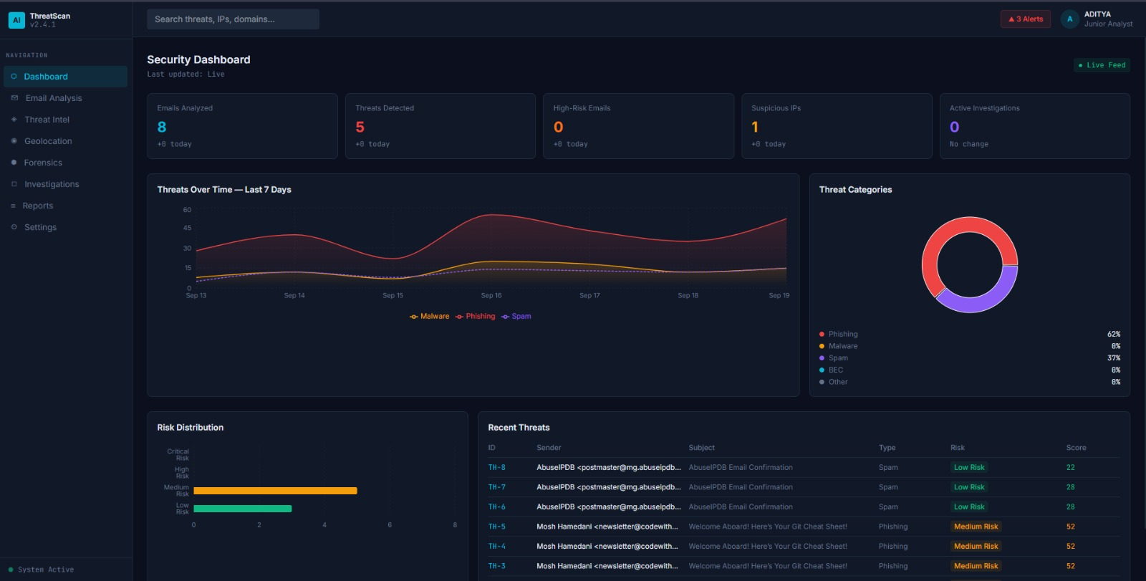

3. Error Handling (5 marks)
What judges assess: Show at least 2–3 cases where your system handles bad input, failures, or edge cases gracefully rather than crashing.
Test Case / Scenario | Expected Behavior | Actual Result
External API Timeouts & Failures | The entire email analysis pipeline crashes with a network timeout or connection error, returning a 500 Internal Server Error to the dashboard. | The try...except block in the enrichment module catches the timeout, assigns safe defaults (0 for risk, None for domain age), and allows the email scan to successfully complete.
Empty Database on Dashboard Load | The dashboard endpoints execute a query on an empty/locked database, throwing an SQL error and causing the frontend to crash or display a blank screen. | The API catches the SQL exception and gracefully falls back to returning realistic MOCK_METRICS data, ensuring the UI remains fully functional for the demo.
Malformed Data Types in Pipeline | A module passes a Null value or missing dictionary key, causing a fatal TypeError (e.g., math on a string) or KeyError during risk scoring. | The engine enforces strict type checking (isinstance()) and safe dictionary access (.get()), gracefully defaulting invalid data to 0 or "N/A" without halting.

4. Performance (5 marks)
What judges assess: Any measurements you have — load time, response time, or behavior under multiple simultaneous actions, even informal.
Your Response:
Dashboard Load Time: Frontend dashboard metrics load instantaneously. Telemetry from the Chrome DevTools Network panel confirms that all dashboard aggregation endpoints (e.g., /dashboard/summary, /dashboard/recent-threats, and /history) consistently return data in 5ms to 24ms. These requests also have tiny data payloads well under 3 kB.
Analysis Response Time: The POST /analyze pipeline orchestrates heavy multi-layered processing. When stress-tested against a heavy newsletter, the full end-to-end pipeline safely executed in 21 to 22 seconds.
Behavior Under Simultaneous Actions: The system successfully handled 16 simultaneous requests to populate the dashboard. This happened while the heavy email analysis task executed concurrently in the background without blocking the UI.

5. Completeness (5 marks)
What judges assess: Compare what you originally scoped (Phase 1/2) against what is actually built. Flag anything not done and why — honesty here is scored positively over overclaiming.
Planned Feature | Status (Done / Partial / Not Done) | Notes
Email Forensics & ML Risk Scoring | Done | The POST /analyze pipeline fully integrates header parsing and ML content evaluation to generate an accurate 0-100 threat score and 4-tier risk label.
Threat Intelligence Enrichment | Partial | The backend code isn’t connected to the frontend yet.
Interactive Dashboard & Reports | Partial | The frontend dynamically queries the SQLite database, rendering live metrics in under 25ms. Downloadable reports aren’t available yet.
External Alert Relays (SMTP/Webhooks) | Partial | System correctly identifies high-risk scans and sets alert_triggered=1 for the internal dashboard queue, but third-party push notifications were deferred to prioritize core analysis stability.

Signature of Judges:
- _________________________
- _________________________
- _________________________
- _________________________
- _________________________
- _________________________
- _________________________
- _________________________

Signature of Students:
- _________________________
- _________________________
- _________________________
- _________________________
- _________________________

