Student Performance Analytics System
Python with AI Project Documentation
Student Name: APSANA SYED
Student ID: STU6a846d3d5d5691787063613
Course/Institute: EWB Courses
GitHub Repository URL: https://github.com/apsanasyed555948

1. Project Title
Student Performance Analytics System

2. Objective
The objective is to build a Python-based system that reads student marks and attendance, calculates totals and averages, assigns grades, identifies pass/fail status, and summarizes overall and subject-wise performance.

3. Technologies Used
Python, NumPy, Pandas, CSV, and GitHub. Confirm that these are the tools actually used in your final project.

4. Dataset Description
The sample CSV contains 20 student records. Columns include Student_ID, Name, Department, Python_Marks, AI_Marks, Data_Analysis_Marks, and Attendance_Percent. Replace or adapt the sample data as permitted by your trainer.

5. Implementation
1. Load the CSV using pandas.read_csv().
2. Check that required columns are present.
3. Calculate totals and averages using Pandas and NumPy.
4. Use a reusable function to assign grades.
5. Use loops and conditions to check pass/fail status.
6. Calculate class statistics, subject averages, department averages, and top performers.
7. Save processed output to student_results.csv.

6. Key Features
Student-level totals and averages; grade assignment; pass/fail classification; highest and lowest average; overall class average; attendance average; subject-wise average; department-wise average; top-five list; export of processed results.

7. Output / Screenshots
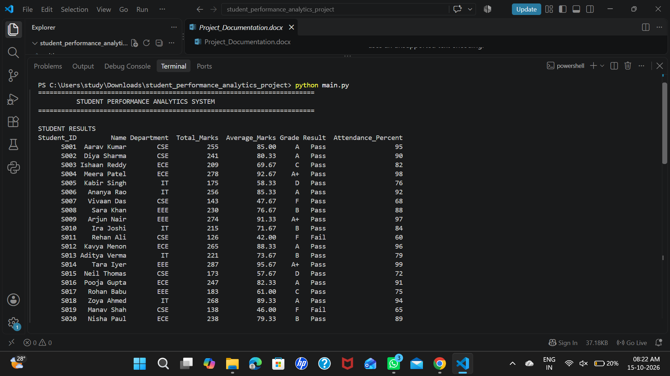
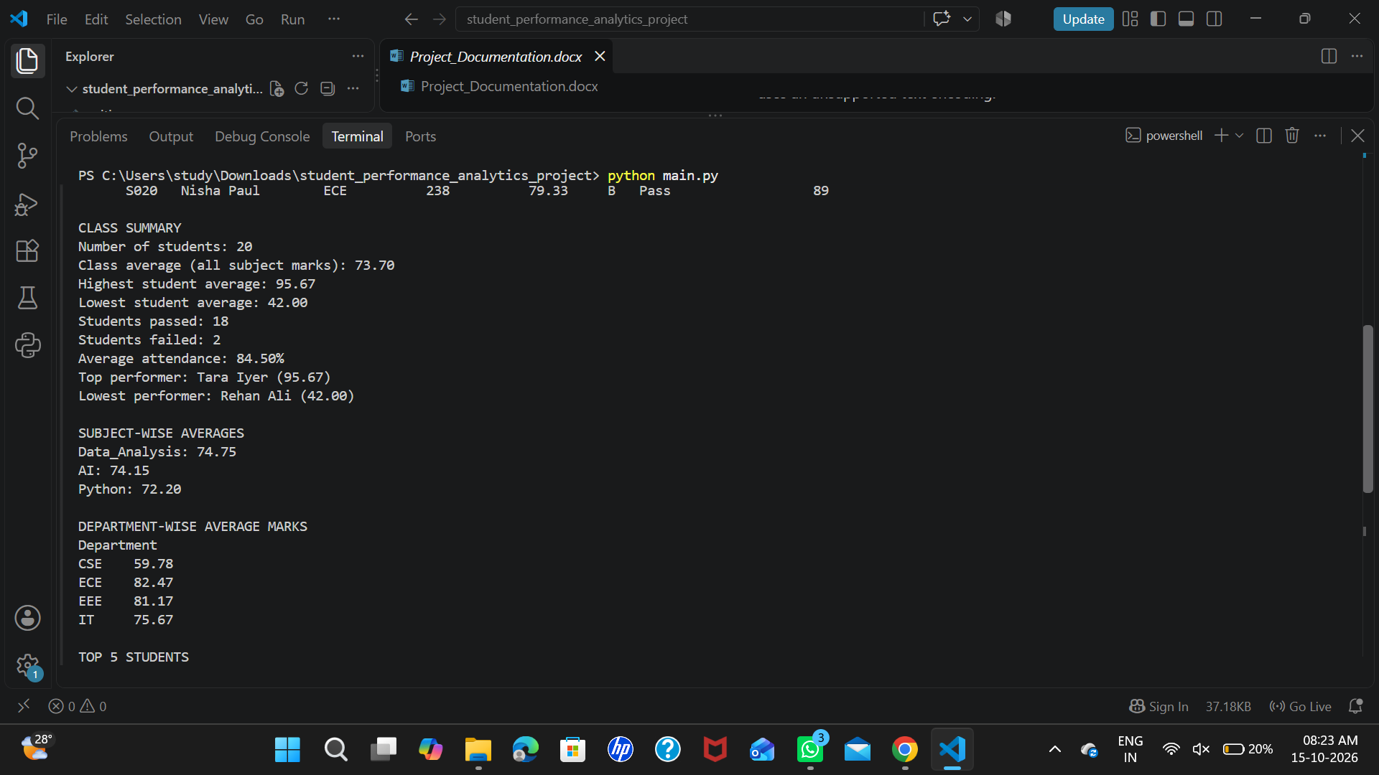
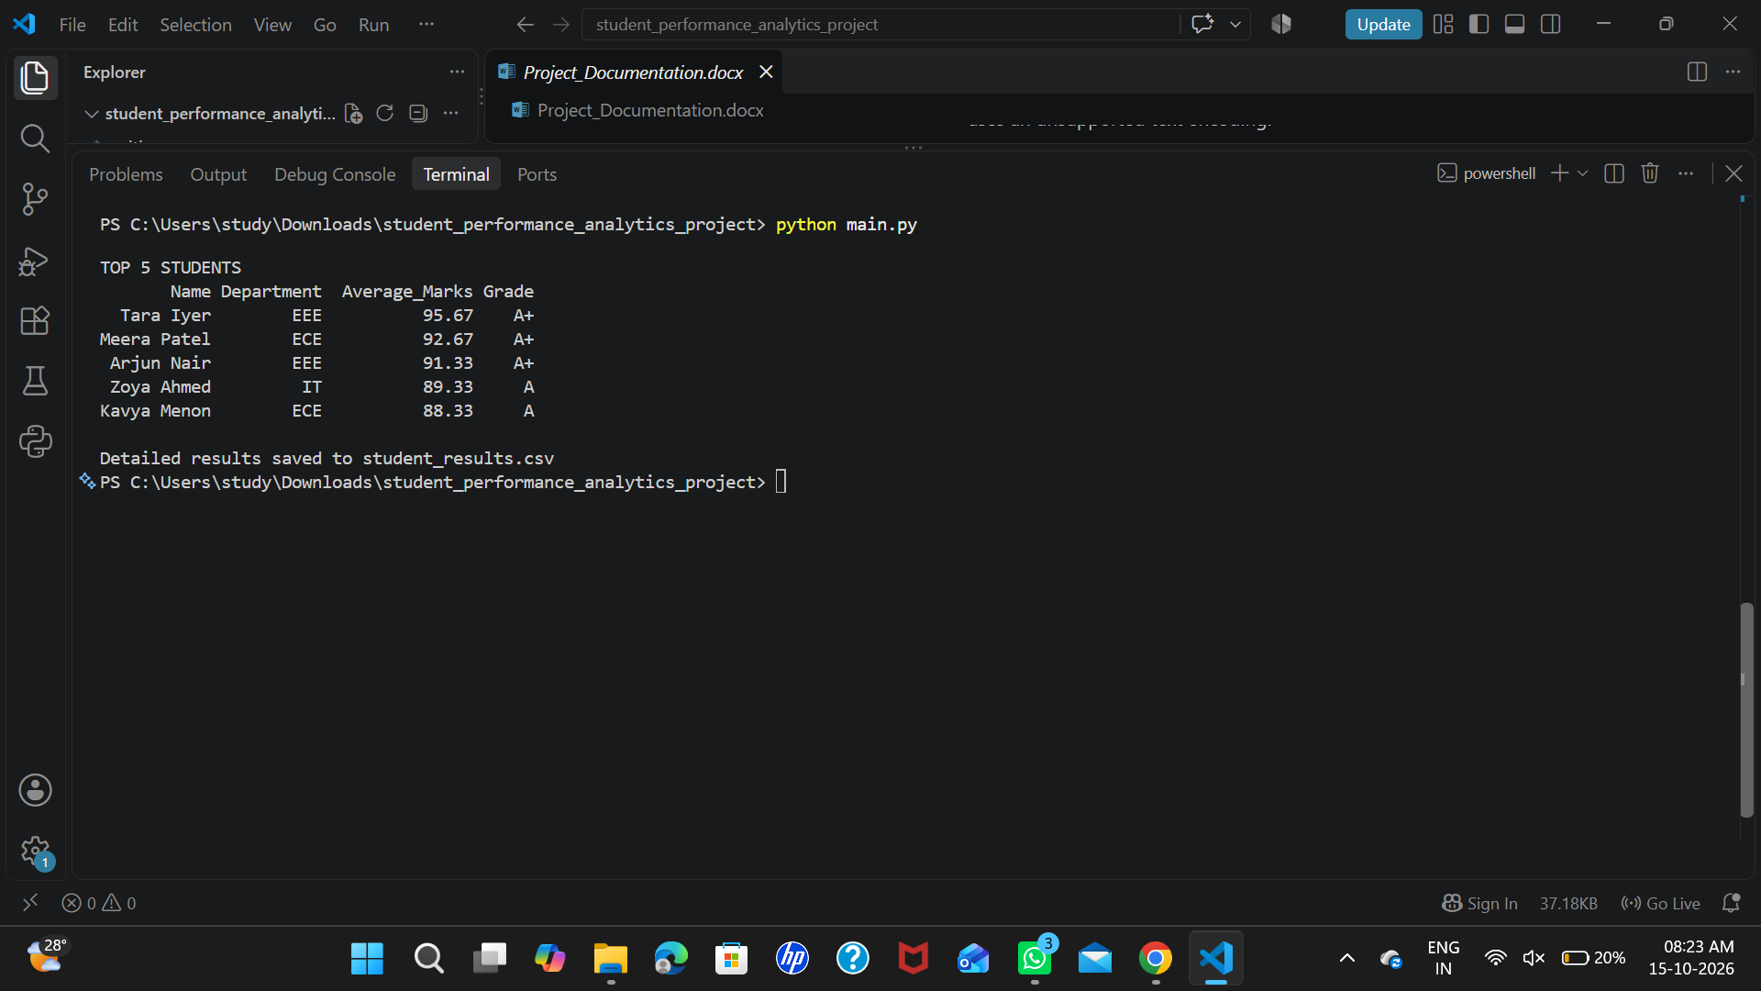

8. Final Outcome
The program produces a readable summary of student performance and exports a processed CSV file. Update this section after testing and recording your actual results.

9. Challenges & Learning
Write about challenges you personally encountered, such as understanding DataFrames, choosing a grading rule, debugging file paths, or using loops. Explain how you solved each issue and what you learned.

10. GitHub Repository
Final public repository URL here: https://github.com/apsanasyed555948/student-performance-analytics

