[ROOMMATE SEARCH]



2017
Team Project 4

Arshpreet Singh(1694159)
Simranjot kaur(1694164)
Jasleen kaur(1694169)
Divyansh Khajuria(1694167)
Gurpreet Singh(1694392)

Table of Contents

Work Distribution

Introduction
Purpose:
Scope

Description
Product Functions:
User Characteristics:

Specific Requirements
Functional Requirements:
3.2 Non-Functional Requirements:

analysis model11
4.1 Use Case Diagram
4.3 Class Diagram
4.4 Screen flow diagram and Screen design
Database
Database Schema
database script 27-28

Web Services’ calls details

Work Distribution
Introduction & General Description - Jasleen kaur
Specific Requirements - Simranjot kaur & Jasleen kaur
Analysis Model - Arshpreet singh & Gurpreet singh
Screens – Divyansh
Database – Gurpreet singh & Arshpreet singh
Web Service Calls - Simranjot kaur & divyansh

Introduction

ROOM4U is a location-based searching mobile app that facilitates people to find easily accommodation and roommate. The app is most commonly used as a finding roommate or rent rooms. ROOM4U is one of the few roommate or renting appt apps that doesn’t require Facebook to sign up. You create a username and fill out a profile. This creates a percentile score for users that reflects your “compatibility.” All options, including those for accessing the settings and viewing profiles, are located in a slide-out menu.

Purpose:
ROOM4U actually has one of the best user interfaces for searching room or roommate app around. It facilitates communication between mutually interested users, allow users to chat. The site screens all listings and users before they go live, ensuring that you won’t fall victim to a scam. ROOM4U is going to be the most popular renting or roommate finder app so this app is specially design to for user to search, chat, view post, add post, send link save or share or comment.

Scope:
ROOM4U works in over 192 countries with over four million users. Verified users can reach out to each other's email, phone. A user creates a profile, which grants them access to searching other profiles. A user is then able to modify his or her profile, send messages, search for advertisement or post advertisement users with its free, map-based interface, makes it easy to find apartments roommate in a particular neighborhood or even on a particular block.

Description

This section describes the factor which affects their functions. It also describes the relation of the function with each other and the software is dependent or independent.

Product Functions:

This subsection provides a summary of the functions that the software will perform. It will discuss major functional areas without mentioning any of the large amounts of detail that goes with those areas. The function needs to be organized so that the customer will understand them.

- Administration:

The admin must have the following options in the application:

- Add/delete posts: Admin can add/delete posts in the database of the app.
- Register users: Register user accounts for room owner and renters.
- Help: He can provide help to the users by answering questions related to the post.
- Change password: He can also change password for security concerns for users on their request.

- User:

The users are provided with the following options:

- Help: Users must have access to help option so that he/she can ask questions about related to the post.
- Browse post: Normal user can browse post in the category page of the application.
- Request/rent room: Users should have an option to request for or rent a room.
- Review/feedback events: He can give feedback for any post

- Share: User can share post with other user.

User Characteristics:

This subsection describes the general characteristics of the users that will influence the SRS. Describe intended system users in terms of the following:

- Education level, Experience, Technical expertise.
- What type of customer can use this application?
- The literacy of the user affects the application or not.
- The application environment is friendly or not for the user.
- If the User can easily use it or not.

These all factors directly affect the application popularity.

Specific Requirements

The main purpose for preparing this document is to give a general insight into the analysis and requirements of the existing system or situation and for determining the operating characteristics of the system.

Functional Requirements:

FR-1: Create User Account: App must have a registration page where a new User can register after downloading the App.
FR-2: Login for user: After signup user can any time log in to their account by entering their username and password in to the log-in screen and clicks the submit button. If entered wrong username or password then the application will redirect the user to forget password screen.
FR-3: Forgot password: User enters the username or mobile number in to forget password form and then clicks submit. Then the user will be presented with new password or reset password link.
FR-4: The application must have an option of making changes like addition and removal of post.
FR-5: The application can only allow user to view posts by being a registered user.
FR-6: Registered user and can add post, delete post, add comment, share and rate for the post.
FR-7: Application should provide students to change language to English, French, Chinese and Spanish.
FR-8: The application must provide an option of search and filter for any item they wish to find.
FR-9: Application should provide an option to add or remove any user/post by the admin.
FR-10:Application will have an option of feedback and review.
FR-11: Every post should be divided into two categories such as room or roommate search.
FR-12: Application should have an option to add or remove categories by admin.
FR-13: Application should have an option for user to make request before rent any room.
FR-14: The application must provide notification to user about new posted add.
FR-15: The application should have report option regarding any fake post or user.
FR-16: The application must have allow user to block the other user..
FR-17: The application must have term & conditions for app.

3.2 Non-Functional Requirements:

NFR-1: The application must provide security to user’s accounts from fishing and hacking.

NFR-2: If the application is closed from screen but not from the task bar, the application should
have a session time of 2 minutes, afterwards it would be logged out automatically.

NFR-3: The application should be easy to maintain i.e. Bugs should be easily traced and fixed.

NFR-4: The size of the application should be small and take less memory to install.

NFR-5: The application should not take more than 2 seconds for loading a page.

NFR-6: The application should handle large no. of users and data at a time.

NFR-7: The application must automatically update the category or history of new post in the category when a new post is deleted or added.

NFR-8: The application should be able to export data to mails or doc files for future reference in order to make system more convenient.

NFR-9: The app must be available offline or online

NFR-10: The application will run on both android and ios platform. It will support following minimum version

Android Android (IceCream Sandwich, Jelly Bean, Kitkat, Lollipop, marshmallow)

IOS IOS (8.0 to further updates)

4. Analysis Model

The model that is basically being followed is the WATER FALL MODEL, which states that the phases are organized in a linear order. First of all the feasibility study is done. Once that part is over the requirement analysis and project planning begins. If system exists one and modification and addition of new module is needed, analysis of present system can be used as basic model.

The design starts after the requirement analysis is complete and the coding begins after the design is complete. Once the programming is completed, the testing is done. In this model the sequence of activities performed in a software development project are: -

Here the linear ordering of these activities is critical. End of the phase and the output of one phase is the input of other phase. The output of each phase is to be consistent with the overall requirement of the system. Some of the qualities of spiral model are also incorporated like after the people concerned with the project review completion of each of the phase the work done.

WATER FALL MODEL was being chosen because all requirements were known beforehand and the objective of our software development is the computerization/automation of an already existing manual working system.

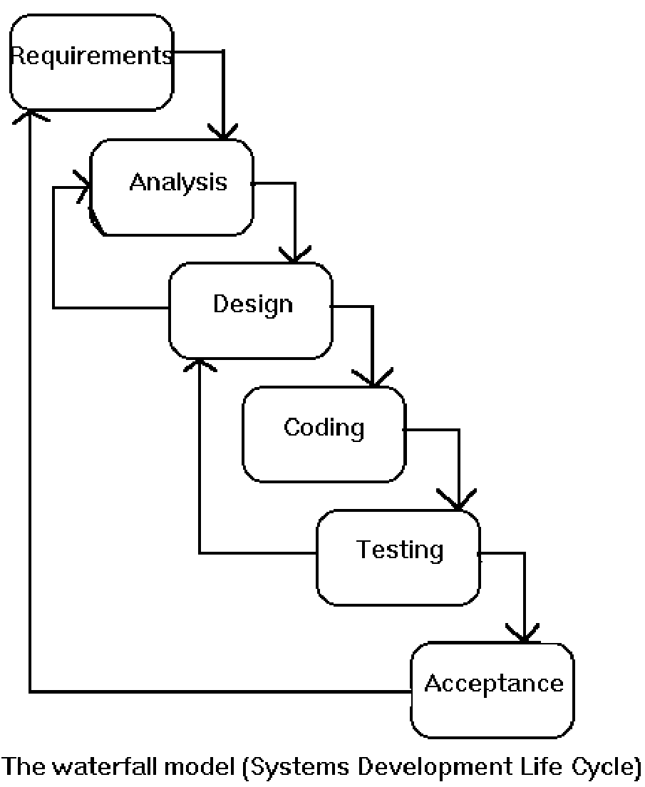

4.1 Use Case Diagram

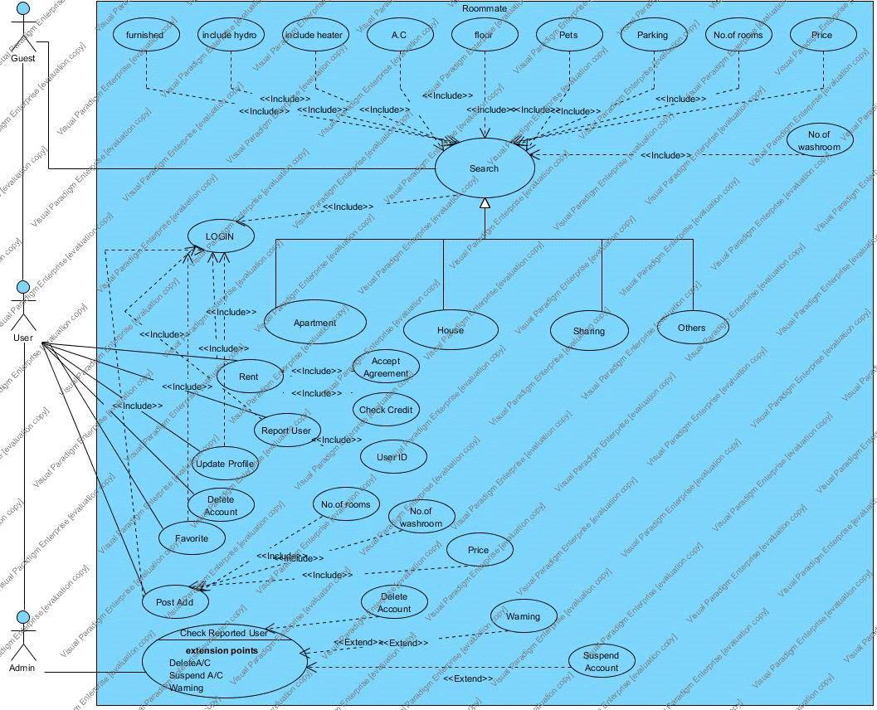

4.3 Class Diagram

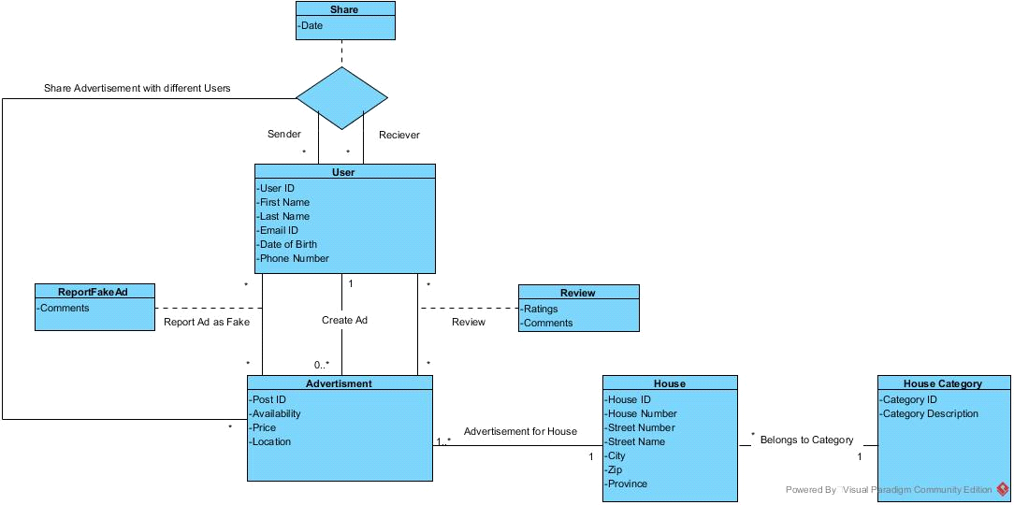

4.4 Screen flow diagram and Screen design

Screens
Ist screen

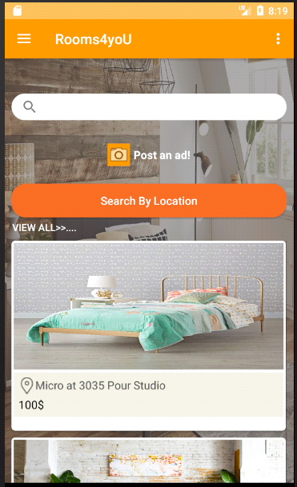

Sign up screen

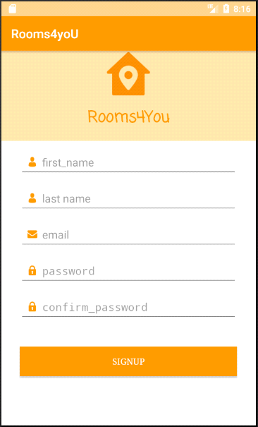

Login Page
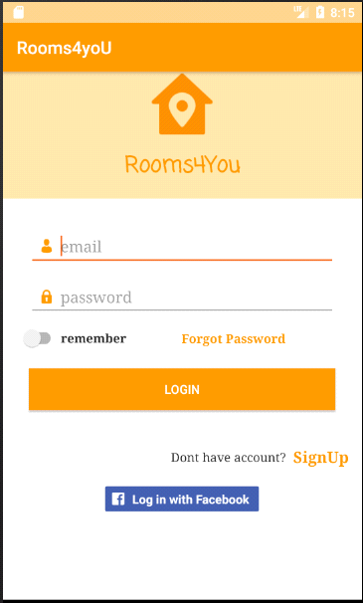

Home Page

Profile screen

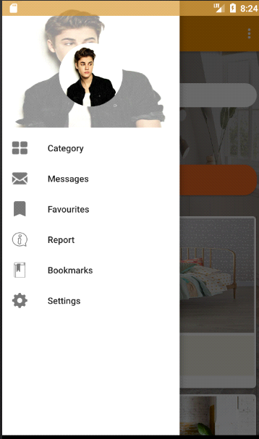

Categories screen

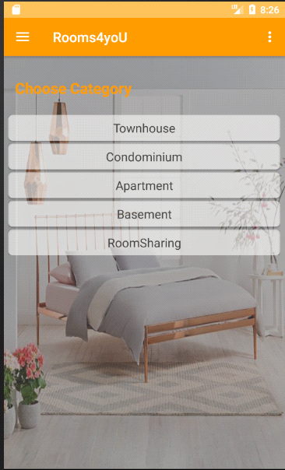

Post Ad screen

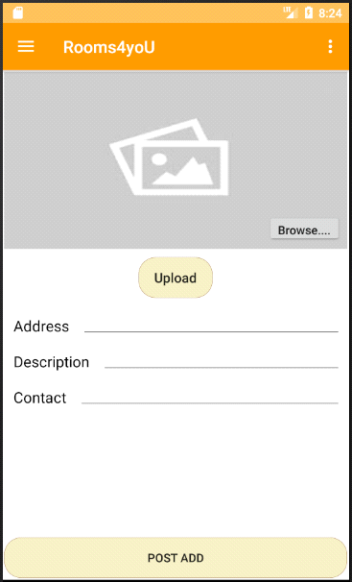

AD screen

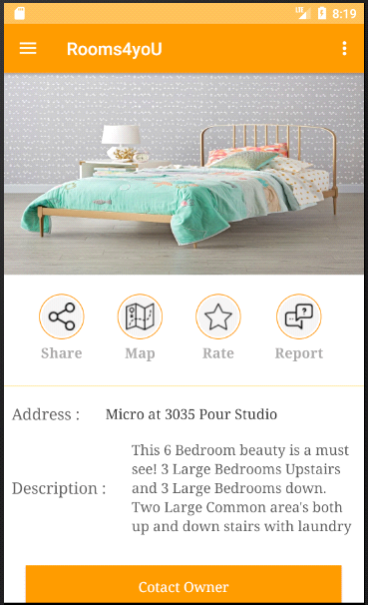

Search by location screen
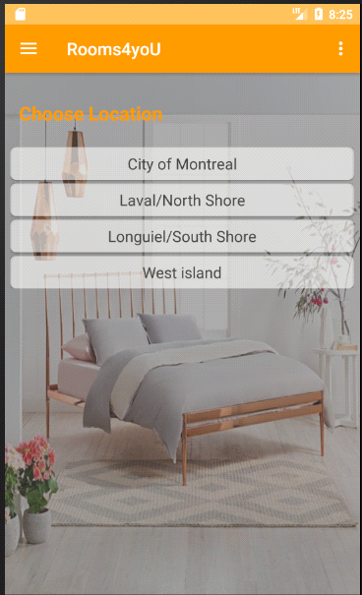

Contact screen

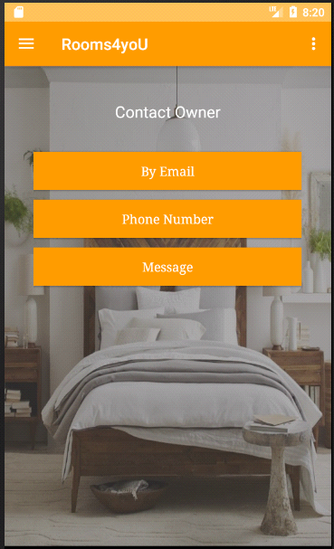

Report Ad:

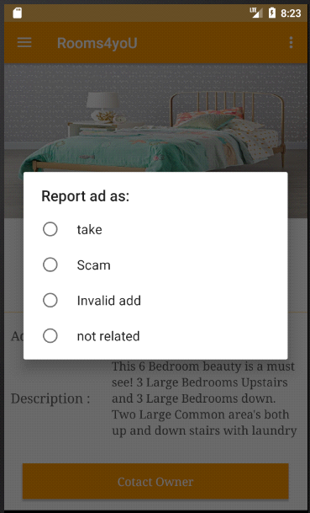

Settings Screen:

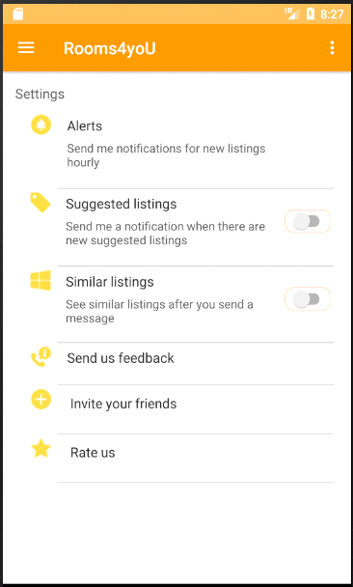

Database

Database Schema

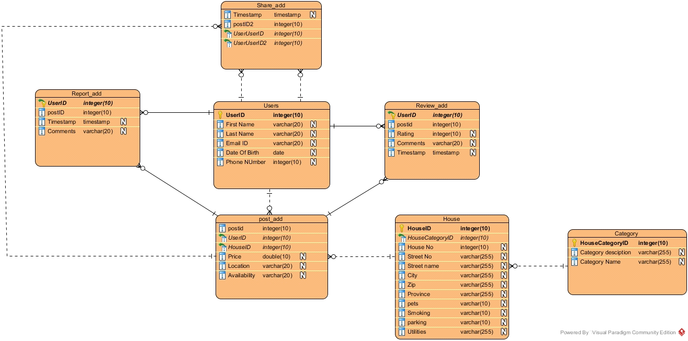

Web Services’ calls details

URL | http://www.localhost:8080/call/generic/Userlogin HYPERLINK "http://www.localhost:8080/call/generic/Userlogin&Loginid&Password"& HYPERLINK "http://www.localhost:8080/call/generic/Userlogin&Loginid&Password"Loginid HYPERLINK "http://www.localhost:8080/call/generic/Userlogin&Loginid&Password"& HYPERLINK "http://www.localhost:8080/call/generic/Userlogin&Loginid&Password"Password
Call | Userlogin
Parameters | Loginid  Password
Response | Example 1  {  “Status”: ”OK”,  “Timestamp”: 1478351819,  “Message”: ”Login Successful”  }  Example 2  {  “Status”: ”Error”,  “Timestamp”: 1478351819,  “Message”: “Database connection failed”  }  Example 3  {  “Status”: ”Wrong”,  “Timestamp”: 1478351819,  “Message”: ”Must not start with symbol”  }
Keys | “Status” | Status of the response  Possible values :“OK”, “WRONG”,“ERROR” | Mandatory
Keys | “Timestamp” | UTC format response timestamp | Mandatory
Keys | “Message” | Message to display | Optional

URL | http://www.localhost:8080/call/generic/ forgotpassword&emailid
Call | Forgotpassword
Parameters | Emailid
Response | Example 1  {  “Status”: ”OK”,  “Timestamp”: 1478351819,  “message”: ”link sent to the email”  }  Example 2  {  “Status”: ”Error”,  “Timestamp”: 1478351819,  “Message”: “Database connection failed”  }  Example 3  {  “Status”: ”Wrong”,  “Timestamp”: 1478351819,  “Message”: ”Must not start with symbol”  }
Keys | “Status” | Status of the response  Possible values :“OK”, “WRONG”,“ERROR” | Mandatory
Keys | “Timestamp” | UTC format response timestamp | Mandatory
 | “Message” | Message to display | Optional

URL | http://www.localhost:8080/call/generic/signup HYPERLINK "http://www.localhost:8080/call/generic/signup HYPERLINK "http://www.localhost:8080/call/generic/signup&username&Password&Age&DOB&Phoneno&Emailid"& HYPERLINK "http://www.localhost:8080/call/generic/signup&username&Password&Age&DOB&Phoneno&Emailid"username HYPERLINK "http://www.localhost:8080/call/generic/signup&username&Password&Age&DOB&Phoneno&Emailid"& HYPERLINK "http://www.localhost:8080/call/generic/signup&username&Password&Age&DOB&Phoneno&Emailid"Password HYPERLINK "http://www.localhost:8080/call/generic/signup&username&Password&Age&DOB&Phoneno&Emailid"& HYPERLINK "http://www.localhost:8080/call/generic/signup&username&Password&Age&DOB&Phoneno&Emailid"Age HYPERLINK "http://www.localhost:8080/call/generic/signup&username&Password&Age&DOB&Phoneno&Emailid"& HYPERLINK "http://www.localhost:8080/call/generic/signup&username&Password&Age&DOB&Phoneno&Emailid"DOB HYPERLINK "http://www.localhost:8080/call/generic/signup&username&Password&Age&DOB&Phoneno&Emailid"& HYPERLINK "http://www.localhost:8080/call/generic/signup&username&Password&Age&DOB&Phoneno&Emailid"Phoneno HYPERLINK "http://www.localhost:8080/call/generic/signup&username&Password&Age&DOB&Phoneno&Emailid"& HYPERLINK "http://www.localhost:8080/call/generic/signup&username&Password&Age&DOB&Phoneno&Emailid"Emailid" HYPERLINK "http://www.localhost:8080/call/generic/signup&username&Password&Age&DOB&Phoneno&Emailid"& HYPERLINK "http://www.localhost:8080/call/generic/signup HYPERLINK "http://www.localhost:8080/call/generic/signup&username&Password&Age&DOB&Phoneno&Emailid"& HYPERLINK "http://www.localhost:8080/call/generic/signup&username&Password&Age&DOB&Phoneno&Emailid"username HYPERLINK "http://www.localhost:8080/call/generic/signup&username&Password&Age&DOB&Phoneno&Emailid"& HYPERLINK "http://www.localhost:8080/call/generic/signup&username&Password&Age&DOB&Phoneno&Emailid"Password HYPERLINK "http://www.localhost:8080/call/generic/signup&username&Password&Age&DOB&Phoneno&Emailid"& HYPERLINK "http://www.localhost:8080/call/generic/signup&username&Password&Age&DOB&Phoneno&Emailid"Age HYPERLINK "http://www.localhost:8080/call/generic/signup&username&Password&Age&DOB&Phoneno&Emailid"& HYPERLINK "http://www.localhost:8080/call/generic/signup&username&Password&Age&DOB&Phoneno&Emailid"DOB HYPERLINK "http://www.localhost:8080/call/generic/signup&username&Password&Age&DOB&Phoneno&Emailid"& HYPERLINK "http://www.localhost:8080/call/generic/signup&username&Password&Age&DOB&Phoneno&Emailid"Phoneno HYPERLINK "http://www.localhost:8080/call/generic/signup&username&Password&Age&DOB&Phoneno&Emailid"& HYPERLINK "http://www.localhost:8080/call/generic/signup&username&Password&Age&DOB&Phoneno&Emailid"Emailid" HYPERLINK "http://www.localhost:8080/call/generic/signup&username&Password&Age&DOB&Phoneno&Emailid"username HYPERLINK "http://www.localhost:8080/call/generic/signup HYPERLINK "http://www.localhost:8080/call/generic/signup&username&Password&Age&DOB&Phoneno&Emailid"& HYPERLINK "http://www.localhost:8080/call/generic/signup&username&Password&Age&DOB&Phoneno&Emailid"username HYPERLINK "http://www.localhost:8080/call/generic/signup&username&Password&Age&DOB&Phoneno&Emailid"& HYPERLINK "http://www.localhost:8080/call/generic/signup&username&Password&Age&DOB&Phoneno&Emailid"Password HYPERLINK "http://www.localhost:8080/call/generic/signup&username&Password&Age&DOB&Phoneno&Emailid"& HYPERLINK "http://www.localhost:8080/call/generic/signup&username&Password&Age&DOB&Phoneno&Emailid"Age HYPERLINK "http://www.localhost:8080/call/generic/signup&username&Password&Age&DOB&Phoneno&Emailid"& HYPERLINK "http://www.localhost:8080/call/generic/signup&username&Password&Age&DOB&Phoneno&Emailid"DOB HYPERLINK "http://www.localhost:8080/call/generic/signup&username&Password&Age&DOB&Phoneno&Emailid"& HYPERLINK "http://www.localhost:8080/call/generic/signup&username&Password&Age&DOB&Phoneno&Emailid"Phoneno HYPERLINK "http://www.localhost:8080/call/generic/signup&username&Password&Age&DOB&Phoneno&Emailid"& HYPERLINK "http://www.localhost:8080/call/generic/signup&username&Password&Age&DOB&Phoneno&Emailid"Emailid" HYPERLINK "http://www.localhost:8080/call/generic/signup&username&Password&Age&DOB&Phoneno&Emailid"& HYPERLINK "http://www.localhost:8080/call/generic/signup HYPERLINK "http://www.localhost:8080/call/generic/signup&username&Password&Age&DOB&Phoneno&Emailid"& HYPERLINK "http://www.localhost:8080/call/generic/signup&username&Password&Age&DOB&Phoneno&Emailid"username HYPERLINK "http://www.localhost:8080/call/generic/signup&username&Password&Age&DOB&Phoneno&Emailid"& HYPERLINK "http://www.localhost:8080/call/generic/signup&username&Password&Age&DOB&Phoneno&Emailid"Password HYPERLINK "http://www.localhost:8080/call/generic/signup&username&Password&Age&DOB&Phoneno&Emailid"& HYPERLINK "http://www.localhost:8080/call/generic/signup&username&Password&Age&DOB&Phoneno&Emailid"Age HYPERLINK "http://www.localhost:8080/call/generic/signup&username&Password&Age&DOB&Phoneno&Emailid"& HYPERLINK "http://www.localhost:8080/call/generic/signup&username&Password&Age&DOB&Phoneno&Emailid"DOB HYPERLINK "http://www.localhost:8080/call/generic/signup&username&Password&Age&DOB&Phoneno&Emailid"& HYPERLINK "http://www.localhost:8080/call/generic/signup&username&Password&Age&DOB&Phoneno&Emailid"Phoneno HYPERLINK "http://www.localhost:8080/call/generic/signup&username&Password&Age&DOB&Phoneno&Emailid"& HYPERLINK "http://www.localhost:8080/call/generic/signup&username&Password&Age&DOB&Phoneno&Emailid"Emailid" HYPERLINK "http://www.localhost:8080/call/generic/signup&username&Password&Age&DOB&Phoneno&Emailid"Password HYPERLINK "http://www.localhost:8080/call/generic/signup HYPERLINK "http://www.localhost:8080/call/generic/signup&username&Password&Age&DOB&Phoneno&Emailid"& HYPERLINK "http://www.localhost:8080/call/generic/signup&username&Password&Age&DOB&Phoneno&Emailid"username HYPERLINK "http://www.localhost:8080/call/generic/signup&username&Password&Age&DOB&Phoneno&Emailid"& HYPERLINK "http://www.localhost:8080/call/generic/signup&username&Password&Age&DOB&Phoneno&Emailid"Password HYPERLINK "http://www.localhost:8080/call/generic/signup&username&Password&Age&DOB&Phoneno&Emailid"& HYPERLINK "http://www.localhost:8080/call/generic/signup&username&Password&Age&DOB&Phoneno&Emailid"Age HYPERLINK "http://www.localhost:8080/call/generic/signup&username&Password&Age&DOB&Phoneno&Emailid"& HYPERLINK "http://www.localhost:8080/call/generic/signup&username&Password&Age&DOB&Phoneno&Emailid"DOB HYPERLINK "http://www.localhost:8080/call/generic/signup&username&Password&Age&DOB&Phoneno&Emailid"& HYPERLINK "http://www.localhost:8080/call/generic/signup&username&Password&Age&DOB&Phoneno&Emailid"Phoneno HYPERLINK "http://www.localhost:8080/call/generic/signup&username&Password&Age&DOB&Phoneno&Emailid"& HYPERLINK "http://www.localhost:8080/call/generic/signup&username&Password&Age&DOB&Phoneno&Emailid"Emailid" HYPERLINK "http://www.localhost:8080/call/generic/signup&username&Password&Age&DOB&Phoneno&Emailid"& HYPERLINK "http://www.localhost:8080/call/generic/signup HYPERLINK "http://www.localhost:8080/call/generic/signup&username&Password&Age&DOB&Phoneno&Emailid"& HYPERLINK "http://www.localhost:8080/call/generic/signup&username&Password&Age&DOB&Phoneno&Emailid"username HYPERLINK "http://www.localhost:8080/call/generic/signup&username&Password&Age&DOB&Phoneno&Emailid"& HYPERLINK "http://www.localhost:8080/call/generic/signup&username&Password&Age&DOB&Phoneno&Emailid"Password HYPERLINK "http://www.localhost:8080/call/generic/signup&username&Password&Age&DOB&Phoneno&Emailid"& HYPERLINK "http://www.localhost:8080/call/generic/signup&username&Password&Age&DOB&Phoneno&Emailid"Age HYPERLINK "http://www.localhost:8080/call/generic/signup&username&Password&Age&DOB&Phoneno&Emailid"& HYPERLINK "http://www.localhost:8080/call/generic/signup&username&Password&Age&DOB&Phoneno&Emailid"DOB HYPERLINK "http://www.localhost:8080/call/generic/signup&username&Password&Age&DOB&Phoneno&Emailid"& HYPERLINK "http://www.localhost:8080/call/generic/signup&username&Password&Age&DOB&Phoneno&Emailid"Phoneno HYPERLINK "http://www.localhost:8080/call/generic/signup&username&Password&Age&DOB&Phoneno&Emailid"& HYPERLINK "http://www.localhost:8080/call/generic/signup&username&Password&Age&DOB&Phoneno&Emailid"Emailid" HYPERLINK "http://www.localhost:8080/call/generic/signup&username&Password&Age&DOB&Phoneno&Emailid"Age HYPERLINK "http://www.localhost:8080/call/generic/signup HYPERLINK "http://www.localhost:8080/call/generic/signup&username&Password&Age&DOB&Phoneno&Emailid"& HYPERLINK "http://www.localhost:8080/call/generic/signup&username&Password&Age&DOB&Phoneno&Emailid"username HYPERLINK "http://www.localhost:8080/call/generic/signup&username&Password&Age&DOB&Phoneno&Emailid"& HYPERLINK "http://www.localhost:8080/call/generic/signup&username&Password&Age&DOB&Phoneno&Emailid"Password HYPERLINK "http://www.localhost:8080/call/generic/signup&username&Password&Age&DOB&Phoneno&Emailid"& HYPERLINK "http://www.localhost:8080/call/generic/signup&username&Password&Age&DOB&Phoneno&Emailid"Age HYPERLINK "http://www.localhost:8080/call/generic/signup&username&Password&Age&DOB&Phoneno&Emailid"& HYPERLINK "http://www.localhost:8080/call/generic/signup&username&Password&Age&DOB&Phoneno&Emailid"DOB HYPERLINK "http://www.localhost:8080/call/generic/signup&username&Password&Age&DOB&Phoneno&Emailid"& HYPERLINK "http://www.localhost:8080/call/generic/signup&username&Password&Age&DOB&Phoneno&Emailid"Phoneno HYPERLINK "http://www.localhost:8080/call/generic/signup&username&Password&Age&DOB&Phoneno&Emailid"& HYPERLINK "http://www.localhost:8080/call/generic/signup&username&Password&Age&DOB&Phoneno&Emailid"Emailid" HYPERLINK "http://www.localhost:8080/call/generic/signup&username&Password&Age&DOB&Phoneno&Emailid"& HYPERLINK "http://www.localhost:8080/call/generic/signup HYPERLINK "http://www.localhost:8080/call/generic/signup&username&Password&Age&DOB&Phoneno&Emailid"& HYPERLINK "http://www.localhost:8080/call/generic/signup&username&Password&Age&DOB&Phoneno&Emailid"username HYPERLINK "http://www.localhost:8080/call/generic/signup&username&Password&Age&DOB&Phoneno&Emailid"& HYPERLINK "http://www.localhost:8080/call/generic/signup&username&Password&Age&DOB&Phoneno&Emailid"Password HYPERLINK "http://www.localhost:8080/call/generic/signup&username&Password&Age&DOB&Phoneno&Emailid"& HYPERLINK "http://www.localhost:8080/call/generic/signup&username&Password&Age&DOB&Phoneno&Emailid"Age HYPERLINK "http://www.localhost:8080/call/generic/signup&username&Password&Age&DOB&Phoneno&Emailid"& HYPERLINK "http://www.localhost:8080/call/generic/signup&username&Password&Age&DOB&Phoneno&Emailid"DOB HYPERLINK "http://www.localhost:8080/call/generic/signup&username&Password&Age&DOB&Phoneno&Emailid"& HYPERLINK "http://www.localhost:8080/call/generic/signup&username&Password&Age&DOB&Phoneno&Emailid"Phoneno HYPERLINK "http://www.localhost:8080/call/generic/signup&username&Password&Age&DOB&Phoneno&Emailid"& HYPERLINK "http://www.localhost:8080/call/generic/signup&username&Password&Age&DOB&Phoneno&Emailid"Emailid" HYPERLINK "http://www.localhost:8080/call/generic/signup&username&Password&Age&DOB&Phoneno&Emailid"DOB HYPERLINK "http://www.localhost:8080/call/generic/signup HYPERLINK "http://www.localhost:8080/call/generic/signup&username&Password&Age&DOB&Phoneno&Emailid"& HYPERLINK "http://www.localhost:8080/call/generic/signup&username&Password&Age&DOB&Phoneno&Emailid"username HYPERLINK "http://www.localhost:8080/call/generic/signup&username&Password&Age&DOB&Phoneno&Emailid"& HYPERLINK "http://www.localhost:8080/call/generic/signup&username&Password&Age&DOB&Phoneno&Emailid"Password HYPERLINK "http://www.localhost:8080/call/generic/signup&username&Password&Age&DOB&Phoneno&Emailid"& HYPERLINK "http://www.localhost:8080/call/generic/signup&username&Password&Age&DOB&Phoneno&Emailid"Age HYPERLINK "http://www.localhost:8080/call/generic/signup&username&Password&Age&DOB&Phoneno&Emailid"& HYPERLINK "http://www.localhost:8080/call/generic/signup&username&Password&Age&DOB&Phoneno&Emailid"DOB HYPERLINK "http://www.localhost:8080/call/generic/signup&username&Password&Age&DOB&Phoneno&Emailid"& HYPERLINK "http://www.localhost:8080/call/generic/signup&username&Password&Age&DOB&Phoneno&Emailid"Phoneno HYPERLINK "http://www.localhost:8080/call/generic/signup&username&Password&Age&DOB&Phoneno&Emailid"& HYPERLINK "http://www.localhost:8080/call/generic/signup&username&Password&Age&DOB&Phoneno&Emailid"Emailid" HYPERLINK "http://www.localhost:8080/call/generic/signup&username&Password&Age&DOB&Phoneno&Emailid"& HYPERLINK "http://www.localhost:8080/call/generic/signup HYPERLINK "http://www.localhost:8080/call/generic/signup&username&Password&Age&DOB&Phoneno&Emailid"& HYPERLINK "http://www.localhost:8080/call/generic/signup&username&Password&Age&DOB&Phoneno&Emailid"username HYPERLINK "http://www.localhost:8080/call/generic/signup&username&Password&Age&DOB&Phoneno&Emailid"& HYPERLINK "http://www.localhost:8080/call/generic/signup&username&Password&Age&DOB&Phoneno&Emailid"Password HYPERLINK "http://www.localhost:8080/call/generic/signup&username&Password&Age&DOB&Phoneno&Emailid"& HYPERLINK "http://www.localhost:8080/call/generic/signup&username&Password&Age&DOB&Phoneno&Emailid"Age HYPERLINK "http://www.localhost:8080/call/generic/signup&username&Password&Age&DOB&Phoneno&Emailid"& HYPERLINK "http://www.localhost:8080/call/generic/signup&username&Password&Age&DOB&Phoneno&Emailid"DOB HYPERLINK "http://www.localhost:8080/call/generic/signup&username&Password&Age&DOB&Phoneno&Emailid"& HYPERLINK "http://www.localhost:8080/call/generic/signup&username&Password&Age&DOB&Phoneno&Emailid"Phoneno HYPERLINK "http://www.localhost:8080/call/generic/signup&username&Password&Age&DOB&Phoneno&Emailid"& HYPERLINK "http://www.localhost:8080/call/generic/signup&username&Password&Age&DOB&Phoneno&Emailid"Emailid" HYPERLINK "http://www.localhost:8080/call/generic/signup&username&Password&Age&DOB&Phoneno&Emailid"Phoneno HYPERLINK "http://www.localhost:8080/call/generic/signup HYPERLINK "http://www.localhost:8080/call/generic/signup&username&Password&Age&DOB&Phoneno&Emailid"& HYPERLINK "http://www.localhost:8080/call/generic/signup&username&Password&Age&DOB&Phoneno&Emailid"username HYPERLINK "http://www.localhost:8080/call/generic/signup&username&Password&Age&DOB&Phoneno&Emailid"& HYPERLINK "http://www.localhost:8080/call/generic/signup&username&Password&Age&DOB&Phoneno&Emailid"Password HYPERLINK "http://www.localhost:8080/call/generic/signup&username&Password&Age&DOB&Phoneno&Emailid"& HYPERLINK "http://www.localhost:8080/call/generic/signup&username&Password&Age&DOB&Phoneno&Emailid"Age HYPERLINK "http://www.localhost:8080/call/generic/signup&username&Password&Age&DOB&Phoneno&Emailid"& HYPERLINK "http://www.localhost:8080/call/generic/signup&username&Password&Age&DOB&Phoneno&Emailid"DOB HYPERLINK "http://www.localhost:8080/call/generic/signup&username&Password&Age&DOB&Phoneno&Emailid"& HYPERLINK "http://www.localhost:8080/call/generic/signup&username&Password&Age&DOB&Phoneno&Emailid"Phoneno HYPERLINK "http://www.localhost:8080/call/generic/signup&username&Password&Age&DOB&Phoneno&Emailid"& HYPERLINK "http://www.localhost:8080/call/generic/signup&username&Password&Age&DOB&Phoneno&Emailid"Emailid" HYPERLINK "http://www.localhost:8080/call/generic/signup&username&Password&Age&DOB&Phoneno&Emailid"& HYPERLINK "http://www.localhost:8080/call/generic/signup HYPERLINK "http://www.localhost:8080/call/generic/signup&username&Password&Age&DOB&Phoneno&Emailid"& HYPERLINK "http://www.localhost:8080/call/generic/signup&username&Password&Age&DOB&Phoneno&Emailid"username HYPERLINK "http://www.localhost:8080/call/generic/signup&username&Password&Age&DOB&Phoneno&Emailid"& HYPERLINK "http://www.localhost:8080/call/generic/signup&username&Password&Age&DOB&Phoneno&Emailid"Password HYPERLINK "http://www.localhost:8080/call/generic/signup&username&Password&Age&DOB&Phoneno&Emailid"& HYPERLINK "http://www.localhost:8080/call/generic/signup&username&Password&Age&DOB&Phoneno&Emailid"Age HYPERLINK "http://www.localhost:8080/call/generic/signup&username&Password&Age&DOB&Phoneno&Emailid"& HYPERLINK "http://www.localhost:8080/call/generic/signup&username&Password&Age&DOB&Phoneno&Emailid"DOB HYPERLINK "http://www.localhost:8080/call/generic/signup&username&Password&Age&DOB&Phoneno&Emailid"& HYPERLINK "http://www.localhost:8080/call/generic/signup&username&Password&Age&DOB&Phoneno&Emailid"Phoneno HYPERLINK "http://www.localhost:8080/call/generic/signup&username&Password&Age&DOB&Phoneno&Emailid"& HYPERLINK "http://www.localhost:8080/call/generic/signup&username&Password&Age&DOB&Phoneno&Emailid"Emailid" HYPERLINK "http://www.localhost:8080/call/generic/signup&username&Password&Age&DOB&Phoneno&Emailid"Emailid
Call | Signup
Parameters | username  Password  Age  DOB  Phoneno  Emailid
Response | Example 1  {  “Status”: ”OK”,  “Timestamp”: 1478351819,  “Result”: “registration successful”  }  Example 2  {  “Status”: ”Error”,  “Timestamp”: 1478351819,  “Message”: “Database connection failed”  }  Example 3  {  “Status”: ”Wrong”,  “Timestamp”: 1478351819,  “Message”: ”Must not start with symbol”  }
Keys | “Status” | Status of the response  Possible values :“OK”, “WRONG”,“ERROR” | Mandatory
Keys | “Timestamp” | UTC format response timestamp | Mandatory
 | “Message” | Message to display | Optional

URL | http://www.localhost:8080/call/generic/UserProfile HYPERLINK "http://www.localhost:8080/call/generic/UserProfile HYPERLINK "http://www.localhost:8080/call/generic/UserProfile&userid"& HYPERLINK "http://www.localhost:8080/call/generic/UserProfile&userid"userid" HYPERLINK "http://www.localhost:8080/call/generic/UserProfile&userid"& HYPERLINK "http://www.localhost:8080/call/generic/UserProfile HYPERLINK "http://www.localhost:8080/call/generic/UserProfile&userid"& HYPERLINK "http://www.localhost:8080/call/generic/UserProfile&userid"userid" HYPERLINK "http://www.localhost:8080/call/generic/UserProfile&userid"userid
Call | UserProfile
Parameters | Userid
Response | Example 1  {  “Status”: ”OK”,  “Timestamp”: 1478351819,  "FName": ”Zied”,  “LName”: “Zaier”,  “Age” :40,  “Email”:Z@gmail.com,  “DOB”:”09-09-1980”,  “Gender”:”Male”,  }  Example 2  {  “Status”: ”Error”,  “Timestamp”: 1478351819,  “Message”: “Database connection failed”  }  Example 3  {  “Status”: ”Wrong”,  “Timestamp”: 1478351819,  “Message”: ”Must not start with symbol”  }
Keys | “Status” | Status of the response  Possible values :“OK”, “WRONG”,“ERROR” | Mandatory
Keys | “Timestamp” | UTC format response timestamp | Mandatory
Keys | "FName" | The first name of the user | Optional
Keys | “Lname” | The last name of the user | Optional
Keys | "Age" | The age of the user | Optional
Keys | “Email” | The Email of the user | Optional
Keys | “DOB” | The Date of Birth Of the user | Optional
Keys | “Gender” | The gender of the user | Optional
 | “Message” | Message to display | Optional

URL | http://www.localhost:8080/call/generic/homepage
Call | Homepage
Parameters | No parameters
Response | Example 1  {  "Status": "OK",  "Timestamp": 1478351900,  "Homepage": [{  "id": 101,  "name": “Search"},  {  "id": 102,  "name": " Categories"}  {  "id": 103,  "name": " Viewhouses"}  {  "id": 104,  "name": " MyProfile"}  {  "id": 105,  "name": " Feedback"}]  }  Example 2  {  “Status”: ”Error”,  “Timestamp”: 1478351819,  “Message”: “Database connection failed”  }  Example 3  {  “Status”: ”Wrong”,  “Timestamp”: 1478351819,  “Message”: ”Must not start with symbol”  }
Keys | “Status” | Status of the response  Possible values :“OK”,“ERROR” | Mandatory
Keys | “Timestamp” | UTC format response timestamp | Mandatory
Keys | " Homepage" | The name of the functions | Optional
 | “Message” | Message to display | Optional

URL | http://www.localhost:8080/call/generic/Search/category
Call | Category
Parameters | No parameter
Response | Example 1  {  "Status": "OK",  "Timestamp": 1478351900,  "Category": [{  "id": 101,  "name": “Appartment",  “Description”:”No of appartments in one building”,  }  {  "id": 102,  "name": " Condo",  “Description”:”Several units separately owned”  }  {  "id": 103,  "name": " TownHouse",  “Description”:”Traditional house with 2 or 3 floors”  }  {  "id": 104,  "name": " Share Room",  “Description”:”Two person sharing the same room”  }  {  "id": 105,  "name": " Single Room",  “Description”:”A bed with single room”  }]  }  Example 2  {  “Status”: ”Error”,  “Timestamp”: 1478351819,  “Message”: “Database connection failed”}  Example 3  {  “Status”: ”Wrong”,  “Timestamp”: 1478351819,  “Message”: ”Must not start with symbol”  }
Keys | “Status” | Status of the response  Possible values :“OK”, “WRONG”,“ERROR” | Mandatory
Keys | “Timestamp” | UTC format response timestamp | Mandatory
Keys | “Name” | The category of the rental houses | Mandatory
 | “Description” | The description of the house | Optional
 | “Message” | Message to display | Optional

URL | http://www.localhost:8080/call/generic/Search HYPERLINK "http://www.localhost:8080/call/generic/Search HYPERLINK "http://www.localhost:8080/call/generic/Search&Location"& HYPERLINK "http://www.localhost:8080/call/generic/Search&Location"Location" HYPERLINK "http://www.localhost:8080/call/generic/Search&Location"& HYPERLINK "http://www.localhost:8080/call/generic/Search HYPERLINK "http://www.localhost:8080/call/generic/Search&Location"& HYPERLINK "http://www.localhost:8080/call/generic/Search&Location"Location" HYPERLINK "http://www.localhost:8080/call/generic/Search&Location"Location
Call | Search
Parameters | Location
Response | Example 1  {  “Status”: ”OK”,  “Timestamp”: 1478351819,  “Location”: “Montreal”  "description": " Côte Des Neiges close to Outremont"  }  Example 2  {  “Status”: ”Error”,  “Timestamp”: 1478351819,  “Message”: “Database connection failed”  }  Example 3  {  “Status”: ”Wrong”,  “Timestamp”: 1478351819,  “Message”: ”Must not start with symbol”  }
Keys | “Status” | Status of the response  Possible values :“OK”, “WRONG”,“ERROR” | Mandatory
Keys | “Timestamp” | UTC format response timestamp | Mandatory
Keys | “Location” | The location of the user | Mandatory
Keys | “description” | Description of the Tool | Optional
 | “Message” | Message to display | Optional

URL | http://:8080/call/generic/House HYPERLINK "http://:8080/call/generic/House&houseid"& HYPERLINK "http://:8080/call/generic/House&houseid"houseid
Call | House
Parameters | houseid
Response | Example 1  {  “Status”: ”OK”,  “Timestamp”: 1478351819,  "description": "three bed room, Beautiful apartment. Bus stop a few steps away. The apartments are renovated with quality materials."  }  Example 2  {  “Status”: ”Error”,  “Timestamp”: 1478351819,  “Message”: “Database connection failed”  }  Example 3  {  “Status”: ”Wrong”,  “Timestamp”: 1478351819,  “Message”: ”Must not start with symbol”  }
Keys | “Status” | Status of the response  Possible values :“OK”, “WRONG”,“ERROR” | Mandatory
Keys | “Timestamp” | UTC format response timestamp | Mandatory
Keys | “description” | Description of the Tool | Optional
 | “Message” | Message to display | Optional

URL | http://:8080/call/generic/Price HYPERLINK "http://:8080/call/generic/Price&Maxprice&Minprice"& HYPERLINK "http://:8080/call/generic/Price&Maxprice&Minprice"Maxprice HYPERLINK "http://:8080/call/generic/Price&Maxprice&Minprice"& HYPERLINK "http://:8080/call/generic/Price&Maxprice&Minprice"Minprice
Call | Price
Parameters | Maxprice  Minprice
Response | Example 1  {  "Status": "OK",  "Timestamp": 1478351900,  "houselist": [{  "id": 101,  "category": “condo",  “description”:” three bed room, Beautiful apartment, Balcony. The apartments are renovated with quality materials. Large bedroom, very large living room and kitchen. 1 cat allowed”  “Price”:”1000”,}  {  "id": 102,  "category": " townhouse",  “description”:” shared bed room, Beautiful apartment, for student. 1 cat allowed. Easy street parking. Include  d: Heating, hot water, refrigerator and stove”  “Price”:”1000”,}]  }  Example 2  {  “Status”: ”Error”,  “Timestamp”: 1478351819,  “Message”: “Database connection failed”  }  Example 3  {  “Status”: ”Wrong”,  “Timestamp”: 1478351819,  “Message”: ”Must not start with symbol”  }
Keys | “Status” | Status of the response  Possible values :“OK”, “WRONG”,“ERROR” | Mandatory
Keys | “Timestamp” | UTC format response timestamp | Mandatory
Keys | “description” | Description of the Tool | Optional
 | Category | Category of houses of same prices | Mandatory
 | “Message” | Message to display | Optional

URL | http://www.localhost:8080/call/generic/Review &Reviewid
Call | Review
Parameters | Reviewid
Response | Example 1  {  "Status": "OK",  "Timestamp": 1478351900,  "Review": "text",  }  Example 2  {  “Status”: ”Error”,  “Timestamp”: 1478351819,  “Message”: “Database connection failed”  }  Example 3  {  “Status”: ”Wrong”,  “Timestamp”: 1478351819,  “Message”: ”Must not start with symbol”  }
Keys | “Status” | Status of the response  Possible values :“OK”,“ERROR” | Mandatory
Keys | “Timestamp” | UTC format response timestamp | Mandatory
Keys | " Review" | The feedback from renters | Optional
 | “Message” | Message to display | Optional

URL | http://www.localhost:8080/call/generic/Allads HYPERLINK "http://www.localhost:8080/call/generic/Allads HYPERLINK "http://www.localhost:8080/call/generic/Allads&Localityid"& HYPERLINK "http://www.localhost:8080/call/generic/Allads&Localityid"Localityid" HYPERLINK "http://www.localhost:8080/call/generic/Allads&Localityid"& HYPERLINK "http://www.localhost:8080/call/generic/Allads HYPERLINK "http://www.localhost:8080/call/generic/Allads&Localityid"& HYPERLINK "http://www.localhost:8080/call/generic/Allads&Localityid"Localityid" HYPERLINK "http://www.localhost:8080/call/generic/Allads&Localityid"Localityid
Call | Allads
Parameters | Localityid
Response | Example 1  [{  "Status": "OK",  "Timestamp": 1478351900,  “Image”: "House.jpg”,  “Address”:”Montreal”,  “Price”:”$1000”,  }]  Example 2  {  “Status”: ”Error”,  “Timestamp”: 1478351819,  “Message”: “Database connection failed”  }  Example 3  {  “Status”: ”Wrong”,  “Timestamp”: 1478351819,  “Message”: ”Must not start with symbol”  }
Keys | “Status” | Status of the response  Possible values :“OK”,“ERROR” | Mandatory
Keys | “Timestamp” | UTC format response timestamp | Mandatory
Keys | " Image" | The image of the ad | Optional
 | “Address” | The address of the house | Optional
 | “Price” | The price for the house | Optional
 | “Message” | Message to display | Optional

URL | http://www.localhost:8080/call/generic/Singlead
Call | Singlead
Parameters | No Parameter
Response | Example 1  {  "Status": "OK",  "Timestamp": 1478351900,  “Image”: "House.jpg”,  “Houseno”:”25”,  “Street Name”:”Jarry”,  “Province”:”Quebec”,  “Zip”:”H2N1B9”,  “Locality”:”Montreal”,  “Pets”:”Allowed”,  “Smoking”:”Not Allowed”,  “Parking”:”1 allowed”,  “Utilities”:”All included”,  “Furnished”:”Not Furnished”,  }  Example 2  {  “Status”: ”Error”,  “Timestamp”: 1478351819,  “Message”: “Database connection failed”}  Example 3  {  “Status”: ”Wrong”,  “Timestamp”: 1478351819,  “Message”: ”Must not start with symbol”  }
Keys | “Status” | Status of the response  Possible values :“OK”,“ERROR” | Mandatory
Keys | “Timestamp” | UTC format response timestamp | Mandatory
Keys | " Image" | The image of the ad | Optional
 | “Houseno” | The number of the house | Optional
 | “Street Name” | The name of the street | Optional
 | “Province” | The province of the state | Optional
 | “Zip” | The zip code of the area | Optional
 | “Locality” | The Locality of the house | Optional
 | “Pets” | The Pets allowed or not in house | Optional
 | “Smoking” | The smoking allowed or not in house | Optional
 | “Parking” | The parking lots given to renter in house | Optional
 | “Utilities” | The utilities included or not in rent | Optional
 | “Furnished” | The furniture is provided by owner | Optional
 | “Message” | Message to display | Optional

URL | http://www.localhost:8080/call/generic/TownhouseList
Call | TownhouseList
Parameters | No Parameters
Response | Example 1  {  "Status": "OK",  "Timestamp": 1478351900,  TownList:[{  "Image": "house.jpg",  “TownhouseNo”: 101,  “StreetName”:”Jean Talon”,  “Locality”:”Dorval”,  }  "Image": "house.jpg",  “TownhouseNo”: 102,  “StreetName”:”Ball”,  “Locality”:”Dorval”,  }]  }  Example 2  {  “Status”: ”Error”,  “Timestamp”: 1478351819,  “Message”: “Database connection failed”  }  Example 3  {  “Status”: ”Wrong”,  “Timestamp”: 1478351819,  “Message”: ”Must not start with symbol”  }
Keys | “Status” | Status of the response  Possible values :“OK”,“ERROR” | Mandatory
Keys | “Timestamp” | UTC format response timestamp | Mandatory
Keys | " Image" | The image of the house | Optional
 | “HouseNo” | The house no of the owner | Optional
 | “StreetName | The name of the street | Optional
 | “Locality” | The area where townhouse is located | Optional
 | “Message” | Message to display | Optional

URL | http://www.localhost:8080/call/generic/ApartmentList
Call | AppartmentList
Parameters | No Parameters
Response | Example 1  {  "Status": "OK",  "Timestamp": 1478351900,  AppartList[{  "Image": "house.jpg",  “AppartmentNo”: 101,  “StreetName”:”Jean Talon”,  “Locality”:”Dorval”,  },  {  "Image": "house.jpg",  “AppartmentNo”: 102,  “StreetName”:”Ogilvy”,  “Locality”:”Dorval”,  }]  }  Example 2  {  “Status”: ”Error”,  “Timestamp”: 1478351819,  “Message”: “Database connection failed”  }  Example 3  {  “Status”: ”Wrong”,  “Timestamp”: 1478351819,  “Message”: ”Must not start with symbol”  }]
Keys | “Status” | Status of the response  Possible values :“OK”,“ERROR” | Mandatory
Keys | “Timestamp” | UTC format response timestamp | Mandatory
Keys | " Image" | The image of the house | Optional
 | “AppartmentNo” | The Appartment no of the unit | Optional
 | “StreetName | The name of the street | Optional
 | “Locality” | The area where the apartment is located | Optional
 | “Message” | Message to display | Optional

URL | http://www.localhost:8080/call/generic/Condo
Call | Condo
Parameters | No Parameters
Response | Example 1  {  "Status": "OK",  "Timestamp": 1478351900,  CondoList[{  "Image": "list.jpg",  “condoNo”: 101,  “StreetName”:”Rue Tolhurst”,  “Locality”:”Laval”,  },  {  "Image": "list.jpg",  “condoNo”: 102,  “StreetName”:”Rue govier”,  “Locality”:”Laval”,  }]  }  Example 2  {  “Status”: ”Error”,  “Timestamp”: 1478351819,  “Message”: “Database connection failed”  }  Example 3  {  “Status”: ”Wrong”,  “Timestamp”: 1478351819,  “Message”: ”Must not start with symbol”  }]
Keys | “Status” | Status of the response  Possible values :“OK”,“ERROR” | Mandatory
Keys | “Timestamp” | UTC format response timestamp | Mandatory
Keys | " Image" | The images of the condo | Optional
 | “COndoNo” | The condo no of the building | Optional
 | “StreetName | The main name of the street near building | Optional
 | “Locality” | The area in which condo is located | Optional
 | “Message” | Message to display | Optional

URL | http://www.localhost:8080/call/generic/ShareRoom
Call | ShareRoom
Parameters | No Parameters
Response | Example 1  {  "Status": "OK",  "Timestamp": 1478351900,  Showroomlist:[{  "Image": "room.jpg",  “Houseno”: 101,  “StreetName”:”Sherbrooke”,  “Locality”:”Montreal”,  “Price”: $1000,  },  {  "Image": "room.jpg",  “Houseno”: 102,  “StreetName”:”Sherbrooke”,  “Locality”:”Montreal”,  “Price”: $1000,  }]  }  Example 2  {  “Status”: ”Error”,  “Timestamp”: 1478351819,  “Message”: “Database connection failed”  }  Example 3  {  “Status”: ”Wrong”,  “Timestamp”: 1478351819,  “Message”: ”Must not start with symbol”  }]
Keys | “Status” | Status of the response  Possible values :“OK”,“ERROR” | Mandatory
Keys | “Timestamp” | UTC format response timestamp | Mandatory
Keys | " Image" | The image of the house | Optional
 | “HouseNo” | The house no of the owner | Optional
 | “StreetName | The name of the street | Optional
 | “Price” | The rent of the room | Optional
 | “Message” | Message to display | Optional

URL | http://www.localhost:8080/call/generic/SingleRoom
Call | SingleRoom
Parameters | No Parameters
Response | Example 1  {  "Status": "OK",  "Timestamp": 1478351900,  SingleroomList:[{  "Image": "house.jpg",  “Houseno”:101,  “StreetName”:”St Laurent”,  “Locality”:”Brampton”,  “Price”: $500,  },  {  "Image": "house.jpg",  “Houseno”:102,  “StreetName”:”St john”,  “Locality”:”Brampton”,  “Price”: $400,  }]  Example 2  {  “Status”: ”Error”,  “Timestamp”: 1478351819,  “Message”: “Database connection failed”  }  Example 3  {  “Status”: ”Wrong”,  “Timestamp”: 1478351819,  “Message”: ”Must not start with symbol”  }]
Keys | “Status” | Status of the response  Possible values :“OK”,“ERROR” | Mandatory
Keys | “Timestamp” | UTC format response timestamp | Mandatory
Keys | " Image" | The image of the house | Optional
 | “HouseNo” | The house no in which single room provided | Optional
 | “StreetName | The name of the street | Optional
 | “Locality” | The name of the area where house located | Optional
 | “Price” | The price for the single room | Optional
 | “Message” | Message to display | Optional

