cognizant

They have asked Java oops concept like hash map ,hash table, polymorphism ,Abstraction and selenium based question and how to handle dynamic table in selenium .They have asked Java oops concept like hash map ,hash table, polymorphism ,Abstraction and selenium based question and how to handle dynamic table in selenium

It is smooth. Prepare well about the automation testing concepts. You may need to ask to write the code in selenium with Java. Prepare well about different scenarios in Automating the UI of web applications. Actions, handling windows, frames and alerts. Prepare well about java concepts. Should have good understanding about java.

Desired capabilities in selenium Final Vs finally Vs finalise Hashmap, hashtable String buffer Vs string builder Super Vs this

**Application**

I applied online. The process took 2 weeks. I interviewed at Cognizant Technology Solutions (Pune) in Mar 2022

**Interview**

Program:- 1. String Reverse 2.Remove duplciate element from an array 3.Array Sorting 4.Arranging alternative positivee and negative number in array 5.one progrm was on Exception ask what will be output Java:--- 1.Static and final 2.Exception and types,how you handle them 3.Differnce between Encapsulation and Inheritance 4.Difference between use of extend and implements 5.Differnce between throw and throws 6.Various cases of abstraction and asked for output 7.Collection explaination 8.HashSet vs HashMap Manual:---- 1.Agile 2. Differnece between Verification and Validation 3. Testcase on Lift 4.Sprint Retrospective Meeting. 5. How will you handle the dropdown which contains 1000 value Automation:------ 1. How take screen shot 2. Jars for Excelsheet 3.which one you preferred for test data extraction exxcelsheet,.properties or manually 4.how to handle dropdown 5.testng----execute only failed testcases 6.report creation using testng 7.explain ExtentReports and ExtentSparkReporter and some of method in that 8. Where you are Remote webDriver explicitly ? 9. How you are performing cross browser testing? 10. How you perform the testing on clouds ...??? 11. Same explain WebDriver driver = new ChromeDriver(); 12.What will happen if we are giving both implicit 20 sec and explicit wait of 5 sec 13.Default value of Explicit and Implicit ?

**Interview Questions**

* OOPS,Testng , Framework, Selenium,Java, Exception

Q1. Prepare all the basic Testing questions, 1) Functional and Non Functional testing 2) Cross browser testing 3) Regression and Retesting difference 4) bug and defect difference and definition 5) severity and priority 6) tell about if you found any defect or bug during testing ( tell them how you found the bug and how effective it was, what was the steps you have taken to check if its really a bug or test plan issue ) 7) cucumber , GIT, Jenkins, Java, SQL 8) Tools you have worked on 9) Explain about the automation tool you have worked on, how you performed testing using that tool in detail 10) Frameworks and types of frame works 11) explain about the types of frameworks 12) TestNG , Maven 13) Agile testing 14) where you track the defect and task ( bout the defect and task management tool, which tool) 15) Did you do documentation of your work, how efficient is documentation

Q1. 1) cucumber 2) Defects worked on, tell me about the bugs you found during testing 3) Functional Testing 4) Automation testing tools you worked on how you worked on in detail

**04/12/2022**

**LTI Mindtree Technologies.**

**What is Constructor, where we use the constructor**

**What is abstraction with example**

**Array program. find the smallest no**

**Final finally finalise,**

**If the element is not clickable, what can be used to do.**

**WebDriver Wait.**

**For test if you want ignore the Test suite how you.**

[Mindtree Bangalore Hyderabad Interview Questions New 2022 (softwaretestingo.com)](https://www.softwaretestingo.com/mindtree-selenium-interview-questions/)

Slightly tough. Questions –

* Java – What is final, finally, and finalize?
* Web Element and Webdriver
* Difference between overloading and overriding.
* Different OOPs concepts.
* What is Polymorphism?
* Xpath
* What is a list, set, and map?
* Difference between interface and abstraction?
* What are collections in Java?
* Explain the defect life cycle.
* Difference between method and construct
* Can the constructor be final?
* Can constructors be inherited?
* Can we use super and this keyword together?
* Difference between oops and java?
* How pointer works in java
* Aggregation in java
* TestNG annotations
* Priority in TestNG

Mindtree interviews will be a bit harder compared to other service-based companies.

The interview had 3 rounds:

* Technical
* Managerial
* HR

Questions:

* The difference between final, finally and finalize
* Oops, concepts and the multiple inheritance concept. How do achieve multiple inheritances?
* TestNG annotations, Priorities of TestNG tests, Order of execution of tests, Groups, Group of groups, Include and exclude concepts, Data provider, Invocation count, Parallel testing
* **Cucumber:** What is BDD and TDD, Types of frameworks, how is keyword stored in Keyword driven framework, Data handling code using Apache POI, Scenarios, Scenario outline, Background, Examples keyword, Testrunner file, Plugins in Testrunner, Monochrome in Testrunner, Dryrun in Testrunner, Strict in Testrunner, Glue in Testrunner, what is Maven and how to skip the scenarios in Cucumber, Hooks concepts.
* **MANAGERIAL ROUND:** It was some scenario-based questions, the latest tools used, and Collection concepts.
* **HR Round:** General discussion about salary

Tips: Be prepared with your framework explanation of what you do in your company.

**01/12/2022**

**DTCC interview question:**

**Behavioural**

**Agile spring planning**

**Reporting different than usual**

**For accident the application what you can tell to the tester.**

**Testcase positive and negative**

**Api testing**

**Get ant to method different**

**Super keyword used**

**Difference between the method overload and overwrite**

**Polymorphism**

**Run time Polymorphism**

**Java string methods**

**Dynamic web element**

**Database SQL**

**Array methods**

**Web driver waits**

**How can get the all the links**

**Call by value call by reference**

**What is static blocks in java**

**Why we declare the final in the before the class**

**why we use the static keyword in java**

**String Methods**

**Diff bw following and following sibling**

28/11/2022

**Lux Soft Technologies.**

Method overloading and method over ridding

{1,8,9,4,7,0,0,0,0,0}

{0,1,0,8,0,9,0,4,0,7}

Emp ID Salary

1 40000

2 60000

3 90000

4 100000

array to print the last second value

{1,8,9,4,7}

array to print the first number and valaues

{1,8,9,4,7,0,0,0,0,0}

{0,1,0,8,0,9,0,4,0,7}

dropdown for dynamic web elements

Arraylist

Hashmap

List and set difference

Jenkin report

Report for automation

Jira end to end testing

Testcases automation or low

Hook and tags

Before and after

Testing annotations

Sql joins

**Karomi Technologies**

**Database testing**

**Method Overloading and Overwriting**

**Tell me about yourself**

1

Good Morning

I am sankaralingam, currently working as Technical Lead in HCL Technologies ltd,

I am an innovative and 10 years of experienced in quality software testing specialist in both automation and manual.

2

I had a good experience in selenium with java and handling of QA team.

3

[25 Behavioural Interview Questions (With Example Answers) | Indeed.com India](https://in.indeed.com/career-advice/interviewing/behavioral-interview-questions)

[How to Answer Tell Me About Yourself [in 2022] (novoresume.com)](https://novoresume.com/career-blog/tell-me-about-yourself)

**Where do u see next 5 years.**

I am really excited about this position because in the next 5 years, I would like to see myself having end to end expertise in the domain. And I know that this job will give me that opportunity. I am even excited about the developing my managerial skills. And next couple of years possibly take the lead on some projects

**Why should we hire you**

Hashmap key problems, most usuals -> reference of a key that is an Object and it change its value inside Entity rules to create a table, need ID @entity annotation Spring Transactional types for db What annotation you use and hoy do you inject via - Contructor, variable, set, what is the best way? -> Contructor, why Spring annotations in general, Diference with Service & Repository annotation,-> mostly excpetions String pool? what is Rest, what is , difierence between POST & PUT Patterns, say some and explain them Solid, best priciple, what do you like and why Have you coded TDD way? how do you test, what kind of test , Capture in mockito what is Multithreading, deadlock, how it is generated, -> synchronized methods or code, and block Hibernate questions, native queries?, some annotations. Example of 2 interfaces extended in a class, you call same method, what happen?,-> it breaks Stream questions Best practices questions, code review what do you check try/catch/final, -> (if system.exit() in catch final is not executed.) try with resources, kafka examplain what is your exaperience with it: diference Topic and Queue How to manage a big amount of exceptions in Spring controllers, -> @ControllerAdvice What was your experience in RDB, manual queries , in project repositories. How do you do inmutable objects? -> final

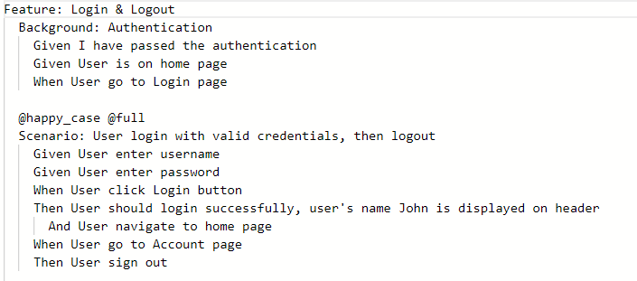

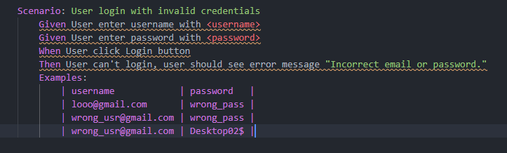

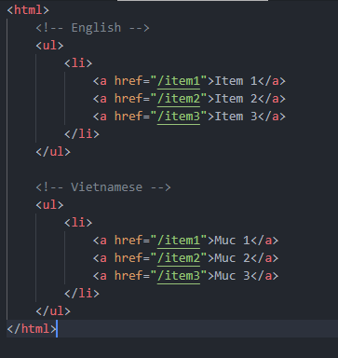

[14:01] Tran Huy Dat

broken link

[14:02] Tran Huy Dat

iframe

[14:03] Tran Huy Dat

new window

[14:06] Tran Huy Dat

window popup

[14:07] Tran Huy Dat

browser.execute()

[14:07] Tran Huy Dat

$shadow

[14:08] Tran Huy Dat

UI Auto Test

[14:08] Tran Huy Dat

UI/UX

[14:09] Tran Huy Dat

Responsive

What is difference between cssvalue and xpath and on which case cssvalue used and xpath used.

What is iframe

Window handles