ECO114 A3 — Unit 8 Graph Pack
Corrected & Complete | Redraw Aids — Not Official Replicas
7 graphs · Exam sentences · Trap warnings · 80%/100% guidance

Graph | Must Draw | Key Labels | Trap
1. Equilibrium | D↓, S↑, intersection | P*, Q*, E | No shortage at equilibrium
2. Tax Wedge | D, S, S+tax above | Qt, Pb, Ps, revenue rect, DWL Δ | Revenue uses Qt NOT Q*
3. Price Ceiling | Horizontal line BELOW P* | Qs left, Qd right, shortage | Ceiling above P* = non-binding
4. Price Floor | Horizontal line ABOVE P* | Qd left, Qs right, surplus | Floor below P* = non-binding
5. CS / PS | D, S, price line, shade | CS above P; PS below P | Never swap the triangles
6. Price-taking firm | Horizontal P=MR, MC, AC, AVC | q*, profit/loss rect, shutdown | Horizontal demand — NOT downward
7. Long-run eq. | MC, AC meeting at min AC | P=MC=min AC point | Normal profit = zero economic profit

Graph 1: Demand/Supply Equilibrium
A competitive market clears where demand meets supply. At P*, Qd = Qs — no shortage or surplus.
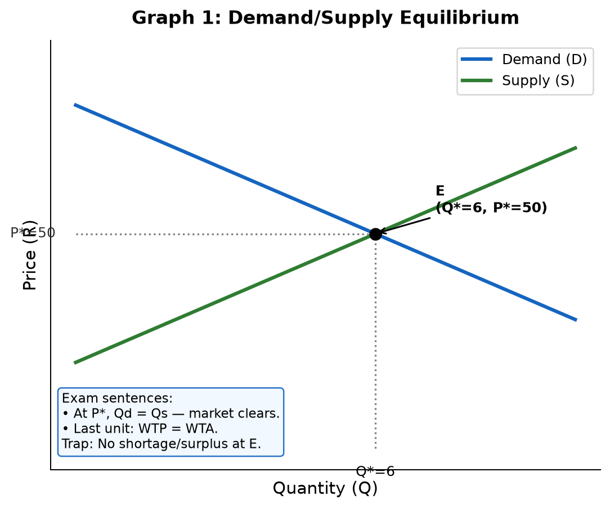
How to draw: P on y-axis, Q on x-axis. Draw D downward, S upward. Mark E at intersection; dashed lines to P* and Q*.
Exam: At P*, Qd = Qs, so the market clears. For the last unit, willingness to pay equals willingness to accept.
TRAP: Do NOT label a shortage or surplus at equilibrium. Shortage/surplus only arise when price is forced away from P*.
80%: axes, D/S, correct E, P*/Q*. | 100%: add interpretation sentence about the last unit traded.

Graph 2: Tax Wedge, Revenue & DWL
A per-unit tax shifts supply UP by the tax amount, creating a wedge between buyer price (Pb) and seller price (Ps).
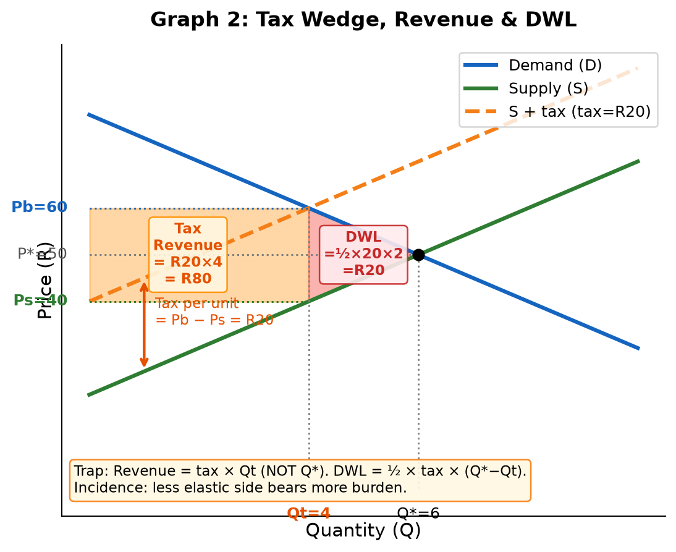
How to draw: D and S first. Shift S up by tax → S+tax. New intersection gives Qt. Read Pb from D at Qt; read Ps from S at Qt. Shade revenue rectangle (Pb to Ps, width Qt). Shade DWL triangle (Qt to Q*).
Key formulas:
Tax per unit = Pb − Ps | Revenue = tax × Qt | DWL = ½ × tax × (Q* − Qt)
Buyer burden = Pb − P* | Seller burden = P* − Ps | Buyer burden + Seller burden = tax
Exam: A per-unit tax creates a wedge between buyer price and seller price. Revenue = R20 × Qt. DWL = ½ × R20 × (Q*−Qt) — the triangle of mutually beneficial trades that no longer occur.
Exam: Incidence: the less elastic side bears more of the tax burden, regardless of who legally pays.
TRAP: Revenue uses Qt (post-tax quantity), NOT Q* (pre-tax). Using Q* gives an inflated revenue — this is the classic trap.
TRAP: DWL is a triangle (½ × base × height). Tax revenue is the rectangle. Do not mix them up.
80%: correct wedge, Pb/Ps, Qt, revenue formula used correctly. | 100%: fully labelled graph + incidence rule with direction + ceiling comparison.

Graph 3: Binding Price Ceiling (Shortage)
A price ceiling is a legal maximum price. It binds only when set BELOW equilibrium price.
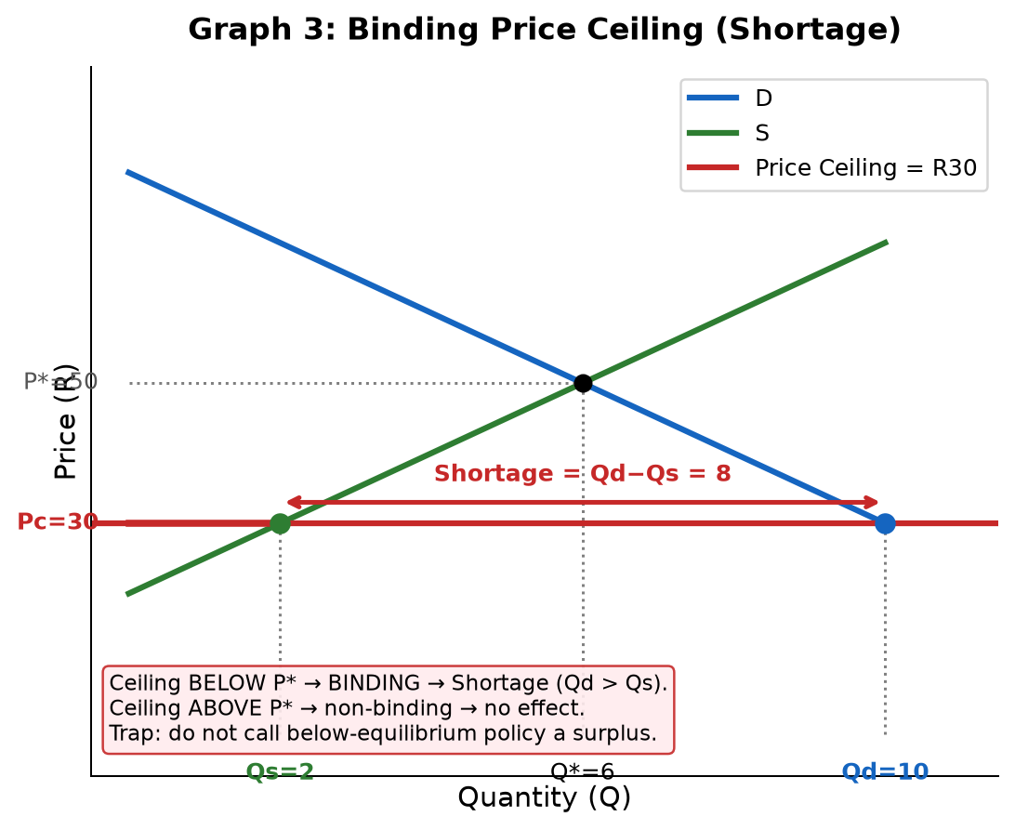
How to draw: Draw D/S equilibrium first. Draw horizontal ceiling line BELOW P*. At ceiling price: read Qs from S (left) and Qd from D (right). Mark shortage = Qd − Qs.
Exam: Because the ceiling is below P*, Qd exceeds Qs. The shortage equals Qd − Qs units.
Exam: A binding price ceiling creates a shortage, not a surplus.
TRAP: A ceiling ABOVE P* is non-binding — it has no effect on the market.
TRAP: The shortage is at the ceiling price, not at the equilibrium. Use ceiling-price quantities.
80%: correct below-P* line, Qs left, Qd right, shortage label. | 100%: state non-binding rule + explain welfare (CS and PS affected, DWL created).

Graph 4: Binding Price Floor (Surplus)
A price floor is a legal minimum price. It binds only when set ABOVE equilibrium price.
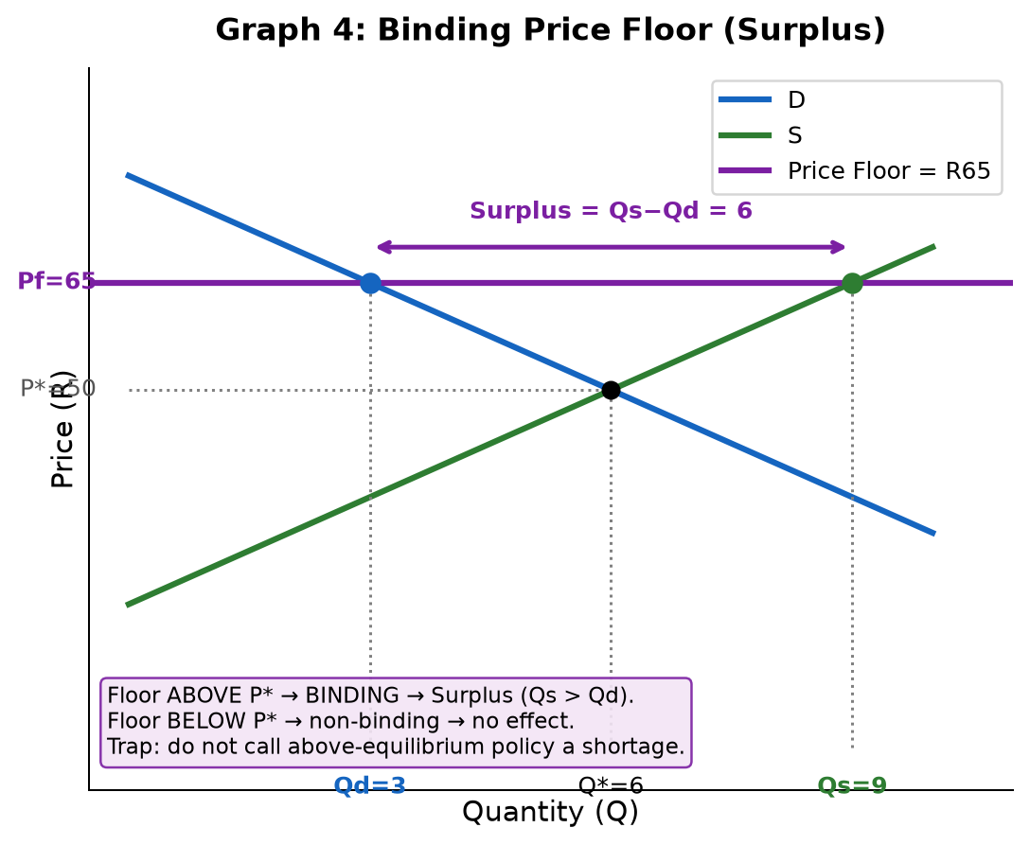
How to draw: Draw D/S equilibrium first. Draw horizontal floor line ABOVE P*. At floor price: read Qd from D (left) and Qs from S (right). Mark surplus = Qs − Qd.
Exam: Because the floor is above P*, Qs exceeds Qd. The surplus equals Qs − Qd units.
Exam: A binding price floor creates a surplus — quantity supplied exceeds quantity demanded.
TRAP: A floor BELOW P* is non-binding — it has no effect on the market.
TRAP: Minimum wage is a price floor on labour. If set above equilibrium wage: surplus of labour = unemployment.
80%: correct above-P* line, Qd left, Qs right, surplus label. | 100%: non-binding rule + real-world example (minimum wage).

Graph 5: Consumer Surplus & Producer Surplus
CS = gain to buyers (paid less than WTP). PS = gain to sellers (received more than their cost).
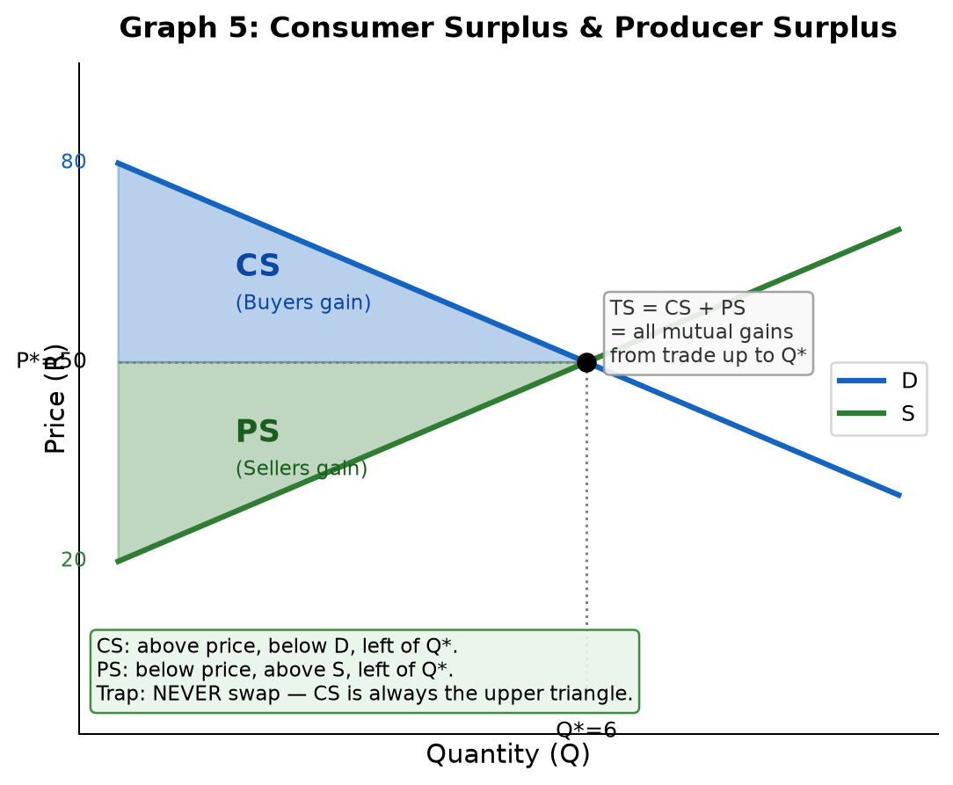
How to draw: D and S at equilibrium. Price line P*. CS = triangle ABOVE price, BELOW demand, left of Q*. PS = triangle BELOW price, ABOVE supply, left of Q*.
Total surplus = CS + PS = all mutual gains from trade at competitive equilibrium. At Q*, all units where WTP ≥ MC are traded → efficient (no DWL).
Exam: CS + PS = total surplus. At competitive equilibrium, all mutually beneficial trades up to Q* occur — total surplus is maximised.
TRAP: NEVER swap the triangles. CS is always the upper triangle (above price). PS is always the lower triangle (below price).
TRAP: After a tax: TS = remaining CS + remaining PS + tax revenue. DWL = the triangle between Qt and Q* that is LOST from all three.
80%: correct triangle positions + price line. | 100%: welfare interpretation ("all mutual gains from trade") + DWL explanation after policy change.

Graph 6: Price-Taking Firm — Profit, Loss & Shutdown Rule
A price-taking firm accepts market price as given. Its demand is horizontal: P = MR = AR.
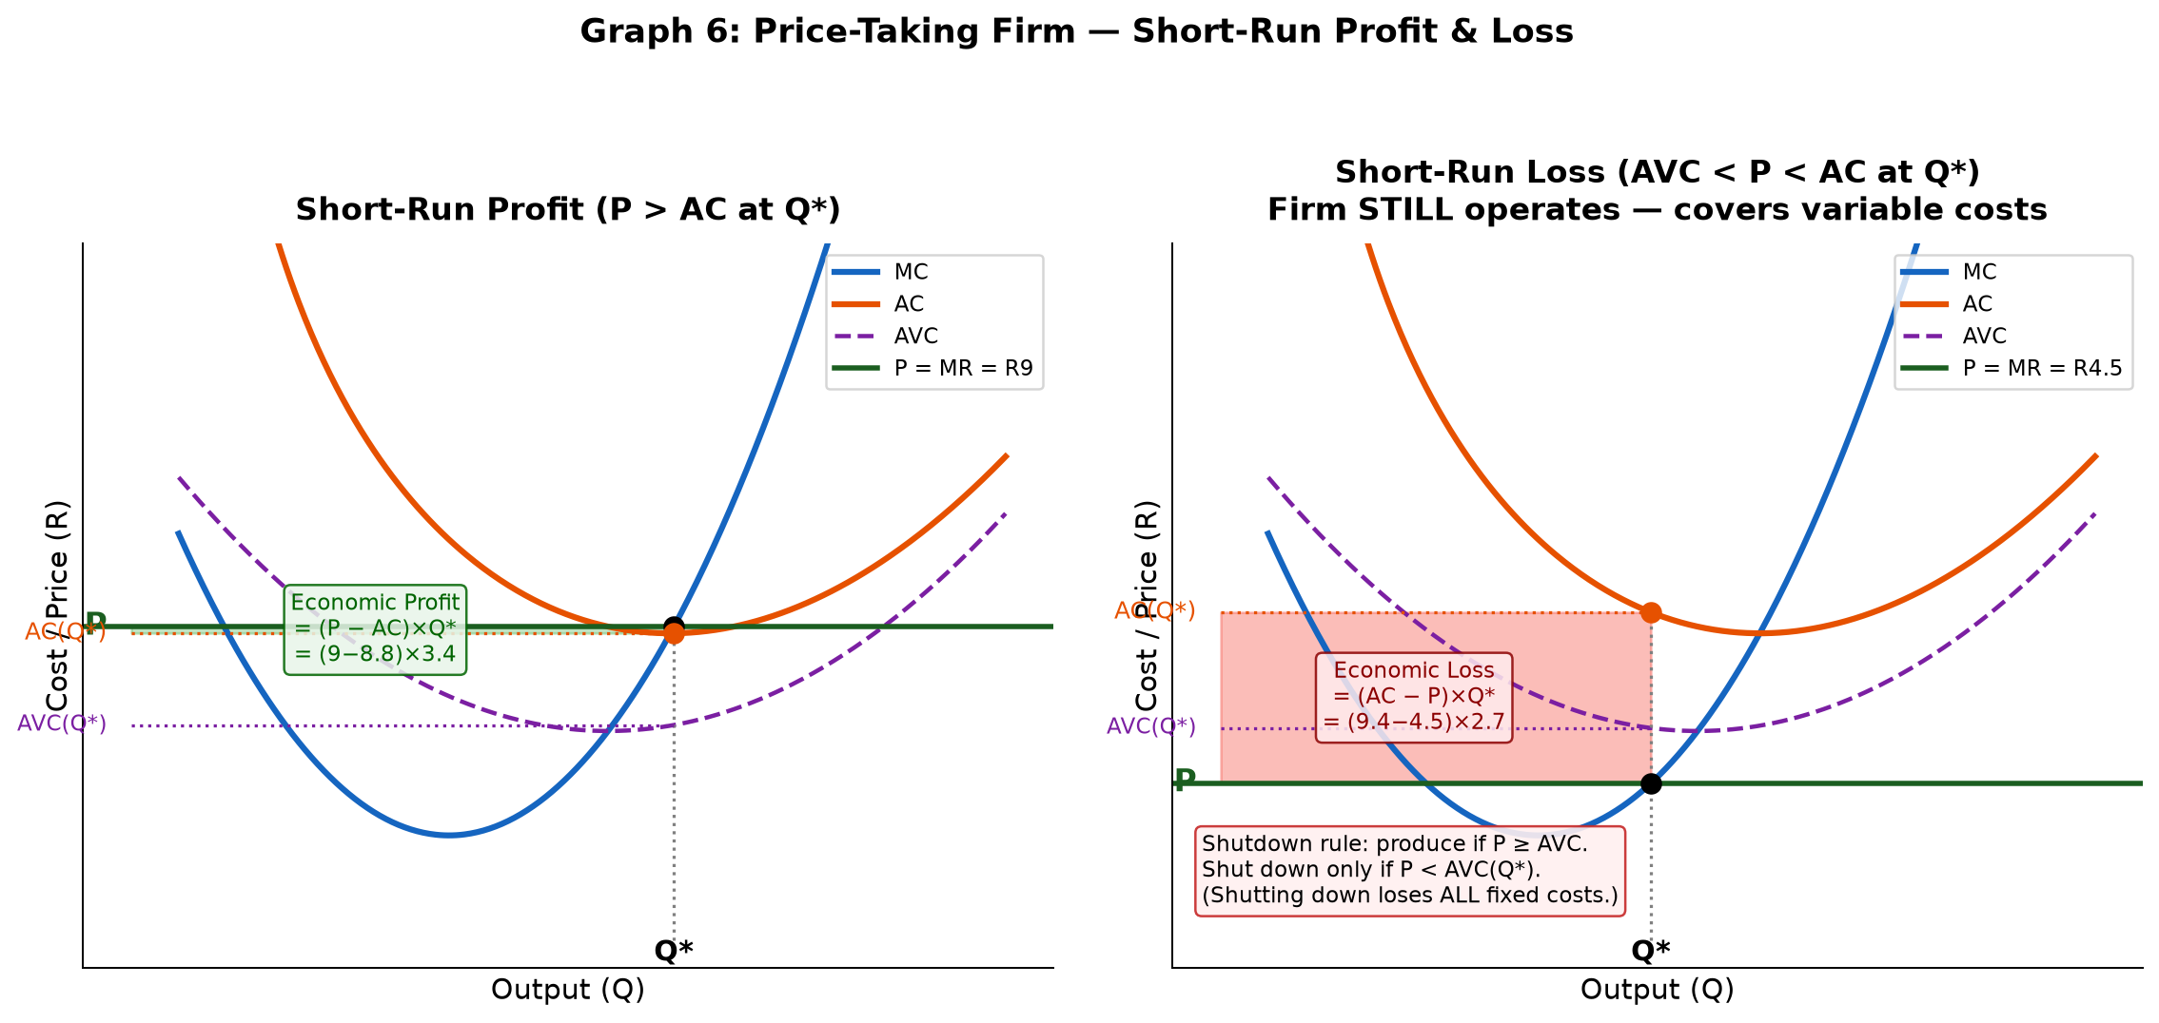
How to draw: Horizontal P=MR line. U-shaped MC and AC. Mark q* where P intersects rising part of MC. Compare P with AC(q*) for profit/loss.
Profit/Loss formulas:
Profit = (P − AC(q*)) × q* [when P > AC → green rectangle]
Loss = (AC(q*) − P) × q* [when AVC < P < AC → red rectangle]
Shutdown rule: Firm operates in short run if P ≥ AVC. Firm shuts down only if P < AVC. (Shutting down = lose ALL fixed costs. Operating at P ≥ AVC = lose less.)
Exam: A price-taking firm accepts the market price as given, so its demand curve is horizontal and P = MR = AR. Profit is maximised where P = MC. Profit/loss is determined by comparing P with AC(q*), NOT with MC.
Exam: A firm making a short-run loss will still operate if P ≥ AVC, because it covers variable costs and contributes something toward fixed costs.
TRAP: Do NOT compare P with MC to find profit/loss. Use AC(q*). Also: profit rectangle uses AC, NOT AVC.
TRAP: Individual firm demand is HORIZONTAL — not downward sloping. The downward demand is the MARKET demand.
80%: horizontal P=MR, q* at P=MC, identify profit/loss by P vs AC. | 100%: AVC curve + shutdown rule + long-run note.

Graph 7: Long-Run Competitive Equilibrium (P = MC = min AC)
In the long run, entry/exit drives economic profit to zero. The equilibrium condition is P = MC = min AC.
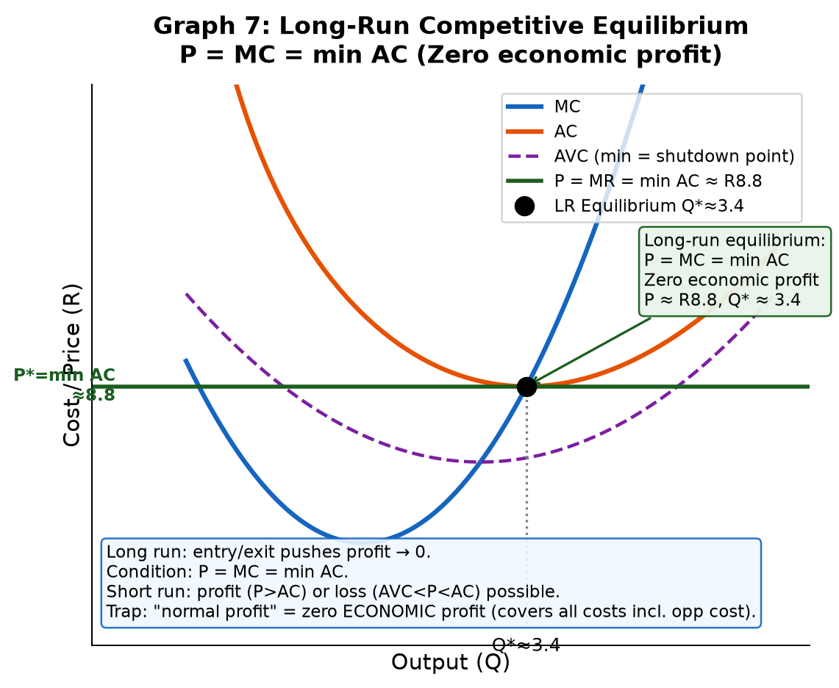
How to draw: MC and AC curves (and AVC for completeness). Mark min AC point where MC crosses AC from below. Draw horizontal P=MR at min AC level. This is the long-run equilibrium.
Why P = MC = min AC?
• If P > AC: firms earn economic profit → new firms enter → supply increases → P falls.
• If P < AC: firms make losses → some exit → supply decreases → P rises.
• At P = AC: zero economic profit → no incentive to enter or exit → long-run equilibrium.
• At the minimum of AC: MC = AC (calculus / cost property). So P = MC = min AC.
Exam: In long-run competitive equilibrium, entry and exit drive economic profit to zero. At this point, P = MC = min AC: the firm produces at minimum average cost (efficient scale) and earns only normal profit.
TRAP: Normal profit ≠ zero. It means zero ECONOMIC profit — all costs including opportunity cost are covered. The firm earns a normal return on capital.
TRAP: Short-run equilibrium only requires P = MC. Long-run adds P = min AC (entry/exit has done its work).
80%: state P = MC = min AC + explain entry/exit mechanism. | 100%: draw the diagram with min AC point marked + distinguish economic vs normal profit.

Closed-Book Drill Schedule
Task | Time | Pass rule
Redraw equilibrium. Write: "Qd=Qs at P*. No shortage at E." | 90 sec | All axes, labels, E, trap sentence correct.
Redraw tax wedge. Label Qt, Pb, Ps, revenue rectangle, DWL triangle. | 2 min | Correct wedge + Qt for revenue + DWL formula stated.
Redraw price ceiling (shortage) AND price floor (surplus) side by side. | 90 sec | Ceiling below P* → shortage. Floor above P* → surplus.
Redraw CS/PS triangles. Explain which belongs to buyers/sellers. | 90 sec | Correct triangle positions, no swap.
Redraw price-taking firm (profit case). Label all curves. | 2 min | Horizontal P=MR, q*, AC, profit rectangle, AVC shown.
Redraw long-run equilibrium. State the full condition. | 90 sec | P = MC = min AC, zero economic profit explained.
Write the 4 core formulas from memory (revenue, DWL, profit, loss). | 60 sec | All 4 correct without notes.
Strict rule: If you cannot redraw a graph cleanly from memory with all labels, it is NOT mastered yet.

