ECO114 A3 — Units 1 & 2 Graph Pack
10 Exam Graphs | Redraw Aids | Trap Warnings | 80%/100% Guidance
Sources: Unit 1 & 2 lecture slides (2026). Redraw aids only — not official replicas.

# | Graph | Key Labels / Points | Core Trap
1 | Hockey Stick (GDP over time) | Kink ~1800, flat before, rapid after | "GDP per capita ≠ wellbeing; ignores inequality"
2 | Production function (farmers → grain) | Points A, B; APL slopes; concave curve | APL ≠ MPL. Slope from origin = APL; tangent = MPL.
3 | Malthusian equilibrium (APL vs pop) | APL curve, subsistence line, E*, arrows | E* is stable — any deviation is self-correcting via population.
4 | Malthus: tech improvement (E→F→G) | E (old eq), F (APL rises), G (new eq) | Tech improvement does NOT permanently raise wages in Malthusian model.
5 | Technology choice (5 techs) | A,B,C,D,E plotted; dominated C and D | Dominated = more of ≥1 input, no less of any other. Never chosen.
6 | Isocost: expensive coal (w=10,p=20) | J(0,4), H(8,0); B on £80 isocost | Slope = −w/p = −10/20 = −½. Not −p/w.
7 | Cheap coal (w=10,p=5): A cheapest | F(4,0),G(0,8); A on £40 isocost | Innovation rent = £10 = B cost − A cost = £50−£40.
8 | Industrial Revolution: 1600s vs 1700s | HJ (1600s, coal dear) vs FG (1700s, coal cheap) | Price change SHIFTS isocost slope — technologies stay fixed.
9 | Escaping Malthusian trap | Multiple APL curves rising over time | PERMANENT tech revolution required. One-off improvement ≠ escape.
10 | Economic rent & opportunity cost | Table: net benefit, opp cost, rent | Economic rent = surplus above reservation option — NOT land rent.

Graph 1: The Hockey Stick — GDP per Capita over Time
GDP per capita across history shows ~700 years of stagnation, then a dramatic upward kink around 1800 — the Industrial Revolution.
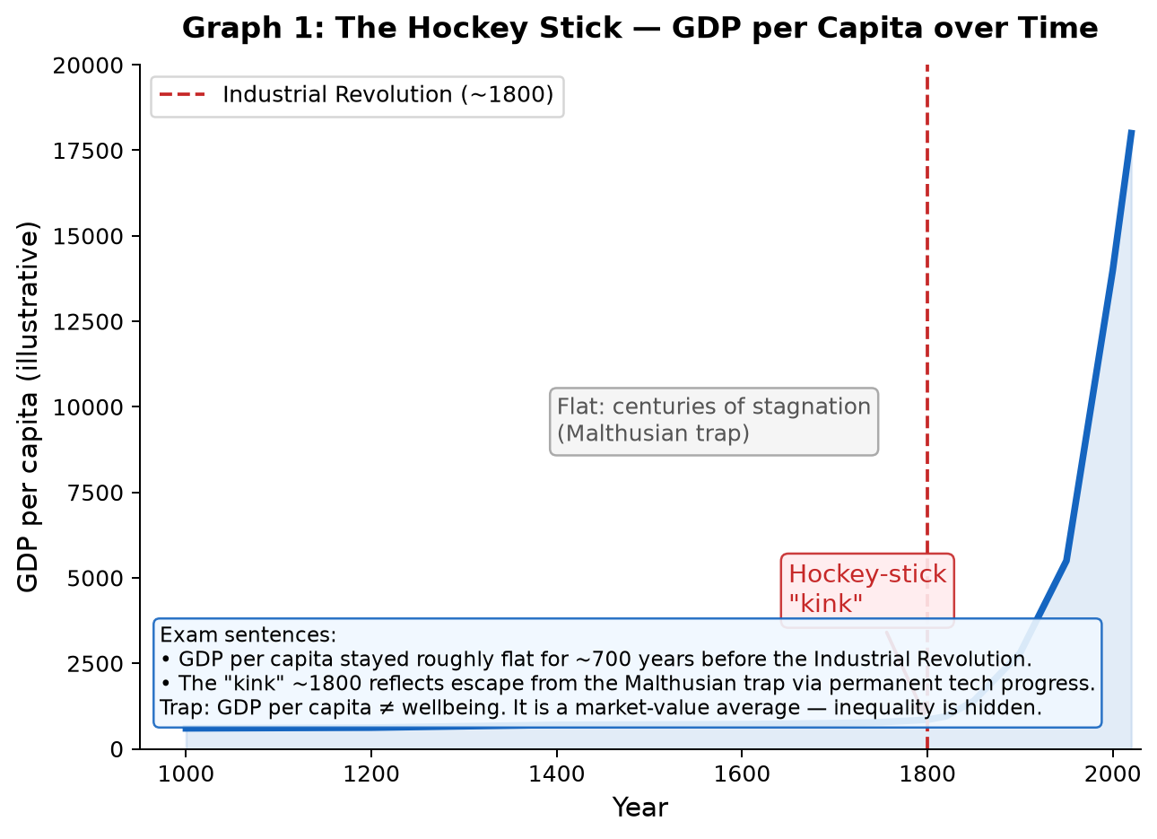
What the graph shows:
• From ~1000–1800: GDP per capita stayed near subsistence. This is the Malthusian trap.
• Around 1800: Britain escapes with the Industrial Revolution → permanent tech progress.
• The kink happens at different times in different countries (UK earliest, then Europe/US, then Asia/Africa).
✎ Exam: GDP per capita is the market value of all final goods and services produced in a country, divided by population. It measures average income, not wellbeing.
✎ Exam: The hockey-stick pattern reflects the escape from the Malthusian trap through permanent technological progress and capitalism.
⚠ TRAP: GDP per capita (a) ignores distribution/inequality (b) excludes unpaid work (c) includes "bads" like pollution clean-up. GDP ↑ does not mean everyone is better off.
⚠ TRAP: "Countries with high GDP are capitalist" does not prove capitalism caused growth — correlation ≠ causation. Use natural experiments to test causation.
80%: Define GDP per capita, identify the kink, name the Malthusian trap. | 100%: Add: why different countries have different kink dates; why GDP ≠ wellbeing; natural experiment logic for causation.

Graph 2: Production Function — Diminishing Average Product
A concave production function shows how output increases as more labour is added to fixed land — but at a decreasing rate.
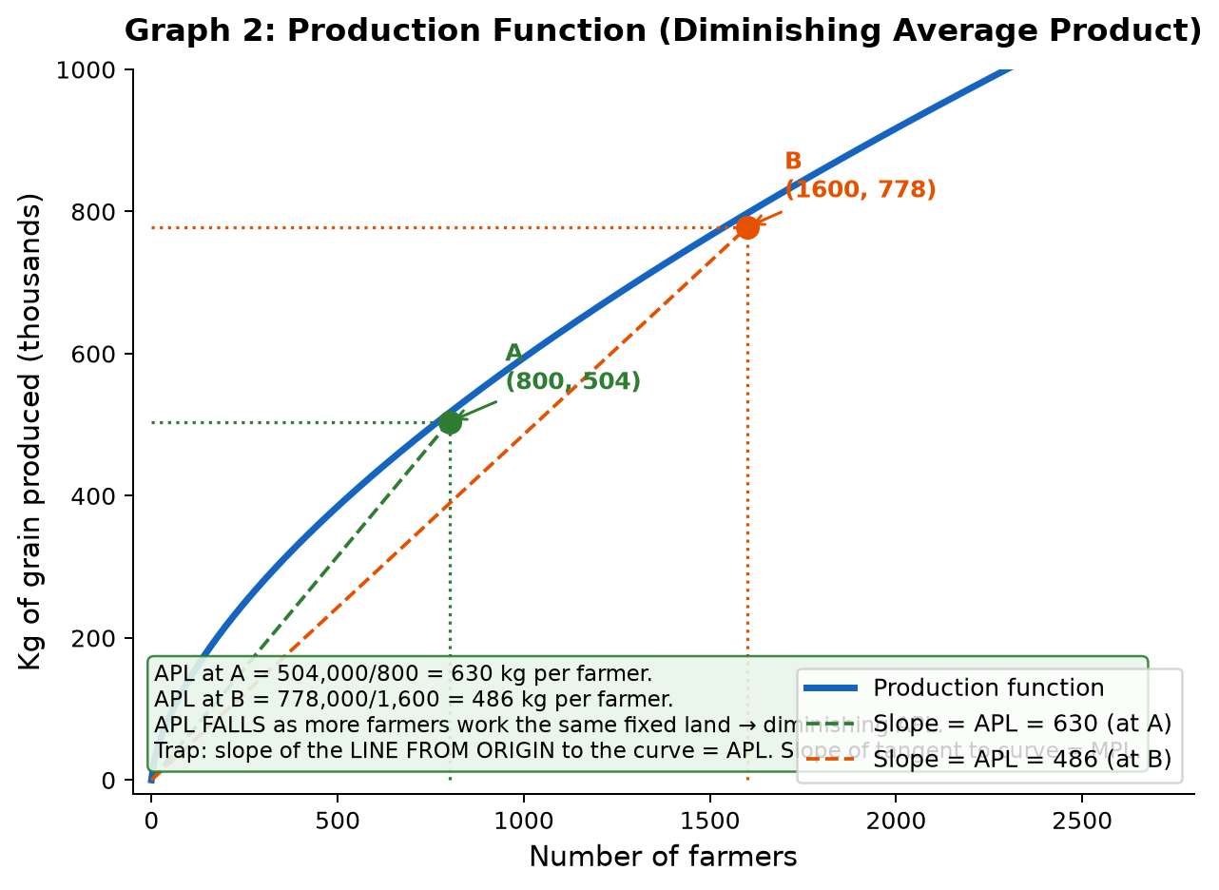
Axes: Number of farmers (x) | Kg of grain produced — thousands (y)
Key points from the lecture:
• Point A: 800 farmers → 504,000 kg of grain. APL = 504,000 / 800 = 630 kg per farmer.
• Point B: 1,600 farmers → 778,000 kg of grain. APL = 778,000 / 1,600 = 486 kg per farmer.
• APL falls from 630 to 486 as farmers double → diminishing average product of labour.
✎ Exam: The farmer's production function shows how the number of farmers translates into grain produced. The function is concave — the more farmers work a fixed quantity of land, the lower the average product of labour.
✎ Exam: Slope of the line from the origin to any point on the curve = average product of labour (APL = total output / total labour). APL falls as labour increases on fixed land.
⚠ TRAP: APL (average product) ≠ MPL (marginal product). APL = slope from ORIGIN to curve. MPL = slope of TANGENT to curve (rate of change). Both diminish as labour rises.
⚠ TRAP: Do not confuse "more output" with "higher APL". Moving from A to B: output rises (from 504k to 778k) but APL falls (630→486). Adding labour still produces more grain, just less per farmer.
80%: Draw concave curve; mark A and B; calculate APL at each; state APL falls as labour rises. | 100%: Add: distinguish APL (slope from origin) vs MPL (tangent slope); explain WHY APL falls (inferior land, fixed land constraint).

Graph 3: Malthusian Equilibrium — APL and Subsistence Income
The Malthusian model predicts that incomes stabilise at subsistence level through a self-correcting population mechanism.
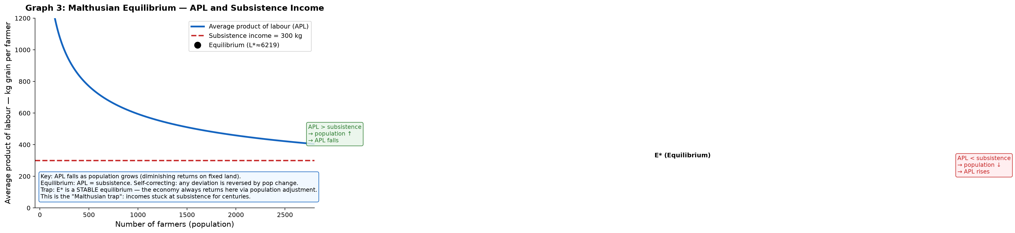
Axes: Number of farmers / population (x) | Average product of labour — kg per farmer (y)
How to draw:
1. Downward-sloping APL curve (reflects diminishing returns from Graph 2).
2. Horizontal subsistence income line.
3. Equilibrium E* at intersection.
4. Arrows showing self-correction: above sub → pop ↑ → APL ↓; below sub → pop ↓ → APL ↑.
✎ Exam: "In Malthusian equilibrium, the average product of labour equals subsistence income. Any deviation is self-correcting through population adjustment."
✎ Exam: APL above subsistence: people have more children → population rises → APL falls back to subsistence. APL below subsistence: mortality rises → population falls → APL rises back.
⚠ TRAP: E* is a STABLE equilibrium, not a "desirable" outcome. The economy always returns to subsistence — this is the tragedy of the Malthusian trap.
⚠ TRAP: "Malthusian equilibrium is inefficient" — True, but the model shows it is self-sustaining without external tech shock. Do not say the economy "chooses" subsistence.
80%: Draw APL curve + subsistence line; mark E*; state the self-correction mechanism. | 100%: Add: explain WHY APL slopes down (fixed land, diminishing returns); annotate both arrows with population logic; state E* is stable.

Graph 4: Malthus — Effect of Technology Improvement (E → F → G)
A technology improvement temporarily raises APL above subsistence, but the Malthusian trap re-asserts itself through population growth.
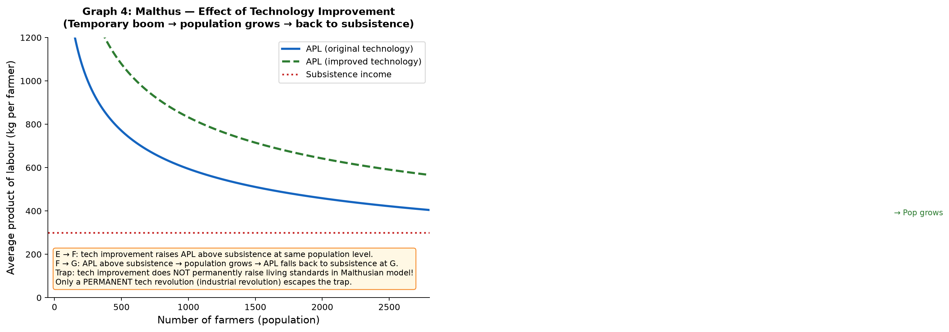
Three key points:
• E: Original equilibrium — APL = subsistence on old technology curve.
• F: After tech improvement — same population, but APL is now ABOVE subsistence (on new curve). Living standards temporarily rise.
• G: New equilibrium — population grows until APL falls back to subsistence level on the new technology curve.
✎ Exam: "A one-off technology improvement in the Malthusian model temporarily raises APL above subsistence at F. This causes population growth, which reduces APL until the new equilibrium G is reached — still at subsistence, but with a larger population."
⚠ TRAP: Technology improvement does NOT permanently escape the trap in Malthus's model! The population absorbs the gains. Only a PERMANENT, CONTINUOUS technological revolution (like the Industrial Revolution) can escape.
⚠ TRAP: G is at the SAME subsistence level as E, but at higher population. Do not say G has higher income than E.
Why Britain escaped (3 conditions of the Malthusian trap — ALL must hold for trap to persist):
1. Diminishing APL — still true in modern economies to some degree.
2. Population grows when APL > subsistence — weakened by birth control, urbanisation.
3. No PERMANENT tech improvement — THIS condition failed after the Industrial Revolution.
80%: Draw both APL curves + subsistence; identify E, F, G; explain population adjustment. | 100%: Add: explicitly state all 3 conditions; explain which condition the Industrial Revolution violated; use "permanent tech revolution" language.

Graph 5: Technology Choice — 5 Technologies (Fig 2.5)
Five technologies for producing 100 metres of cloth are plotted by their input requirements (workers vs coal tonnes).
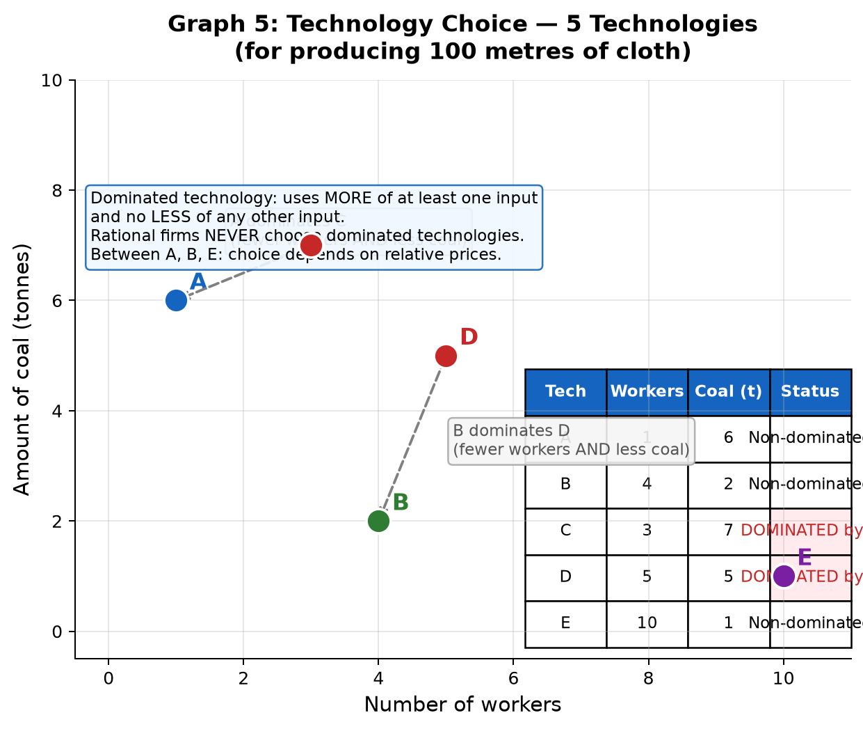
Technologies (from lecture slides):
A: 1 worker, 6 tonnes coal | B: 4 workers, 2 tonnes | C: 3 workers, 7 tonnes
D: 5 workers, 5 tonnes | E: 10 workers, 1 tonne
Dominated technologies (NEVER chosen by rational firm):
• C is dominated by A: A uses 1 worker (< 3) AND 6 coal (< 7). A wins on both inputs.
• D is dominated by B: B uses 4 workers (< 5) AND 2 coal (< 5). B wins on both inputs.
• E is not dominated: it uses less coal than A and B, but more workers.
✎ Exam: "A technology dominates another if it requires less of at least one input and no more of any input. A rational firm never uses a dominated technology."
✎ Exam: "After ruling out dominated technologies C and D, the firm must choose between A, B, and E based on relative input prices."
⚠ TRAP: Dominated technology: uses more of ≥1 input AND no less of any other. If one tech uses more coal but fewer workers, it is NOT necessarily dominated — it depends on relative prices.
⚠ TRAP: "E uses the most workers so it is dominated" — FALSE. E uses the least coal (1 tonne). No single technology dominates E on all inputs.
80%: Plot all 5 points; identify dominated C and D; state which 3 remain viable. | 100%: Add: precise definition of dominance; explain why relative prices determine the final choice among A, B, E.

Graph 6: Isocost Line — Expensive Coal (w=£10, p=£20)
The isocost line shows all input combinations that cost the same total. With w=£10 and p=£20, technology B is cheapest.
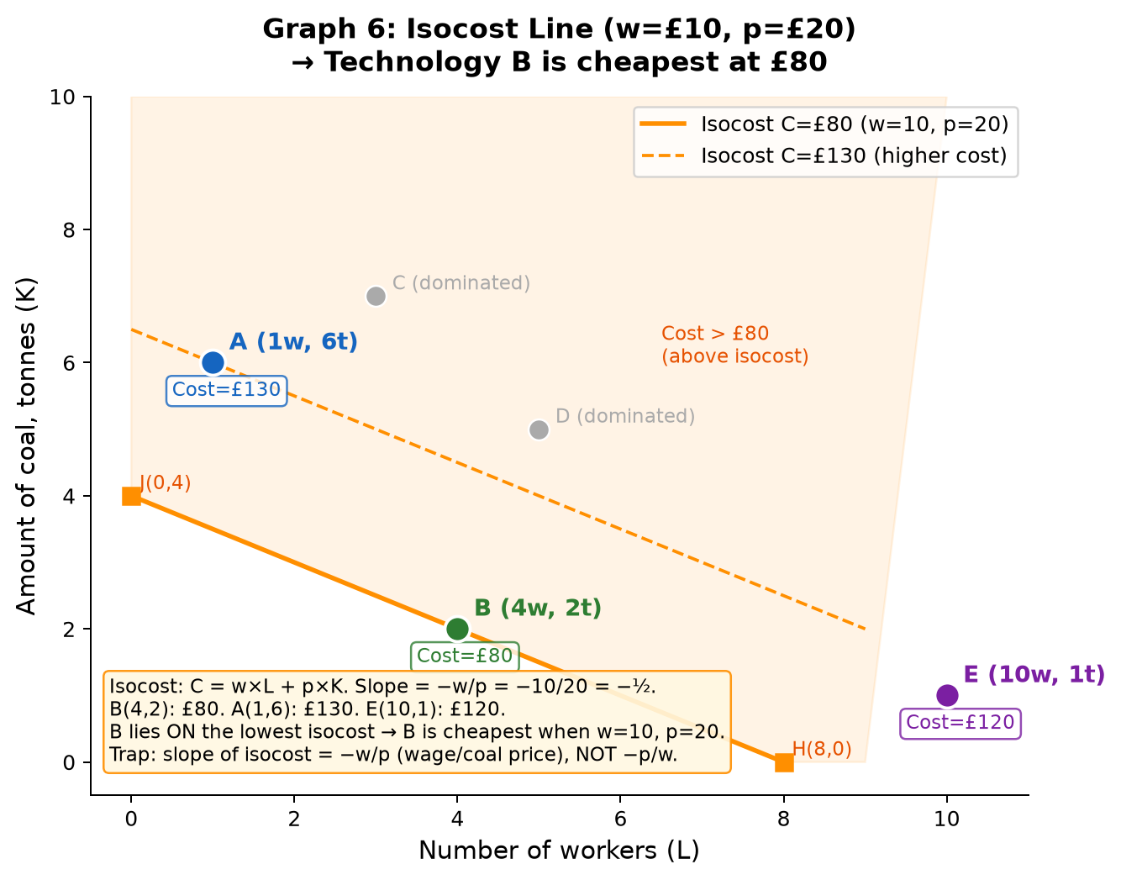
Key calculations (from lecture slides):
Cost = w × workers + p × coal. With w=10, p=20:
• Technology A: 10×1 + 20×6 = £130
• Technology B: 10×4 + 20×2 = £80 ← cheapest, lies ON the £80 isocost
• Technology E: 10×10 + 20×1 = £120
Isocost equation: K = C/p − (w/p)×L = C/20 − ½×L
• At C=£80: J(0, 4) on coal axis; H(8, 0) on labour axis. Slope = −w/p = −½.
✎ Exam: "An isocost line represents all combinations of labour and coal that cost the same total amount. Its slope is −w/p. A firm minimises cost by choosing the technology on the lowest isocost."
✎ Exam: "When wages=£10 and coal=£20, technology B lies on the lowest isocost (£80). A and E cost more. B is the profit-maximising technology choice."
⚠ TRAP: Slope of isocost = −w/p (labour price ÷ capital price). NOT −p/w. This is the relative price of labour in terms of coal.
⚠ TRAP: "The firm minimises cost by choosing the point closest to the origin" — only true if all choices lie on the same curve (isoquant). Here, A, B, E produce the SAME output (100m cloth), so the cheapest wins.
80%: Draw isocost with correct intercepts J and H; show B on the line; state B is cheapest. | 100%: Add: full cost calculations for A, B, E; isocost equation with slope = −w/p; explain shaded area above = higher cost.

Graph 7: Cheap Coal (w=£10, p=£5) — A becomes cheapest; Innovation Rent
When coal price falls from £20 to £5, the isocost slope steepens and technology A becomes the cost-minimising choice.
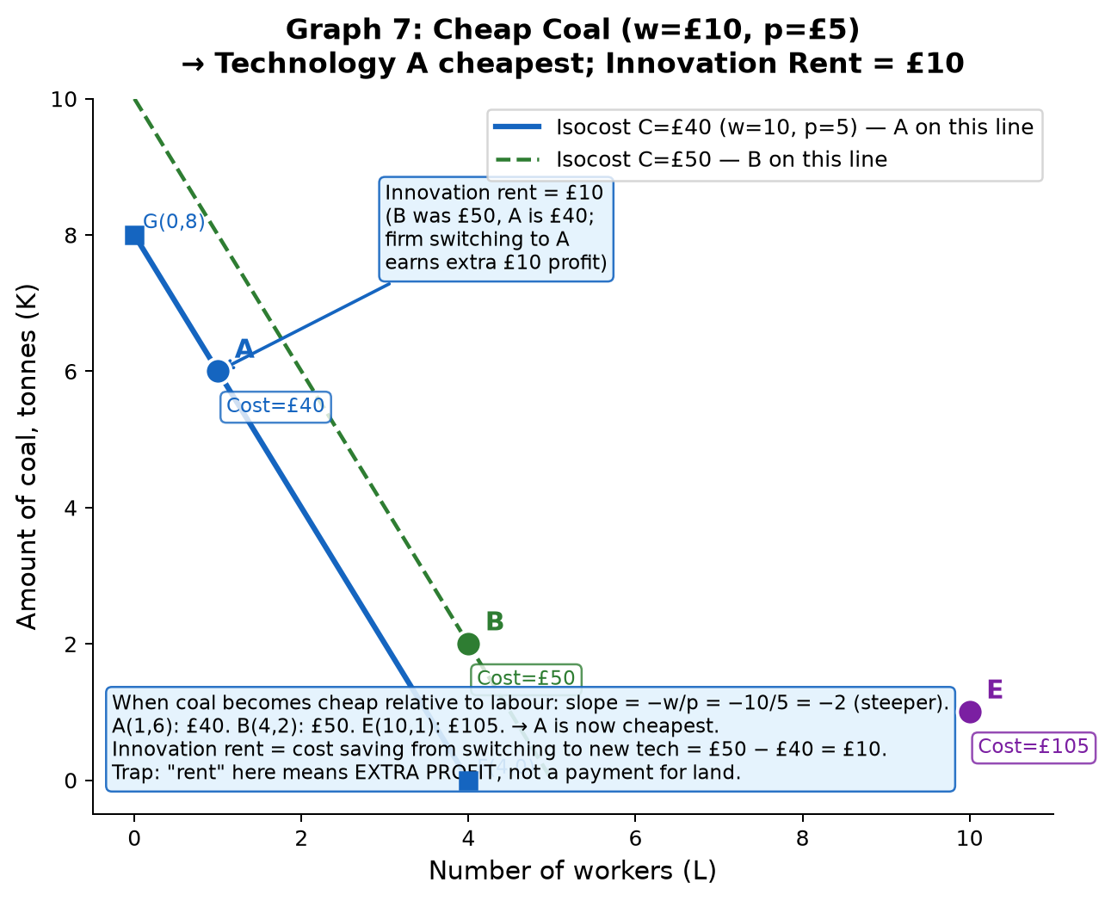
Key calculations (from lecture slides, w=10, p=5):
• Technology A: 10×1 + 5×6 = £40 ← now cheapest, lies ON the £40 isocost
• Technology B: 10×4 + 5×2 = £50
• Technology E: 10×10 + 5×1 = £105
New isocost slope: −w/p = −10/5 = −2 (steeper, because labour is now relatively MORE expensive).
• At C=£40: G(0, 8) on coal axis; F(4, 0) on labour axis.
Innovation rent:
• If a firm FIRST adopts A while competitors still use B, it saves £50 − £40 = £10 per batch.
• This extra profit (£10) is the innovation rent — the temporary reward for adopting new technology.
• Long run: all firms adopt A → no more rent → firms using old B go bankrupt.
✎ Exam: "When coal becomes cheap relative to labour, the isocost slope steepens. Technology A (coal-intensive) becomes cheapest. The first firm to adopt A earns an innovation rent equal to the cost saving over B."
⚠ TRAP: "Innovation rent persists forever" — FALSE. In the long run, competitors adopt the same technology, competition drives price down, and the rent disappears. Innovation rents are TEMPORARY.
⚠ TRAP: Do not confuse "economic rent" (surplus above reservation option) with "land rent" (payment for land). Innovation rent is the economic profit from being first to adopt new tech.
80%: Draw steep isocost; show A on the lowest line; state A is cheapest; define innovation rent. | 100%: Add: calculate cost of A, B, E at new prices; calculate innovation rent explicitly; explain long-run erosion of rent.

Graph 8: Industrial Revolution in Britain — 1600s vs 1700s Isocosts
Britain's high wages and cheap coal shifted the isocost slope, making capital-intensive technology A optimal by the 1700s — triggering the Industrial Revolution.
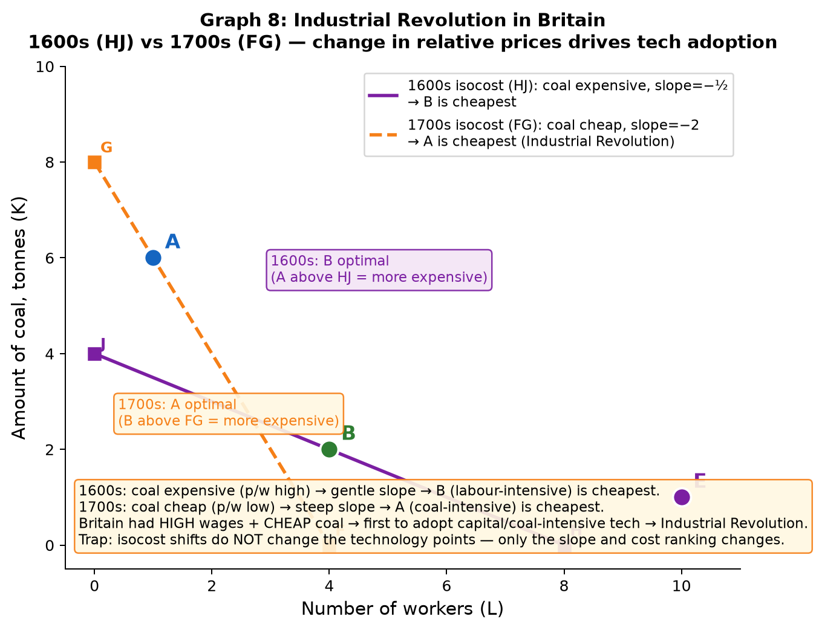
Two isocosts on the same technology diagram:
• 1600s (isocost HJ, gentle slope): Coal is expensive relative to labour. Slope ≈ −½.
→ B (labour-intensive, 4 workers, 2 coal) lies on the lowest isocost. A costs more.
→ No incentive to adopt capital-intensive technology A.
• 1700s (isocost FG, steep slope): Coal is CHEAP relative to labour. Slope ≈ −2.
→ A (coal-intensive, 1 worker, 6 coal) now lies on the lowest isocost. B costs more.
→ Firms have incentive to switch to A → innovation rents available → Industrial Revolution.
Robert Allen's theory: Britain had BOTH high wages AND cheap coal → uniquely positioned to profit from coal-intensive technology. This is why Britain industrialised first.
✎ Exam: "The slope of the isocost line changes when relative input prices change. In 1700s Britain, cheap coal and expensive labour made the isocost steeper, so capital-intensive technology A became cheapest. This changed the incentive to innovate."
⚠ TRAP: The technologies A, B, E are fixed points — they don't move when prices change. Only the isocost SLOPE changes. A firm's choice changes because a different technology now hits a lower isocost.
⚠ TRAP: "Britain had better technology first" is incomplete. Britain had the RIGHT relative prices (cheap coal, expensive labour) that INCENTIVISED adoption of coal-intensive technology.
80%: Draw both isocosts with different slopes; show which technology is optimal in each era; explain relative price change. | 100%: Add: calculate costs at each price ratio; state Allen's theory explicitly; explain why other countries (with cheap labour) had no incentive to industrialise the same way.

Graph 9: Escaping the Malthusian Trap — Permanent Tech Revolution
The Industrial Revolution escaped the Malthusian trap because technological progress was PERMANENT and continuous — APL rose faster than population.
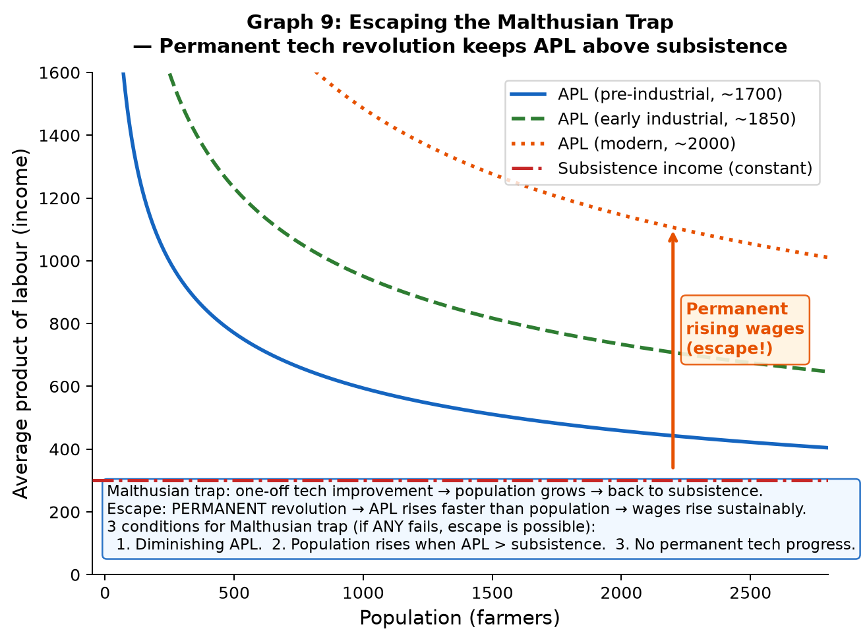
The 3 conditions required for the Malthusian trap to hold:
1. Diminishing APL as population grows (from fixed land).
2. Population grows when APL > subsistence.
3. No PERMANENT improvement in technology.

Condition 3 fails after the Industrial Revolution:
• Before: one-off tech improvement → population grows → APL returns to subsistence (Graph 4).
• After: continuous tech progress → APL rises faster than population grows → permanent income growth.
• Multiple APL curves shift upward over time → wages rise above subsistence sustainably.
✎ Exam: "The Malthusian trap requires three conditions. The Industrial Revolution broke condition 3 — permanent technological progress meant APL kept rising faster than population, allowing sustained increases in living standards."
⚠ TRAP: One-off vs permanent tech change: Malthus assumed tech improvements were temporary. The Industrial Revolution introduced CONTINUOUS innovation (capitalism + competition + incentives). This is the crucial distinction.
⚠ TRAP: "Population growth was the cause of the escape" — FALSE. Population DID grow after 1800, but productivity grew faster, so income per capita still rose.
80%: State all 3 conditions; explain which failed; distinguish one-off vs permanent tech change. | 100%: Add: draw multiple APL curves rising over time; link to isocost model (why firms kept innovating); connect to capitalism providing incentives.

Graph 10: Economic Rent & Opportunity Cost — Core Framework (Unit 2.2)
Economic rent is the surplus benefit from your chosen option above your best alternative (reservation option).
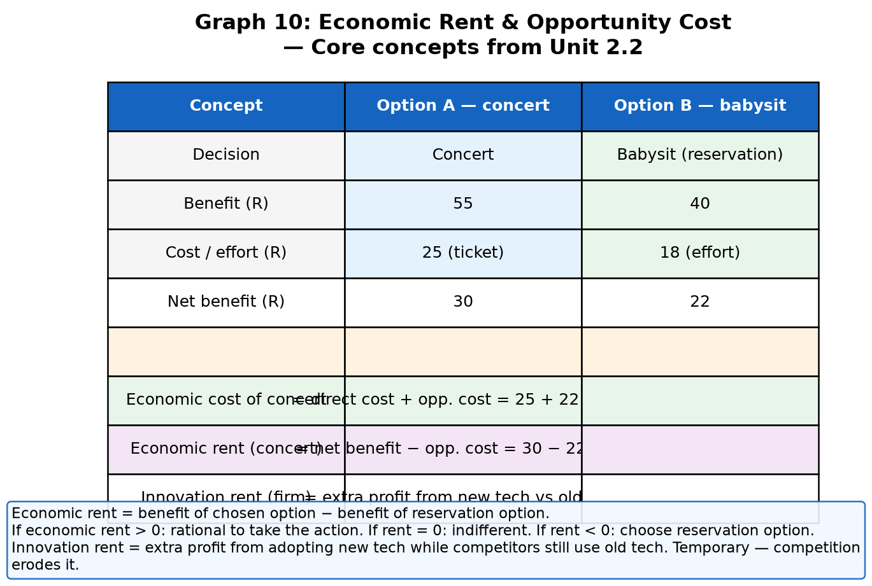
Definitions:
• Reservation option: the next best alternative always available (benchmark).
• Opportunity cost: the NET benefit of the reservation option (what you give up by NOT choosing it).
• Economic rent: NET benefit of chosen option − net benefit of reservation option.
• Innovation rent: extra profit a firm earns from adopting a new technology that competitors have not yet adopted.
Worked example (from lecture):
Concert: benefit £55, ticket cost £25 → net benefit = £30.
Babysit (reservation): payment £40, effort cost £18 → net benefit = £22.
Economic cost of concert = direct cost + opportunity cost = £25 + £22 = £47.
Economic rent from attending concert = £30 − £22 = £8.
✎ Exam: "Economic rent is the benefit of the chosen action minus the benefit of the reservation option. If rent > 0, the action is rational. Innovation rent is the cost saving a firm makes by adopting new technology before its competitors."
✎ Exam: "The possibility of earning a rent creates an economic incentive. Firms innovate to earn innovation rents; these are temporary because competitors eventually adopt the same technology."
⚠ TRAP: "Economic rent" ≠ "land rent". The term "rent" in economics means any surplus above your reservation option. It can apply to workers, firms, or consumers.
⚠ TRAP: "Opportunity cost = the price paid for something" — FALSE. Opportunity cost = NET benefit of the forgone option. In the example, opportunity cost = £22 (net benefit of babysitting), not £40.
80%: Define economic rent; calculate from a given example; state when rent is positive/zero/negative. | 100%: Add: connect innovation rent to isocost model; explain why innovation rents are temporary; distinguish from land rent.

Closed-Book Drill Schedule — Units 1 & 2
Task | Target time | Pass rule
Redraw hockey stick. Mark kink ~1800. Write one GDP limitation. | 60 sec | Kink + flat period + one valid limitation (inequality/unpaid work/bads).
Redraw production function. Mark A(800,504) and B(1600,778). Calculate APL at each. | 2 min | Correct concave shape + both APL calculations + state APL falls.
Redraw Malthusian equilibrium. Draw APL curve, subsistence line, E*. Add both correction arrows. | 90 sec | Both arrows + equilibrium at intersection + stability explained.
Redraw E→F→G diagram. Explain why income does not permanently rise. | 2 min | Three points labelled + population mechanism + "not permanent" stated.
Plot A,B,C,D,E. Circle dominated technologies. Explain which 3 remain viable. | 90 sec | C and D circled + "less of BOTH inputs" explanation + A,B,E viable.
Redraw isocost (w=10,p=20). Plot A,B,E. State which is cheapest and why. | 2 min | Correct intercepts J,H + B on £80 line + costs A=130,B=80,E=120.
Draw new isocost (w=10,p=5). State which tech is now cheapest. Calculate innovation rent. | 2 min | Steep slope + A on £40 line + rent = £50−£40 = £10.
Draw 1600s vs 1700s isocosts on same diagram. State which tech is optimal in each era. | 2 min | Two slopes + B optimal 1600s + A optimal 1700s + Allen's theory named.
State the 3 Malthusian trap conditions. Explain which the Industrial Revolution violated. | 60 sec | All 3 correct + condition 3 (permanent tech change) identified.
Define: economic rent, opportunity cost, reservation option, innovation rent. | 60 sec | All 4 definitions correct — from memory.
Strict rule: A graph is not mastered until you can redraw it with all labels from memory. Missing labels = lost marks.

