ECO114 A3 — All Possible Exam Graphs Master Pack
Stellenbosch University | BAccLLB | ECO114 Assignment 3
Prepared: 2026-06-15 | Version 1.0
19 graphs covering all 9 A3 units (Units 1–8, 10)
⚠ REDRAW AIDS ONLY — NOT OFFICIAL REPLICAS
These diagrams are study redraw aids based on CORE Econ curriculum conventions. They are NOT official reproductions of any exam paper. Axis scales and exact coordinates are illustrative. Always redraw from principles in the exam.

Summary Table — All 19 Graphs
ID | Title | Unit | Exam Use / Status | Must-Know Trap
G01 | Supply & Demand Equilibrium | 8 | Core setup for all market questions  [Past-paper confirmed] | Confusing Qd=Qs with Qd>Qs (shortage label)
G02 | Tax Wedge, Revenue, DWL | 8 | Tax incidence, DWL calculation  [Past-paper confirmed] | Tax shifts supply UP, not down; buyer pays more, seller receives less
G03 | Binding Price Ceiling | 8 | Shortage, rent-seeking, black markets  [Past-paper confirmed] | Ceiling must be BELOW equilibrium to bind; causes shortage
G04 | Binding Price Floor | 8 | Surplus, minimum wage analysis  [Past-paper confirmed] | Floor must be ABOVE equilibrium to bind; causes surplus
G05 | Consumer & Producer Surplus | 8 | Welfare analysis, CS+PS = total surplus  [Past-paper confirmed] | CS is ABOVE price, PS is BELOW price — not the other way
G06 | Price-Taking Firm P=MC | 8 | Competitive firm profit max  [Source confirmed] | P=MR=MC — do not confuse with monopoly where P>MR
G07 | Monopoly MR=MC, Profit, DWL | 7 | Monopoly welfare loss, markup  [Past-paper confirmed] | MR lies inside (steeper than) demand; MR=0 at midpoint of D
G08 | Elasticity Along Linear Demand | 7 | PED, TR analysis  [Source confirmed] | Elastic at top, inelastic at bottom; |e|=1 at midpoint = TR max
G09 | Negative Externality MSC | 10 | Pigouvian tax, DWL, social cost  [Past-paper confirmed] | Qm > Q* (overproduction); tax = MEC at Q*, not at Qm
G10 | Positive Externality MSB | 10 | Pigouvian subsidy, underproduction  [Past-paper confirmed] | Q* > Qm (underproduction); subsidy = MEB at Q*
G11 | Budget Constraint & Feasible Set | 3 | Consumer choice, opportunity sets  [Source confirmed] | Slope = −Px/Py (not −Py/Px)
G12 | MRS = MRT Optimum (IC tangency) | 3 | Consumer optimum, utility max  [Source confirmed] | Tangency, not intersection; MRS = slope of IC = slope of BC
G13 | Wage Increase: Income & Sub Effects | 3 | Labour supply, ambiguous hours  [Past-paper confirmed] | Income effect can outweigh substitution → backward-bending supply
G14 | Angela-Bruno Feasible Frontier | 5 | Bargaining, surplus, fairness  [Reasonable A3 risk] | Production function is concave; subsistence line limits Bruno
G15 | Isocost Lines & Technology Choice | 2 | Cost minimisation, input choice  [Source confirmed] | Dominated technology: more of both inputs — never choose it
G16 | Payoff Matrix & Nash Equilibrium | 4 | Strategic interaction, dominance  [Source confirmed] | Nash ≠ Pareto optimal; check by asking "can either deviate profitably?"
G17 | Labour Discipline Best-Response | 6 | Efficiency wage, involuntary unemployment  [Reasonable A3 risk] | Efficiency wage > market-clearing wage → involuntary unemployment exists
G18 | GDP Hockey Stick | 1 | Long-run growth, Malthusian trap  [Reasonable A3 risk] | GDP per capita (not total GDP); Malthus assumed no tech progress
G19 | Goods Classification Matrix | 10 | Public/private/common/club goods  [Source confirmed] | Common goods ARE rival; Public goods require BOTH non-rival AND non-excludable

G01 — Supply & Demand Equilibrium
Unit: Unit 8 Exam Use: Foundation of all market questions — used in every price/quantity calculation Status: Past-paper confirmed
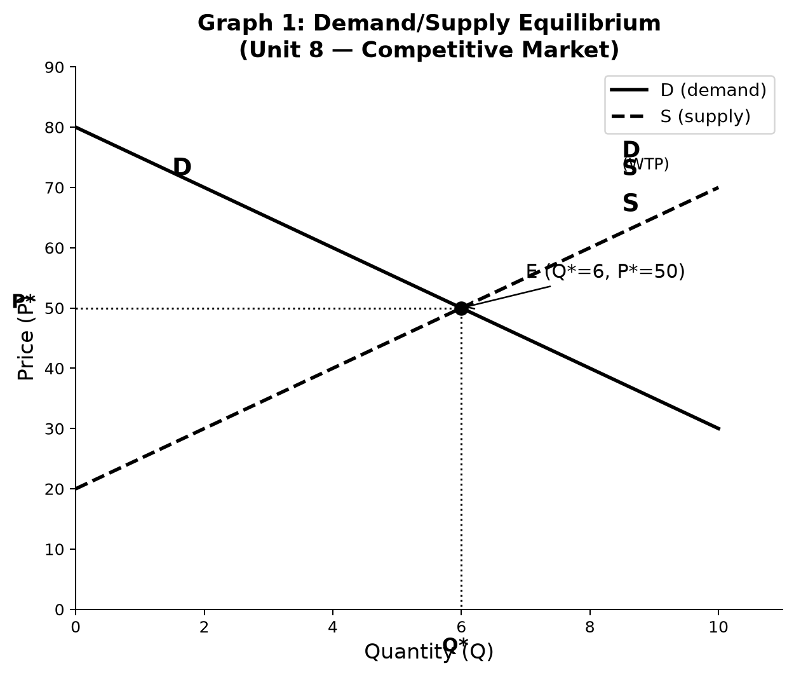
1. Axes: Vertical: Price (P) in Rand. Horizontal: Quantity (Q) in units.
2. Curves & Lines: Downward-sloping Demand (D) curve. Upward-sloping Supply (S) curve. Both linear.
3. Key Points: Equilibrium: intersection of D and S → (Q*, P*). Read off axes.
4. Explanation: At P*, Qd = Qs — the market clears. Above P*: surplus (Qs > Qd). Below P*: shortage (Qd > Qs). Equilibrium is stable because price adjusts.
5. Step-by-Step Redraw:
- 1. Draw axes: vertical=Price, horizontal=Quantity.
- 2. Draw downward-sloping D from top-left to bottom-right.
- 3. Draw upward-sloping S from bottom-left to top-right.
- 4. Mark intersection — label Q* on x-axis, P* on y-axis.
- 5. Draw dashed lines from intersection to both axes.
6. Exam Sentences: At equilibrium, Qd = Qs = Q* and P = P*, so the market clears with no excess demand or supply.
⚠ TRAP: Never say "demand equals supply" without specifying QUANTITY. Demand and supply are curves; only quantities demanded and supplied are equal at equilibrium.
8. 80% / 100% Guidance:
80%: Correct intersection, axes labelled, Q* and P* identified.
100%: Dashed projection lines to both axes, equilibrium interpretation in words, note on what happens above/below P*.
9. Mini Practice Question:
Given Qd = 80 − 5P and Qs = 20 + 5P, find equilibrium price and quantity.
Memo: Set equal: 80−5P = 20+5P → 60=10P → P*=6. Q*=80−30=50. Equilibrium: P=6, Q=50.

G02 — Tax Wedge, Revenue & DWL
Unit: Unit 8 Exam Use: Tax incidence, deadweight loss calculation, buyer vs seller burden Status: Past-paper confirmed
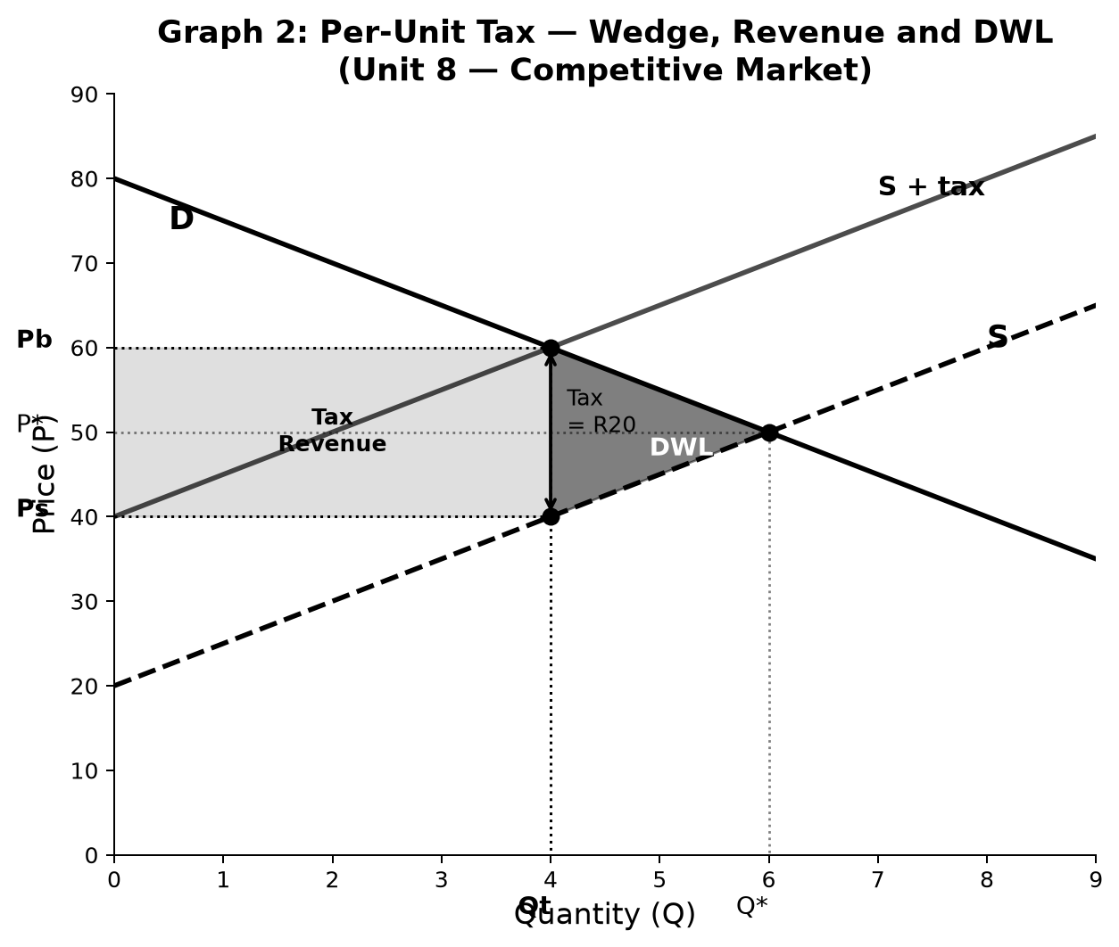
1. Axes: Vertical: Price (P). Horizontal: Quantity (Q).
2. Curves & Lines: Original D and S. New S_tax shifted up by tax amount. Wedge between Pb (buyer price) and Ps (seller price).
3. Key Points: Qt < Q* (tax reduces quantity). Pb > P* (buyers pay more). Ps < P* (sellers receive less). Tax revenue = tax × Qt (rectangle). DWL = triangle between Qt and Q*.
4. Explanation: A per-unit tax creates a wedge: Pb − Ps = tax. Buyers pay Pb, sellers keep Ps. Government collects tax × Qt. The triangle Qt to Q* is DWL — trades that would have occurred but no longer do.
5. Step-by-Step Redraw:
- 1. Draw equilibrium D and S, mark Q* and P*.
- 2. Shift S curve up by the tax amount → S_tax.
- 3. New equilibrium at Qt: read Pb from D, Ps from original S.
- 4. Mark dashed lines for Pb and Ps on price axis.
- 5. Shade tax revenue rectangle (Pb to Ps, 0 to Qt).
- 6. Shade DWL triangle (Qt to Q*, between D and S).
6. Exam Sentences: The per-unit tax of R20 creates a wedge: buyers pay R60, sellers receive R40. Tax revenue = R20×4 = R80. DWL = ½×(6−4)×20 = R20.
⚠ TRAP: A specific tax shifts the SUPPLY curve up (costs rise for sellers). It does NOT shift demand. The tax wedge is vertical, not horizontal.
8. 80% / 100% Guidance:
80%: Correct S_tax shift, Pb and Ps identified, tax revenue rectangle shaded.
100%: DWL triangle shaded and calculated, incidence split named (if elastic: seller bears more; if inelastic: buyer bears more), formula stated.
9. Mini Practice Question:
Supply: Qs = −20 + 5P. Demand: Qd = 80 − 5P. Equilibrium: P*=10, Q*=30. A tax of R4 per unit is imposed. Find Qt, Pb, Ps, tax revenue, DWL.
Memo: Tax shifts S up: new S: Qs=−20+5(P−4)=−40+5P. Set equal to D: 80−5P=−40+5P → Qt=12, Pb=13.6, Ps=9.6. Tax rev=4×12=R48. DWL=½×(30−12)×4=R36.

G03 — Binding Price Ceiling
Unit: Unit 8 Exam Use: Rent control, price caps — shortage, misallocation, black markets Status: Past-paper confirmed
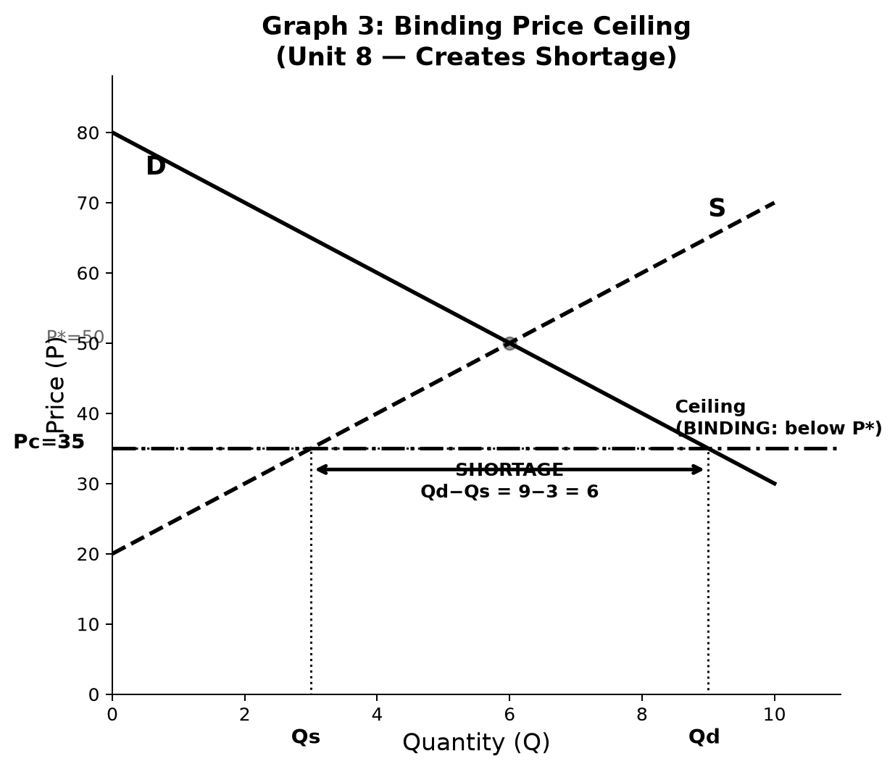
1. Axes: Vertical: Price (P). Horizontal: Quantity (Q).
2. Curves & Lines: D and S curves. Horizontal dashed line at ceiling price Pc < P*.
3. Key Points: At Pc: Qd > Qs → shortage = Qd − Qs. Market quantity = Qs (the short side).
4. Explanation: Government sets Pc below P*. Sellers only supply Qs. Buyers want Qd > Qs. Shortage = Qd − Qs. Non-price rationing emerges (queues, connections). DWL from lost trades between Qs and the efficient Q*.
5. Step-by-Step Redraw:
- 1. Draw D and S, mark P* and Q*.
- 2. Draw horizontal line below P* at ceiling Pc.
- 3. Read Qd from D at Pc → mark on x-axis.
- 4. Read Qs from S at Pc → mark on x-axis.
- 5. Bracket the shortage gap between Qs and Qd.
- 6. Optionally shade DWL triangle.
6. Exam Sentences: At ceiling price Pc, Qs = 3 < Qd = 9, creating a shortage of 6 units. Quantity exchanged = 3 (minimum of supply and demand).
⚠ TRAP: A binding ceiling causes a SHORTAGE. Students often say "surplus" — wrong. The ceiling keeps price down, quantity supplied falls below quantity demanded.
8. 80% / 100% Guidance:
80%: Ceiling line below P*, shortage gap labelled (Qd − Qs), market quantity = Qs.
100%: DWL triangle shaded, non-price rationing mechanism named, welfare effects on CS and PS discussed.
9. Mini Practice Question:
P* = 50, Q* = 6. Government sets ceiling at P = 35. At P=35: Qd=9, Qs=3. State (i) effect on market quantity, (ii) shortage size, (iii) one welfare consequence.
Memo: (i) Quantity exchanged = Qs = 3. (ii) Shortage = 9−3 = 6 units. (iii) DWL arises from 3 lost trades; non-price rationing replaces price rationing.

G04 — Binding Price Floor
Unit: Unit 8 Exam Use: Minimum wage, agricultural price supports — surplus, unemployment Status: Past-paper confirmed
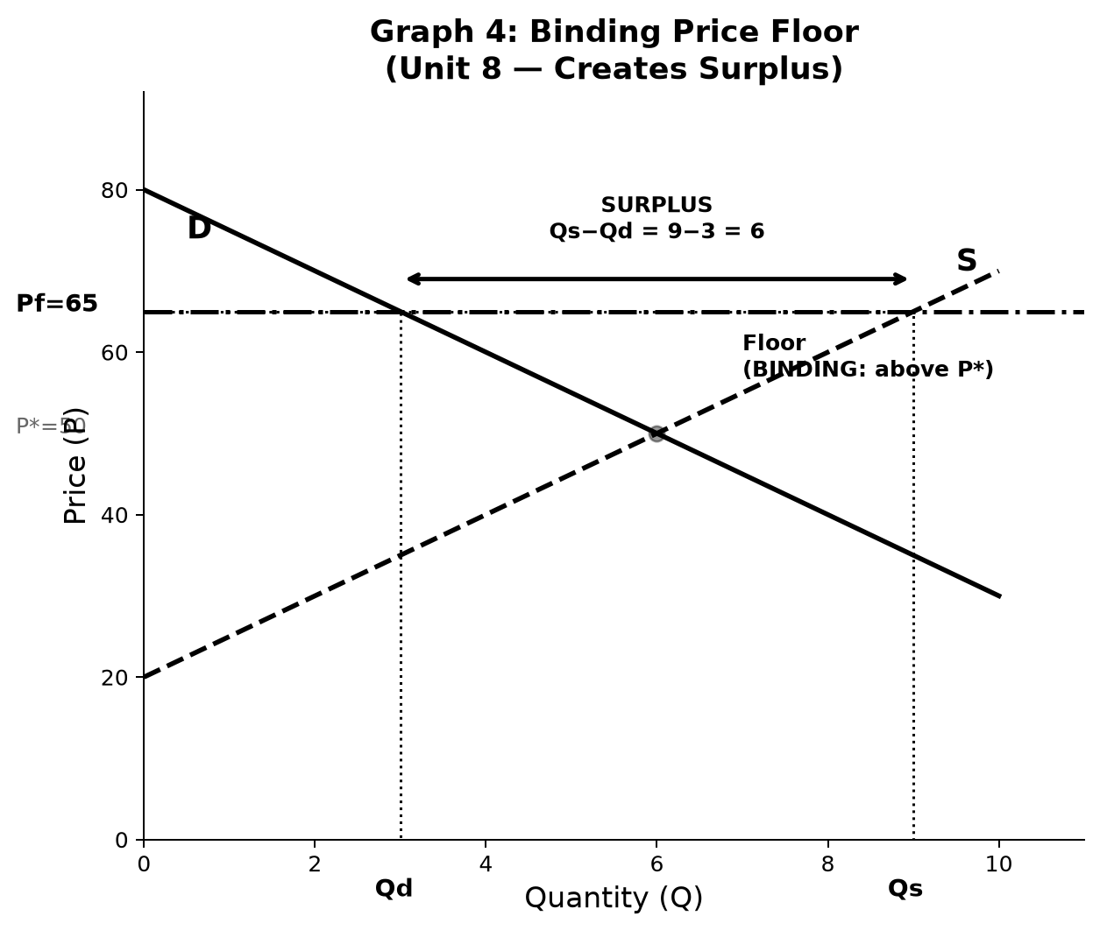
1. Axes: Vertical: Price (P). Horizontal: Quantity (Q).
2. Curves & Lines: D and S curves. Horizontal line at floor price Pf > P*.
3. Key Points: At Pf: Qs > Qd → surplus = Qs − Qd. Market quantity = Qd (the short side).
4. Explanation: Government sets Pf above P*. Sellers want to supply Qs > Qd. Buyers only buy Qd. Surplus = Qs − Qd. In labour markets: minimum wage above equilibrium → involuntary unemployment (Qs of labour > Qd of labour).
5. Step-by-Step Redraw:
- 1. Draw D and S, mark P* and Q*.
- 2. Draw horizontal line above P* at floor Pf.
- 3. Read Qd from D at Pf.
- 4. Read Qs from S at Pf.
- 5. Bracket the surplus gap between Qd and Qs.
6. Exam Sentences: At floor price Pf, Qs = 9 > Qd = 3, creating a surplus of 6 units. Only Qd = 3 units are traded.
⚠ TRAP: A binding floor causes a SURPLUS (excess supply). In labour markets this is called involuntary unemployment — workers want to work at Pf but firms only hire Qd workers.
8. 80% / 100% Guidance:
80%: Floor line above P*, surplus gap labelled (Qs − Qd), market quantity = Qd.
100%: Labour market application stated (min wage → unemployment), DWL identified, government response options noted (buy surplus).
9. Mini Practice Question:
P* = 50, Q* = 6. Government sets floor at P = 65. At P=65: Qd=3, Qs=9. Calculate (i) surplus size and (ii) quantity exchanged.
Memo: (i) Surplus = Qs − Qd = 9 − 3 = 6 units. (ii) Quantity exchanged = Qd = 3 (sellers cannot force buyers).

G05 — Consumer & Producer Surplus
Unit: Unit 8 Exam Use: Welfare analysis, total surplus, impact of price changes and taxes Status: Past-paper confirmed
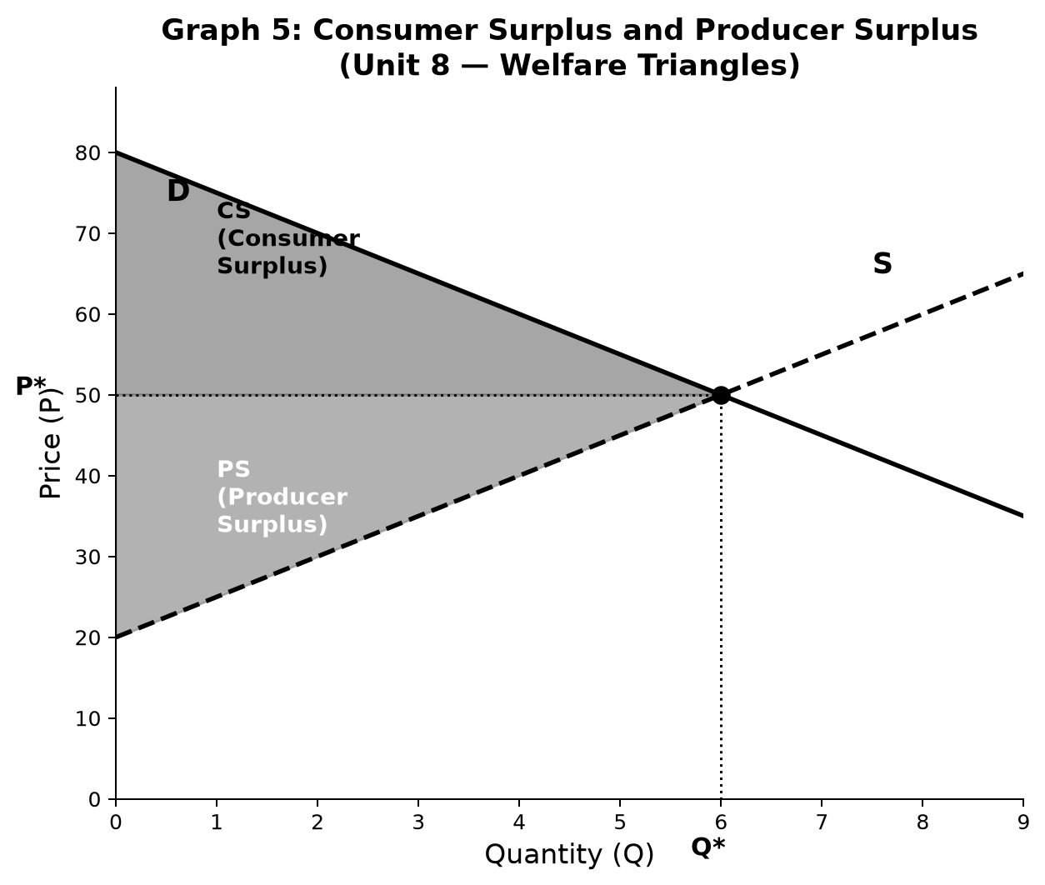
1. Axes: Vertical: Price (P). Horizontal: Quantity (Q).
2. Curves & Lines: Demand (D) downward-sloping. Supply (S) upward-sloping. Equilibrium at (Q*, P*).
3. Key Points: CS = triangle above P* below D. PS = triangle below P* above S. TS = CS + PS = full triangle between D and S up to Q*.
4. Explanation: CS measures what consumers gain beyond what they pay. PS measures what sellers gain above their minimum acceptable price. Both are triangles with the equilibrium price as the common base. TS = CS + PS is maximised at the competitive equilibrium.
5. Step-by-Step Redraw:
- 1. Draw D and S, mark Q* and P*.
- 2. Shade triangle above P* and below D (CS) — usually blue.
- 3. Shade triangle below P* and above S (PS) — usually green.
- 4. Label each triangle clearly.
- 5. Formula: CS = ½ × base × height; PS = ½ × base × height.
6. Exam Sentences: Consumer surplus = ½ × Q* × (max WTP − P*). Producer surplus = ½ × Q* × (P* − min WTA). Total surplus = CS + PS.
⚠ TRAP: Students often shade CS below the price line — that is PRODUCER surplus. CS is the area consumers SAVE relative to their willingness to pay (the area between D and the price).
8. 80% / 100% Guidance:
80%: Both triangles correctly identified and shaded, area formula applied.
100%: Effect of price change on each surplus stated (e.g. price rises: CS falls, PS rises, net effect depends on DWL), tax effects: some CS and PS transferred to government as revenue, rest is DWL.
9. Mini Practice Question:
Demand: P = 80 − 5Q. Supply: P = 20 + 5Q. Find equilibrium, then calculate CS, PS, and TS.
Memo: Equilibrium: P*=50, Q*=6. CS = ½×6×(80−50)=½×6×30=90. PS = ½×6×(50−20)=½×6×30=90. TS = 180.

G06 — Price-Taking Firm: Profit Maximisation (P = MC)
Unit: Unit 8 Exam Use: Competitive firm output decision, short-run profit, shutdown condition Status: Source confirmed
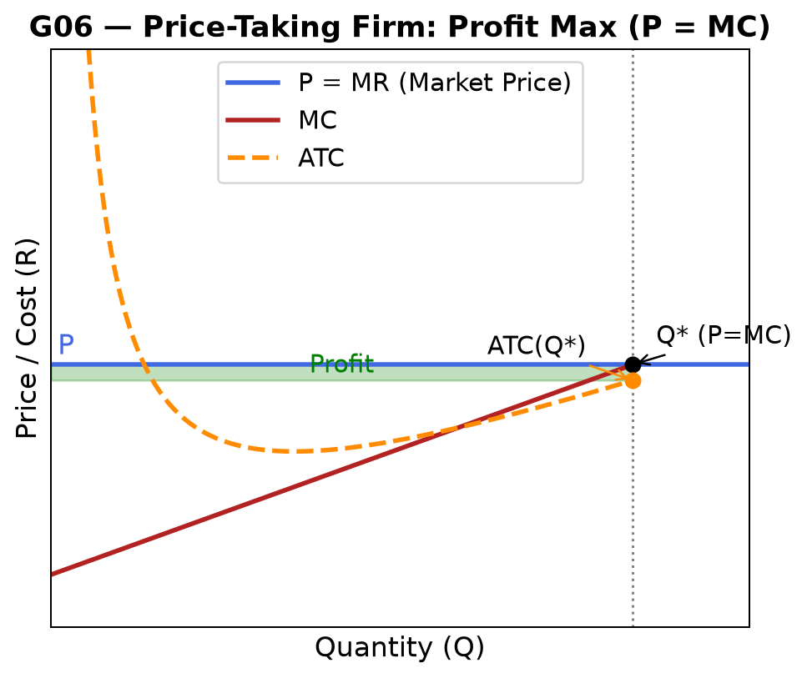
1. Axes: Vertical: Price / Cost (R). Horizontal: Quantity (Q).
2. Curves & Lines: Horizontal P = MR line (market price). Rising MC curve. U-shaped ATC curve.
3. Key Points: Profit-max: P = MC → find Q*. Profit = (P − ATC) × Q* (rectangle). Shutdown: P < min AVC.
4. Explanation: A price-taking firm maximises profit where MC equals the market price. If P > ATC at Q*, profit is positive. If P < ATC but P > AVC, firm produces but makes a loss (covers variable costs). If P < AVC, shut down in short run.
5. Step-by-Step Redraw:
- 1. Draw horizontal P=MR line at the market price.
- 2. Draw rising MC curve — crosses ATC at ATC minimum.
- 3. Draw U-shaped ATC above MC minimum.
- 4. Mark Q* where MC intersects P=MR.
- 5. Mark ATC(Q*). If P > ATC: shade profit rectangle.
6. Exam Sentences: The price-taking firm maximises profit at Q* where P = MC. Economic profit = (P − ATC) × Q*.
⚠ TRAP: A competitive firm NEVER chooses P. It takes P from the market and chooses Q. Setting P = MC means choosing the Q at which its own MC equals the given market price.
8. 80% / 100% Guidance:
80%: P=MR horizontal line, MC intersects it at Q*, profit rectangle shaded.
100%: ATC drawn correctly (U-shaped, crossing MC at min ATC), shutdown condition stated (P < min AVC), distinction from monopoly stated (P=MC vs P>MR=MC).
9. Mini Practice Question:
Market price P = R10. Firm MC = 2 + 0.8Q. ATC(10) = R9.40. Find Q*, state profit or loss, and calculate profit/loss amount.
Memo: P=MC: 10=2+0.8Q → Q*=10. ATC(10)=9.40. P>ATC → profit. Profit=(10−9.40)×10=R6.

G07 — Monopoly: MR = MC, Profit & DWL
Unit: Unit 7 Exam Use: Monopoly output and price, markup, welfare loss Status: Past-paper confirmed
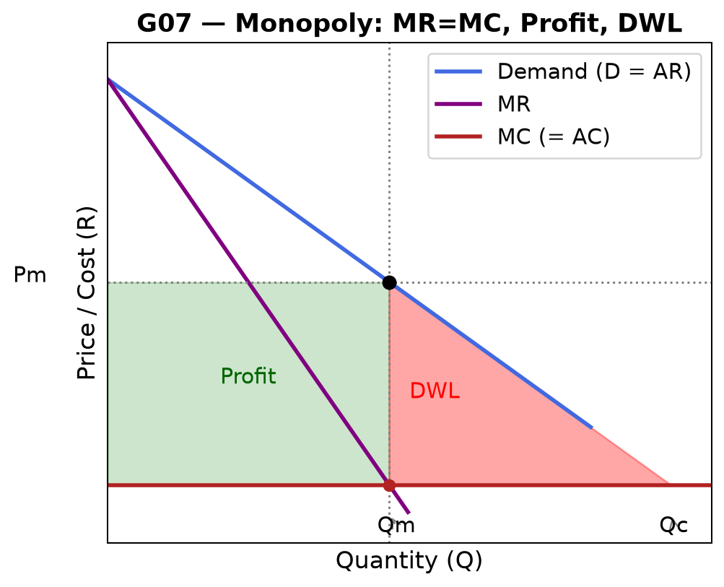
1. Axes: Vertical: Price / Cost (R). Horizontal: Quantity (Q).
2. Curves & Lines: Downward-sloping D (= AR). MR below D (twice as steep for linear D). Flat or rising MC.
3. Key Points: Profit-max: MR = MC → Qm. Price: read from D at Qm → Pm > MC. Profit rectangle: (Pm − ATC) × Qm. DWL triangle between Qm and competitive Qc.
4. Explanation: The monopolist restricts output to Qm < Qc and charges Pm > MC. This creates DWL — trades that would benefit both parties don't happen. Profit = (Pm − ATC) × Qm. The markup above MC comes from market power (price-setting ability).
5. Step-by-Step Redraw:
- 1. Draw D from top-left to bottom-right.
- 2. Draw MR — same intercept as D, twice the slope (for linear D).
- 3. Draw flat or rising MC.
- 4. Mark MR=MC intersection → Qm.
- 5. Go up from Qm to D → read Pm.
- 6. Shade profit rectangle and DWL triangle.
6. Exam Sentences: The monopolist sets MR = MC at Qm = 7, then reads price from demand: Pm = 32. At competitive equilibrium Qc = 14, Pc = MC = 4. DWL = ½ × (14−7) × (32−4) = R98.
⚠ TRAP: MR = 0 at the midpoint of a linear demand curve (where |e| = 1). A monopolist NEVER produces on the inelastic part of demand. If MR < 0, the firm can raise TR by reducing output.
8. 80% / 100% Guidance:
80%: MR drawn below D, MR=MC gives Qm, Pm read from D, profit and DWL areas identified.
100%: Markup formula: (Pm − MC)/Pm = 1/|e|. Comparison to competitive outcome (Qc = 14, Pc = 4). Total surplus decomposition.
9. Mini Practice Question:
Demand: P = 60 − 4Q. MC = AC = 4. Find Qm, Pm, profit, and DWL.
Memo: MR: 60−8Q=4 → Qm=7. Pm=60−28=32. Profit=(32−4)×7=R196. Qc: 60−4Q=4→Qc=14. DWL=½×(14−7)×(32−4)=½×7×28=R98.

G08 — Elasticity Along a Linear Demand Curve
Unit: Unit 7 Exam Use: Price elasticity of demand (PED), total revenue maximisation Status: Source confirmed
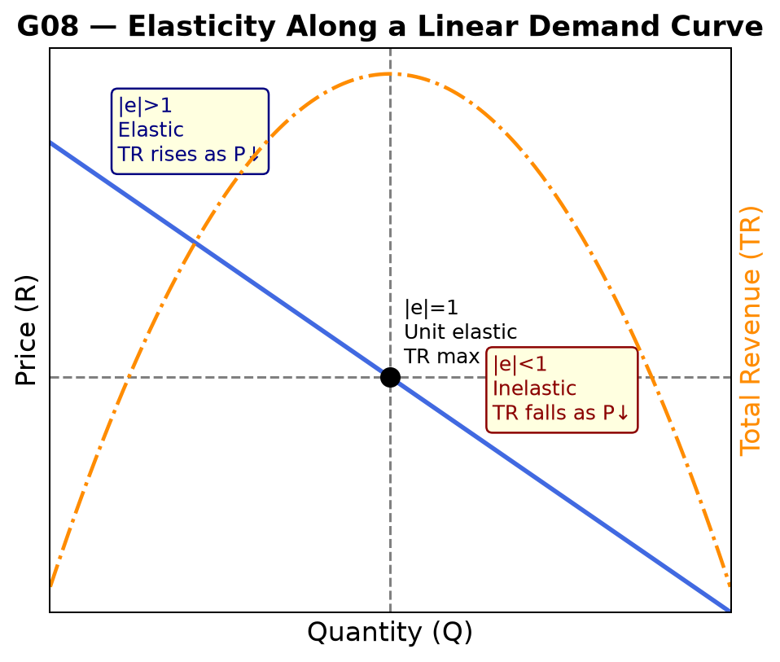
1. Axes: Vertical: Price (P). Horizontal: Quantity (Q). Secondary vertical axis: Total Revenue (TR).
2. Curves & Lines: Linear demand curve D. TR arc below (rises then falls).
3. Key Points: Top half of D: elastic (|e| > 1), TR rises as P falls. Midpoint: unit elastic (|e| = 1), TR maximised. Bottom half: inelastic (|e| < 1), TR falls as P falls.
4. Explanation: For a linear demand P = a − bQ, elasticity at any point = −(1/b) × (P/Q). At the midpoint, |e| = 1 and TR = PQ is at its maximum. Above midpoint, lowering P raises TR. Below midpoint, lowering P reduces TR.
5. Step-by-Step Redraw:
- 1. Draw linear downward-sloping demand.
- 2. Mark the midpoint of the demand curve (midpoint of both axis intercepts).
- 3. Label upper half "elastic" and lower half "inelastic".
- 4. Optionally sketch TR as an inverted U below, peaking at the midpoint quantity.
6. Exam Sentences: Along a linear demand curve, price elasticity falls from −∞ at the price intercept to 0 at the quantity intercept. TR is maximised where |e| = 1 (unit elastic).
⚠ TRAP: A steeper demand curve is NOT necessarily more inelastic at every point — inelasticity depends on the ratio P/Q, not just the slope. Compare at the same price, not at the same point.
8. 80% / 100% Guidance:
80%: Midpoint identified, elastic/inelastic regions labelled, TR relationship stated.
100%: Formula for PED at a point, TR = P×Q maximised at midpoint, application to monopolist (never produces inelastic portion), relationship to MR (MR = P(1 + 1/e)).
9. Mini Practice Question:
Demand: P = 50 − 5Q. (a) Find the midpoint quantity and price. (b) Calculate |e| at P=40. (c) Does TR rise or fall if price falls from 40 to 30?
Memo: (a) Midpoint: P=25, Q=5. (b) At P=40: Q=2; |e|=(1/5)×(40/2)=4 → elastic. (c) TR at P=40: 80; at P=30: Q=4, TR=120. TR rises (elastic region — price cut raises TR).

G09 — Negative Externality: MSC, DWL, Pigouvian Tax
Unit: Unit 10 Exam Use: Market failure from pollution/congestion — overconsumption, corrective tax Status: Past-paper confirmed
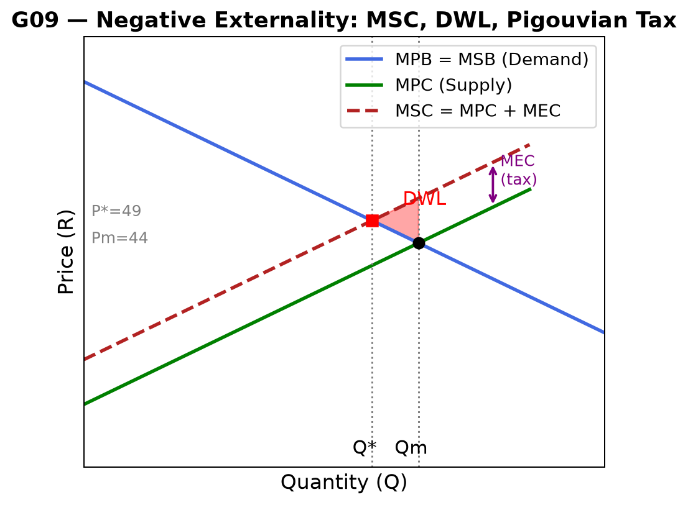
1. Axes: Vertical: Price (R). Horizontal: Quantity (Q).
2. Curves & Lines: D = MPB = MSB (downward-sloping). MPC = S (upward-sloping). MSC = MPC + MEC (above MPC by MEC).
3. Key Points: Market: D = MPC → Qm (overproduction). Efficient: D = MSC → Q* < Qm. Pigouvian tax = MEC at Q*. DWL = triangle between Q* and Qm.
4. Explanation: Negative externality: private cost MPC < social cost MSC. Market ignores external cost, produces too much (Qm > Q*). Pigouvian tax corrects this — shifts MPC up to equal MSC. Tax equals the external cost at the efficient quantity Q*, not at market output Qm.
5. Step-by-Step Redraw:
- 1. Draw D (MPB=MSB) and MPC (Supply).
- 2. Draw MSC = MPC + MEC — parallel shift up by MEC.
- 3. Mark Qm (D=MPC intersection).
- 4. Mark Q* (D=MSC intersection).
- 5. Show tax wedge = MEC at Q*.
- 6. Shade DWL triangle between Q* and Qm, bounded by D and MSC.
6. Exam Sentences: With a negative externality of MEC = R10, the market produces Qm = 9 but the efficient output is Q* = 7.75. The Pigouvian tax = MEC = R10 per unit, reducing output to Q*.
⚠ TRAP: Pigouvian tax = MEC evaluated at Q*, not at Qm. Common error: applying MEC at Qm. Also: MSC is ABOVE MPC (negative externality = third-party cost, not benefit).
8. 80% / 100% Guidance:
80%: MSC above MPC, Qm > Q*, tax equals MEC at Q*, DWL shaded.
100%: DWL calculated (formula + substitution), distinction from positive externality (overproduction vs underproduction), Coase theorem alternative stated (property rights bargaining if transaction costs = 0).
9. Mini Practice Question:
MPB = MSB = 80 − 4Q. MPC = 8 + 4Q. MEC = 10. Find: (a) Qm, (b) Q*, (c) Pigouvian tax, (d) DWL.
Memo: (a) 80−4Q=8+4Q → Qm=9, Pm=44. (b) MSC=18+4Q; 80−4Q=18+4Q → Q*=7.75, P*≈49. (c) Tax=MEC=R10. (d) DWL=½×(9−7.75)×10=R6.25.

G10 — Positive Externality: MSB, Q* > Qm, Subsidy
Unit: Unit 10 Exam Use: Underproduction from positive spillovers — education, vaccines, research Status: Past-paper confirmed
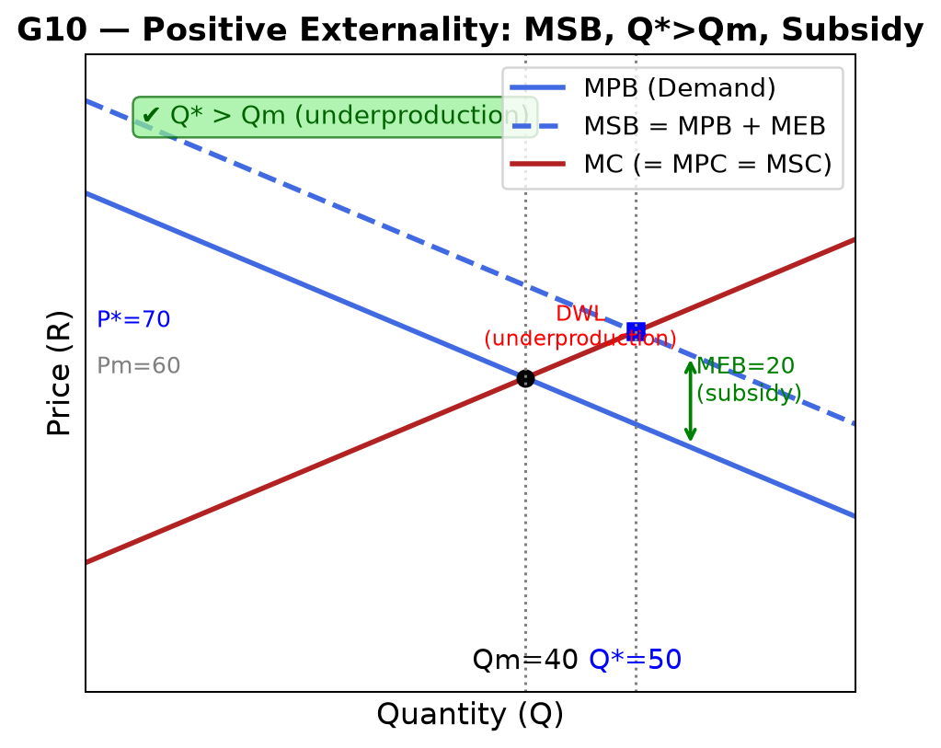
1. Axes: Vertical: Price (R). Horizontal: Quantity (Q).
2. Curves & Lines: MPB (Demand) downward-sloping. MC (= MPC = MSC) upward-sloping. MSB = MPB + MEB above MPB.
3. Key Points: Market: MPB = MC → Qm = 40. Efficient: MSB = MC → Q* = 50. Q* > Qm (underproduction confirmed). Pigouvian subsidy = MEB = R20 at Q*.
4. Explanation: Positive externality: private benefit MPB < social benefit MSB. Market produces too little (Qm < Q*). Pigouvian subsidy = MEB at Q* corrects the distortion by reducing effective cost to producers or increasing effective price for consumers.
5. Step-by-Step Redraw:
- 1. Draw MC (supply) and MPB (demand).
- 2. Draw MSB = MPB + MEB — parallel shift up from MPB by MEB.
- 3. Mark Qm (MPB = MC intersection) → label Q_m = 40.
- 4. Mark Q* (MSB = MC intersection) → label Q* = 50.
- 5. Confirm Q* > Qm → underproduction gap = 10 units.
- 6. Show subsidy = MEB at Q* = R20.
6. Exam Sentences: With MEB = R20, private market produces Qm = 40 < Q* = 50. The Pigouvian subsidy of R20 per unit at Q* restores efficiency. ✔ Q* > Qm always for positive externalities.
⚠ TRAP: CRITICAL: Q* > Qm for positive externalities (underproduction). If your calculation gives Q* < Qm, recheck — you have a sign error or have used negative externality formulas.
8. 80% / 100% Guidance:
80%: MSB above MPB, Q* > Qm confirmed, subsidy = MEB at Q*, DWL shaded.
100%: Numeric proof: MC=20+Q, MPB=100−Q → Qm=40; MSB=120−Q → Q*=50; subsidy=20 (MEB at Q*=50); DWL=½×(50−40)×20=R100.
9. Mini Practice Question:
MC = 20 + Q. MPB = 100 − Q. MEB = 20. Find Qm, Q*, Pigouvian subsidy, and DWL.
Memo: Qm: 100−Q=20+Q → Qm=40. MSB=120−Q. Q*: 120−Q=20+Q → Q*=50. Subsidy=MEB at Q*=R20. DWL=½×(50−40)×20=R100.

G11 — Budget Constraint & Feasible Set
Unit: Unit 3 Exam Use: Consumer choice, opportunity sets, income and price effects Status: Source confirmed
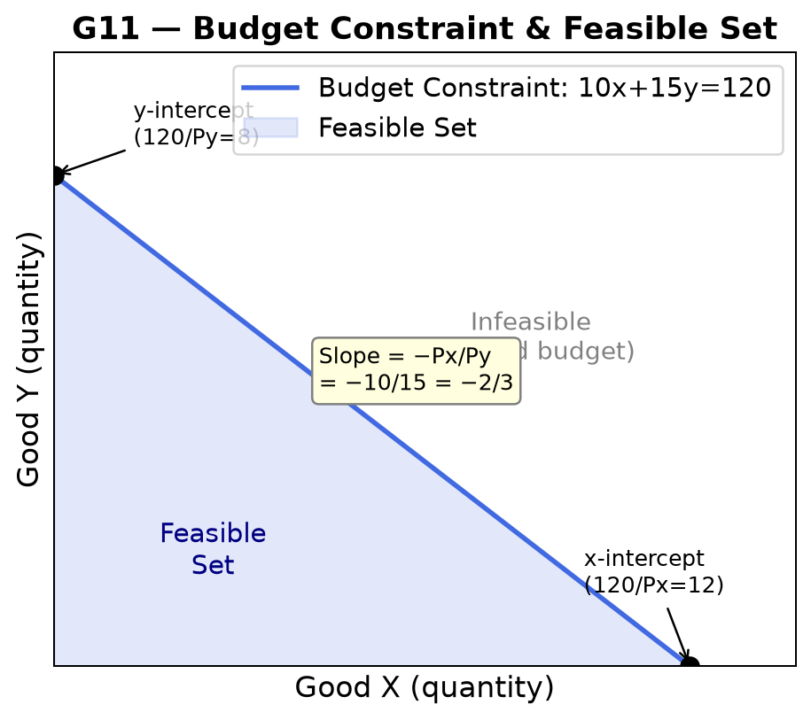
1. Axes: Vertical: Good Y (quantity). Horizontal: Good X (quantity).
2. Curves & Lines: Budget constraint: straight line from (0, I/Py) to (I/Px, 0). Feasible set: triangle below the line.
3. Key Points: x-intercept: I/Px (max X if all income on X). y-intercept: I/Py (max Y if all income on Y). Slope = −Px/Py.
4. Explanation: The budget constraint shows all combinations affordable with income I. Slope reflects the opportunity cost of X in terms of Y. A price change rotates the line; an income change shifts it parallel. The feasible set is all points on or below the constraint.
5. Step-by-Step Redraw:
- 1. Label axes: vertical = Good Y, horizontal = Good X.
- 2. Mark x-intercept: I/Px on horizontal axis.
- 3. Mark y-intercept: I/Py on vertical axis.
- 4. Draw straight line connecting the two intercepts.
- 5. Shade the triangle below as the feasible set.
- 6. Label slope = −Px/Py.
6. Exam Sentences: With income I = R120, Px = 10, Py = 15: x-intercept = 12, y-intercept = 8, slope = −10/15 = −2/3.
⚠ TRAP: Do not invert the slope. Slope = −Px/Py because giving up 1 unit of X frees Px rands, buying Px/Py units of Y. A change in Px rotates the line (pivots at y-intercept if only Px changes).
8. 80% / 100% Guidance:
80%: Intercepts correctly calculated, slope formula stated, feasible set identified.
100%: Effect of price change vs income change shown (rotation vs parallel shift), opportunity cost interpretation of slope, link to indifference curve optimum.
9. Mini Practice Question:
Income = R200. Px = 20, Py = 10. (a) Write the budget constraint equation. (b) Find both intercepts. (c) What is the slope and what does it mean?
Memo: (a) 20x + 10y = 200, or y = 20 − 2x. (b) x-intercept = 10, y-intercept = 20. (c) Slope = −Px/Py = −20/10 = −2: to get 1 more unit of X you give up 2 units of Y.

G12 — Consumer Optimum: MRS = MRT (IC Tangency)
Unit: Unit 3 Exam Use: Utility maximisation, corner vs interior solutions, consumer surplus Status: Source confirmed
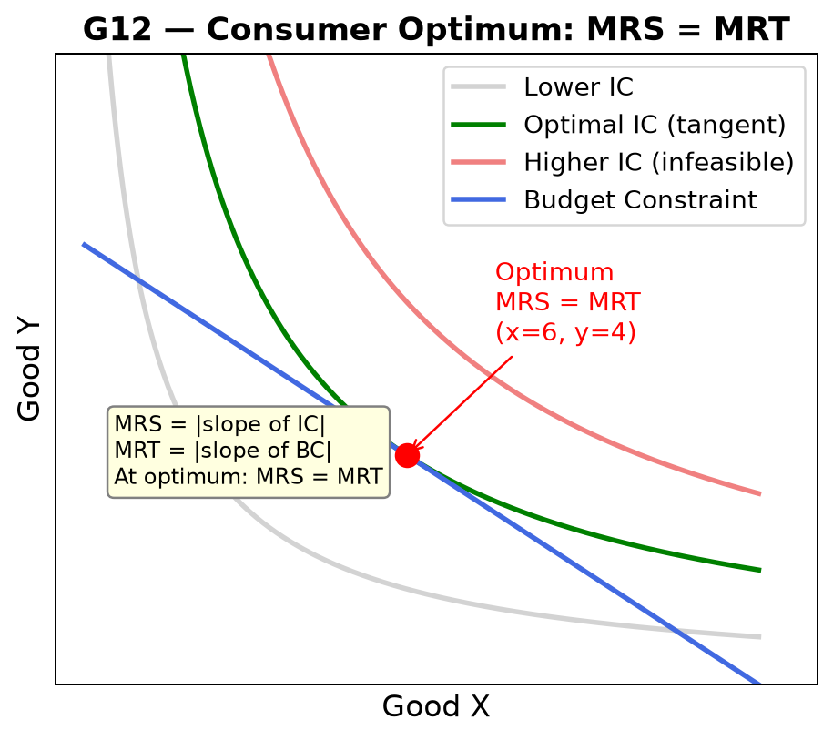
1. Axes: Vertical: Good Y. Horizontal: Good X.
2. Curves & Lines: Budget constraint (straight line). Indifference curves (convex to origin). Optimal IC is tangent to budget constraint.
3. Key Points: Optimum: MRS = MRT = Px/Py. At this point: MUx/MUy = Px/Py (bang-per-buck condition). Lower IC: affordable but suboptimal. Higher IC: infeasible.
4. Explanation: The consumer maximises utility where the indifference curve (IC) is tangent to the budget constraint. MRS (slope of IC) equals MRT (slope of BC = Px/Py). This is the "bang-per-buck" condition: the last rand spent on X gives the same marginal utility as the last rand on Y.
5. Step-by-Step Redraw:
- 1. Draw budget constraint.
- 2. Sketch 3 indifference curves: one below (achievable, suboptimal), one tangent, one above (infeasible).
- 3. Mark tangency point as the optimum.
- 4. Label MRS = MRT at the tangency.
6. Exam Sentences: At the optimum, MRS = MRT = Px/Py, meaning MUx/Px = MUy/Py — a rand spent on either good yields the same marginal utility.
⚠ TRAP: An IC crossing the budget constraint (intersection) is NOT optimal — moving along the BC to a higher IC is still feasible and increases utility. Optimal = tangency only.
8. 80% / 100% Guidance:
80%: Tangency correctly identified, MRS = MRT stated, infeasible/suboptimal ICs shown.
100%: Bang-per-buck condition derived (MUx/Px = MUy/Py), corner solution scenario described (when MRS ≠ MRT at any interior point), substitution and income effects linked to the diagram.
9. Mini Practice Question:
U = xy. Budget: 10x + 15y = 120. Find the optimal bundle.
Memo: MRS = MUx/MUy = y/x. MRT = Px/Py = 10/15 = 2/3. Set equal: y/x = 2/3 → y = 2x/3. Substitute into budget: 10x + 15(2x/3) = 10x+10x = 20x = 120 → x = 6, y = 4. Optimum: (6, 4).

G13 — Wage Increase: Income & Substitution Effects
Unit: Unit 3 Exam Use: Labour supply analysis, backward-bending labour supply curve Status: Past-paper confirmed
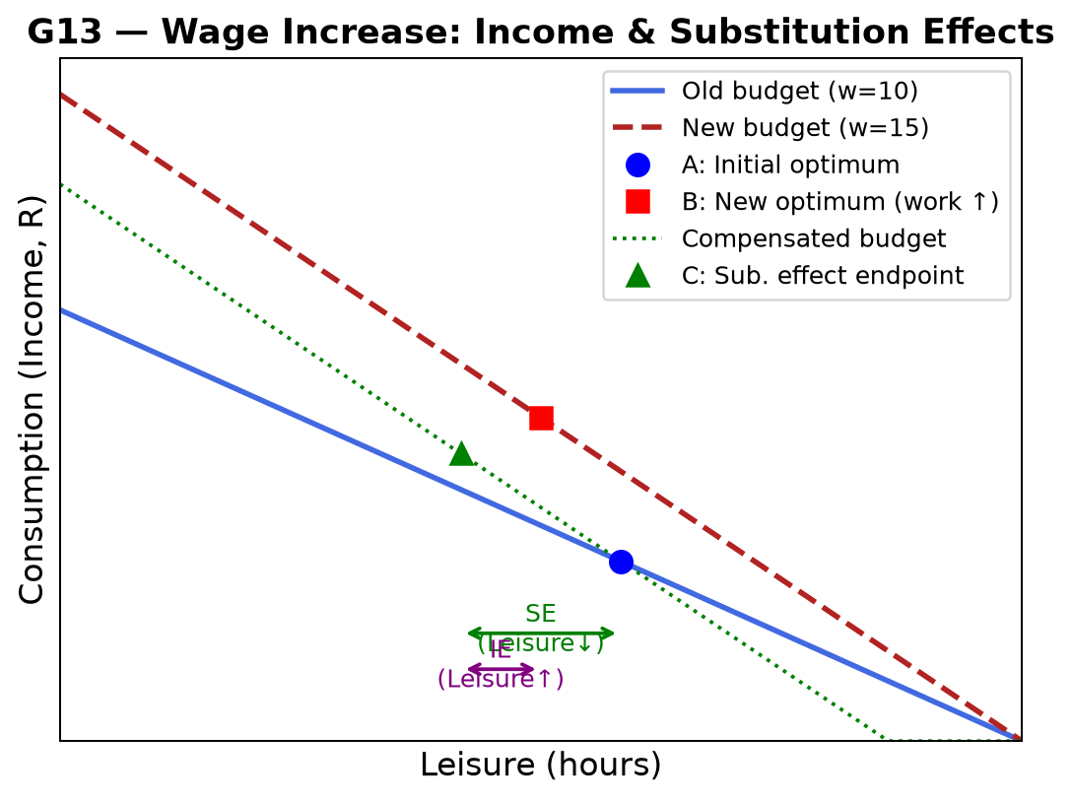
1. Axes: Vertical: Consumption (income, R). Horizontal: Leisure (hours).
2. Curves & Lines: Old budget constraint (lower wage). New budget constraint (higher wage, steeper — pivots at max leisure point). Compensated budget at new wage slope through old optimum.
3. Key Points: SE: higher wage makes leisure more expensive → leisure decreases (work more). IE: higher wage increases real income → demand for leisure rises (work less). Net effect: ambiguous — labour supply curve can bend backward at high wages.
4. Explanation: A wage increase rotates the budget constraint counter-clockwise (from the 24-hour leisure intercept). Substitution effect always reduces leisure. Income effect increases leisure (normal good). If IE > SE, the person works LESS at higher wages — backward-bending supply.
5. Step-by-Step Redraw:
- 1. Draw axes: Horizontal = Leisure, Vertical = Consumption.
- 2. Draw old budget constraint; mark original optimum A.
- 3. Rotate to new budget constraint (new wage, same leisure endowment at 24h).
- 4. Draw compensated BC (new slope through A): mark sub-effect endpoint C.
- 5. Mark new optimum B on new BC.
- 6. SE = A→C (leisure change). IE = C→B (leisure change).
6. Exam Sentences: Wage rise: SE → leisure falls (work more). IE → leisure rises (work less). If IE > SE, hours worked fall — backward-bending labour supply.
⚠ TRAP: Always start from the LEISURE axis (24 hours). Wage rise pivots the budget line INWARD at the leisure intercept (same maximum leisure, more income if all hours worked). Do not shift parallel.
8. 80% / 100% Guidance:
80%: SE direction correct (leisure falls), IE direction correct (leisure rises), ambiguity stated.
100%: Compensated budget drawn, backward-bending labour supply curve referenced, income/substitution effects calculated from specific utility function if given.
9. Mini Practice Question:
A worker earns w=R10/hr. Wage rises to R15/hr. Explain (without calculation) how the income and substitution effects work in opposite directions for hours of leisure chosen.
Memo: SE: leisure is now more expensive (each hour costs R15 in foregone income vs R10 before) → worker substitutes away from leisure → hours worked rise. IE: higher wage increases real income → normal goods (including leisure) demanded more → hours worked fall. Net effect depends on which effect dominates.

G14 — Angela-Bruno: Feasible Frontier
Unit: Unit 5 Exam Use: Bargaining, surplus distribution, fairness vs efficiency Status: Reasonable A3 risk
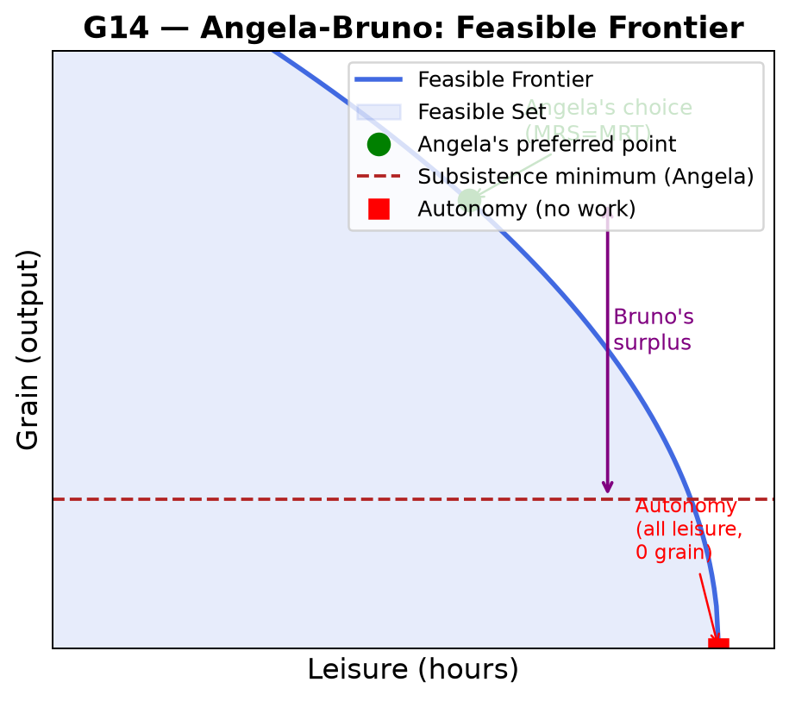
1. Axes: Vertical: Grain (output). Horizontal: Leisure (hours).
2. Curves & Lines: Concave feasible frontier (production function, inverted). Subsistence line (horizontal). Angela's indifference curves.
3. Key Points: Angela's preferred point: MRS (IC slope) = MRT (frontier slope). Bruno's maximum claim: frontier point less Angela's subsistence minimum. "Just enough" point: where Angela is indifferent between working and not.
4. Explanation: Angela produces grain by working. The feasible frontier shows all (leisure, grain) combinations. Bruno (landlord) takes grain above Angela's minimum. Efficient allocation: where Angela's MRS = MRT. Fair allocation: depends on bargaining power and institutions (coercion vs voluntary trade).
5. Step-by-Step Redraw:
- 1. Draw axes: Leisure (horizontal), Grain (vertical).
- 2. Draw concave frontier from (0, max grain) to (24, 0).
- 3. Draw horizontal subsistence line at Angela's minimum grain.
- 4. Mark Angela's preferred point (tangency with IC).
- 5. Shade Bruno's surplus above subsistence and below frontier at Angela's work point.
6. Exam Sentences: At Angela's preferred point, MRS = MRT. Bruno's surplus = grain produced − Angela's grain share. The frontier is concave because labour has diminishing marginal product.
⚠ TRAP: Angela's subsistence minimum is a CONSTRAINT on Bruno, not Angela's preferred consumption. Bruno can take grain up to the frontier minus subsistence, but no more.
8. 80% / 100% Guidance:
80%: Frontier concave, subsistence line shown, Angela's preferred point identified.
100%: Bruno's surplus shaded and named, bargaining power shifts (from coercion to voluntary — Angela gets more), link to Unit 5 fairness concepts (substantive vs procedural).
9. Mini Practice Question:
Angela's subsistence grain = 10 units. At Angela's preferred working point she produces 30 units. What is Bruno's maximum claim? What happens if Angela gains the right to refuse?
Memo: Bruno's max claim = 30 − 10 = 20 units. If Angela can refuse, she will only accept a deal giving her > 10 units, shrinking Bruno's maximum surplus. She may negotiate a higher share based on her outside option.

G15 — Isocost Lines & Technology Choice
Unit: Unit 2 Exam Use: Cost minimisation, factor substitution, dominated technologies Status: Source confirmed
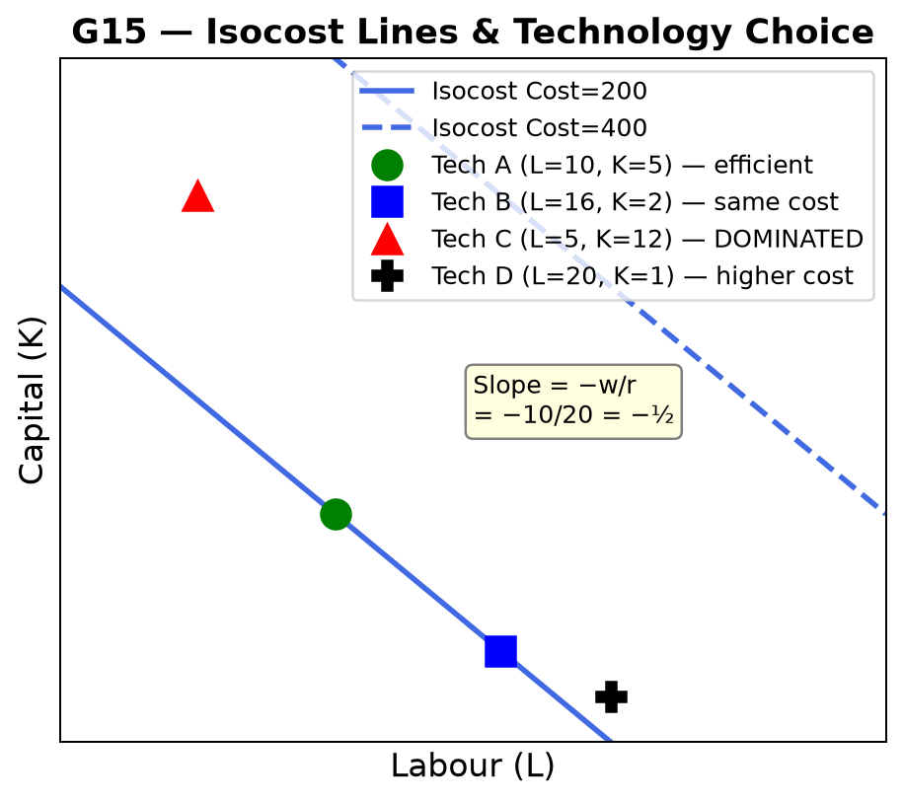
1. Axes: Vertical: Capital (K). Horizontal: Labour (L).
2. Curves & Lines: Isocost lines: straight lines with slope = −w/r. Multiple isocost lines (lower = cheaper). Technology points: specific (L, K) combinations for producing one unit of output.
3. Key Points: Isocost slope = −w/r. Cost = wL + rK. Minimum cost technology: point on LOWEST isocost line. Dominated: uses more L AND more K than another option.
4. Explanation: Isocost lines show all input combinations with the same total cost. To produce output at minimum cost, choose the technology point on the lowest (leftmost) isocost line. If wages rise, the slope steepens → switch to more capital-intensive technology.
5. Step-by-Step Redraw:
- 1. Draw axes: vertical = K, horizontal = L.
- 2. Draw isocost lines (slope = −w/r) at various cost levels.
- 3. Plot technology points A, B, C on the graph.
- 4. Identify which point is on the lowest isocost (minimum cost).
- 5. Identify dominated technology (northeast of another — more of both inputs).
6. Exam Sentences: With w=10 and r=20, isocost slope = −w/r = −½. Tech A (L=10, K=5): Cost = 200. Tech C (L=5, K=12): Cost = 290. Tech A is cheaper; Tech C is dominated if another point has L≤5, K≤12.
⚠ TRAP: A technology is dominated only if another option uses LESS of BOTH inputs. Using less of one and more of the other is NOT dominated — it may be preferred at different relative prices.
8. 80% / 100% Guidance:
80%: Slope of isocost correctly derived (−w/r), cost calculated for given technologies, cheapest identified.
100%: Price change analysis: if w rises, slope steepens, switch to more K-intensive tech; dominated technology identified and explained; isoquant tangency condition mentioned if isoquants given.
9. Mini Practice Question:
w = 10, r = 20. Technology A: (L=10, K=5). Technology B: (L=4, K=8). Technology C: (L=12, K=9). (a) Calculate cost for each. (b) Identify any dominated technology. (c) Which technology minimises cost?
Memo: Cost A = 10×10+20×5=200. Cost B=10×4+20×8=200. Cost C=10×12+20×9=300. Tech C is NOT dominated (no other uses ≤12 L AND ≤9 K with same output). C is most expensive. A and B tie at minimum cost. C should not be chosen.

G16 — Payoff Matrix & Nash Equilibrium
Unit: Unit 4 Exam Use: Strategic interaction, dominant strategies, Pareto improvements Status: Source confirmed
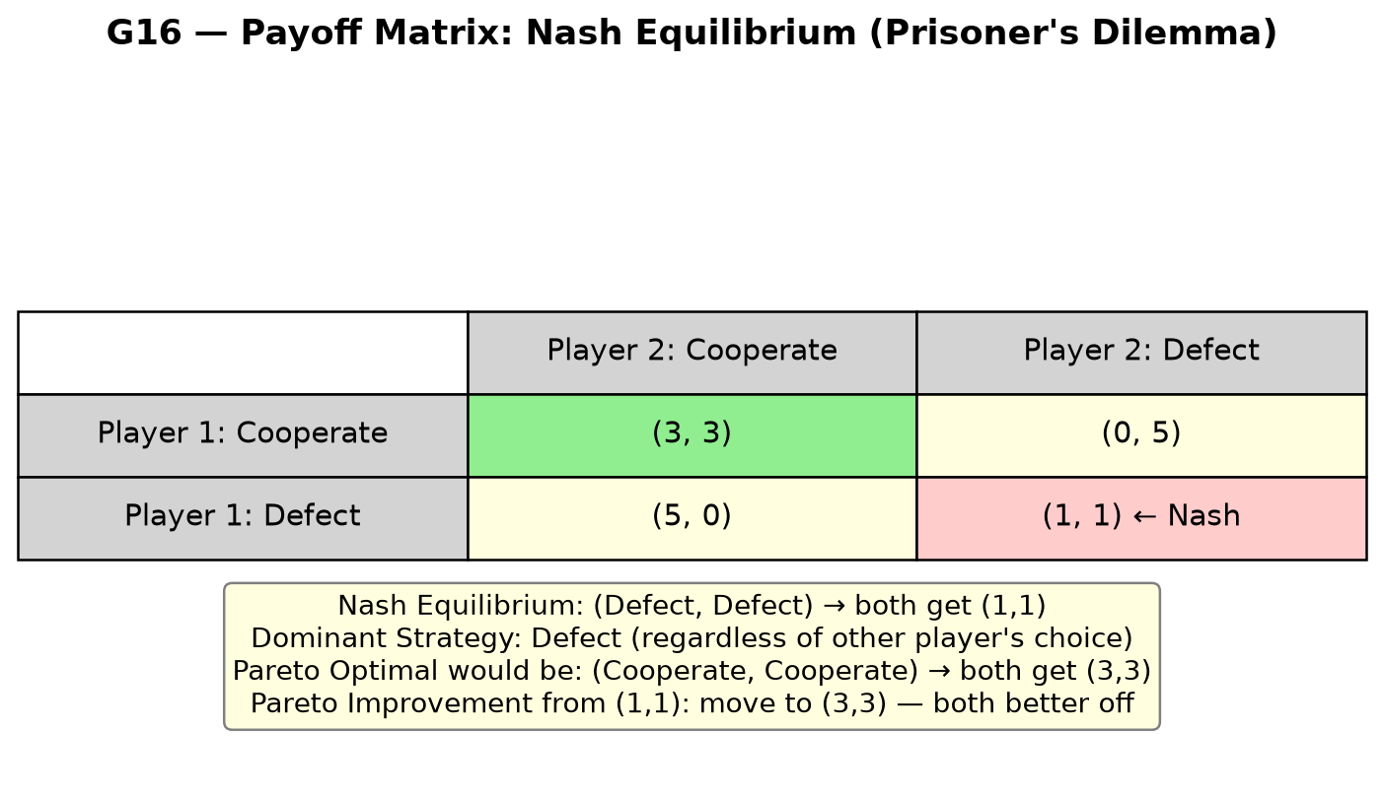
1. Axes: Not a graph — a 2×2 payoff matrix. Rows = Player 1 strategies. Columns = Player 2 strategies. Each cell = (P1 payoff, P2 payoff).
2. Curves & Lines: Four cells in a 2×2 table. Nash equilibrium: cell from which neither player can profitably deviate unilaterally.
3. Key Points: Nash: each player's strategy is a best response to the other's. Dominant strategy: best regardless of opponent's choice. Prisoner's Dilemma: Nash ≠ Pareto optimal (e.g. Defect/Defect vs Cooperate/Cooperate).
4. Explanation: In the Prisoner's Dilemma, Defect dominates Cooperate for BOTH players individually, so (Defect, Defect) is the Nash equilibrium. But (Cooperate, Cooperate) gives higher payoffs for both — Pareto improvement. The dilemma shows why individually rational choices can lead to collectively poor outcomes.
5. Step-by-Step Redraw:
- 1. Draw 2×2 table: label rows as P1 strategies, columns as P2 strategies.
- 2. Fill in payoff pairs (P1, P2) in each cell.
- 3. Find Nash: for each cell, check if either player would want to deviate.
- 4. Mark Nash equilibrium cell.
- 5. Check for dominant strategies: one strategy is best in every row/column.
6. Exam Sentences: (Defect, Defect) is the Nash equilibrium: given Defect by P2, P1 prefers Defect (1>0). Given Defect by P1, P2 prefers Defect (1>0). Neither player can gain by deviating unilaterally.
⚠ TRAP: Check EACH player's best response separately. A Nash equilibrium can exist even without dominant strategies. There can also be MULTIPLE Nash equilibria.
8. 80% / 100% Guidance:
80%: Nash identified correctly, check method stated (best response), one dominant strategy identified.
100%: Pareto improvement from Nash identified, repeated game logic mentioned (cooperation can emerge with sufficient discount factor), distinction from socially optimal outcome.
9. Mini Practice Question:
Payoffs: (C,C)=(3,3); (C,D)=(0,5); (D,C)=(5,0); (D,D)=(1,1). (a) Find Nash equilibrium. (b) Is there a Pareto improvement available? (c) What is the dominant strategy?
Memo: (a) Nash: (D,D) — given D by P2: P1 prefers D(1>0). Given D by P1: P2 prefers D(1>0). (b) Yes: (C,C) gives (3,3) — both better off. (c) Dominant strategy for both: Defect (payoff is higher regardless of opponent's choice).

G17 — Labour Discipline: Best-Response Curve e(w)
Unit: Unit 6 Exam Use: Efficiency wages, involuntary unemployment, labour market equilibrium Status: Reasonable A3 risk
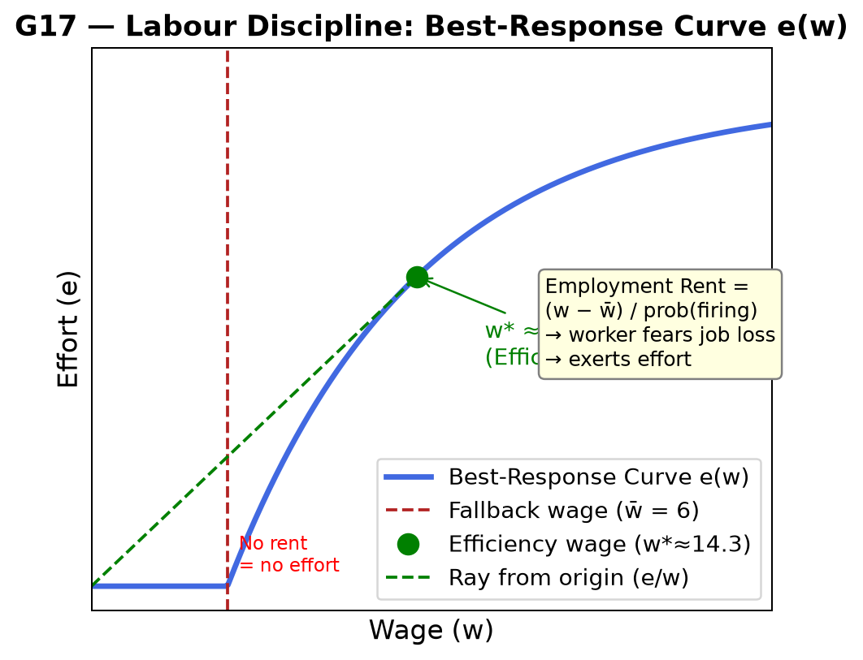
1. Axes: Vertical: Effort (e), range 0 to 1. Horizontal: Wage (w).
2. Curves & Lines: Best-response curve e(w): starts at 0 when w = fallback wage (w̄), rises (increasing returns to wage), flattens at maximum effort.
3. Key Points: Efficiency wage w*: tangency of ray from origin (e/w constant) with best-response curve. At w*, cost per unit of effort (w/e) is minimised. Fallback wage w̄: minimum below which effort = 0.
4. Explanation: Workers choose effort based on the employment rent = (w − w̄)/(probability of being fired). Higher wages increase the cost of job loss → more effort. The firm picks the wage that minimises cost per unit of effort, not the wage that clears the market. This leads to wages above market-clearing and involuntary unemployment.
5. Step-by-Step Redraw:
- 1. Draw axes: horizontal = wage, vertical = effort.
- 2. Draw vertical dashed line at w̄ (fallback wage).
- 3. Draw best-response curve starting at e=0 when w=w̄, rising steeply then flattening.
- 4. Draw a ray from the origin: slope = e/w.
- 5. Mark tangency point of ray with curve as efficiency wage w*.
6. Exam Sentences: The efficiency wage w* minimises the cost per unit of effort (w/e). At w*, the ray from the origin is tangent to the best-response curve. Because w* > market-clearing wage, involuntary unemployment results.
⚠ TRAP: Involuntary unemployment in this model is NOT caused by a minimum wage or monopoly — it arises endogenously because firms pay above market-clearing to discipline workers. Workers who lose their jobs at w* cannot get hired at w* elsewhere.
8. 80% / 100% Guidance:
80%: Best-response curve correctly shaped, fallback wage marked, efficiency wage at tangency identified.
100%: Employment rent defined, tangency condition derived (slope of ray = slope of curve), involuntary unemployment explained (unemployment is the "stick" that makes workers fear job loss).
9. Mini Practice Question:
The fallback wage is R6. The best-response effort function is e(w) = 0 for w ≤ 6, else e = 1 − e^(−0.12(w−6)). (a) What is effort at w=6? (b) Why does the firm pay above R6? (c) What is the key trade-off in choosing the efficiency wage?
Memo: (a) e(6) = 0 (no rent → no effort). (b) Paying above R6 creates employment rent: workers fear job loss and exert effort. (c) Higher w raises effort (good) but also raises wage cost per unit (bad). Efficiency wage w* balances these at the minimum cost per unit of effort.

G18 — GDP Hockey Stick: Long-Run Growth
Unit: Unit 1 Exam Use: Capitalism, Malthusian trap, Industrial Revolution, wellbeing beyond GDP Status: Reasonable A3 risk
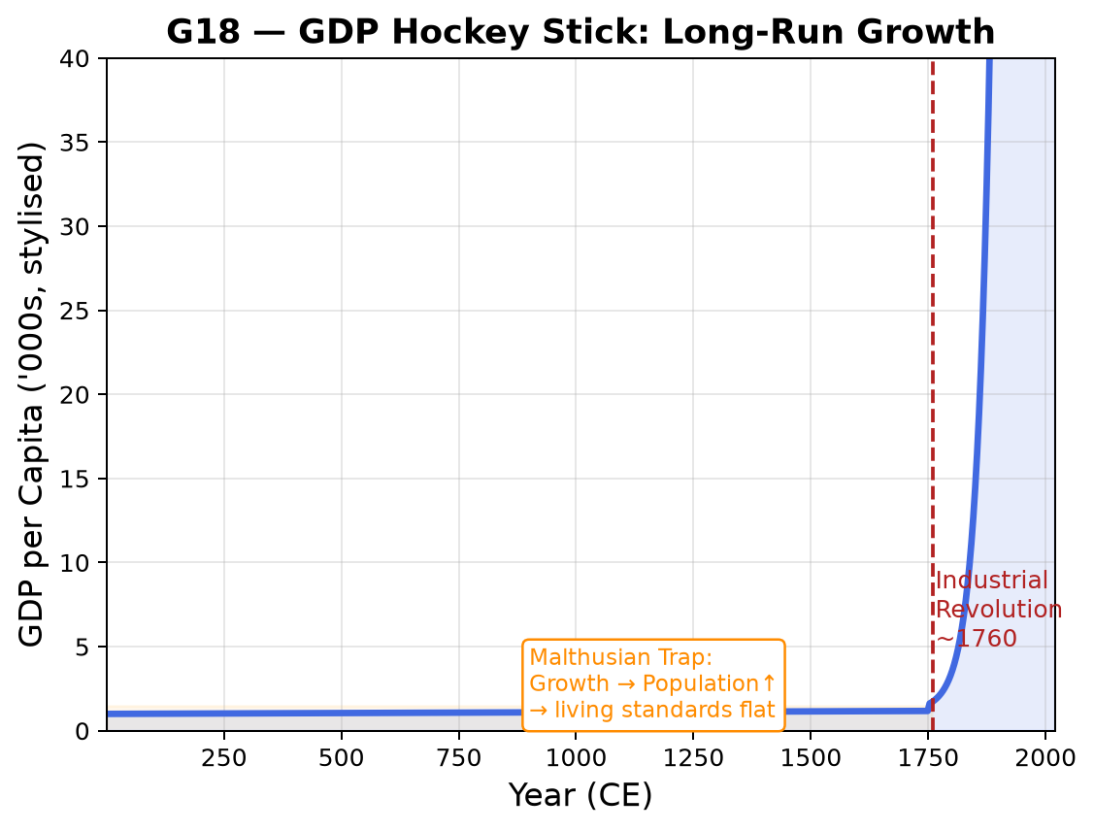
1. Axes: Vertical: GDP per capita (index or thousands of R/PPP). Horizontal: Year (CE, 1 to ~2020).
2. Curves & Lines: Nearly flat line for most of human history. Sharp upward bend ("hockey stick") from ~1800.
3. Key Points: Malthusian era: growth → population rise → living standards revert to subsistence. Post-Industrial Revolution: sustained technological change → GDP per capita grows exponentially. Hockey stick shape: almost flat for 1800+ years, then steep rise.
4. Explanation: Before ~1760, productivity gains led to population growth that offset per-capita gains (Malthusian trap). After the Industrial Revolution, technological change was fast enough that GDP per capita rose continuously despite population growth. This "great escape from poverty" is the central fact of modern economics.
5. Step-by-Step Redraw:
- 1. Draw horizontal axis (Year) from year 1 to ~2020.
- 2. Draw vertical axis (GDP per capita).
- 3. Draw nearly flat line from year 1 to ~1760.
- 4. Mark "Industrial Revolution ~1760" with a vertical dashed line.
- 5. Draw sharply rising curve after 1760 (exponential shape).
- 6. Label "Malthusian Trap" region (flat) and "Hockey Stick" region (steep).
6. Exam Sentences: GDP per capita was roughly constant for millennia (Malthusian trap), then rose exponentially after the Industrial Revolution (~1760), producing the characteristic "hockey stick" shape.
⚠ TRAP: GDP per capita measures average income only. It misses inequality, unpaid work, sustainability, and wellbeing (HDI, Gini). "GDP rises → everyone better off" is the trap answer.
8. 80% / 100% Guidance:
80%: Correct shape (flat then steep), Malthusian trap region labelled, post-IR growth explained.
100%: Malthus's prediction explained (food grows arithmetically, population geometrically), why it failed (technology), GDP limitations listed (excludes unpaid work, negative externalities, inequality), PPP adjustment explained.
9. Mini Practice Question:
(a) What is the "Malthusian trap"? (b) Why did GDP per capita stay nearly flat before 1760? (c) State TWO limitations of GDP per capita as a wellbeing measure.
Memo: (a) Malthusian trap: any rise in income → population grows → per capita income returns to subsistence. (b) Technology improved slowly; gains were absorbed by population growth. (c) (i) Excludes unpaid work (domestic labour, childcare). (ii) Ignores distribution (high average can mask extreme inequality). Also valid: excludes negative externalities, non-market goods, leisure.

G19 — Goods Classification Matrix (Unit 10)
Unit: Unit 10 Exam Use: Public goods, common goods, free rider problem, tragedy of the commons Status: Source confirmed
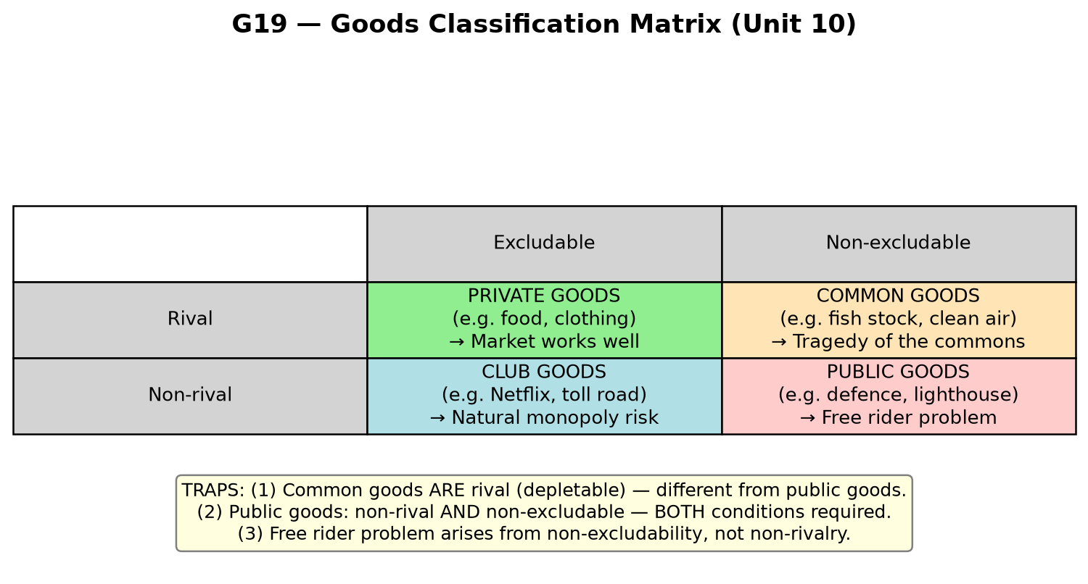
1. Axes: Not a graph — a 2×2 classification matrix. Rows = Rival vs Non-rival. Columns = Excludable vs Non-excludable.
2. Curves & Lines: Four quadrants: Private goods, Common goods, Club goods, Public goods.
3. Key Points: Private: rival + excludable → market works. Common: rival + non-excludable → tragedy of commons. Club: non-rival + excludable → natural monopoly risk. Public: non-rival + non-excludable → free rider problem.
4. Explanation: Goods differ on two dimensions: (1) Rivalry: does one person's use reduce availability for others? (2) Excludability: can you prevent people from using the good? Markets work well only for private goods. Public goods face the free rider problem — no incentive to pay voluntarily for something you cannot be excluded from.
5. Step-by-Step Redraw:
- 1. Draw 2×2 grid.
- 2. Label rows: Rival (top) / Non-rival (bottom).
- 3. Label columns: Excludable (left) / Non-excludable (right).
- 4. Fill quadrants: Private / Common / Club / Public.
- 5. Add one example per quadrant.
- 6. Note the market failure in each non-private quadrant.
6. Exam Sentences: Public goods are non-rival and non-excludable. Free riders consume public goods without paying, making private provision underprovided. Common goods are rival but non-excludable — overuse leads to tragedy of the commons.
⚠ TRAP: Do NOT confuse "public good" (economics definition: non-rival + non-excludable) with "government-provided good." A government toll road is a club good (non-rival until congested, excludable by tolling). Defence is the classic public good.
8. 80% / 100% Guidance:
80%: All four quadrants correctly classified, one example each, free rider problem identified for public goods.
100%: Market failure mechanism explained for each non-private quadrant, policy responses stated (government provision for public goods, quotas/property rights for common goods, regulation for club goods), moral hazard vs free rider distinction noted.
9. Mini Practice Question:
Classify each: (a) A lighthouse. (b) A fish stock in international waters. (c) A Netflix subscription. (d) A sandwich. State (Rival/Non-rival) + (Excludable/Non-excludable) + good type.
Memo: (a) Lighthouse: non-rival + non-excludable → PUBLIC GOOD. (b) Fish stock: rival (fish caught = fish gone) + non-excludable → COMMON GOOD. (c) Netflix: non-rival + excludable → CLUB GOOD. (d) Sandwich: rival + excludable → PRIVATE GOOD.

