**Species Invasion in a Network Population Model**

The spread of invasive species is increasingly driven by the introduction of foreign species to new habitats via man-made transport networks. Species introduction and establishment represent two distinct stochastic processes, which we model respectively, as movement between and growth within population nodes on a network. We present the steady state analyses from one and two dimensional cases of our model. For higher dimensions and complex network geometries, we perform numerical simulations. In addition, we investigate the effects of stochasticity in biologically pertinent cases and present the aggregated results. In the biological world, the success of individuals within a population is density-dependent in many aspects, for example, in mate searching or pack behavior. We explore the influence of such Allee effects on the propagation of invasive species to new habitats.

To do:

PPT: Give to leah by Wednesday.

Small world – reconcile with the watts strogatz model, does the curve agree with some sort of network metric, say, mean path length?, test extremes (low growth vs low migration – alter r and v, see whether the characteristic curve changes, and the network metric agreement). Remember to switch to the discrete map. The reason that the curve asymptotes to a non zero number is because there is some delay between spread and growth across the threshold. Even a direct connection does not mean that a node receiving the infection in the first step will cross the threshold to infection at the first step as well.

Hubs – incorporate hubs into directed weighted network

Analysis – find analytic for fixed points of 2d. Jacobian optional. Parameter expansion (r^2 and HOT)

Latex – Write in the result of 2d analysis.

--🡪allee effect in the stochastic model

Eigenvalue analysis – write the simulation in R and reveal the conclusions

Edit the 1-d section.

Write the analysis section of the thesis – full up

Notes: Think about biology and math sections as separate. Having long winded biology explanations in the middle of precise mathematical definitions can be confusing and affect the flow negatively.

Use \ref for references of equations (and find a way to automatically include parentheses).

Reference Strogatz for the Taylor Series Expansion.

Be sure to define f(N) as the logistic before using it

Define EVERY PARAMATER BEFORE YOU USE IT!

Motivation for the 1-d map discrete instead of continuous. Ie. We use 1 year periodic data in the transition matrix so there’s no need for finer resolution. Also, it’s perhaps more computationally efficient to use a discrete map instead of ode.

Explore the parameter space: involves thinking about what parameters at low or high values would mean for the qualitative model results, and which may be biologically relevant. For example, think about low migration rate and high birth and death. This might be a realistic interpretation of invasive species movement. Be careful to run the simulations long enough for the parameter rates to take effect. Recall… if the birth rate if 10^-3 then it would occur once every 10^3 events. If you run for only 10^2 events, you would never see it.

Investigate different network geometries. Which would be either realistic which we should investigate, or which ones would likely result in interesting behavior.

Implement the Allee Effect into the model. Begin by looking at the birth and death rate in that Allee paper we discussed and see whether or not we just want to use that. Also, maybe just the ODE?

Does eigenvalue analysis on the ODE tell us anything qualitative of predictive value that we can use in place of running the whole model?

In all of these, the idea is can we figure something out that lets us know about the behavior of the system without us having to completely run the model or analyze it.

Standard network geometries for directed weighted networks. Look for numeric simulation papers.

Anticorrelation of the outward and inward weights on connections.

Weighted Directed Networks: Start with the small-world network ring model. Figure out the plot of “time to spread to x” with the probability of long distance dispersals (again, I think this might be a matrix of weights.) This will require looking up a standard small-world model and implementing it, then plotting the probability outcomes over a large number of simulations. Find something qualitative to say about long-distance spread vs. local spreading. Do this qualitatively change when you implement the allee effect? Does the weight matter more now? **Long range probability of spreading and local spreading effects. Small-world network.** Start with one hub and local spreading to nearest neighbors, and possibility of long-distance spread to the “opposite” side of the world (ring).

(scan matrix before using it. Test connections by building up the connections. Start with a matrix with a 1 in the corner, then add connections… something) Note: Actually currently just testing this by finding the distance between the two points, reproducing matrix if that distance is INFINITY.

To implement deterministic map for small world simulation, have to scale by movement factor “v”.

Check the original Watts & Strogatz paper and see exactly what are they looking for in terms of plotting vs. probability of rewiring or time to reach target.

Next, we will look into the role of large hubs with high degree and high strengths (weights). To do this, we will need to find or build and implement an add-on model which builds a network (scale-free?), pulling from a certain distribution. The problem might be in finding the exponent of the degree distribution. I might be able to pull this from the global shipping Drake or Kaluza papers. Optimally, this program generates a matrix of weights (ie. Connections between nodes) and then plugging it into the model that I already have in R (recall here we can control the allee effect implementation). Run it and aggregate the results in order to produce results? Let’s look at what people have said about these networks in the past (look into invasive or infection spread models) and see what types of results people want. I’d imagine, you’d want to know the importance of these hubs qualitatively (taking one out?) and whether the connectivity or the weights matter more. Maybe we could generate another plot of time to spread to (50 or x number of nodes) vs. connectivity or weight of the hubs.

**Eigenvector analysis:** Imagine the stability graph in three dimensions. Imagine a small perturbation from the null state (unstable zero population state) as approximated by the evolution of the associated eigenvector of the largest eigenvalue of A. This matrix A will combine the function of growth (allee effect), the transition matrix, and the state vector? (Next step: What exactly is A? I think I have this written down in my notebook. Otherwise, how to apply the logistic growth w/ allee to the transition matrix? And state vector?) This could either be recalculated at every time step, or calculated in the beginning and tested to see how well it held up.

In the biological world, the success of individuals within a population is density-dependent in many aspects, for example, in mate searching or pack behavior. We explore the influence of such Allee effects on the propagation of invasive species to new habitats.

**March 21, 2016:** Priority list for upcoming week:

1) Go back to the small-world network model. Make sure you understand how “v” parameter is being input. Maybe it doesn’t have to be in the model in the first place. Maybe, instead, the one parameter we use is “q”, which is the “self_rate”, the percentage that each state takes from the one delivering (ie. The non self-loop coefficients in the coefficient matrix P).

*UPDATE: changed the three models to just use “v” (which is equal to what Leah talked about as “q”. Need to go in and add the deterministic map to the make_plots and see if all three models are working the same way.

2) Also understand how the parameters of birth and death rate are being used by the simulations. Does it align with the ODE model? According to Leah’s work, the parameters of “r” and “v” or “q” should align (maybe this also goes under bullet point 1).

3) Once I understand the simulations and exactly what they are doing (this is a big step). I should expand the chapters in my thesis.

->3.5) Okay, so maybe I should go back to SageMath and see if the computer can solve the equation I have now (I have s2 isolated in terms of s1 and all other params, with highest order of s1 being quadratic). This is a *side* priority.

4) Small World – using the symmetric values of “r” and “q”, check whether these two plots are roughly the same. We might expect them to yield similar results since they are “directly relatable” as in the rates of growth associated with them for each node is roughly the same as derived from the ODE / deterministic map.

5) See whether it would be easy or not to do a characteristic path length calculation for the small world networks (loop through and calculate all path lengths... or possibly r package already exists… regardless, the input would be the original small world network as generated? Or how would I involve the invasive species simulation? Maybe I don’t need to, but I do need to think about this.)

6) Go back to the three models (ODE, stochastic, discrete map), and then see whether they are all agreeing and doing what is expected (ie. Check if the code is working properly). Let’s make a graph comparing all three of them in a “typical” parameter regime, and then do another one where I try to tease out stochasticity (low low immigration and population).

7) When I have the qualitative results from this, think about it for a bit and then talk to Leah about how to quantify the regime (what kind of distribution are we looking at when?).

8) Once the stochastic and deterministic simulations are working out, need to introduce the Allee Effect. Looking into the old group meeting paper, and into a novel lit review, what are the “standard growth rules” for a stochastic Allee Effect implementation

**For writing:**

1) Introduction – Use references more, and for multi-sentence citations, try to work citation into the paragraph.

2) Add a section about the different diffusive spread models? This is the general idea: I am trying to give a background on research done into network models and invasive species in general. I am going to say that there has been research on x, y, z, part of invasive species, but part w is not covered. Concretely, I will discuss Barabassi-Albert (why network models rock). Drake / Kaluza & HWA paper (large-scale data driven models, but lack small-scale resolution so we don’t know what is affecting what). Small-scale papers (they set some precedence but don’t explore…). And so, we are pursuing this research to fill the gap in knowledge, which is a critical one.

3) For citations: Each sentence should be able to be traced back to a source, but a good practice is to embed the source somewhere into the paragraph so that not every sentence has to be followed by a parenthetical citation. Go over references in writing and choose which articles go to where.

4) Latex – don’t put line break after equation (it starts a new paragraph)

5) Structure with spatial modeling covered after logistic / allee effect. (overall structure of modeling section)

6) Figure subtext – more detail regarding the figure, explaining each subfigure. Allee effect describing intervals or critical points on the interval?

7) Integro-difference? Integro-differential? Describe as an example, not as the most general version.

Writing in modeling 2 d analysis / computational section:

1) some standard variable changes

2) Standard sentence formatting on “we define the following:” in the model formulation section.

3) P matrix should have small “n” instead of “m”. s vector should have “t,I” instead of “t_i”.

4) Define a vector where s_t,I has g(N_t) is applied here.

5) Mathematical rigor.

6) Bold case matrices and vectors, then italicized lowercase entries within each of them.

7) Agreement of ODE / discrete map. Talk about how big proportions in transport might break the agreement.

To do:

Add in jacobian stuff

r

Agreement of ODE / discrete map

Write in results of smallworld

Reformat / editing

The small world results – explain differences between the three lines (different v values).

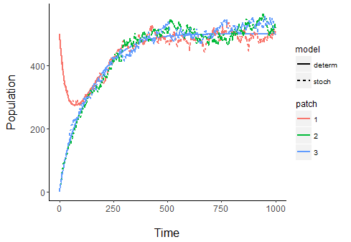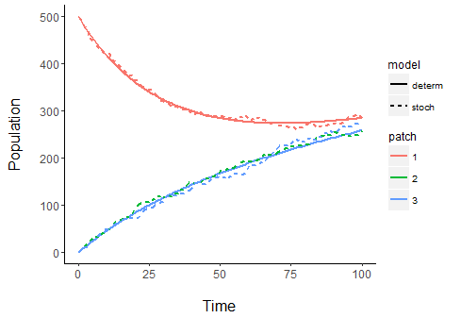

Fig. Migration rate = 0.01

­

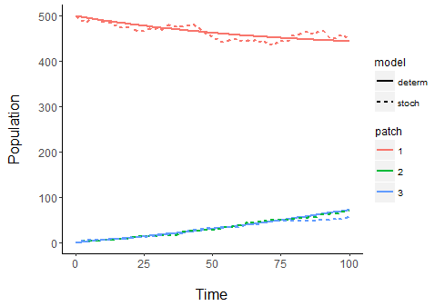

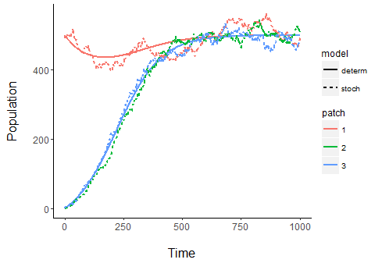

Fig. Migration rate = 0.001

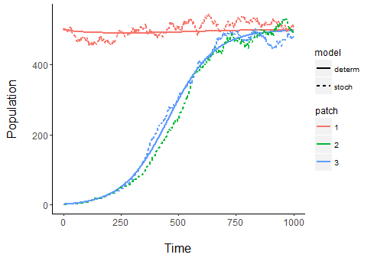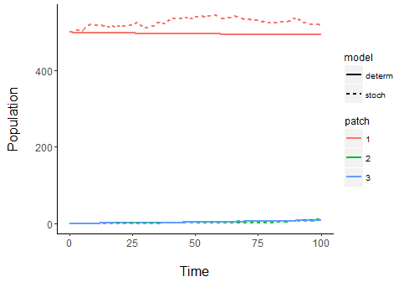

Fig. Migration rate = 0.0001

List of things that need to be done:

1) Writing:

a. Why not IDE?

b. Environmental Niche Models

c. Network Models

d. Outline of Thesis

e. 2d analysis / Jacobian section

f. Small world – algorithmic implementation & results

g. Stochastic Modeling comparison of stochastic logistic and deterministic (std. / mean prop. To sqrt(N))

h. Conclusions, summary, future work (hubs, allee effect)

2) Revising:

a. Go through noted sections (model formulation & simulations)

b. Read through and edit

3) Results:

a. Small world – have characteristic path length graph matched up with the triple graph

b. Small world – show the absolute time graphs and compare them with the normalized graph

c. Stochastic – don’t show zoom. Show place where the blue / green nodes disagree (i.e. result of difference between growth in different stochastic patches is caused by them taking off at different times. Reveal this, and describe what you’re doing in the caption).

d. Stochastic – noise should drop off as we approach equilibrium. Why is it getting larger? At least, with increased carrying capacity, we should think that noise decreases.

e. Jacobian Stability – calculate when > 1 and < -1

f. Fixed point – calculate degree of polynomial, is it reasonable to solve it?