A

Mini-Project Report on

### Personal Shopping Assistance using Brain

**Shop API**

Submitted in partial fulfillment of the requirements for the degree of

BACHELOR OF ENGINEERING IN

#### Computer Science & Engineering

Artificial Intelligence & Machine Learning

by

Kartik Parmar (22106101)

Pratham Patange (22106045)

Niraj Patel (22106050)

Jay Patil (22106020)

Under the guidance of

### Prof. Monali Korde



#### Department of Computer Science & Engineering (Artificial Intelligence & Machine Learning)

**A. P. Shah Institute of Technology**

#### G. B. Road, Kasarvadavali, Thane (W)-400615 University Of Mumbai

**2023-2024**

## A. P. SHAH INSTITUTE OF TECHNOLOGY

### CERTIFICATE

This is to certify that the project entitled **“Personal Shopping Assistance using Brain shop API”** is a bonafide work of Kartik Parmar (22106101),Pratham Patange (22106045), Niraj Patel (22106050), Jay Patil (22106020) submitted to the University of Mumbai in partial fulfillment of the requirement for the award of **Bachelor of Engineering** in **Computer Science & Engineering (Artificial Intelligence & Machine Learning).**

Prof. Monali Korde Dr. Jaya Gupta

Mini Project Guide Head of Department

## A. P. SHAH INSTITUTE OF TECHNOLOGY

### Project Report Approval

This Mini project report entitled “**Personal Shopping Assistance using Brain shop API*”*** by **Kartik Parmar (22106101),Pratham Patange (22106045),Niraj Patel (22106050),Jay Patil (22106020)** is approved for the degree of ***Bachelor of Engineering*** in ***Computer Science & Engineering***, (AIML) ***2023-24***.

External Examiner: Internal Examiner:

Place: APSIT, Thane Date:

**Declaration**

We declare that this written submission represents my ideas in my own words and whereothers' ideas or words have been included, I have adequately cited and referenced the original sources. I also declare that I have adhered to all principles of academic honesty and integrity and have not misrepresented or fabricated or falsified any idea/data/fact/source in my submission. I understand that any violation of the above will be cause for disciplinary action by the Institute and can also evoke penal action from the sources which have thus not been properly cited or from whom proper permission has not been taken when needed.

|  |  |  |  |
| --- | --- | --- | --- |
| Kartik Parmar | Pratham Patange | Niraj Patel | Jay Patil |
| (22106101) | (22106045) | (22106050) | (22106020) |

**ABSTRACT**

In an era where digital transformation is reshaping consumer behaviour, "Empowering Local Commerce" seeks to revolutionize the way we engage with and support local businesses in India. This project introduces a cutting-edge mobile application, a Shop Bot, designed to bridge the gap between traditional local shopping and the convenience of online retail. The Shop Bot is a versatile platform that empowers local shops to extend their reach beyond brick-and-mortar confines. It offers a seamless online shopping experience, enabling users to browse, select, and purchase a diverse range of products from local businesses, all from the comfort of their homes. This innovative platform is tailored to the unique needs of local shops, allowing them to showcase their products, manage inventory, and fulfil orders efficiently. One distinctive feature of the Shop Bot is its AI-powered shopbot, which serves as a knowledgeable and responsive assistant. Users can ask questions, seek recommendations, and gain valuable insights on products and services. This shopbot not only enhances the shopping experience but also fosters trust and engagement between customers and local businesses. The project's overarching goal is to foster community-driven economic growth and strengthen the local economy by supporting and revitalising local commerce. "Empowering Local Commerce" embodies the fusion of modern technology and traditional values, offering a sustainable and accessible solution that empowers local businesses while satisfying the ever-evolving needs of consumers. By implementing this innovative platform, we aim to pave the way for a more inclusive and vibrant local economy, further connecting communities with their beloved local shops and delivering a superior shopping experience for all. In a rapidly evolving retail landscape, "Empowering Local Commerce" stands as a beacon of progress, uniting the convenience of e-commerce with the authenticity of local businesses.

**Index**

|  |  |  |  |
| --- | --- | --- | --- |
| Index | | | Page No. |
| Chapter-1 | | |  |
|  | Introduction | | 1 |
| Chapter-2 | | |  |
|  | Literature Survey | | 3 |
|  | 2.1 | History | 4 |
|  | 2.1 | Review | 5 |
| Chapter-3 | | |  |
|  | Problem Statement | | 7 |
| Chapter-4 | | |  |
|  | Experimental Setup | | 9 |
|  | 4.1 | Hardware Setup | 10 |
|  | 4.2 | Software Setup | 10 |
| Chapter-5 | | |  |
|  | Proposed System and Implementation | | 11 |
|  | 5.1 | Block Diagram of Proposed System | 19 |
|  | 5.2 | Description of Block Diagram | 19 |
|  | 5.3 | Implementation | 20 |
| Chapter-6 | | |  |
|  | Conclusion | | 25 |
| References | | | 27 |

Table of Figures:

|  |  |  |
| --- | --- | --- |
| Figure no. | Figure name | Page no. |
| 5.1.1 | Block Diagram | 13 |
| 5.1.2 | Level 0 Diagram | 14 |
| 5.1.3 | Level 1 Diagram | 15 |
| 5.1.4 | Level 2 Diagram | 15 |
| 5.3.1 | Login Page. | 18 |
| 5.3.2 | Register page | 18 |
| 5.3.3 | Chat screen | 19 |
| 5.3.4 | Shopping screen | 19 |
| 5.3.5 | Checkout screen | 20 |

# CHAPTER 1 INTRODUCTION

#### 1. INTRODUCTION

In India we have a traditional method to purchase items from shop. To break this traditional chain, we are introducing shop bot using this we can purchase online items even if we are in home. This is a proposal for the design and development of a Shopbot. Also, this chat bot not only purchase an item but also gives to answers to the users question. Now a days many big giant companies are going online and they are inventing online apps, but these apps are not interactive so to achieve the interactive shopping we are coming up with Shopbot. Traditional shopping in India often involves time-consuming visits to physical stores, particularly in the context of a diverse and vast retail landscape. With the growth of the internet and e-commerce, online shopping has gained significant popularity. However, many consumers still miss the personal touch and interaction they get from in-store shopping. This is where the Shopbot comes in, offering a blend of online convenience and human-like interaction.

The primary objectives of this project are as follows:

1. Develop a user-friendly app.
2. To help discover products users are interested to buy.
3. Enhance the user experience by providing detailed insights about products, including their specifications, features, pricing.
4. Improve transparency and trust in the buying and selling process.

The Shop Bot provides conversational interface,the Shopbot will feature a user friendly conversational interface, enabling users to interact with it as if they were talking to a knowledgeable salesperson, the product discovery users will be able to inquire about products, find specific items, and explore various options using natural language queries. Personalised recommendations by employing advanced algorithms, the Shopbot will analyze user behaviour and preferences to offer tailored product recommendations.Interactive shopping as users will receive detailed information about products, including specifications, reviews, and pricing, and be able to make purchases seamlessly.

# CHAPTER 2 LITERATURE SURVEY

##### 2. LITERATURE SURVEY

###### 2.1-HISTORY

The historical development of shopbots traces back to the early days of the internet and the emergence of e-commerce. In the late 1990s and early 2000s, as online shopping gained popularity, the need for tools to help consumers navigate the vast array of products and prices became apparent. Initially, shopbots were rudimentary price comparison tools that allowed users to search for a specific product and compare prices across different online retailers. These early shopbots relied on basic search algorithms and web scraping techniques to gather product information from various websites.

As internet technology advanced, so did shopbots. Throughout the early 2000s, developers began to implement more sophisticated algorithms and data retrieval methods to improve the accuracy and relevance of search results. The introduction of APIs (Application Programming Interfaces) allowed shopbots to directly access data from e-commerce platforms, enabling real-time price updates and inventory tracking. Additionally, advancements in natural language processing and machine learning paved the way for more intelligent shopbots capable of understanding user preferences and providing personalised recommendations.

Over the years, shopbots diversified in terms of functionality and features. Today, shopbots continue to evolve alongside advancements in technology and changes in consumer behaviour. Another significant development in the evolution of shopbots was the introduction of mobile apps and platforms. With the widespread adoption of smartphones and tablets, shopbots became accessible on-the-go, allowing users to compare prices and shop conveniently from their mobile devices. Overall, the historical development of shopbots reflects a continuous evolution driven by advancements in technology, changes in consumer behaviour, and the ever-expanding landscape of e-commerce.

##### 2.2-LITERATURE REVIEW

In this report a simple economic model is proposed and analyzed, which is intended to characterize some of the likely impacts of a proliferation of shopbots and pricebots.In addition to describing theoretical investigations, this paper also aims toward a practical understanding of the tradeoffs between profitability and computational and informational complexity of pricebot algorithms.[1]A shopbot is a software agent that automatically queries multiple on-line vendors to gather information about prices and other product attributes at a given point in time.Consumers can easily gather information about the prices of multiple competing retailers using shopbots and can typically purchase a product listed at a shopbot by clicking on a corresponding hyperlink to redirect the consumer to the retailer's website. Shopbots have become important tools that facilitate search in online markets, leading to increased consumer search. The central hypothesis of this paper is that because shopbots reduce consumer search costs for prices, the increased adoption of shopbots should influence retailers' pricing strategies.[2]In this study two ShopBots were used to determine high- to-low price dispersion for identical models of 25 consumer durables, in 2007 and again in 2011, revealing substantial but declining price dispersion ratios. A survey of 1,135 American online shoppers revealed their dependence on ShopBots and frequency of other online shopping actions.[3]Findings show that interaction design of the existing conversational commerce are still lacking in various areas. Therefore, an interaction and interface design for chatbot-based conversational commerce are developed in this study using user-centered design. The outcome of this study is a prototype that fulfills the usability goal and the user experience goal defined for chatbot-based conversational commerce on mobile platform. [4]

The growth of Android applications around the world is extraordinary. People turn towards technology for making their life more innovative and find solutions to their daily problems. When it comes to shopping, customers find it very difficult to find their products around the supermarket as well as to stand in long billing counter queues. Here we have come up with an android application which can be used in smart shopping carts that solve these dilemmas and provide a better shopping experience. Our smart app consists of two parts which mainly focuses on navigation to the item's location and automatic billing of the products that the user has purchased. The building environment of the app is the open source software called Android Studio software. An RFID reader is used to scan the products. This paper discusses the design

and implementation of the app and the results thus obtained.[5]

For the past few years, e-commerce has changed the way people buy and sell products. People use this business model to do business over the Internet. In this domain, Human-Computer Interaction has been gaining momentum. Lately, there has been an upsurge in agent based applications in the form of intelligent personal assistants (also known as Chatbots) which make it easier for users to interact with digital services via a conversation, in the same way we talk to humans. In e- commerce, these assistants offer mainly text-based or speech based search capabilities. They can handle search for most products, but cannot handle search that is based on product features, for instance color or pattern of a T-shirt. Most of the times, it is difficult for users to define these characteristics while searching for a product. Furthermore, a growing number of consumers rely on social media to make a purchasing decision. They try to find out what is trending right now and look for similar items. This brings us the need of a virtual shopping assistant or a shopbot which recommends products based on an image of the product provided by a user. It will be designed to provide relevant responses to the user queries by performing image recognition. This report explains the proposed approach along with the

implementation for the virtual shopping assistant.[7]

# CHAPTER 3

**Problem Statement**

##### PROBLEM STATEMENT

In today's rapidly evolving digital landscape, consumers increasingly turn to online platforms for their shopping needs, seeking convenience, variety, and personalized experiences. However, navigating the vast array of products available online can be overwhelming, leading to frustration and decision paralysis. Traditional e-commerce websites often lack the interactivity and guidance necessary to assist users in making informed purchasing decisions. This highlights the need for a solution that bridges the gap between consumers and online retailers, offering personalized assistance and streamlining the shopping experience.

To address this challenge, we propose the development of a shopbot – an intelligent chatbot designed to serve as a virtual shopping assistant. The shopbot aims to revolutionize the way users discover, compare, and purchase products online.By answering user queries, and providing recommendations, the shopbot empowers users to make confident and informed decisions while saving time and effort.

The increase in online shopping platforms has led to an overwhelming abundance of products and prices, presenting consumers with the challenge of navigating this vast and often confusing landscape. While shopbots have emerged as promising tools to solve this problem by offering price comparison. One primary concern is the reliability and accuracy of the information provided by shopbots, as inconsistencies or inaccuracies in pricing data may undermine consumer trust and lead to wrong purchasing decisions.

Through the implementation of this innovative solution, we aim to enhance the online shopping experience, driving customer satisfaction, loyalty. By harnessing the power of technology to deliver personalized assistance and guidance, the shopbot promises to revolutionize the way users shop online, making it a valuable addition to the e-commerce ecosystem.

# CHAPTER 4

**Experimental Setup**

##### EXPERIMENTAL SETUP

###### Hardware Setup

1. CPU: core i5 or higher version
2. RAM: recommended 4GB and More
3. STORAGE: 256GB Disk Space or More
4. OS: Microsoft Windows 7, Microsoft Windows 8, Microsoft Windows 10 or later
5. Android device: An android device, it may be a phone or a tablet.
6. Networking Equipment: Router to connect the server to the internet and manage network
7. Security Equipment: Firewalls and security measures to protect against cyber threats.

###### Software Setup

1. **Integrated Development Environment (IDE):**
   * Android studio:An official IDE for Android app development.
   * JDK: Used to build software/applications on Java.

# CHAPTER 5

**Proposed System & Implementation**

##### Proposed System & Implementation

###### Block Diagram of Proposed System

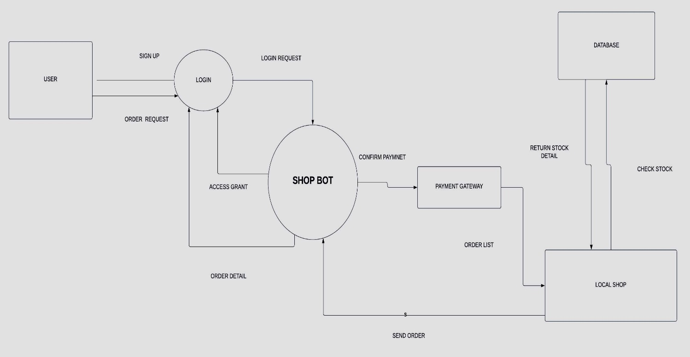

**Fig 5.1.1 Architecture / Block Diagram**

**Data Flow Diagram (Level 0, Level 1 & Level 2)**

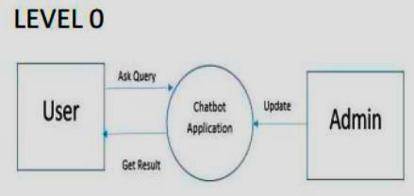

**Fig 5.1.2 DFD Level 0**

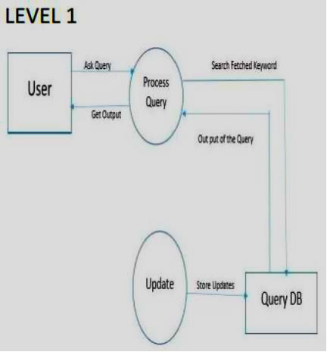

###### Fig 5.1.3 DFD Level 1

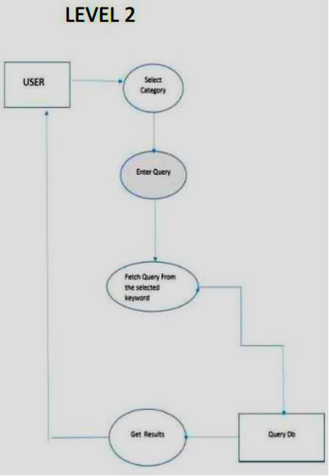

**Fig 5.1.4 DFD Level 2**

###### Description of Block Diagram

* + - **User Sign Up & Login**: This is the initial step where a new user registers for the service. The user provides necessary details like name, email, and password to create an account. Once the account is created, the user can log in to the system using their credentials. The login request is sent to the SHOP BOT, which grants access if the credentials are correct.
    - **Order Request**: After logging in, the user can browse through the items and make an order request. This could involve selecting items, specifying quantities, and adding them to a virtual cart.
    - **Order Processing**: The SHOP BOT receives the order request and processes it. This involves checking the availability of the requested items. The SHOP BOT accesses a database that contains information about the stock details of all items. If the items are available, the SHOP BOT proceeds to the next step.
    - **Payment Confirmation**: The SHOP BOT interacts with a payment gateway to confirm the payment. The user is asked to provide payment details, such as credit card information. Once the payment is confirmed, the SHOP BOT generates an order list.
    - **Order Fulfillment**: The order list is sent to a local shop. The local shop prepares the order and dispatches it for delivery to the user’s specified address.

The user interface includes the following features:

* + - **Login Page:** Login page will provide the UI for the user to enter the credentials to log into the application. Log in can be done by user. Users can login with the credentials. He/She can login as user or admin (Local Shops) according the page will be visible to the user. If the user who is new to our application can register themselves after that they can use the credentials for further uses.
    - **Account Creation:** The Account Creation module within our Shopbot application is designed to facilitate user registration, enabling individuals to establish their presence within the platform.
    - **Chat Screen:** The Chat Screen offers a user-friendly and responsive interface. The chat screen is a pivotal feature within our Shopbot application, exclusively designed for mobile devices, ensuring that users have an optimal and convenient chat experience on the go. It allows shoppers to seek advice, ask questions, and receive personalized assistance.
    - **Shopping Screen:** The Shopping Screen module in our mobile-exclusive application is where the magic of shopping truly comes to life.
    - **Checkout Screen:** In our mobile-exclusive shopping application, the Checkout Screen module is where users finalize their purchases by providing essential personal details, including name, email, phone number, and delivery address. This information is collected seamlessly and securely to ensure accurate and on-time deliveries.
  + **Invoice Screen**: The Invoice Screen in our application is the final stop in the shopping journey, where users receive a detailed bill for their selected product

###### Implementation

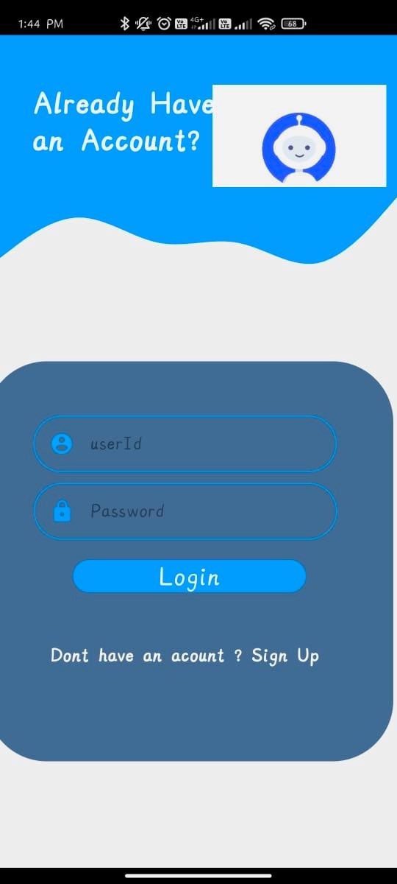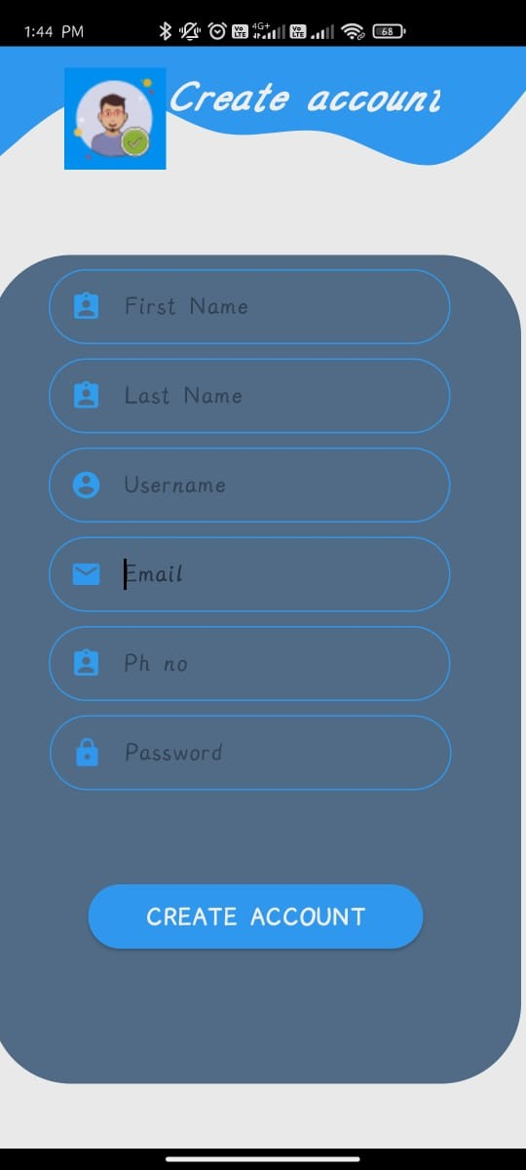

**Fig 5.3.1** Login Page. **Fig 5.3.2** Register Page.

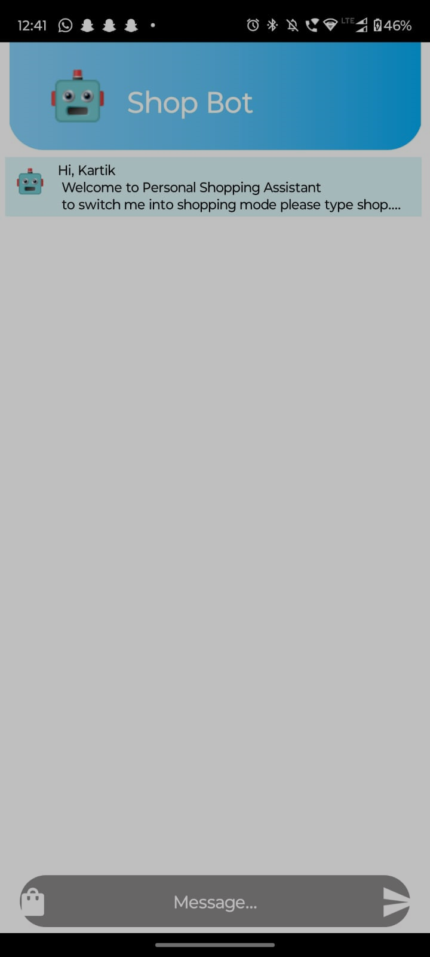

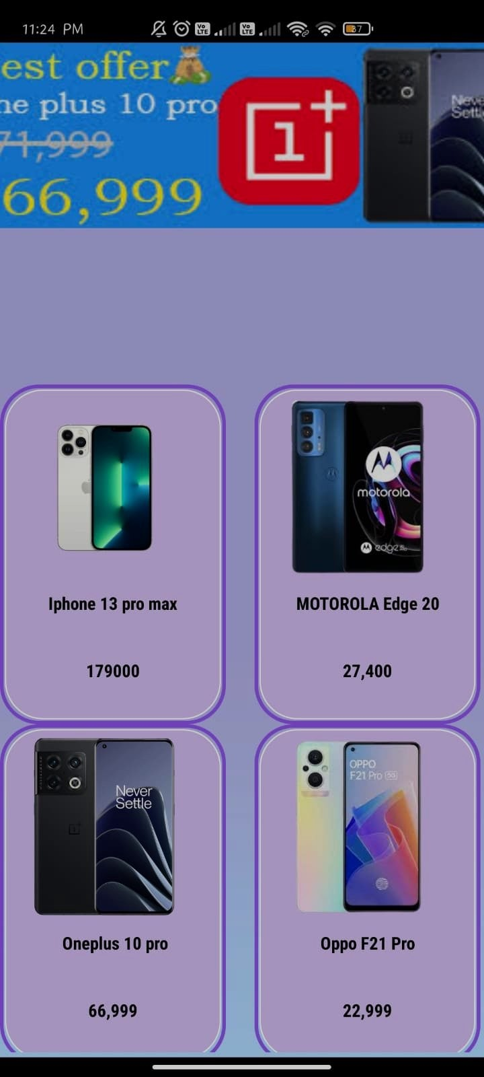

**Fig 5.3.3** Chat Screen. **Fig 5.3.4** Shopping Screen.

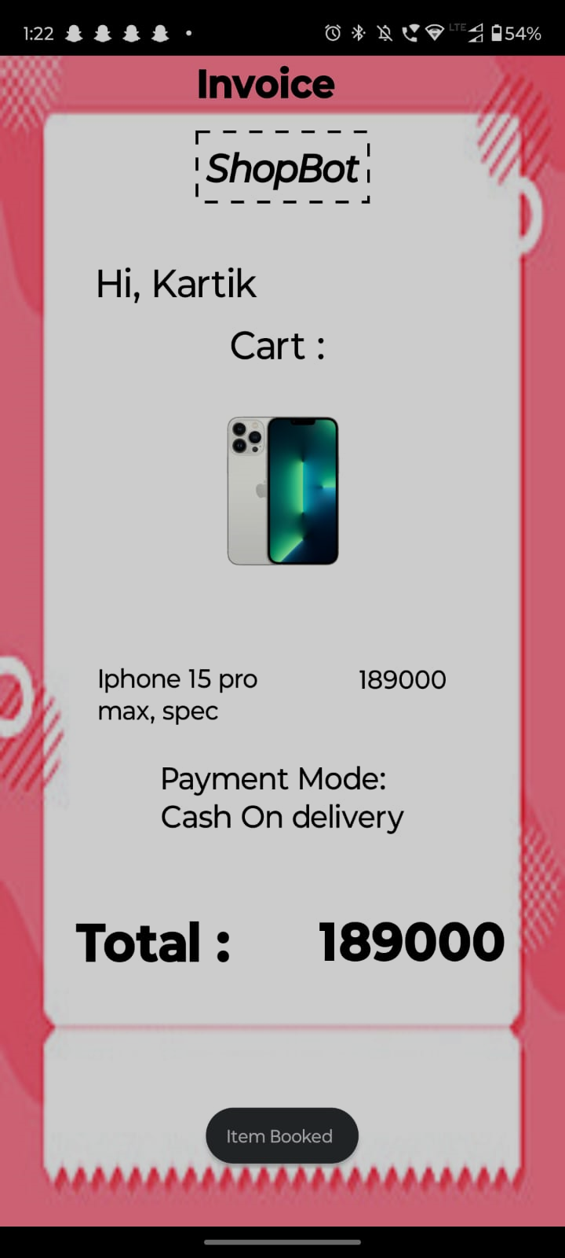

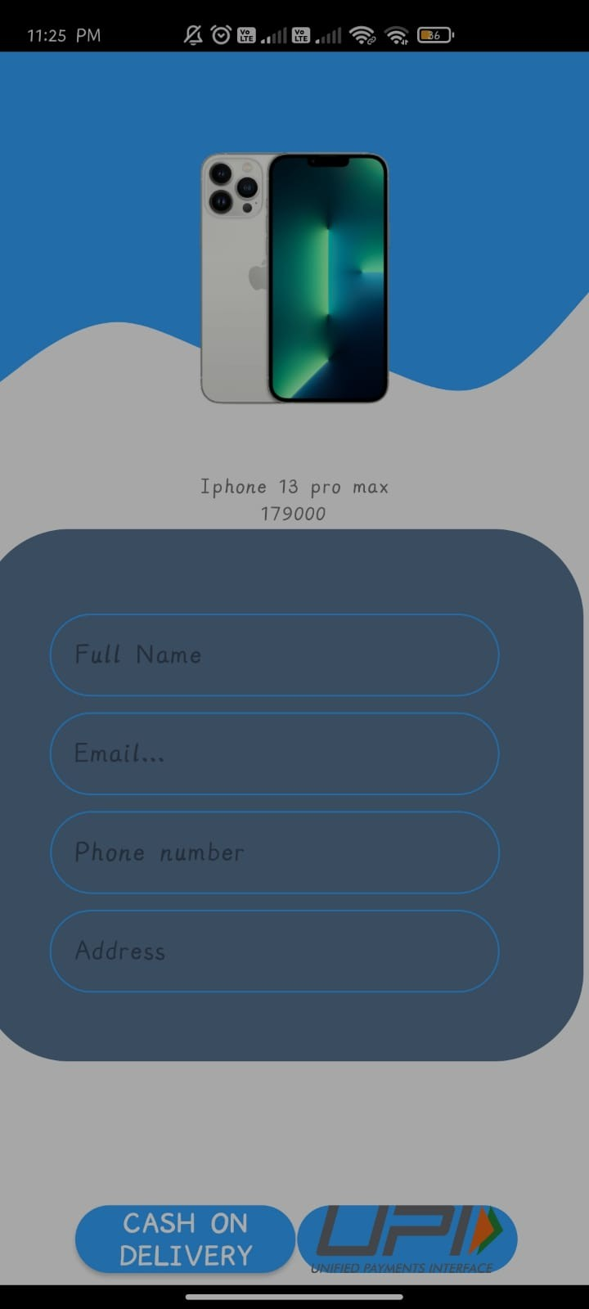

**Fig 5.3.5** Checkout Screen **Fig 5.3.6** Invoice Screen.

# CHAPTER 6

**Conclusion**

##### Conclusion

In conclusion, the development and implementation of a shopbot as a virtual shopping assistant hold immense potential to revolutionize the e-commerce landscape. Through this project, we have identified and addressed the key challenges faced by online shoppers, including information overload and decision paralysis. The shopbot offers a user-friendly solution that streamlines the shopping experience, providing personalized assistance and guidance to consumers. With its ability to assist users in finding products, providing detailed information, facilitating comparison shopping, and supporting purchase decision-making, the shopbot aims to enhance customer satisfaction and loyalty while driving business growth for online retailers. Beyond mere convenience, the shopbot represents a shift towards a more intuitive and interactive shopping journey, where users are empowered to make informed decisions with ease.

Moreover, the shopbot prioritizes user privacy and security, ensuring a safe and trustworthy shopping environment. As we look to the future, continued refinement and adaptation of the shopbot will be essential to meet the evolving needs and expectations of online shoppers. With its potential to deliver convenience, efficiency, and personalized experiences, the shopbot represents a significant advancement in the realm of e-commerce, promising to reshape the way users interact with online retailers and ultimately, enriching the overall online shopping journey for consumers worldwide.

.

**Research Papers:**

##### References

1. Greenwald, Amy R., and Jeffrey O. Kephart. "Shopbots and pricebots.”(2000)
2. Tang, Zhulei, Michael D. Smith, and Alan Montgomery. "The impact of shopbot use on prices and price dispersion: Evidence from online book retailing.”
3. Passyn , Kirsten A., Memo Diriker, and Robert B. Settle. "Price comparison, price competition, and the effects of shopbots." Journal of Business & Economics Research (JBER) 11, no. 9 (2013): 401-416
4. Pricilla, Catherine, Dessi Puji Lestari, and Dody Dharma. "Designing interaction for chatbot-based conversational commerce with user-centered design.”
5. Rajesh Kannan Megalingam, Souraj Vishnu, Swathi Sekhar, Vishnu Sasikumar, Sreekumar s & Thejus R Nair (2019). Design and Implementation of an Android Application for Smart Shopping,

April 4-6, 2019, India

1. Aslam. J. Karjagi, S. A. Quadri, Rafeeda. A. Karjagi, Niyaz Ahamad Herkal(2023). Mobile Forensic for Android Smart Phone, August 5-9, 2023, Harbin Engineering University
2. Nishant Goel (2017). Shopbot: “An Image Based Search Application for E-Commerce Domain ", String 22-30, 2017, San Jose State University

###### URL

###### 1: <https://link.springer.com/chapter/10.1007/10720026_1>

###### 2: <https://www.sciencedirect.com/science/article/abs/pii/S0167718710000469>

###### 3: <https://www.clutejournals.com/index.php/JBER/article/view/8068>

###### 4: <https://ieeexplore.ieee.org/abstract/document/8541320>

###### 5: <https://ieeexplore.ieee.org/abstract/document/8698109>

###### 6:<https://www.researchgate.net/profile/SQuadri2/publication/373167560_Mobile_Forensic_for_Android_Smart_phone/links/64ddfc1314f8d1733807ea77/Mobile-Forensic-for-Android-Smart-phone.pdf>

###### 7: <https://scholarworks.sjsu.edu/etd_projects/516/>