###### A

Mini-Project Report on

### Web Based Discussion Forum

Submitted in partial fulfillment of the requirements for the degree of

BACHELOR OF ENGINEERING

IN

#### Computer Science & Engineering

Artificial Intelligence & Machine Learning by

Aditya Sawant 22106084

Anup Singh 22106104

Ankit Pawar 22106111

Varun Raut 22106106

Under the guidance of

### Prof. Taruna Sharma



**Department of Computer Science & Engineering**

#### (Artificial Intelligence & Machine Learning)

**A. P. Shah Institute of Technology**

**G. B. Road, Kasarvadavali,**

**Thane (W)-400615**

**University Of Mumbai. 2023-2024**

### A. P. SHAH INSTITUTE OF TECHNOLOGY

**CERTIFICATE**

This is to certify that the project entitled “**Web Based Discussion Forum”** is a bonafide work of Aditya Sawant (22106084), Ankit Pawar (22106111), Anup Singh (22106104) and Varun Raut (22106106) submitted to the University of Mumbai in partial fulfillment of the requirement for the award of **Bachelor of Engineering** in **Computer Science & Engineering (Artificial Intelligence & Machine Learning).**

|  |  |
| --- | --- |
|  |  |
| Prof. Taruna Sharma | Dr. Jaya Gupta |
| Mini Project Guide | Head of Department |
|  |  |

**A. P. SHAH INSTITUTE OF TECHNOLOGY**

### Project Report Approval

This Mini project report entitled “**Web based Discussion Forum*”*** by **Aditya Sawant, Anup Singh, Ankit Pawar and Varun Raut** is approved for the degree of ***Bachelor of Engineering*** in ***Computer Science &Engineering***, (AIML) ***2022-23***.

External Examiner:

Internal Examiner:

Place: APSIT, Thane Date:

**Declaration**

We declare that this written submission represents my ideas in my own words and where others' ideas or words have been included, I have adequately cited and referenced the original sources. I also declare that I have adhered to all principles of academic honesty and integrity and have not misrepresented or fabricated or falsified any idea/data/fact/source in my submission. I understand that any violation of the above will be cause for disciplinary action by the Institute and can also evoke penal action from the sources which have thus not been properly cited or from whom proper permission has not been taken when needed.

|  |  |  |  |
| --- | --- | --- | --- |
| Aditya Sawant | Varun Raut | Ankit Pawar | Anup Singh |
| (22106084) | (22106106) | (22106111) | (22106104) |

**Index**

|  |  |  |  |
| --- | --- | --- | --- |
| Index | | | Page no. |
| Chapter-1 | | |  |
|  | Introduction | |  |
|  |  |  |  |
| Chapter-2 | | |  |
|  | Literature Survey | |  |
|  | 2.1 | History |  |
|  | 2.1 | Review |  |
|  |  |  |  |
| Chapter-3 | | |  |
|  | Problem Statement | |  |
|  |  |  |  |
| Chapter-4 | | |  |
|  | Experimental Setup | |  |
|  |  | Software Setup |  |
|  |  |  |  |
|  |  |  |  |
| Chapter-5 | | |  |
|  | Proposed system and Implementation | |  |
|  | 5.1 | Block Diagram of proposed system |  |
|  | 5.2 | Description of Block diagram |  |
|  | 5.3 | Technologies Used |  |
|  |  |  |  |
| Chapter-6 | | |  |
|  | Conclusion | |  |
|  |  |  |  |
| References | | |  |
|  |  |  |  |

# CHAPTER 1

## INTRODUCTION

#### INTRODUCTION

###### **Background**

**Growing Demand for Online Community Spaces:** In today's digital age, there is an increasing reliance on online platforms for communication, networking, and knowledge sharing. This has led to a surge in demand for online discussion forums that serve as virtual meeting places for individuals with common interests or goals.

**Need for Structured and Accessible Discussions**: Many existing online forums lack a structured format for discussions, resulting in cluttered and disjointed conversations that can be challenging for users to navigate. By implementing a structured format, such as threaded discussions and organized question tabs, we aim to enhance the clarity and accessibility of conversations within our platform

**Desire for Targeted Engagement**: Users often seek communities where they can connect with like-minded individuals who share their interests, hobbies, or professional expertise. By providing users with the ability to join or create niche communities, we aim to cater to this desire for targeted engagement, fostering meaningful discussions and collaborations.

###### **Objectives**

**Facilitate User Interaction:** Our primary objective is to facilitate interaction and collaboration among users by providing them with personalized profiles. These profiles will allow users to showcase their expertise, interests, and contributions within the community, thereby enhancing their sense of identity and belonging.

**Enhance Clarity and Navigation**: We aim to enhance the clarity and ease of navigation within our platform by implementing a structured format for discussions and questions. By organizing conversations into threads and providing clear tabs for posting questions, users will be able to navigate topics more efficiently and participate in discussions with greater clarity.

**Foster Niche Communities:** Another key objective is to foster the creation of niche communities within our platform. By enabling users to join or create groups based on specific interests or topics, we aim to provide a space where users can engage in targeted discussions, share relevant content, and connect with others who share their passions.

**Improve Content Discovery**: We seek to improve content discovery within our platform by implementing a robust search functionality. This feature will allow users to easily find relevant discussions, topics, and user-generated content, thereby enhancing their overall browsing experience and facilitating knowledge sharing.

**Ensure Security and Privacy**: Our Project will Implement robust security measures to protect user data and ensure the safety and privacy of community members by secure user authentication.

# CHAPTER 2

## LITERATURE SURVEY

##### LITERATURE SURVEY

* 1. **HISTORY**

##### Evolution of Online Communities:

Online communities have evolved significantly since the early days of bulletin board systems (BBS) and Usenet groups. These primitive forms of online communication laid the foundation for modern discussion forums by enabling users to engage in text-based discussions on various topics.

##### Emergence of web Forums:

With the advent of the World Wide Web, web forums emerged as a popular platform for online discussions. Platforms like phpBB, vBulletin, and Reddit revolutionized the way users interacted and shared information online, offering features such as threaded discussions, user profiles, and community moderation.

##### Shift towards Niche Communities:

In recent years, there has been a noticeable shift towards niche communities and specialized forums catering to specific interests or demographics. This trend reflects users' desire for more targeted engagement and personalized experiences within online communities.

##### LITERATURE REVIEW

**Collective Intelligence and Knowledge Sharing:** Ahn et al. (2014) highlight the concept of collective intelligence in online forums like Stack Overflow. Their research suggests that discussion forums can facilitate knowledge sharing within communities by allowing users to build upon each other's contributions. This concept is directly relevant to your project, as your platform aims to connect users with diverse interests and allow them to share knowledge through discussions.

**Design and User Participation:** Chen et al. (2018) investigate the impact of design elements on user participation in online forums. Their eye-tracking study reveals that specific design choices can influence how users interact with the platform. Considering these findings can be crucial when optimizing the layout and features of your discussion forum to encourage active user engagement.

**Community Building and Conflict Resolution:** Lampe et al. (2006) explore conflict resolution strategies within online communities. Their research provides valuable insights for developing moderation tools and guidelines for your platform. Understanding how online communities manage conflict can help you foster a respectful and productive discussion environment.

**Community Identity and Knowledge Contribution:** Lin et al. (2017) examine how fostering a sense of community identity can encourage knowledge contribution in online forums. Their research suggests that users are more likely to share knowledge if they feel a sense of belonging to the community. This perspective can inform the development of features that promote community engagement and build a strong sense of identity within your platform.

**Addressing Potential Drawbacks of Discussion Forums:** While most research focuses on the benefits, Sun et al. (2013) highlight the potential drawbacks of online forums, such as negativity and trolling. Considering these potential issues allows you to develop strategies to mitigate them in your platform design. By implementing effective moderation tools and fostering a positive community culture, you can create a safe and productive space for discussion.

# CHAPTER 3

## Problem Statement

##### Problem Statement

**Lack of Personalization:**

Existing online discussion forums often lack robust personalization features, making it challenging for users to showcase their expertise and interests. This limitation hinders user engagement and diminishes the sense of community within the platform.

##### Cluttered and Unstructured Discussions:

Many online forums suffer from cluttered and unstructured discussions, making it difficult for users to navigate and participate effectively. Without a clear organization of topics and threads, users may feel overwhelmed and disengaged from the community.

##### Limited Community Building Opportunities and for learning institutes:

The absence of features that facilitate community building and social interaction within online forums can hinder the development of a strong sense of belonging among users. Without opportunities for networking, collaboration, and shared experiences, users may struggle to form meaningful connections with others in the community. Also Fostering the discussions between students through questions, solutions and opinion discussions in colleges and other educational institutes.

##### Inefficient Content Discovery:

Inadequate search functionality and content discovery mechanisms often result in users having difficulty finding relevant discussions and topics of interest within online forums. This inefficiency can lead to frustration and disengagement among users who struggle to locate valuable content.

##### Lack of Targeted Engagement:

Many online forums fail to provide users with opportunities for targeted engagement within niche communities or specialized interest groups. Without features that cater to specific interests or demographics, users may feel disconnected from the broader community and less motivated to participate actively.

##### Poor Moderation and Quality Control:

Inadequate moderation and quality control measures can lead to the proliferation of spam, misinformation, and toxic behavior within online forums. Without effective moderation practices in place, users may encounter a hostile or unwelcoming environment, discouraging them from engaging with the platform.

##### Accessibility Barriers:

Accessibility barriers, such as poor website design, lack of alternative text for images, and inadequate keyboard navigation, can prevent users with disabilities from fully engaging with online forums. Addressing accessibility issues is essential for ensuring inclusivity and equal participation among all users.

##### Data Privacy Concerns:

Users are increasingly concerned about data privacy and security when participating in online forums, particularly with regard to the collection and handling of personal information.

# CHAPTER 5

## Proposed System & Implementation

##### Block diagram of proposed system

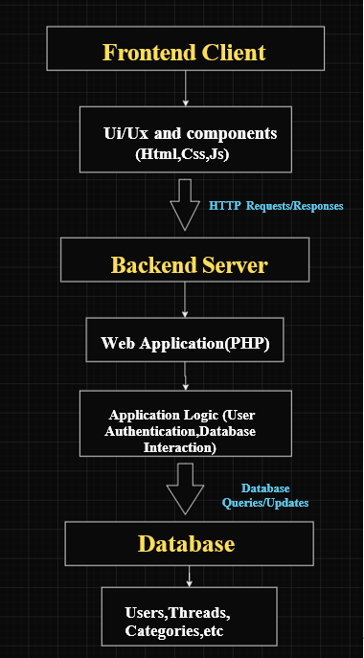

###### **Description of Block diagram**

1. **User Interface (UI/UX):** This component represents the frontend of the Discussion forum app, including the user interface elements created using HTML, CSS, Bootstrap.Users interact with the app through this interface.
2. **Backend (PHP):** The backend of the app is implemented using PHP and Vanila JavaScript. It handles user authentication, data processing, and server side logic. It exposes API endpoints for communication with the frontend.
3. **Database (MySQL):** MySQL is used to store and manage data for the application. It stores user comments, categories, and users ensuring data integrity and persistence.
4. **Authentication:** This component manages user authentication, ensuring secure login and registration processes.

##### Technology used

1. **Frontend Technologies (HTML, CSS, JS)**: HTML (Hypertext Markup Language) provides the structure of the web pages, CSS (Cascading Style Sheets) handles the visual presentation and layout, and JavaScript adds interactivity and dynamic behavior to the website. These technologies together create the user interface and experience for the discussion forum. Utilize modern frontend frameworks like Bootstrap for efficient development and responsive design.
2. **Backend Technology (PHP)**: PHP (Hypertext Preprocessor) is a server-side scripting language that is commonly used for web development. It will handle tasks such as user authentication, database interactions, and server-side processing of user requests. Using PHP frameworks like Laravel or CodeIgniter for efficient development, security features, and structured codebase.
3. **Database Management (MySQL)**: MySQL is a widely used relational database management system (RDBMS) that will store and manage the forum's data, including user profiles, discussion threads, community groups, and search indexes. Utilize proper database design principles to ensure data integrity, scalability, and performance. Implement techniques like indexing and normalization for efficient data retrieval.

##### 5.4 Implementation

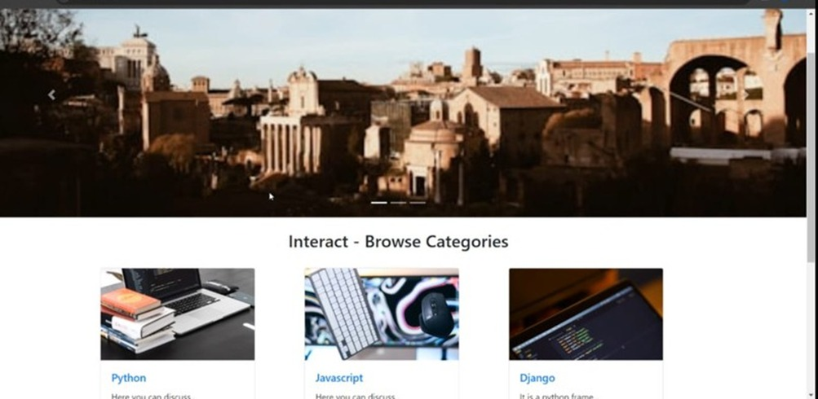

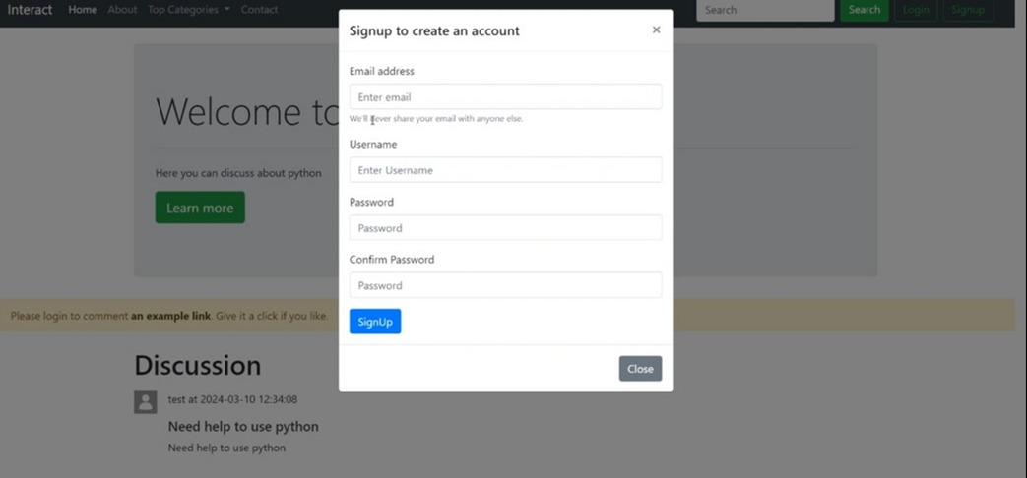

# CHAPTER 6

**Conclusion**

##### Conclusion

* 1. **Enhanced User Engagement:** By providing a platform for structured discussions, personalized user profiles, and niche community groups, the discussion forum fosters deeper engagement among users. This encourages active participation, knowledge sharing, and collaboration within the community.
  2. **Efficient Content Discovery:** The robust search functionality enables users to easily discover relevant discussions and topics based on their interests. This enhances user experience by saving time and effort in finding valuable content within the forum.
  3. **Scalable Architecture:** Leveraging technologies like PHP, MySQL, and JavaScript ensures a scalable and maintainable architecture for the project. With proper database design, optimization, and code structure, the forum can accommodate a growing user base and evolving feature requirements.
  4. **Empowering Community Building:** The platform empowers users to create and join niche communities, facilitating targeted discussions around specific interests or topics. This not only strengthens the sense of belonging within the community but also promotes networking and knowledge exchange among like-minded individuals.

##### References

1. Ahn, J.-H., Kang, Y.-H., & Shin, N. (2014)
2. Chen, Y., Sun, M., & Yang, J. (2018)
3. Lampe, C., Ellison, C., & Steinfield, C. (2006)
4. Lin, C.-Y., Hsieh, S.-H., & Shan, Y.-C. (2017)
5. Sun, C., Liu, Y., Zhang, Q., & Moe, S. (2013)
6. https://www.codewithharry.com/tutorial/php