SS LAB EXPERIMENT: 1

NAME: ADITYA PRATAP SINGH

ROLL NO. : 16EC01028

DATE: 07.08.2017

**Objective:**

1. To demonstrate the elementary signals.
2. To demonstrate the different signals combinations.
3. To demonstrate the scaling and shifting of signal.
4. To demonstrate the energy or power of different signals.

**MATLAB Code:**

clc;

clear all;

close all;

%////////////////////////////PART A////////////%

% PART A - 1

f=50;

t1=linspace(0,4,100); %defining time space

x2 = sin(2*pi*f*t1);

subplot(3,2,1)

plot(t1,x2) % used for to draw new figure()

title('PART A - 1(Sin Function)');

xlabel('time(t) ->');

ylabel('f(t) ->');

% PART A - 2

s=5-j*10; % j is iota

t2=linspace(0,1,50);

x2 = exp(2*s*t2); % exp is in-build function to find exponential

subplot(3,2,2)

plot(t2,x2)

title('PART A - 2');

xlabel('time(t) ->');

ylabel('f(t) ->');

% PART A - 3

t3=linspace(-100,100,1000);

sizet3 = size(t3); % size if t3 matrix

for i=1:sizet3(1,2)

if(t3(1,i)>=0)

y3(1,i)=1;

else

y3(1,i)=0;

end;

end;

subplot(3,2,3)

plot(t3,y3)

title('PART A - 3(Unitstep)');

xlabel('time(t) ->');

ylabel('f(t) ->');

% PART A - 4

t4=linspace(-100,100,1000);

s_t4 =size(t4);

for i=1:s_t4(1,2)

if(t4(1,i)>0)

y4(1,i)=1;

else if(t4(1,i)==0)

y4(1,i)=0;

else

y4(1,i) =-1;

end;

end;

end;

subplot(3,2,4)

plot(t4,y4)

title('PART A - 4');

xlabel('time(t) ->');

ylabel('f(t) ->');

% PART A - 5

t5=linspace(-100,100,1000);

s_t5 =size(t5);

for i=1:s_t5(1,2)

if(t5(1,i)>=0)

y5(1,i)=t5(1,i);

else

y5(1,i)=0;

end;

end;

subplot(3,2,5)

plot(t5,y5)

title('PART A - 5(Ramp fn)');

xlabel('time(t) ->');

ylabel('f(t) ->');

% PART A - 6

t6=(-1:0.0001:1);

impulse = t6==0;

subplot(3,2,6)

stem(t6,impulse)

title('PART A - 6(Impulse fn)');

xlabel('time(t) ->');

ylabel('f(t) ->');

figure()

% PART A - 7

t7=linspace(-2,2,1000);

unit7_1 = t7>=.5;

unit7_2 = t7>= -0.5;

result = unit7_2 - unit7_1;

subplot(2,2,1)

plot(t7,result)

title('PART A - 7');

xlabel('time(t) ->');

ylabel('f(t) ->');

% PART A - 8

t8=linspace(-10,10,1000);

uni1 = t8>=-1;

uni2 = t8>=0;

uni3 = t8>=1;

ramp1 = (t8+1).*uni1;

ramp2 = (t8).*uni2;

ramp3 = (t8-1).*uni3;

res = ramp1-2*ramp2+ramp3;

subplot(2,2,2)

plot(t8,res)

title('PART A - 8');

xlabel('time(t) ->');

ylabel('f(t) ->');

% PART A - 9

t9=linspace(-10,10,1000);

x9 = pi*t9;

sizet9 = size(t9);

for i = 1:sizet9(1,2)

if(x9(1,i)==0) % we have to find limit here

y9(1,i) = 1;

else

y9(1,i) = sin(x9(1,i))/x9(1,i);

end;

end;

subplot(2,2,3)

plot(t9,y9)

title('PART A - 9');

xlabel('time(t) ->');

ylabel('f(t) ->');

% PART A - 10

n10 = 5;

t10=linspace(-2,2,1000);

x10= pi*t10;

sizet10 = size(t10);

for i = 1:sizet10(1,2)

if(x10(1,i)==0) % we have to find limit here

y10(1,i) = 1;

else

y10(1,i) = sin(n10*x10(1,i))/(n10*sin(x10(1,i)));

end;

end;

subplot(2,2,4)

plot(t10,y10)

title('PART A - 10');

xlabel('time(t) ->');

ylabel('f(t) ->');

figure()

%////////////////////////////PART B ///////////%

% PART B - 1

t11=linspace(-5,5,1000);

y11 = exp(-2*t11).*sin(13* pi*t11) - exp(t11/3).*sin(20* pi*t11);

subplot(1,2,1)

plot(t11,y11)

title('PART B - 1');

xlabel('time(t) ->');

ylabel('f(t) ->');

% PART B - 2

t12=linspace(-3,3,1000);

y12 = sinc(t12/2).*cos(17*pi*t12);

subplot(1,2,2)

plot(t12,y12)

title('PART B - 2');

xlabel('time(t) ->');

ylabel('f(t) ->');

figure()

%////////////////////////////PART C ///////////%

% PART C

t13 = linspace(-10,10,1000);

y13 = fuc(t13);

subplot(2,2,1)

plot(t13 , y13)

title('PART C FUNCTION');

xlabel('time(t) ->');

ylabel('f(t) ->');

% PART C - 1

y14=6*(fuc(t13-1));

subplot(2,2,2)

plot(t13,y14)

title('PART C - 1');

xlabel('time(t) ->');

ylabel('f(t) ->');

% PART C - 2

y15=2/3*fuc(t13/8);

subplot(2,2,3)

plot(t13,y15)

title('PART C - 2');

xlabel('time(t) ->');

ylabel('f(t) ->');

% PART C - 3

y16=-9*fuc(5*t13/3+2/7);

subplot(2,2,4)

plot(t13,y16)

title('PART C - 3');

xlabel('time(t) ->');

ylabel('f(t) ->');

%////////////////////////////PART D ///////////%

% PART D

Q1=@(h) (2*h+11/6).^2; %Q1 is the one of the non-zero sloped straight lines of the scaled tri function.

E=2*integral(Q1,-11/12,- 5/12);

disp('Energy:');

disp(E);

Q2=@(m) (3*m).^2;

P=integral(Q2,-15,15);

disp('Power:');

disp(P/30);

(USER-DEFINED)Functions :

function [y] = fuc( x)

y=x;

y(x<-2)=0;

y(x>-2 & x<0)=-8+3*x(x>-2 & x<0);

y(x>0 &x<4)=9-x(x>0 &x<4)/7;

y(x>4 &x<8)=28+2*x(x>4 &x<8);

y(x>8)=0;

end;

**Results:**

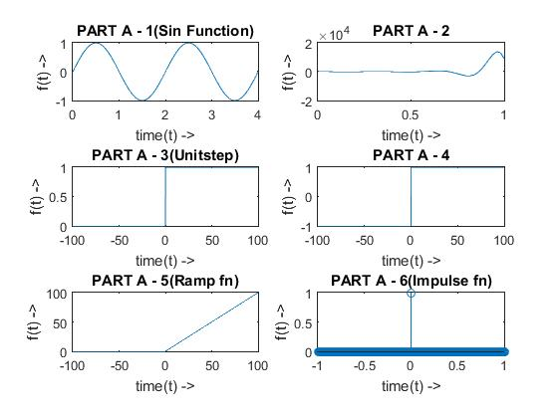

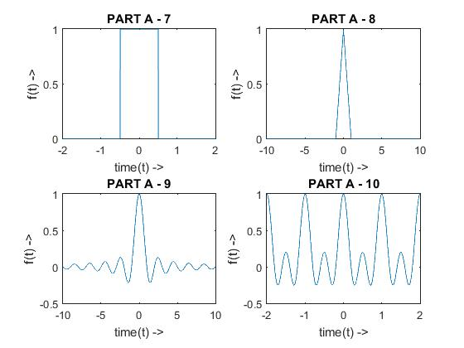

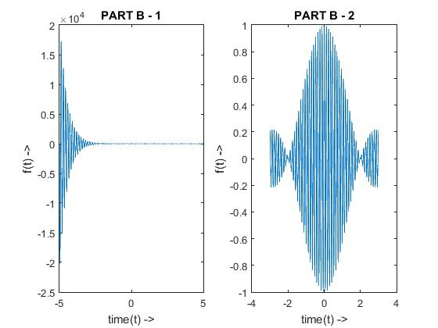

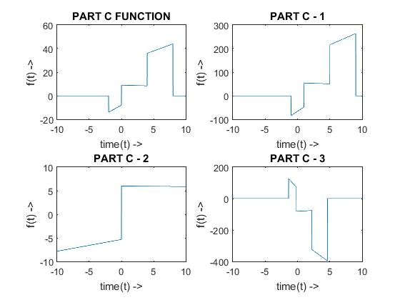

Results of Part-d:

Energy (Theoretical): 0.3371

Numerical (Trapezoidal) Integral Energy: 0.3333

Power (Theoretical): 675.1377

Numerical (Trapezoidal) Integral Energy: 675

**Conclusion :**

After doing this experiment we come to know about various inbuilt functions in matlab abs(),linspace(),subplot() etc.We also learnt about various elementary signals and their representation in matlab and how to find power and energy in matlab.