American International University of

Bangladesh



A
Project Report
On
Veterinary Appointment Application System

Course: Programming In Python

Submitted To: Submitted By:
Md. Tanzeen Rahat 1.Wadifa Apsora (25-62188-2)
(Faculty of Science and Technology) 2.Mst Nahida Akther Liza (25-62195-2)
3.Hemayatun Narisha (25-62478-2)
CONTENT

1.Introduction
2.Imported files and Functions in python
3.Created three windows
4.Table created
5.Coding
6.Output

INTRODUCTION

This project is a Veterinary Appointment Application developed using Python and Tkinter for a simple graphical user interface. The main objective of this system is to simplify the process of booking and managing veterinary appointments for pet owners. It provides a user-friendly plessential pet and owner information can be entered efficiently and the application captures details such as pet name, owner name, date of birth, pet type, breed, and contact number. Moreover a dedicated option to find available doctors improves accessibility to veterinary services. The interface is designed with clarity and simplicity to ensure ease of use for all types of users. Finally data management features such as update and clear options help maintain accuracy and flexibility.

It also reflects proper implementation of GUI components like labels, buttons, entry fields, and combo boxes. This application can serve as a foundational system for more advanced veterinary management solutions. This project aims to improve healthcare services for animals through a digital appointment system.

FILES IMPORTED IN PROJECT

1.Import tkinter for Label ,Button ,Entry ,Frame
2.Import ttk for advanced widgets like Combobox

FUNCTION USED IN PROJECT

1. clear_data() To Reset input fields
2.update_info() To Validate and display
3. find_doctor_window() To Show doctor list
4. select_doctor() To Select chosen doctor

MAIN WINDOW DETAILS
The main window is created using TK() and starts the application and contains the “FIND DOCTOR” button to show Doctor list ,update button to update main window entries ,clear button to delete all entries finally exit button to close the window.
OUTPUT
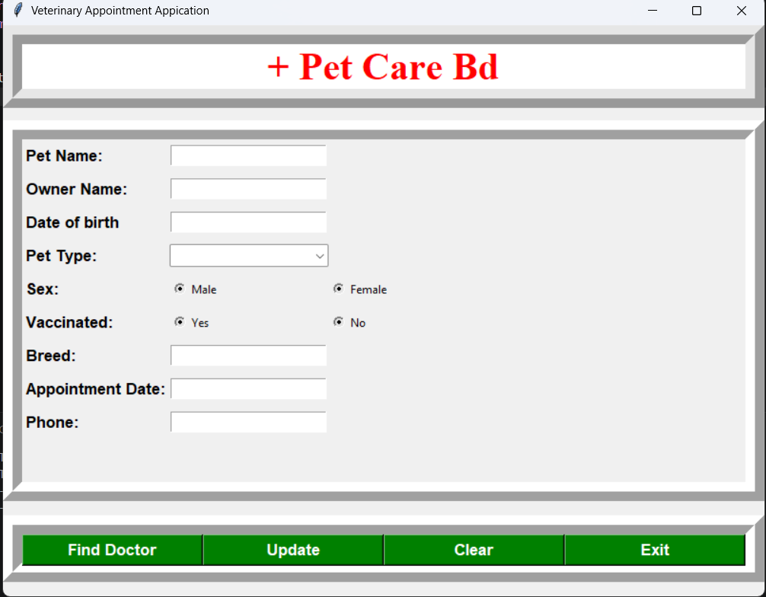

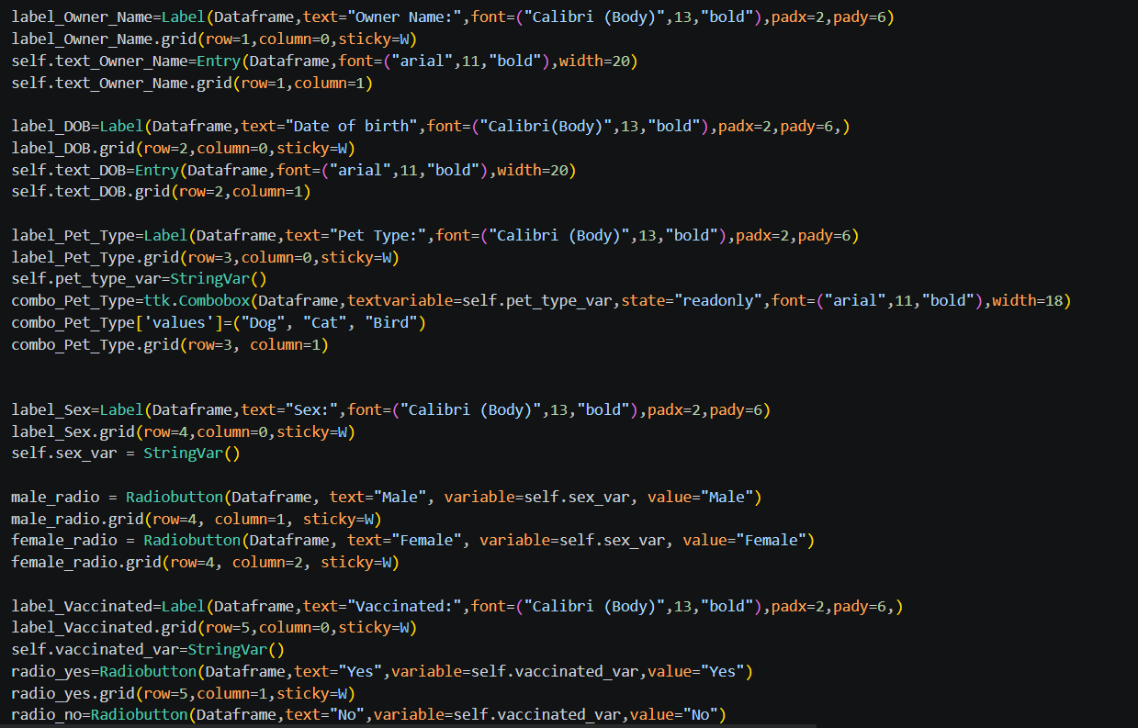
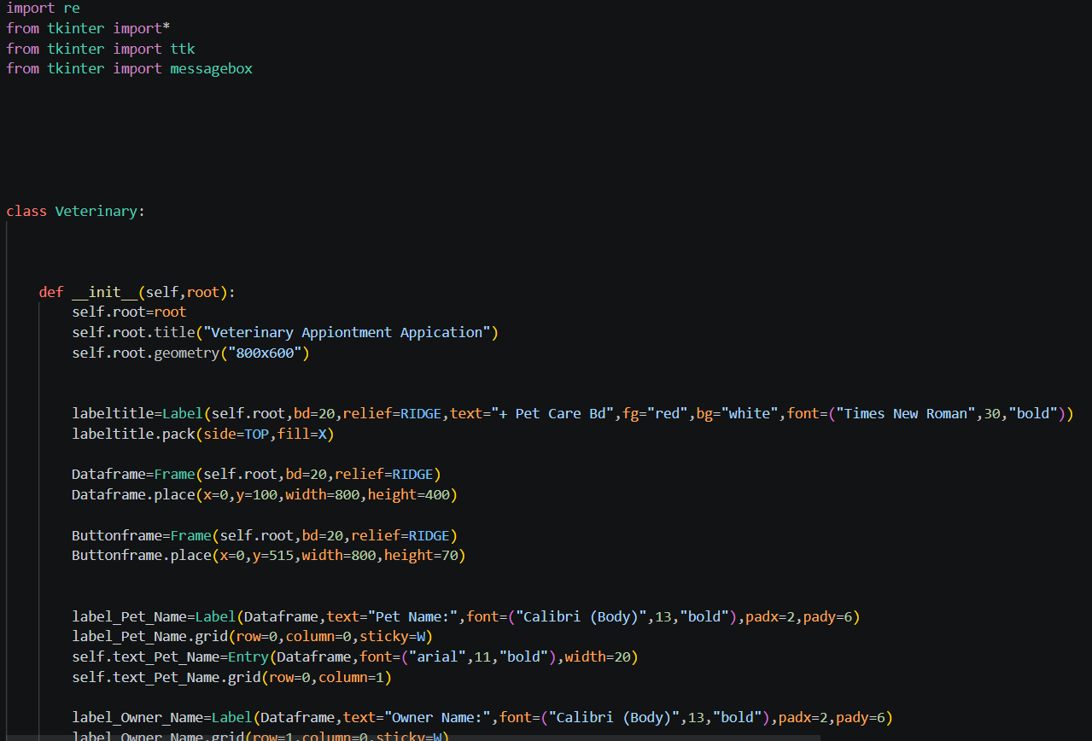
CODING

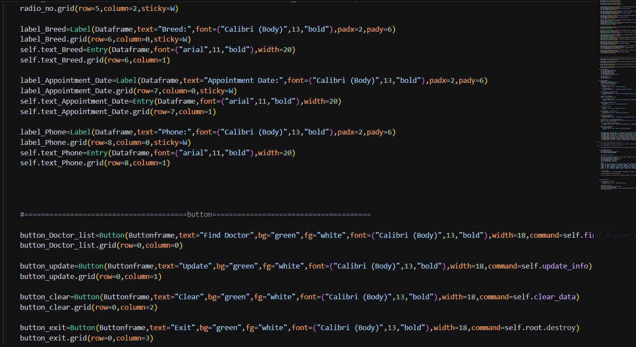
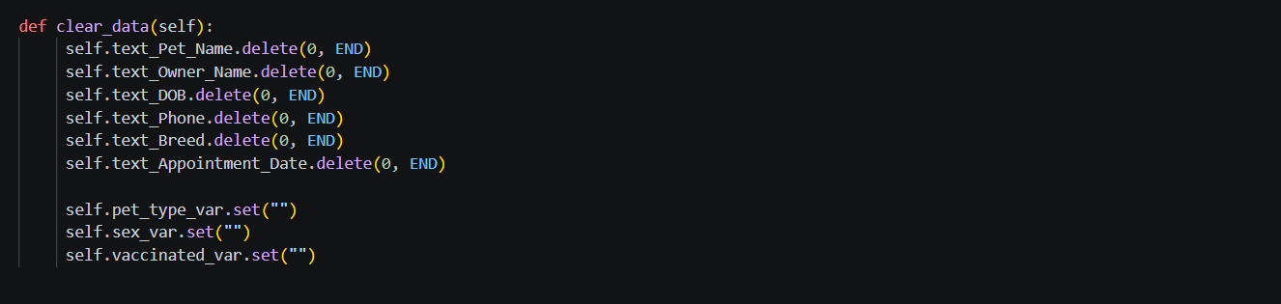

DOCTOR WINDOW
Doctor window is a secondary window created using Toplevel() that displays doctor details as a table and action buttons.
OUTPUT
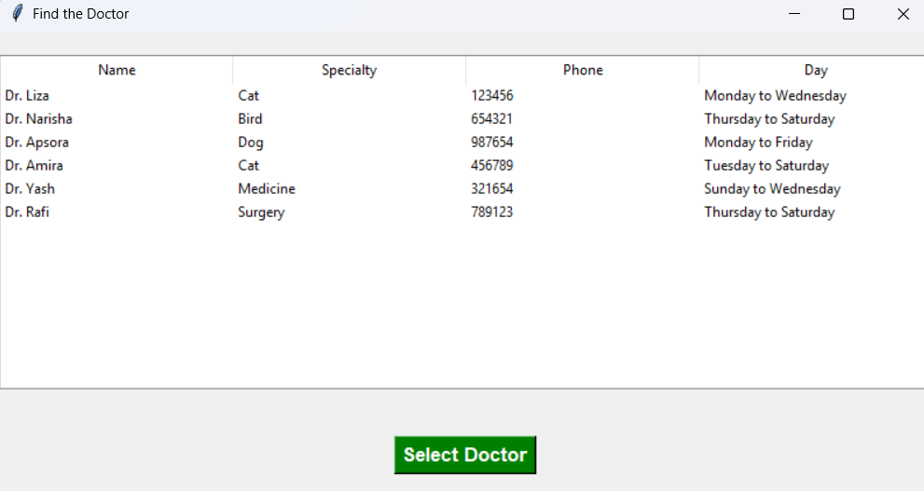

CODING
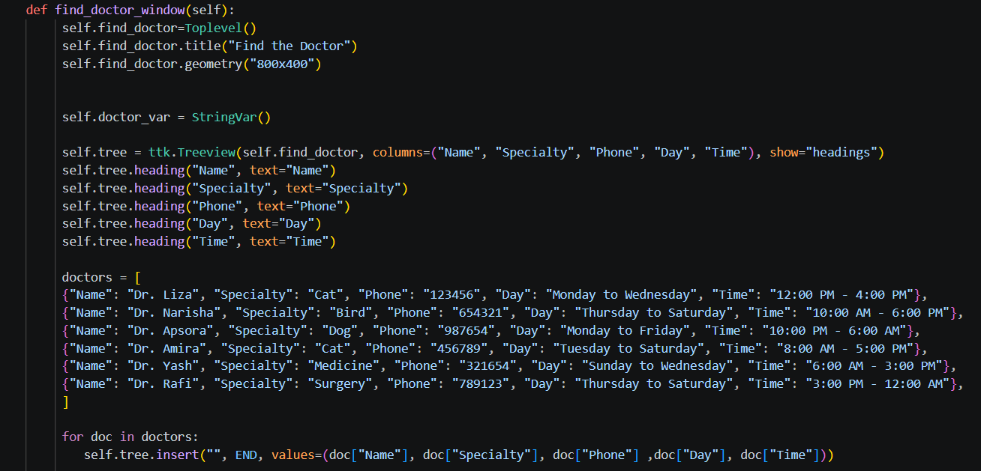

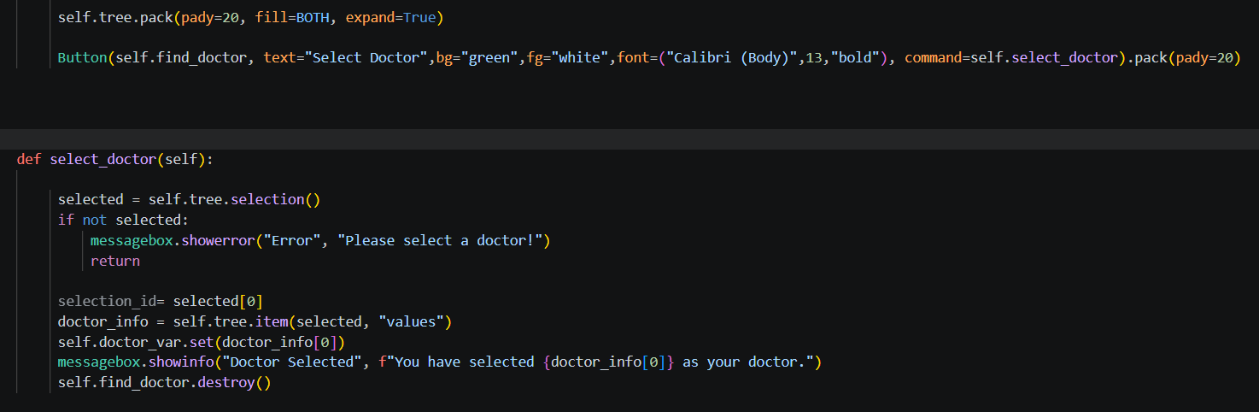

UPDATE WINDOW
Update window is a window that allows editing and saving patients information also action buttons.
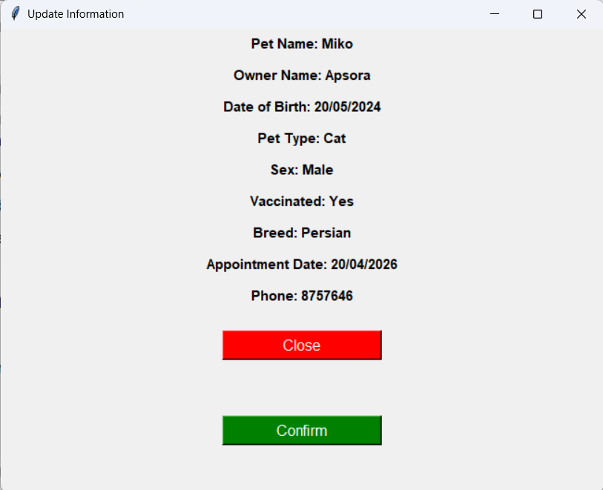
Output
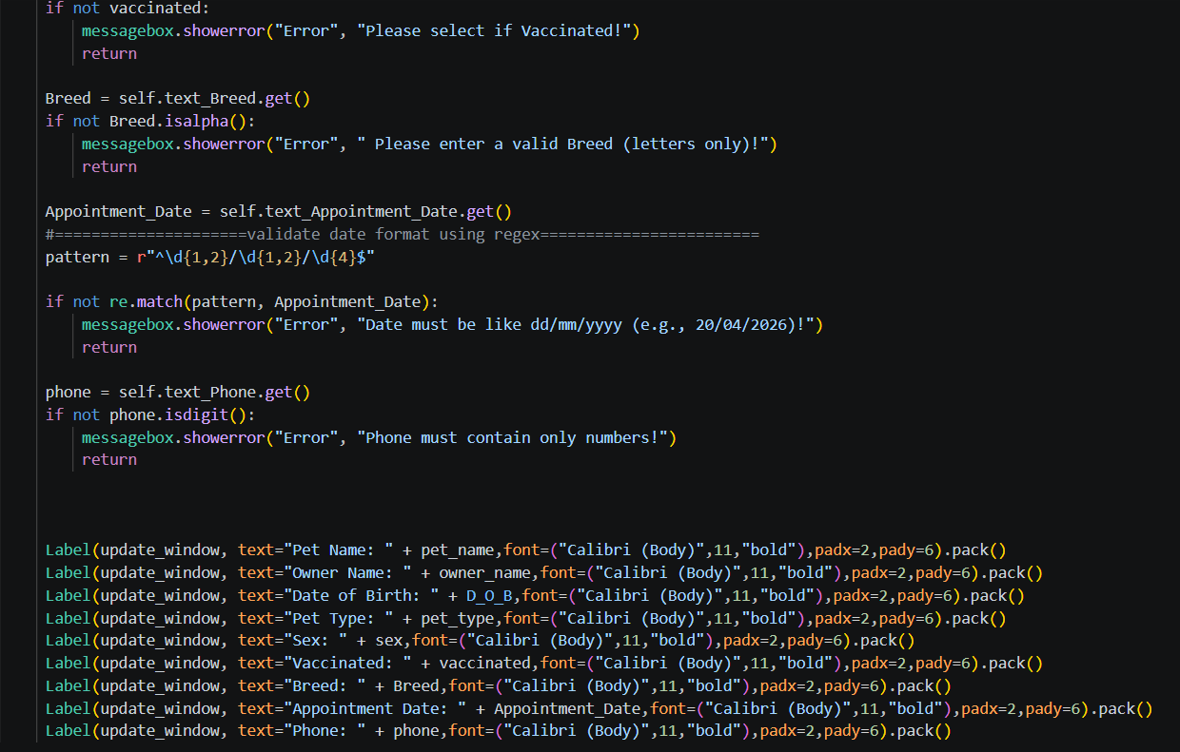
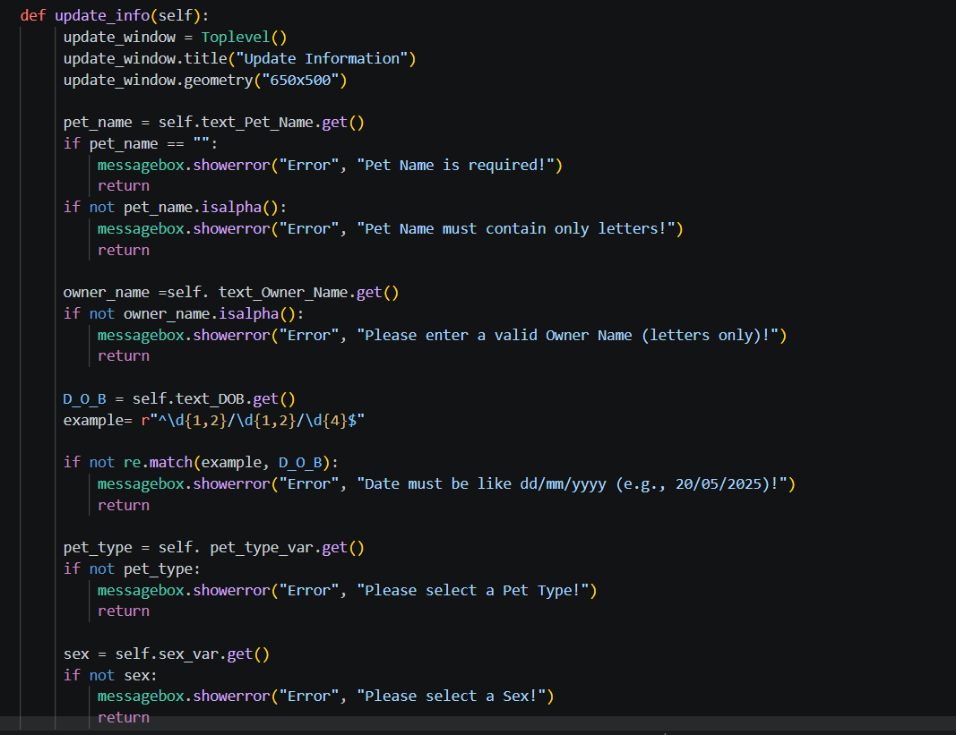
CODING

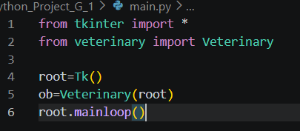
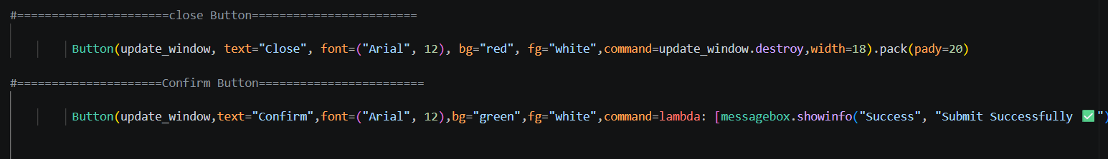
main.py is the main program file that runs the Tkinter application and contains the Veterinary class.
