António Pedro Portfolio

1. Introduction
My website idea is to develop a web site with various type of information related to my professional experience. Website in an initial phase will show information related to my profissional carreer, like professional experience, education, expertise, skills, motivation, gallery of some images of developed software, hobbies and some more extras.

2. User Interface Design and Prototype

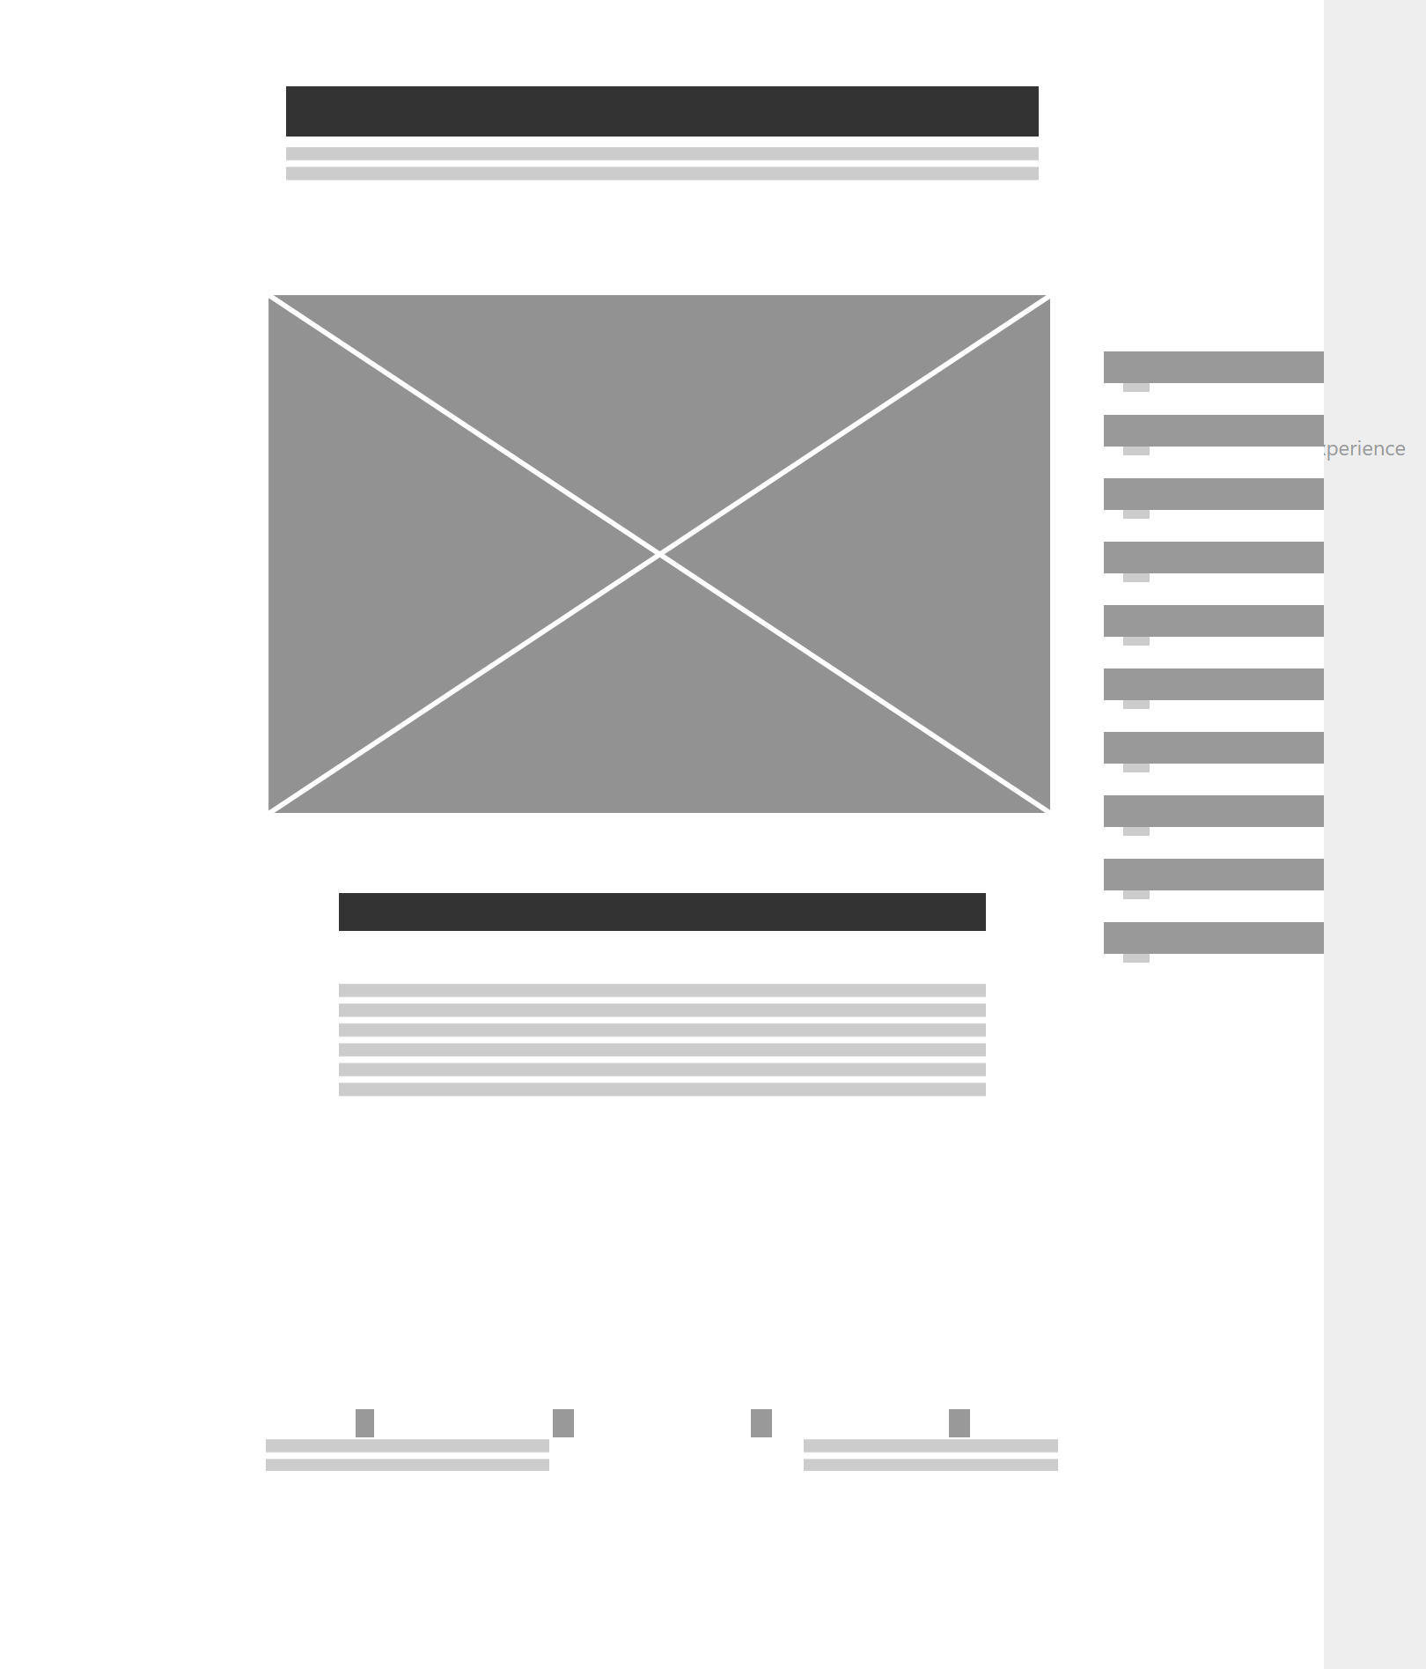
- In the right side of the user interface we can see a list of various options which will support different information that will be available to the user. Footer is a bit simpler, but will have social media links and some personal contact information.

3. Navigation Structure
- Navigation structure is simple. In the right side of the screen you will have all the options to explore the website.
- In terms of user experience, the user will be focused on the right side of the screen by clicking on each option to show the desired information. An example of another screen:
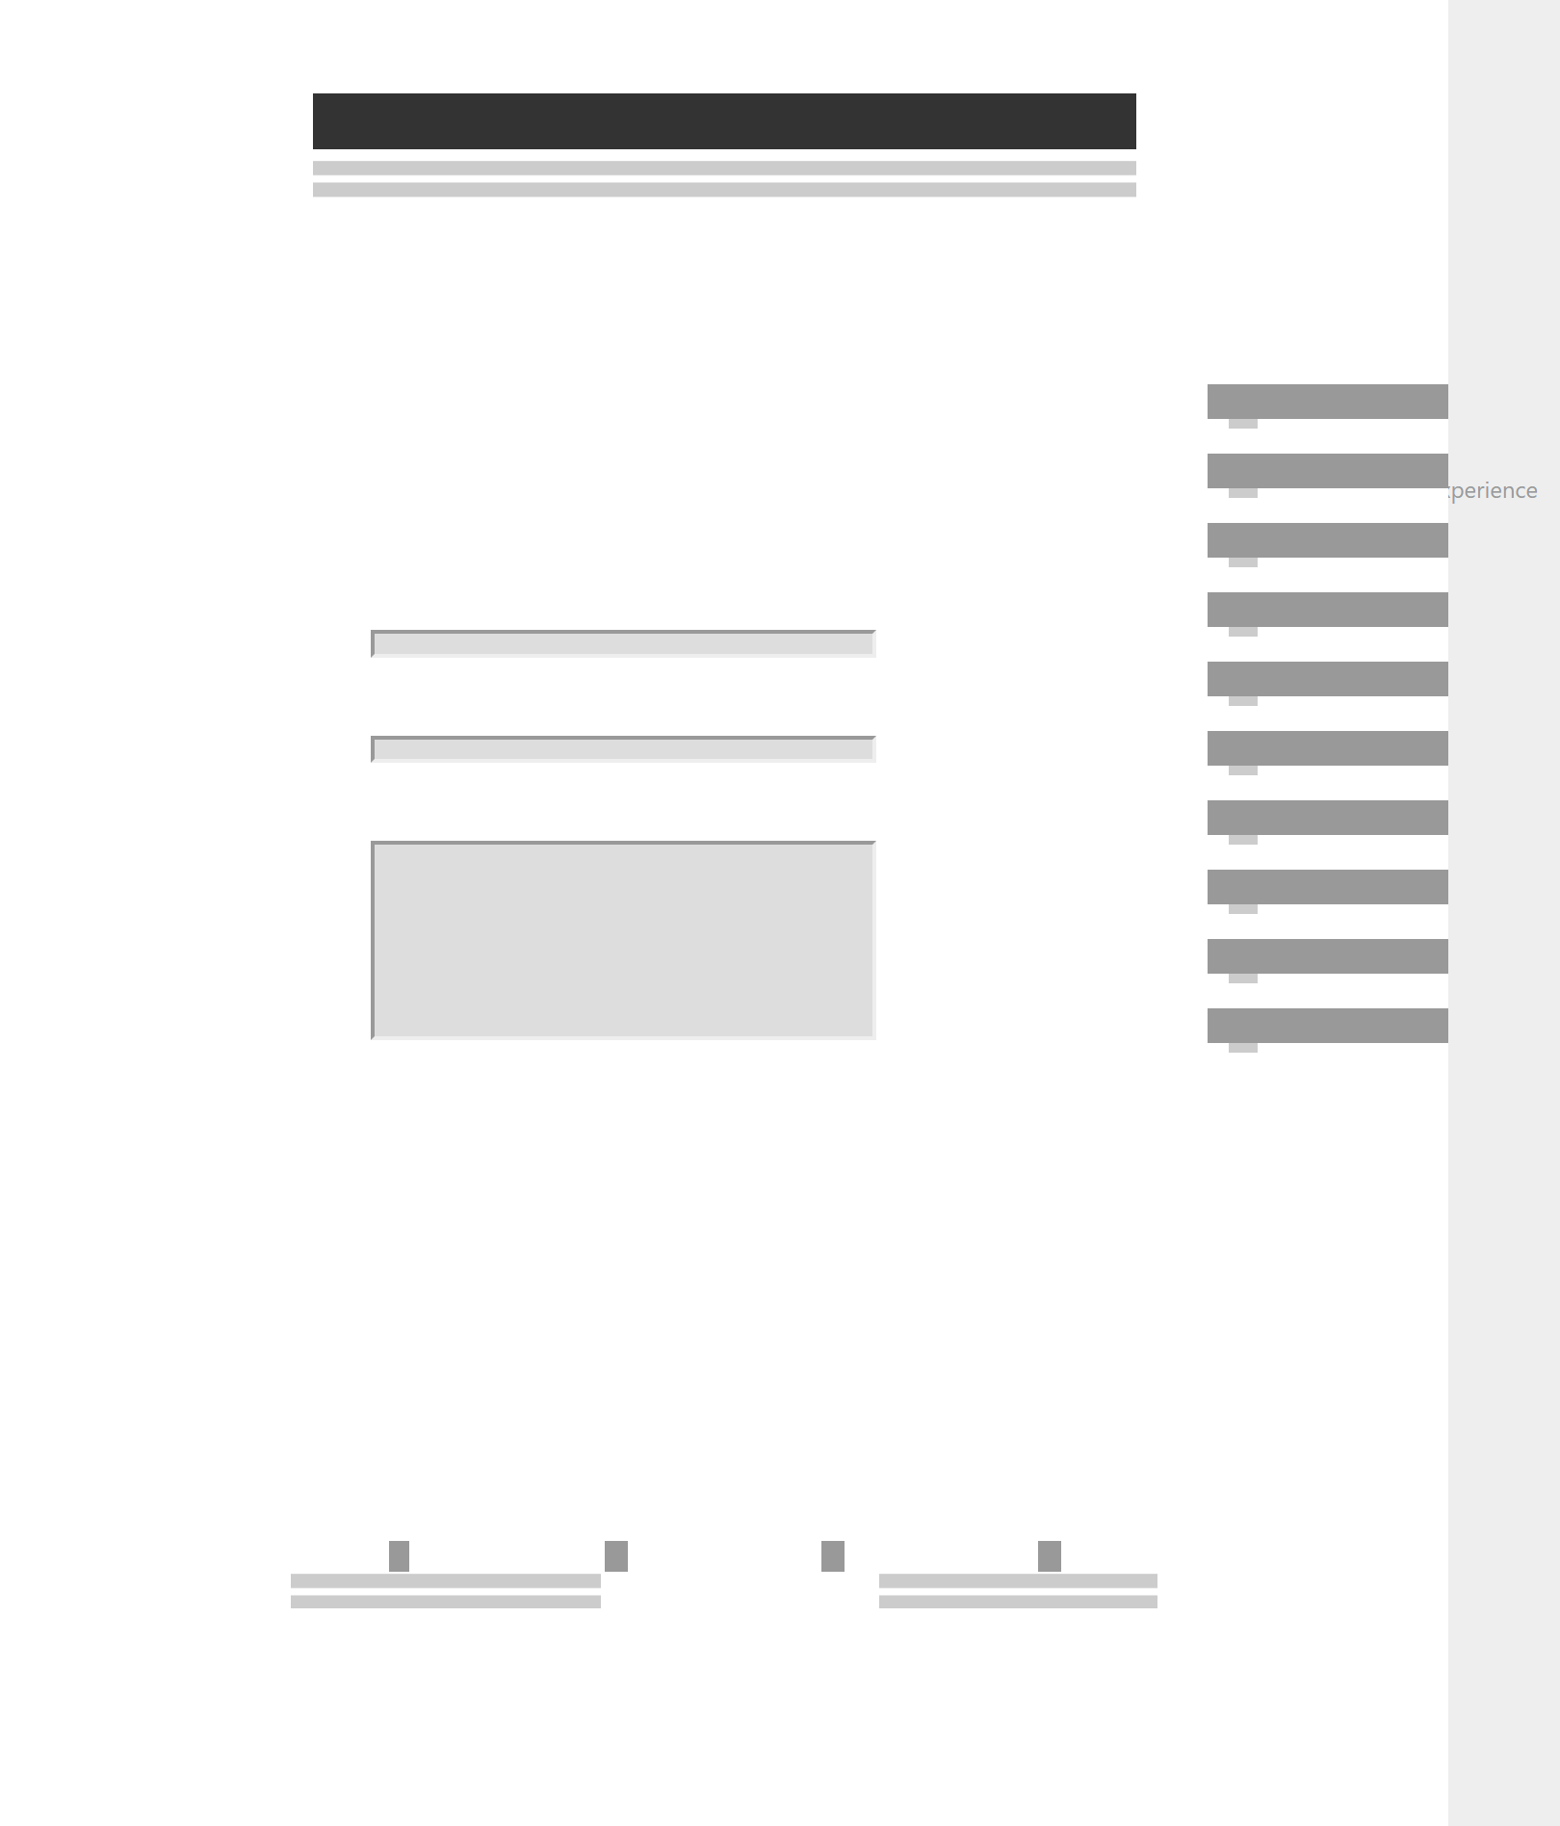

4. References
- Here are some references:
  - http://www.webdesign-inspiration.com/
  - http://www.jjg.net/elements/
  - https://www.wirify.com/

