António Pedro Portfolio

1. Introduction
- My project is a simple portfolio that present accomplishments by myself. It consists of a webpage with an introduction. Professional experience and education are described to show an idea of my background in Computer Science. Motivation behind my whole professional life is presented. There is a gallery with screenshots to software. Personal and social life are also presented in a list of hobbies. In the footer of the webpage I have links for LinkedIn, email, phone and Wordpress.

2. Design and Implementation
- I developed my project with the help of wireframing software, Visual Studio Code, portfolio templates and Angular framework.
- The implementation was straightforward. I used a templated-based portfolio to make the initial version of the website. Then, with the help of wireframing screenshots I have continued with the implementation of the website.
- I used Angular 14 and Angular Material. The reason behind the choice of Angular is because it is a framework that I used before and it was presented in detail in this course. With some background in this framework it was easier to implement the project.
- Here are some screenshots of my current website:
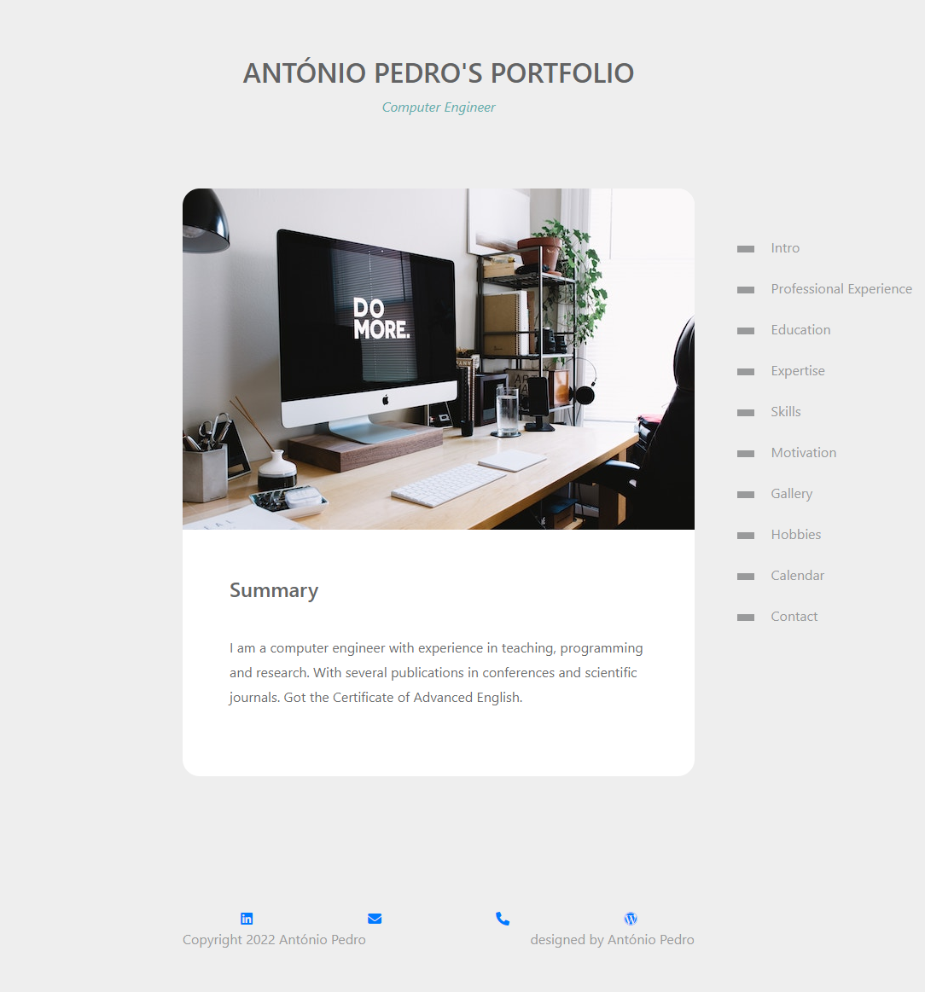
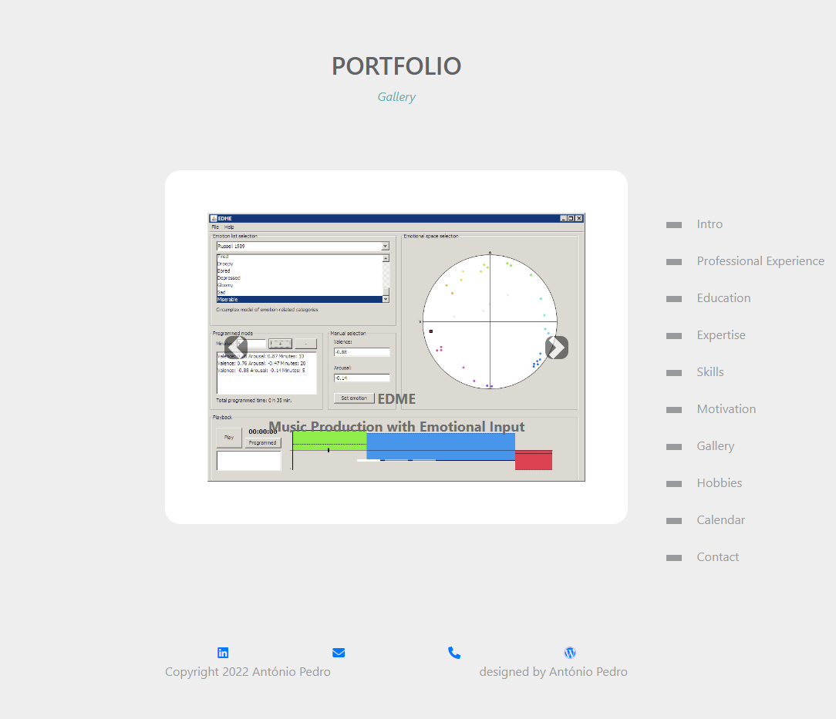

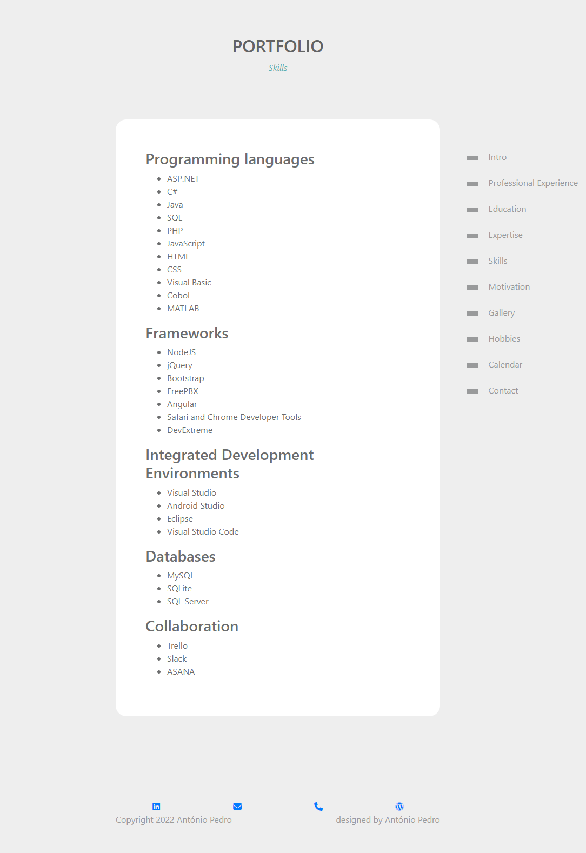

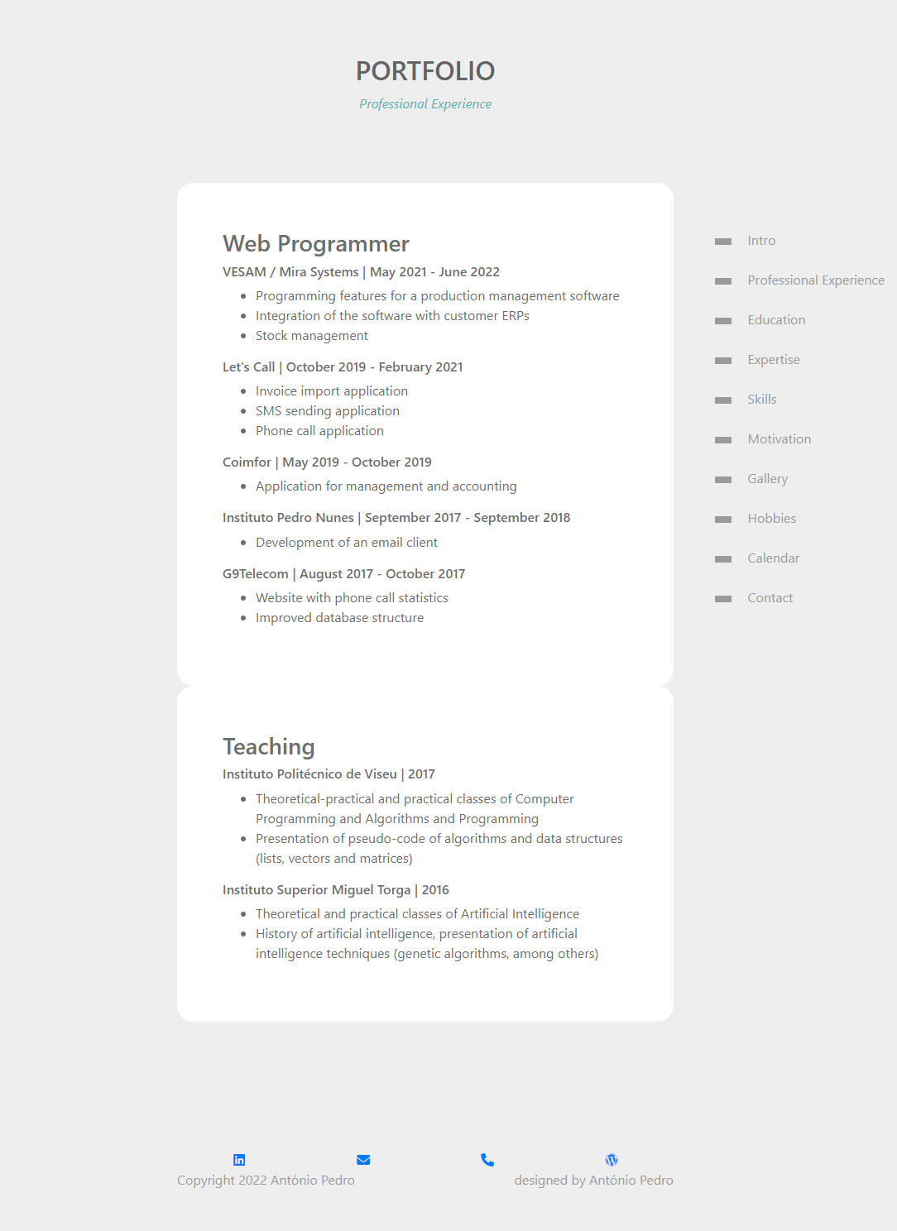

3. Conclusions
- Now, after the current implementation of my portfolio I have available to everyone my professional experience. With an easy navigation bar it is possible to navigate through some important points of my experience.
- I intend to improve this website, namely the layout and content. Now, the layout is very simple, but I intend to improve it with some web design techniques.
- In the development of the project I find it is better to follow a Web Development Framework-based approach instead of template-based or scratch-based approaches.

4. References
Here are some references to material / websites / books relevant to my project:
- http://www.apspoliveira.byethost4.com/skills.html
- https://apspoliveira.wordpress.com/
- https://github.com/apspoliveira/
- https://eden.dei.uc.pt/~apsimoes/
- https://angular.io/
- https://material.angular.io/
- https://getbootstrap.com/docs/4.0/getting-started/introduction/
- https://jquery.com/
- https://en.wikipedia.org/wiki/HTML5
- https://www.w3schools.com/Css/
- https://www.canva.com/presentations/templates/portfolio/
- https://books.google.pt/books?id=NEQ_AwAAQBAJ
- https://books.google.pt/books?id=DAlnDwAAQBAJ

