|  |
| --- |
| LockedMe.com  (Application Screenshots) |

Version History:

|  |  |
| --- | --- |
| Author | Atharv Pratap Singh |
| Purpose | Screenshots of application |
| Date | 13th August 2021 |
| Version | 1.0 |

# Main Menu Screen Shot

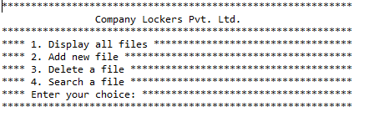

Contents

1. Main Menu Screen Shot 1

1. Main Menu Screen Shot

