Data Governance and Privacy Brief

# Executive Summary

Goal: Adapt research ethics & compliance (from doctoral and regulatory background) to K–12 data privacy. Purpose: Protect students, build trust, and enable actionable data use. This memo anchors governance in FERPA requirements while recognizing Alameda County Office of Education’s (ACOE) unique role managing county-wide, cross-district data.

# FERPA & IRB Parallels

FERPA is often described as education’s HIPAA: it guarantees student privacy, affirms parental rights, and limits unauthorized data sharing. An Institutional Review Board (IRB), common in academic research, ensures that studies meet ethical standards, minimize risk, and incorporate informed consent. Together, these frameworks emphasize both compliance and ethics. My Ph.D. training and experience with research ethics and regulatory compliance directly translate into credibility in overseeing education data privacy, ensuring that evaluation processes are rigorous, ethical, and transparent.

# Proposed Data Governance Framework

Key elements include:  
• Access tiers (Role-Based Access Control): define who can view public, internal, and restricted datasets.  
• Suppression rules: no subgroup data is displayed when cohorts are fewer than 10 students.  
• Audit logs and requests: every dataset access and external data request is logged and reviewed.  
• Review process: an “IRB-lite” governance board screens external research proposals for ethical alignment, privacy protections, and educational value.

Additional FERPA elements:  
• Parent rights: access to records and ability to request corrections.  
• Student records: covers all personally identifiable education information.  
• Consent: required for disclosure except under defined conditions (audit/evaluation, health and safety, etc.

# De-identification & Minimal Viable Dataset

• Remove PII (names, addresses, SSNs, IDs).  
• Suppress subgroup data if N < 10.  
• Use aggregate statistics (percentages, averages) instead of raw data.  
• Only collect fields strictly necessary for decision-making.

# Data Sharing Agreements (MOUs)

Before external researchers or partners can access data, a Data Sharing Agreement must be in place. These agreements specify scope of use, duration, security protocols, destruction of data, and alignment with FERPA and equity principles.

# IRB-Style Review Criteria & Workflow

Criteria include:  
• Minimal risk to students.  
• Clear educational benefit.  
• Alignment with ACOE strategic goals.  
• Equity impact: ensures results do not reinforce disparities.

Workflow: Intake form → IRB-lite committee review → Approve/Conditional/Decline → Monitoring & Close-out.

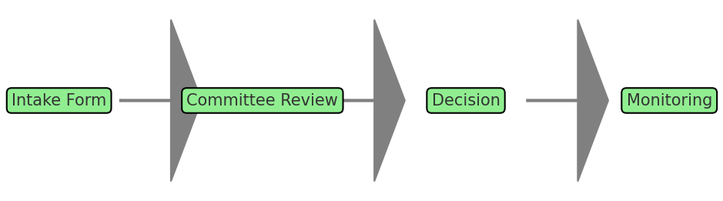

# Role-Based Access & Audit Trails

Access levels:  
• Public: dashboards with suppressed small-N data.  
• Internal: role-based access for staff and administrators.  
• Restricted: approved research datasets after IRB-lite review.

Audit trails log all dataset access and external requests.

# Equity Lens

Governance must ensure not just privacy, but equity. Policies should consider who benefits from data use and whether data informs inclusive supports. Equity-minded governance ensures marginalized student groups remain visible in aggregate reporting while avoiding harm from disclosure of small subgroup data.

# Implementation Plan (30/60/90)

• 30 days: Publish a county-wide data inventory and adopt clear subgroup suppression rules.  
• 60 days: Establish a research review committee, release a standardized intake form and draft MOU template.  
• 90 days: Conduct one external research pilot review, implement audit log system, and refine processes.

# Appendix

Glossary:  
FERPA: Family Educational Rights and Privacy Act – federal law protecting student education records.  
IRB: Institutional Review Board – committee that oversees research ethics and compliance.  
LCAP: Local Control and Accountability Plan – California’s framework for district strategic planning.  
RBAC: Role-Based Access Control – access management by role  
CDE Dashboard: California School Dashboard – accountability system reporting academic and engagement indicators.

References:  
• U.S. Department of Education, FERPA Guidelines  
• California Department of Education, School Dashboard Resources  
• Federal Policy Guidance on Data Privacy and Equity