Anuj Pratap Singh Yadav
 linkedin.com/in/yadavaps77 | 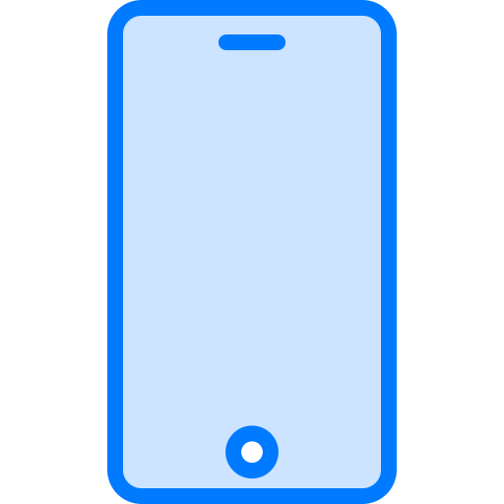 +91-97523-73677 | Noida, India |  yadav.anuj.singh@gmail.com
Summary
Staff engineer with 11 years of C++, the last three-plus in formal verification at Synopsys. I own the coverage subsystems of a C++ vs RTL equivalence app end to end, lead architecture changes across team boundaries in the formal platform, build LLVM-based analysis of C++ designs, and build AI agents that take routine work off the team.
Skills
Formal verification: VC Formal (DPV: C++ vs RTL equivalence; FPV) | Formal coverage and property density | Cone of influence | C++ and RTL code coverage | Sign-off flows | Distributed proofs
Languages: C++ | Tcl | Python | C# | Java | TypeScript
Tools: Verdi | LLVM IR passes (dg) | LSF | FlexNet | GDB | Linux | Perforce | Git | Win32
C++ architecture: Dependency inversion | IWYU | Serialization (XML, pugixml)
AI tooling: Cursor agents, skills, rules and subagents | Scheduled Jira automation
Experience
R&D Staff Engineer | Synopsys Noida, India May 2023 - Present
VC Formal (formal verification), DPV app: C++ vs RTL equivalence
• C++ code coverage for C++ vs RTL sign-off: own it end to end
◦ Shows which parts of the C++ reference model the formal proofs actually exercised, so the C++ side can be signed off like RTL.
◦ Added merging across proofs (a block is covered if any proof covers it, unreachable only if every proof proves it) and export to the standard coverage database, so C++ and RTL coverage are reviewed together in Verdi.
◦ Drive changes with the viewer and GUI teams, handle customer issues, and guided its integration into a new C++ + RTL sign-off app.
• Formal coverage (property density, RTL coverage): own both
◦ They report which design signals, down to the bit, and which RTL lines the properties actually check.
◦ Rebuilt property density so DPV and FPV give the same answer, adding bit-level results, RTL-to-RTL designs and a PASS/FAIL output-coverage check (beta); aligned RTL coverage semantics across the two apps. In production.
• C++ cone of influence (R&D)
◦ Building source-level cone of influence for C++ designs: the exact C++ lines a property depends on.
◦ Wrote LLVM IR passes on the open-source dg slicer for C++ constructs it missed, and a signal-based slicing criterion that cut whole-file slices down to the lines feeding each signal.
◦ Design reviewed weekly with a Distinguished Engineer.
• Build-dependency decoupling (multi-org initiative): led VC Formal's part
◦ The shared C++ layer under ~15 apps and tools included engine headers, so one engine edit rebuilt every app.
◦ Cut wrong-way dependencies ~73% with include-what-you-use, forward declarations, dependency inversion through startup-injected callbacks, and relocating misplaced code.
◦ Rolled out in small changes reviewed by the owning teams; in production. Presented the design in an org-wide tech talk.
• Licensing infrastructure: own it for the DPV app (engine side)
◦ Built token licensing in the C++ proof engine, landed behind a switch and enabled for release.
◦ Root-caused production license-checkout failures in the master/worker distributed solver and shipped the fixes.
• AI agents for the team's workflow: Cursor agents teammates use
◦ A daily scheduled check that flags Jira tickets with missing or wrong validation fields and notifies the owner.
◦ An agent that takes a Jira ticket, reproduces the issue, finds the root cause and drafts a fix as a code review for an engineer to check.
• Customer escalations: own them end to end in my areas: reproduce, root-cause, add a regression test, and ship the fix in service packs.
• Session save/restore: extended snapshots to keep state that was silently lost on restore (user Tcl procedures, engine problem state as XML), and kept new features' state persistent with round-trip tests.
Software Engineer II | Microsoft Noida, India May 2021 - May 2023
• Recording Studio, PowerPoint Win32 (C++): owned camera modes, live background blur, video export and Cameo, a camera object placed on the slide; led v1 test automation and wired Recording and Export telemetry.
• OneDrive commerce (C#): designed catalog filtering plus an allowlist so new commerce SKUs no longer broke OneDrive's upgrade path.
• Stream 2.0 in Excel Win32 (C++, TypeScript): built the video playback component for SharePoint and OneDrive video.
Software Development Engineer 2 | Adobe Noida, India Aug 2015 - Apr 2021
• Photoshop and Premiere Elements builds: moved from RIBS to Hyperdrive builds with parallel install bundles, cutting install time ~50% on average.
• AEM web editor: designed lazy loading for large files, cutting load time ~60% on files customers reported as freezing.
Education
B.Tech (Computer Science and Engineering)  GPA 8.27/10 | Maulana Azad National Institute of Technology (NIT Bhopal) | Bhopal, MP | 2011 - 2015
Class 12 (CBSE)  78% | Kendriya Vidyalaya Shivpuri | Shivpuri, MP | 2009 - 2010
Class 10 (CBSE)  85.6% | Kendriya Vidyalaya JRC Bareilly | Bareilly, UP | 2007 - 2008
Awards
Spot Awards: Synopsys 2023, 2025, 2026 | Adobe 2020
Hobbies and Interests
Competitive programming | Cricket | Football | Chess

